**Greenhouse Gas Reporting Program**

**XML Reporting Instructions**

**for Subpart Y ‑**

**Petroleum Refineries**

United States Environmental Protection Agency

Climate Change Division

Washington, DC

December 15, 2017

*These instructions explain how to report the required data for the applicable regulations. Owners and operators of units should refer to the applicable regulations for information about what data are required to be reported.*

*.*

*[This page intentionally left blank]*

**Table of Contents**

**Page**

I. Introduction 1

II. Summary of Changes 9

III. Subpart Y Overview 10

1.0 Subpart Y Total Emissions 14

2.0 Flares Unit Information 17

2.1 Equation Y‑1a Details, Gas Composition Monitored 22

2.2 Equation Y‑1b Details, Gas Composition Monitored 27

2.3 Equation Y‑2 Details, Heat Content Monitored 31

2.4 Equation Y‑3 Details, Start‑up, Shutdown, Malfunction 34

3.0 Catalytic Cracking, Fluid Coking and Catalytic Reforming Unit Information 36

3.1 Cracking Coking Unit Details 36

3.2 Cracking Coking CEMS Unit Details 56

4.0 Sulfur Recovery Details 57

4.1 Sour Gas Sent Off-site 57

4.2 Sulfur Recovery Plant Information 60

4.3 Sulfur Recovery CEMS Details 75

5.0 Coke Calcining Unit Information 76

5.1 Coke Calcining Unit Details 76

5.2 Coke Calcining CEMS Details 83

6.0 Asphalt Blowing Operations 84

6.1 Equation Y-14 and Y-15 Details 87

6.2 Equation Y-17 Details 89

6.3 Equation Y-19 Process Vent Method Details 92

7.0 Delayed Coking Emissions Summary 96

7.1 Subpart Level Delayed Coking Details 96

7.2 Delayed Coking Unit Details 98

7.3 Coking Drums Set Details 100

8.0 Process Vents Unit Information 104

9.0 Uncontrolled Blowdown Systems 112

10.0 Equipment Leaks 119

11.0 Storage Tanks 122

11.1 Details for Storage Tanks Used to Process Stabilized Crude 122

11.2 Details for Storage Tanks Used to Process Unstabilized Crude 124

12.0 Loading Operations 130

13.0 Tier 4 CEMS Information 134

14.0 Facility-Level Roll-up Emissions 142

IV. Appendix A – Sample XML Document for Subpart Y 144

**List of Tables**

**Page**

Table 1 Reporting Numbers 2

Table 2 Calculated Details Data Element Definitions 5

Table 3 Measurement Details Data Element Definitions 6

Table 4 Unit Identification Details Data Element Definitions 6

Table 6 Required Subpart-Level Summary Data 12

Table 7 Greenhouse Gas Information Details Data Element Definitions 15

Table 8 Flare Gas Unit Details Data Element Definitions 18

Table 9 Flare Gas Emissions Details Data Element Definitions 20

Table 10 Flare Gas Carbon Fraction Basis Data Element Definitions 21

Table 11 Y1aEquationDetails Data Element Definitions 25

Table 12 Y1bEquationDetails Data Element Definitions 29

Table 13 Y2EquationDetails Data Element Definitions 32

Table 14 Y3EquationDetails Data Element Definitions 35

Table 15 Cracking Coking Reforming Unit Data Element Definitions 37

Table 16 Cracking Coking Reforming Emissions Data Element Definitions 40

Table 17 Equation Y-6 Details Data Element Definitions 44

Table 18 Equation Y-7a Details Data Element Definitions 48

Table 19 Equation Y-7b Details Data Element Definitions 51

Table 20 Equation Y-8 Details Data Element Definitions 54

Table 21 Equation Y-11 Data Element Definitions 55

Table 22 Cracking Coking CEMS Details Data Element Definitions 56

Table 23 Sour Gas Sent Off-site Data Element Definitions 58

Table 24 Sulfur Recovery Unit Details Data Element Definitions 61

Table 25 Process Vent Method Details Data Element Definitions 63

Table 26 Mole Fraction Details Data Element Definitions 66

Table 27 Equation Y-12 Details Data Element Definitions 68

Table 28 Recycle Tail Gas Details Data Element Definitions 71

Table 29 Sulfur Recovery Unit CEMS Details Data Element Definitions 75

Table 30 Coke Calcining Unit Details Data Element Definitions 77

Table 31 Coke Calcining Emissions Details Data Element Definitions 79

Table 32 Coke Calcining Unit Method Details Data Element Definitions 81

Table 33 Coke Calcining CEMS Details Data Element Definitions 83

Table 34 Asphalt Blowing Unit Details Data Element Definitions 85

Table 35 Equations Y-14 and Y-15 Details Data Element Definitions 87

Table 36 Equation Y-17 Details Data Element Definitions 90

Table 37 Process Vent Method Details Data Element Definitions 93

Table 38 Mole Fraction Details Data Element Definitions 95

Table 39 Delayed Coking Details (Subpart‑Level) Data Element Definitions 97

Table 40 Delayed Coking Unit Details Data Element Definitions 99

Table 41 Coking Drums Set Details Data Element Definitions 101

Table 42 Process Vents Unit Details Data Element Definitions 105

Table 43 Intermittent Vents Details Data Element Definitions 108

Table 44 Mole Fraction Details Data Element Definitions 110

Table 45 UnControlledBlowDownDetails Data Element Definitions 113

Table 46 Process Vent Method Details Data Element Definitions 115

Table 47 Mole Fraction Details Data Element Definitions 117

Table 48 Basis for CH4 Emissions Factor Data Element Definitions 118

Table 49 Equipment Leaks Details Data Element Definitions 120

Table 50 Storage Tanks (Stabilized Crude) Data Element Definitions 123

Table 51 Storage Tanks (Unstabilized Crude) Data Element Definitions 127

Table 52 Loading Operations Details Data Element Definitions 131

Table 53 Tier 4 CEMS Location and Emissions Details Data Element Definitions 136

Table 54 Tier 4 CEMS Quarter and Additional Details Data Element Definitions 138

Table 55 Tier 4 CEMS Process Units Details Data Element Definitions 141

Table 56 Facility-Level Roll-up Emissions Data Element Definitions 143

**List of Figures**

**Page**

Figure 1 Example of an XML Tree 3

Figure 2 Calculated Details Data Type Schema Diagram 5

Figure 3 Measurement Details Data Type Schema Diagram 5

Figure 4 Unit Identification Details Data Type Schema Diagram 6

Figure 5 “Unbounded” Symbol in Schema Diagram 7

Figure 6 Logical “Or” Symbol in Schema Diagram 8

Figure 7 Subpart Y Reporting Diagram 10

Figure 8 Subpart Y Schema Diagram 13

Figure 9 Greenhouse Gas Information Details Schema Diagram 14

Figure 10 Flare Gas Details Schema Diagram 17

Figure 11 Flare Gas Emissions Details Schema Diagram 19

Figure 12 Y‑1a Equation Details Schema Diagram 22

Figure 13 Equation Y‑1b Details Schema Diagram 27

Figure 14 Compound Identifier Details Schema Diagram 27

Figure 15 Equation Y‑2 Details Schema Diagram 31

Figure 16 Equation Y‑3 Summary and Result Schema Diagram 34

Figure 17 Cracking Coking Reforming Unit Details Schema Diagram 36

Figure 18 Cracking Coking Emissions Details Schema Diagram 38

Figure 19 Equation Y-6 Details Schema Diagram 43

Figure 20 Equation Y-7a Details Schema Diagram 47

Figure 21 Equation Y-7b Details Schema Diagram 50

Figure 22 Equation Y-8 Details Schema Diagram 53

Figure 23 Equation Y-11 Details Schema Diagram 55

Figure 24 Cracking Coking CEMS Details Schema Diagram 56

Figure 25 Sour Gas Sent Off-site Schema Diagram 57

Figure 26 Sulfur Recovery Details Schema Diagram 60

Figure 27 Process Vent Method Details Schema Diagram 63

Figure 28 Mole Fraction Details Schema Diagram 65

Figure 29 Equation Y-12 Details Schema Diagram 67

Figure 30 Recycle Tail Gas (Equation Y-12 Method) Details Schema Diagram 69

Figure 31 Sulfur Recovery Unit CEMS Details Schema Diagram 75

Figure 32 Coke Calcining Unit Details Schema Diagram 76

Figure 33 Coke Calcining Emissions Details Schema Diagram 78

Figure 34 Coke Calcining CEMS Details Schema Diagram 83

Figure 35 Asphalt Blowing Unit Details Schema Diagram 84

Figure 36 Equations Y-14 and Y-15 Details Schema Diagram 87

Figure 37 Equation Y-17 Details Schema Diagram 89

Figure 38 Equation Y-19 Process Vent Method Details Schema Diagram 92

Figure 39 Mole Fraction Details Schema Diagram 94

Figure 40 Delayed Coking Details (Subpart‑Level) Schema Diagram 96

Figure 41 Delayed Coking Details (Unit‑Level) Schema Diagram 98

Figure 42 Delayed Coking Drum Set Details Schema Diagram 100

Figure 43 Process Vents Details (Unit‑Level) Schema Diagram 104

Figure 44 Intermittent Vents Details Schema Diagram 108

Figure 45 Mole Fraction Details Schema Diagram 109

Figure 46 Uncontrolled Blowdown Details Schema Diagram 112

Figure 47 Process Vent Method Details Schema Diagram 114

Figure 48 Mole Fraction Details Schema Diagram 116

Figure 49 Equipment Leaks Details Schema Diagram 119

Figure 50 Storage Tanks (Stabilized Crude) Schema Diagram 122

Figure 51 Storage Tanks (Unstabilized Crude) Schema Diagram 124

Figure 52 Unstabilized Methane Composition Method Details Schema Diagram 125

Figure 53 Loading Operations Details Schema Diagram 130

Figure 54 Vessel Details Schema Diagram 130

Figure 55 Tier 4 CEMS Details Schema Diagram 134

Figure 56 Tier 4 CEMS Location and Emissions Details Schema Diagram 135

Figure 57 Tier 4 CEMS Quarter and Additional Details Schema Diagram 137

Figure 58 Tier 4 CEMS Quarter and Additional Details Schema Diagram 140

Figure 59 Facility-Level Roll-up Emissions Schema Diagram 142

**List of XML Excerpts**

**Page**

XML Excerpt 1 Example for “Unbounded” Parent Element 7

XML Excerpt 2 Example for Greenhouse Gas Information Details 16

XML Excerpt 3 Example for Flare Details if Facility does not have a Flare 18

XML Excerpt 4 Example for Flare Detail 19

XML Excerpt 5 Example for Flare Gas Emissions Details 21

XML Excerpt 6 Example for Flare Gas Carbon Fraction Basis 21

XML Excerpt 7 Example for Equation Y‑1a 26

XML Excerpt 8 Example for Equation Y‑1b 30

XML Excerpt 9 Example for Equation Y‑2 33

XML Excerpt 10 Example for Equation Y‑3 35

XML Excerpt 11 Example for Cracking Coking Reforming Unit Details 38

XML Excerpt 12 Example for Cracking Coking Emissions 42

XML Excerpt 13 Example for Equation Y-6 45

XML Excerpt 14 Example for Equation Y-7a 49

XML Excerpt 15 Example for Equation Y-7b 53

XML Excerpt 16 Example for Equation Y-8 54

XML Excerpt 17 Example for Equation Y-11 55

XML Excerpt 18 Example for Cracking Coking CEMS Details 56

XML Excerpt 19 Example for Sour Gas Sent Off-site 59

XML Excerpt 20 Example for Sulfur Recovery Units 62

XML Excerpt 21 Example for Process Vent Method Details 64

XML Excerpt 22 Example for Mole Fraction Details 66

XML Excerpt 23 Example for Equation Y-12 Details 69

XML Excerpt 24 Example for Recycled Tail Gas Details (Default Correction Factor) 74

XML Excerpt 25 Example for Recycled Tail Gas Details (Unit-Specific Correction Factor) 74

XML Excerpt 26 Example for Sulfur Recovery Unit CEMS Details 75

XML Excerpt 27 Example for Coke Calcining Unit Details 77

XML Excerpt 28 Example for Coke Calcining Emissions Details 80

XML Excerpt 29 Example for Coke Calcining Unit Method Details 82

XML Excerpt 30 Example for Coke Calcining CEMS Details 83

XML Excerpt 31 Example for Asphalt Blowing Unit Details 86

XML Excerpt 32 Example for Equations Y-14 and Y-15 Details 88

XML Excerpt 33 Example for Equation Y-17 and Y-16a Details 91

XML Excerpt 34 Example for Equation Y-17 and Y-16b Details 91

XML Excerpt 35 Example for Process Vent Method Details 93

XML Excerpt 36 Example for Mole Fraction Details 95

XML Excerpt 37 Example for Delayed Coking Details (Subpart‑Level) 97

XML Excerpt 38 Example for Delayed Coking Unit Details 99

XML Excerpt 39 Example for Coking Drums Set Details 103

XML Excerpt 40 Example for Process Vents Unit Details 108

XML Excerpt 41 Example for Intermittent Vents Details 109

XML Excerpt 42 Example for Mole Fraction Details 111

XML Excerpt 43 Example for Uncontrolled Blowdown System Details 113

XML Excerpt 44 Example for Process Vent Method Details 115

XML Excerpt 45 Example for Mole Fraction Details 117

XML Excerpt 46 Example for Basis for CH4 Emissions Factor 118

XML Excerpt 47 Example for Equipment Leaks 121

XML Excerpt 48 Example for Storage Tanks (Stabilized Crude) 124

XML Excerpt 49 Example for Storage Tanks (Unstabilized Crude) 129

XML Excerpt 50 Example for Loading Operations Details 133

XML Excerpt 51 Example for Tier 4 CEMS Location and Emissions Details 137

XML Excerpt 52 Example for Y Tier 4 CEMS Quarter and Additional Details 140

XML Excerpt 53 Example for Tier 4 CEMS Process Units Details 141

XML Excerpt 54 Example for Facility-Level Roll-up Emissions 143

*[This page intentionally left blank]*

# Introduction

The U.S. Environmental Protection Agency’s (EPA’s) electronic greenhouse gas reporting tool (e‑GGRT) extensible markup language (XML) Reporting Schema contains all of the data elements needed to comply with the Greenhouse Gas Reporting Program (GHGRP) beginning with the 2010 data collection year. The XML schema defines expected data elements and attributes, allowable data formats for each data element, and the hierarchical structure and sequence in which data elements must appear in the XML file. Similar to an architectural blueprint that describes the structural design of a house, an XML schema describes the structural design of an XML file. In some cases, it also defines which elements are optional and which are required and the maximum number of occurrences allowed for each element.

The e‑GGRT XML schema is made up of a root data element (GHG) and complex and simple data elements. A simple element is a single piece of data. A complex element is a group of simple elements which are logically grouped together. The root data element is the base of the XML schema.

The data elements are related to each other in parent‑child relationships. The root data element is the parent of the entire schema. Complex data elements are children of the root element, and complex elements can also be children of other complex elements. If a complex element is dependent on a parent complex element, the child complex element cannot be included in the XML file unless the appropriate parent complex element is also included.

The XML upload method may be used for reporting a facility or supplier’s annual greenhouse gas (GHG) data; however, the following actions can only be performed using the e‑GGRT web forms:

* User, facility and supplier registration
* Certificate of Representation and Notice of Delegation signing
* Facility representative and agent changes
* Facility and supplier address changes
* Notice of intent to not submit an annual GHG report

All XML files submitted to e‑GGRT must be well formed and will be accepted only if they conform to the current version of the e‑GGRT XML schema.

An XML submission must only contain GHG data for a single facility or supplier. All data for a facility or supplier must be submitted in a single file as a complete report and must include all of the relevant Subparts. It is not possible to submit a subset of any portion of a facility's data to add, delete, correct or update. The entire report must be resubmitted to make any modification at all. Each subsequent submission for the same facility replaces all of the previously submitted data.

The e‑GGRT XML schema contains enumerated lists of the units of measures for some data elements and allowable values for some data elements. For rules regarding the unit of measure or allowable values for a specific data element, please refer to the appropriate Data Element Definitions table.

The e‑GGRT XML Reporting Schema is available for download at the e-GGRT help website: <http://www.ccdsupport.com/confluence/display/help/XML+Reporting+Instructions>. The page includes:

* **Schema zip file with the master GHG_Final_v*N.n*.xsd and supporting subpart and component xsd files for the current reporting year.**
* **Schema change log files and year to year comparison reports.**

1. Reporting Numbers

|  |  |
| --- | --- |
| **Number Format** | **Description** |
| Rounding | * CO2e and CO2 emissions data expressed in metric tons should be rounded to one decimal place. This should be done regardless of the level of data collection (e.g., unit-level, facility-level). Quantities less than 0.05 metric tons would round to 0.0 and be reported as such. Quantities greater than or equal to 0.05 metric tons would round up to 0.1 and be reported as such. * CH4 emissions data expressed in metric tons should be rounded to two decimal places. * N2O emissions data expressed in metric tons should be rounded to three decimal places. * Emissions data for all GHGs other than CO2, N2O, and CH4 expressed in metric tons should be rounded to the fourth digit to the right of the decimal (one tenth of a kilogram, or 1 ten thousandth of a metric ton). This rounding should be applied regardless of the level of data collection (unit, facility, etc.). * Other (non-emissions) quantitative data reported by the user (e.g., a monthly HHV sample result, an annual production quantity) will not need to be rounded. * In the case of aggregation/roll-ups, those calculations should be performed on the rounded values. |
| Percentages | If a value must be reported as a percentage, then the number should be within the range of 0 to 100 (percent), e.g. 85.5% should be reported as 85.5. |
| Fractions | If a value must be reported as a decimal fraction, then the number should be within the range of 0 and 1, e.g., 1/4 should be reported as 0**.**25. Leading zeroes are optional. |

**Key XML Terms**

* **XML:** A markup language for documents containing structured information. The XML specification defines a standard way to add markup to documents. Its primary purpose is to facilitate the sharing of structured data across different information systems, particularly via the internet.
* **XML Schema:** An XML schema describes the structure of an XML document. The schema also defines the set of rules to which the XML document must conform in order to be considered "valid".
* **XML file:** A file containing data organized into a structured document using XML markup.
* **Data Element:** An XML data element is used for storing and classifying data in an XML file. Opening and closing tags represent the start and end of a data element. An opening tag looks like <elementName>, while a closing tag has a slash that is placed before the element’s name </elementName>. The following example shows how to report the facility’s identification number: <FacilitySiteIdentifier>23222<**/**FacilitySiteIdentifier>. The information shaded in blue represents the data element’s value.   
    
  If a data element does not contain a value, then a single empty tag name may be used. An empty tag has a slash placed after the element’s name <FacilitySiteIdentifier**/**>. **Note:** If you do not intend to report a value for a particular data element, then it is recommended that you do not include the data element in the XML file.
* **Attribute:** An XML attribute contains additional information about a specific data element. An attribute for a data element is placed within the opening tag. The syntax for including an attribute in an element is <elementName attributeName="value">. For example, <TotalCH4CombustionEmissions massUOM="Metric Tons">.
* **Root/Parent/Child Element:** The schema’s structure can be thought of as a family tree. At the top of the tree is some early ancestor and at the bottom of the tree are the latest children. With a tree structure you can see which children belong to which parents and many other relationships.   
    
  XML data elements are sometimes referenced in terms of how they relate to each other, e.g., parent-child relationships, within the schema’s tree structure, also known are hierarchy. The top of the XML tree is considered the root – it is the parent to all data elements within the schema. In the example below, “GHG_Unit_Details” is the root, and just like in many other family trees, there is more than one item with the same name (e.g., “Unit_ID”). The easiest way to distinguish these items is by referencing them in terms of their parent-child relationships, e.g., NoCEMS /Unit_ID vs. CEMS/Unit_ID.

1. Example of an XML Tree

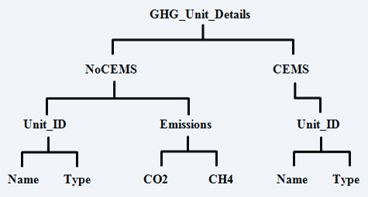

This document provides a step‑by‑step description of how to report emissions data using the XML schema. Please note the following:

* **Non-applicable data elements should not be included in the facility’s XML file.**  The schema contains many data elements, some of which may not be applicable to XML reporters in general or to a particular situation. If a data element is not referenced in the instructions (definition tables), then **do not** report or include it in the facility’s XML file.
* **Data elements must be reported in a specific order.** The figures and tables in this document depict the specific sequence in which data elements must be arranged in the facility’s XML file in order to produce a well‑formed XML report.
* **Enumerations are case sensitive.** Many data elements have a defined set of allowable values, also known as enumerations. Values for enumerations must be entered exactly as they are defined within the schema (including punctuation marks) in order to be accepted by schema validation. See the definition tables for a complete list of enumerations.
* **Schema diagrams depict the hierarchy (or tree structure).** The primary purpose of the schema diagrams is to indicate the sequence in which data elements must appear within the facility’s XML file and to identify the data elements that are required (must be reported) and conditionally required (see last bullet). Required data elements are boxed in red and conditionally required data elements are noted.
* **Definition tables provide details for required and conditionally required data elements.** The tables are designed to provide unique instructions for reporting a given data element, including the list of enumerations and required units of measure, if defined. As noted above, there are some data elements in the schema that are not applicable to XML reporters or to a particular situation. For example, the “OverrideIndicator” data element is used solely by e-GGRT to indicate that the web form reporter chose to override the system’s calculated value with their own. These non‑applicable data elements **are not** included in the definition tables. If a data element is not referenced in a definition table, then **do not** report or include it in the facility’s XML file.
* **Commonly used data types are not depicted in the schema diagrams nor listed separately in the definition tables.** The schema diagrams display almost every data element in the schema except those that are associated with the three most commonly occurring data types:
* Calculated Details
* Measurement Details
* Unit Identification Details

Once defined, these data types (static collection of data elements) are then associated as children to every data element in the schema containing a measured or calculated value or unit details. These child data elements do not appear in the diagrams and are not listed on separate rows in the definition tables in order reduce their redundancy. They are however, referenced in the tables in the description of their parent data element. See Figures 2-4 and Tables 2-4.

* **Some data elements are conditionally required.** Data elements which are conditionally required are noted in the schema diagrams and the data element definitions tables. If your facility meets the condition specified for the data element, then the data element is required and you must report it in the facility’s XML file. If your facility does not meet the condition specified for the data element, then **do not** include the data element in the facility’s XML file. If a parent element is not required, then **do not** include any of its child data elements in the facility’s XML file.

1. Calculated Details Data Type Schema Diagram

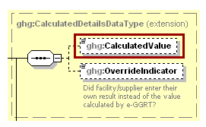

**Note:** Data elements boxed in red are required.

1. Calculated Details Data Element Definitions

|  |  |
| --- | --- |
| **Data Element Name** | **Description** |
| **CalculatedDetailsDataType** |  |
| CalculatedValue | Calculated value (decimal). |
| OverrideIndicator | **Note:** Do not include this data element in the facility’s XML file because it only applies to web form reporters. It is a flag set by e‑GGRT to indicate that the system-calculated value was overridden with the web form reporter’s value. |

1. Measurement Details Data Type Schema Diagram

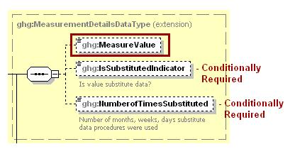

**Note:** Data elements boxed in red are required. Please see page 4 of this document   
for more information on conditionally required elements.

1. Measurement Details Data Element Definitions

|  |  |
| --- | --- |
| **Data Element Name** | **Description** |
| **MeasurementDetailsDataType** |  |
| MeasureValue | Measured value (decimal). |
| IsSubstitutedIndicator | An indication (Y/N) that the measure value contains substituted data.  **Note:** Do not include this data element in your XML file unless noted in the instructions for the particular measured value. |
| NumberofTimesSubstituted | The number (integer) of days, months, weeks, or hours in the reporting year that missing data procedures were followed.  **Note:** Do not include this data element in your XML file unless noted in the instructions for the particular measured value. |

1. Unit Identification Details Data Type Schema Diagram

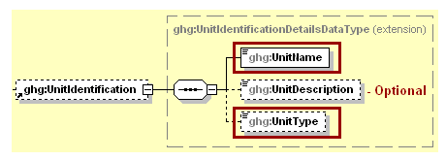

**Note:** Data elements boxed in red are required.

1. Unit Identification Details Data Element Definitions

| **Data Element Name** | **Description** |
| --- | --- |
| **UnitIdentificationDetails** |  |
| UnitName | A unique name (ID) for each unit so that the data for different units can be recorded, maintained and retrieved clearly. |
| UnitDescription | Optional brief description of the unit. |
| UnitType | The type of unit. The list of allowable values varies. For more information, see the instructions for the specific unit process to be reported. For example, if reporting Flare Gas details, the unit type would be “Flare”. |

The XML symbol “1..∞” shown in Figure 5 means that the parent element is “unbounded” so that multiple instances of the parent element can be reported. XML Excerpt 1 shows an example of reporting multiple instances of a parent element.

1. “Unbounded” Symbol in Schema Diagram

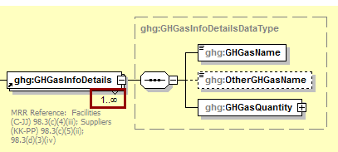

1. Example for “Unbounded” Parent Element

<ghg:GHGasInfoDetails>

<ghg:GHGasName>Biogenic Carbon dioxide</ghg:GHGasName>

<ghg:GHGasQuantity massUOM="Metric Tons">

<ghg:CalculatedValue>600.1</ghg:CalculatedValue>

</ghg:GHGasQuantity>

</ghg:GHGasInfoDetails>

<ghg:GHGasInfoDetails>

<ghg:GHGasName>Methane</ghg:GHGasName>

<ghg:GHGasQuantity massUOM="Metric Tons">

<ghg:CalculatedValue>280.23</ghg:CalculatedValue>

</ghg:GHGasQuantity>

</ghg:GHGasInfoDetails>

<ghg:GHGasInfoDetails>

<ghg:GHGasName>Nitrous Oxide</ghg:GHGasName>

<ghg:GHGasQuantity massUOM="Metric Tons">

<ghg:CalculatedValue>19.456</ghg:CalculatedValue>

</ghg:GHGasQuantity>

</ghg:GHGasInfoDetails>

<ghg:GHGasInfoDetails>

<ghg:GHGasName>Carbon Dioxide</ghg:GHGasName>

<ghg:GHGasQuantity massUOM="Metric Tons">

<ghg:CalculatedValue>10800.7</ghg:CalculatedValue>

</ghg:GHGasQuantity>

</ghg:GHGasInfoDetails>

The XML symbol for a logical “Or” shown in Figure 6 means that **only one** of the data elements following the symbol can be reported for the current instance of the parent element.

1. Logical “Or” Symbol in Schema Diagram

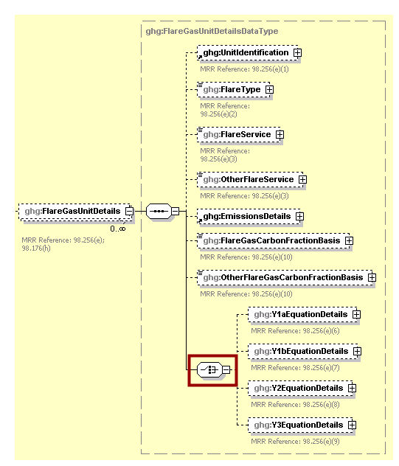

# Summary of Changes

The following modifications were made to the Subpart Y schema for reporting year 2017.

1. **Summary of RY2015 Changes to the Schema for Subpart Y**

| **No.** | **Change Description** | **Applicable Reporting Years** |
| --- | --- | --- |
| 1 | New data elements in the GHGasInfoDetails node (GHGasCASRegistryNumber, GHGasLinearChemicalFormula, OtherGHGasCASRegistryNumber, and OtherGHGaslinearChemicalFormula) now appear in the schema but are only applicable to gases other than Carbon Dioxide, Methane, Nitrous Oxide, and Biogenic Carbon Dioxide so they should not be used in the reporting of Subpart C (see Section 1.0 ubpart Y Total Emissions) | 2017 |
| 2 | CumulativeVentingTime data element (process vents) may now be expressed as a decimal. | All reporting years |
| 3 | TotalVentingTime data element (delayed coking units) may now be expressed as a decimal. | All reporting years |

# Subpart Y Overview

This section provides a step‑by‑step description of how to report emissions data from petroleum refineries as required by Subpart Y of the GHGRP using the XML schema.

1. Subpart Y Reporting Diagram

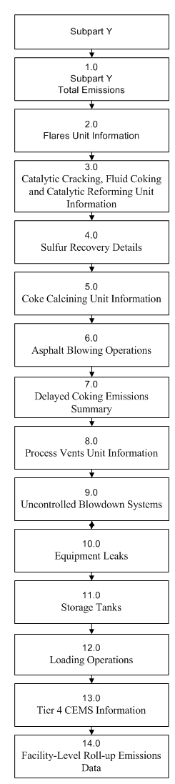

The XML schema includes the following areas for reporting for Subpart Y, as shown in the reporting diagram:

1. Subpart Y Total Emissions: includes the total emissions of CO2 (excluding biogenic CO2), biogenic CO2, CH4 and N2O as reported under Subpart Y.
2. Flares Unit Information: includes emissions information and calculation method details for each flare unit.
3. Catalytic Cracking, Fluid Coking and Catalytic Reforming Unit Information: includes emissions information and calculation method details for each catalytic cracking, fluid coking and catalytic reforming unit.
4. Sulfur Recovery Details: includes subpart-level summary data for CO2 emissions from sour gas sent off-site and emissions and associated details for each sulfur recovery unit.
5. Coke Calcining Unit Information: includes emissions information and calculation method details for each coke calcining unit.
6. Asphalt Blowing Operations: includes emissions information and calculation method details for each asphalt blowing unit.
7. Delayed Coking Emissions Summary: includes subpart-level summary data for cumulative CH4 emissions from all delayed coking units and emissions and details for each delayed coking unit.
8. Process Vents Unit Information: includes emissions information and calculation method details for each process vent unit.
9. Uncontrolled Blowdown Systems: includes subpart-level summary data for CH4 emissions from uncontrolled blowdown systems.
10. Equipment Leaks: includes subpart-level summary data for CH4 emissions from equipment leaks.
11. Storage Tanks: includes subpart-level summary data for annual CH4 emissions from unstabilized crude oil storage and stored liquids other than unstabilized crude oil.
12. Loading Operations: includes subpart-level summary data for cumulative annual CH4 emissions (in metric tons of each pollutant emitted) for loading operations.
13. Tier 4 CEMS Information: includes emissions data for each CEMS monitoring location.
14. Facility‑Level Roll-up Emissions Data: includes information on how to add Subpart Y emissions to the facility-level emissions for CO2e (excluding biogenic CO2) and biogenic CO2. These are aggregated across all source category Subparts associated with the facility.

If your facility is subject to reporting under Subpart Y (Petroleum Refineries), EPA recommends that you also consider the following source categories in your facility applicability determination: Subpart C (General Stationary Fuel Combustion), Subpart P (Hydrogen Production) and Subpart MM (Suppliers of Petroleum Products). These source categories are only provided as suggestions - additional Subparts may be relevant for a given facility/supplier and not all listed Subparts are relevant for all facilities/suppliers.

A petroleum refinery is any facility engaged in producing gasoline, gasoline blending stocks, naphtha, kerosene, distillate fuel oils, residual fuel oils, lubricants, or asphalt (bitumen) by the distillation of petroleum or the redistillation, cracking, or reforming of unfinished petroleum derivatives.

Reporters of the affected facilities are required to report greenhouse gas (GHG) emissions from the following sources: flares, catalytic cracking units, traditional fluid coking units, fluid coking units with flexicoking design, delayed coking units, catalytic reforming units, sulfur recovery units, coke calcining units, asphalt blowing, equipment leaks, storage tanks, uncontrolled blowdown systems, loading operations, process vents and non‑merchant hydrogen plants.

**Note:** If you are using a Best Available Monitoring Method (BAMM) in accordance with the rule in place of a method in Subpart Y, you should report the "Other" option for the method data element and report "BAMM" or "Best Available Monitoring Method" for the corresponding “Other” data element. Details regarding BAMM methods used should be included in Subpart A.

1. Required Subpart-Level Summary Data

|  |  |
| --- | --- |
| **Section** | **Subpart-Level Summary Data** |
| 1.0 | Subpart Y Total Emissions |
| 2.0 | Flares Unit Information |
| 4.1 | Sour Gas Sent Off-site |
| 7.1 | Subpart Level Delayed Coking Details |
| 7.3 | Coking Drums Set Details |
| 9.0 | Uncontrolled Blowdown Systems |
| 10.0 | Equipment Leaks |
| 11.0 | Storage Tanks |
| 12.0 | Loading Operations |
| 14.0 | Facility-Level Roll-up Emissions |

1. Subpart Y Schema Diagram

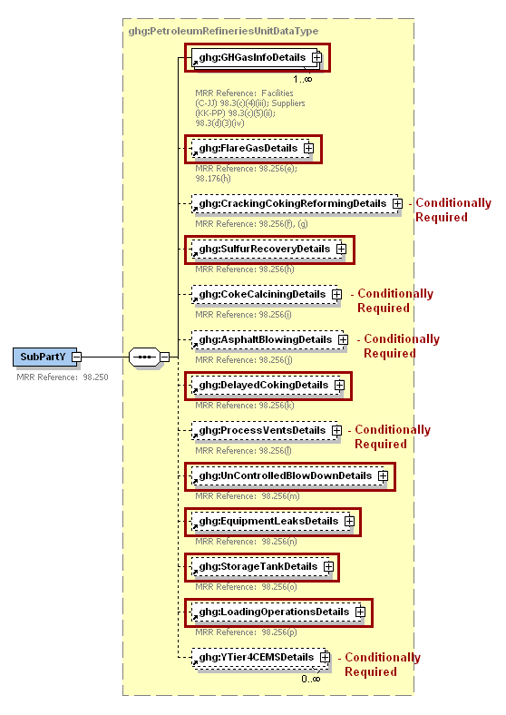

**Note:** Data elements boxed in red are required. Please see page 4 of this document   
for more information on conditionally required elements.

## Subpart Y Total Emissions

**Required Subpart-Level Summary Data**

Greenhouse gas information details comprise a collection of data elements to report the total annual emissions of each greenhouse gas (GHG) listed in Table A‑1 of 40 CFR 98 Mandatory Reporting of Greenhouse Gases, reported under Subpart Y, expressed in metric tons.

1. Greenhouse Gas Information Details Schema Diagram

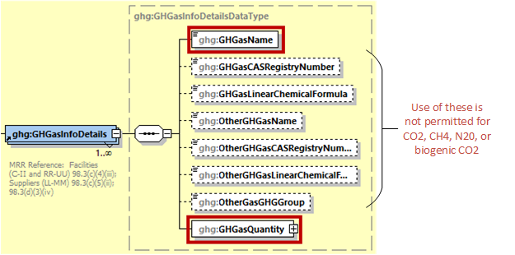

**Note:** Data elements boxed in red are required.

The GHGasInfoDetails parent element is for reporting emissions rolled up to the Subpart level. For Subpart Y, report the gas name and emissions for biogenic carbon dioxide (CO2), CO2 (excluding biogenic CO2), methane (CH4) and nitrous oxide (N2O); do not report the CAS Registry Number, Linear Chemical Formula, or the other gas data elements for CO2, biogenic CO2, CH4, or N2O, using the following guidelines:

1. **Total CO2 emissions (excluding biogenic CO2)**:

* Add the total annual CO2 mass emissions measured by the CEMS for each CEMS monitoring location (CML) in metric tons. Then subtract the total annual biogenic CO2 emissions for each CML in metric tons.
* Add the annual CO2 emissions from sour gas sent off-site in metric tons.
* Add the annual CO2 emissions from each asphalt blowing unit in metric tons.
* Add the annual CO2 emissions from each coke calcining unit in metric tons.
* Add the annual CO2 emissions from each coking/cracking/reforming unit in metric tons.
* Add the annual CO2 emissions from each flare in metric tons.
* Add the annual CO2 emissions from each process vent in metric tons.
* Add the annual CO2 emissions from each sulfur recovery plant in metric tons.

1. **Total biogenic CO2 emissions:** Add the total annual biogenic CO2 mass emissions for each CML in metric tons.
2. **Total CH4 emissions**:

* Add the total CH4 emissions measured by the CEMS for each CML in metric tons.
* Add the total CH4 emissions from each uncontrolled blowdown system, each stabilized/unstabilized crude storage tank, all equipment leaks, all loading operations and each delayed coking unit in metric tons.
* Add the annual CH4 emissions from each asphalt blowing unit in metric tons.
* Add the annual CH4 emissions from each coke calcining unit in metric tons.
* Add the annual CH4 emissions from each coking/cracking/reforming unit in metric tons.
* Add the annual CH4 emissions from each flare in metric tons.
* Add the annual CH4 emissions from each process vent in metric tons.
* Add the total annual CH4 emissions measured by the CEMS for each coke calcining unit in metric tons.
* Add the total annual CH4 emissions measured by the CEMS for each coking/cracking/reforming unit in metric tons.

1. **Total N2O emissions**:

* Add the total annual N2O emissions measured by the CEMS for each CML in metric tons.
* Add the annual N2O emissions from each coke calcining unit in metric tons.
* Add the annual N2O emissions from each coking/cracking/reforming unit in metric tons.
* Add the annual N2O emissions from each flare in metric tons.
* Add the annual N2O emissions from each process vent in metric tons.
* Add the total annual N2O emissions measured by the CEMS for each coke calcining unit in metric tons.
* Add the total annual N2O emissions measured by the CEMS for each coking/cracking/reforming unit in metric tons.

**Note:** You must follow the rounding rules found in Table 1.

1. Greenhouse Gas Information Details Data Element Definitions

| **Data Element Name** | **Description** |
| --- | --- |
| GHGasInfoDetails | **Parent Element:** A collection of data elements containing the total annual emissions of each greenhouse gas (GHG) listed in Table A‑1 of 40 CFR 98 Mandatory Reporting of Greenhouse Gases, or other GHGs reported under this Subpart, expressed in metric tons. |
| GHGasName | Specify the name of the GHG. See list of allowable values:   |  | | --- | | Carbon Dioxide  Biogenic Carbon dioxide | | Methane | | Nitrous Oxide | |
| GHGasQuantity | A collection of data elements that quantify the annual emissions from this source category. Report the emissions value in the child data element **CalculatedValue**. Set the units of measure to “Metric Tons” in the attribute**massUOM**. |

**Note:** OtherGHGasName and OtherGasGHGroup are not applicable to Subpart Y

1. Example for Greenhouse Gas Information Details

<ghg:GHGasInfoDetails>

<ghg:GHGasName>Biogenic Carbon dioxide</ghg:GHGasName>

<ghg:GHGasQuantity massUOM="Metric Tons">

<ghg:CalculatedValue>3234.6</ghg:CalculatedValue>

</ghg:GHGasQuantity>

</ghg:GHGasInfoDetails>

<ghg:GHGasInfoDetails>

<ghg:GHGasName>Methane</ghg:GHGasName>

<ghg:GHGasQuantity massUOM="Metric Tons">

<ghg:CalculatedValue>89536.24</ghg:CalculatedValue>

</ghg:GHGasQuantity>

</ghg:GHGasInfoDetails>

<ghg:GHGasInfoDetails>

<ghg:GHGasName>Nitrous Oxide</ghg:GHGasName>

<ghg:GHGasQuantity massUOM="Metric Tons">

<ghg:CalculatedValue>156042.623</ghg:CalculatedValue>

</ghg:GHGasQuantity>

</ghg:GHGasInfoDetails>

<ghg:GHGasInfoDetails>

<ghg:GHGasName>Carbon Dioxide</ghg:GHGasName>

<ghg:GHGasQuantity massUOM="Metric Tons">

<ghg:CalculatedValue>298375.8</ghg:CalculatedValue>

</ghg:GHGasQuantity>

</ghg:GHGasInfoDetails>

**Note:** The XML example above is presented here to demonstrate the concept of reporting greenhouse gas emissions data.

## Flares Unit Information

**Required Unit-Level Data**

This topic provides a step‑by‑step description of how to report Subpart Y Flares unit information for a facility. You must report CO2, CH4 and N2O combustion emissions from each flare.

1. Flare Gas Details Schema Diagram

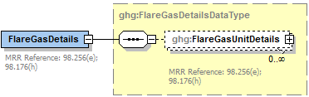

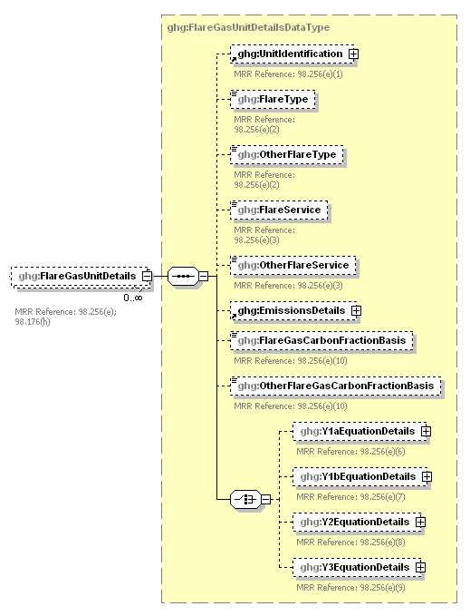

**Report only one**

**Conditionally**

**Required**

**Conditionally**

**Required**

**Conditionally**

**Required**

**Note:** Data elements boxed in red are required. Please see page 4 of this document   
for more information on conditionally required elements.

**Note:** If the facility does not have a flare, then report this information in the data element “OtherFlareService” (see excerpt below) and proceed to the next relevant reporting section.

1. Example for Flare Details if Facility does not have a Flare

<ghg:FlareGasDetails>

<ghg:FlareGasUnitDetails>

<ghg:OtherFlareService>Facility does not have a flare</ghg:OtherFlareService>

</ghg:FlareGasUnitDetails>

</ghg:FlareGasDetails>

**Note:** The XML example above is presented here to demonstrate the concept of reporting flare details if the facility does not have a flare.

Subpart Y collects the following data about your flare unit:

* A unique name or identifier, plus optional description for this flare unit.
* Type of flare.
* Flare service type.
* Details about the methods used to calculate the CO2 emissions. For more information, see the applicable section:
* 98.253(b)(1)(ii)(A) – Equation Y-1a – Gas Composition Monitored
* 98.253(b)(1)(ii)(A) – Equation Y-1b – Gas Composition Monitored
* 98.253(b)(1)(ii)(B) – Equation Y-2 – Heat Content Monitored
* 98.253(b)(1)(iii) – Equation Y-3 – Start-up, Shutdown, Malfunction
* The CO2, CH4 and N2O annual emissions for each flare.
* The basis for the fraction of carbon in the flare gas contributed by methane used in Equation Y‑4, if applicable.

1. Flare Gas Unit Details Data Element Definitions

| **Data Element Name** | **Description** |
| --- | --- |
| **FlareGasDetails** | **Parent Element** |
| **FlareGasUnitDetails** | **Parent Element** |
| UnitIdentification | A collection of data elements containing the identity of each Flare Gas unit. Report a unique unit name (ID) in the child data element **UnitName**, an optional brief description in the child data element **UnitDescription** and the type of unit in the child data element **UnitType**. [98.256(e)(1)] Report the following unit type:   |  | | --- | | Flare | |
| FlareType | Type of flare. [98.256(e)(2)] Below is the list of allowable values.  Steam assisted  Air-assisted  Unassisted  Other (specify) |
| OtherFlareType | **Conditionally Required:** Specify the type of flare if not listed above. |
| FlareService | Type of flare service. [98.256(e)(3)] Below is the list of allowable values.  General facility flare  Unit flare  Emergency only flare  Back-up flare  Other (specify) |
| OtherFlareService | **Conditionally Required:** Specify the type of flare service if not listed above. |

1. Example for Flare Detail

<ghg:FlareGasDetails>

<ghg:FlareGasUnitDetails>

<ghg:UnitIdentification>

<ghg:UnitName>FLARE-001</ghg:UnitName>

<ghg:UnitDescription>Unit altered to increase the flow.</ghg:UnitDescription>

<ghg:UnitType>Flare</ghg:UnitType>

</ghg:UnitIdentification>

<ghg:FlareType>Steam assisted</ghg:FlareType>

<ghg:FlareService>General facility flare</ghg:FlareService>

**Note:** The XML example above is presented here to demonstrate the concept of reporting details about a flare gas unit.

1. Flare Gas Emissions Details Schema Diagram

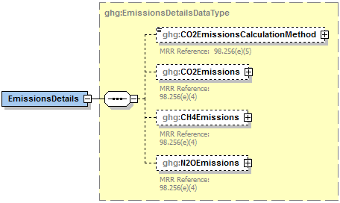

**Note:** Data elements boxed in red are required. Please see page 4 of this document   
for more information on conditionally required elements.

Subpart Y collects the following data about your flare unit emissions:

* Method used to calculate the CO2 emissions.   
  + 98.253(b)(1)(ii)(A) ‑ Equation Y‑1a Gas Composition Monitored   
    (Equation Y‑1a or Y‑1b must be used if you have a continuous gas composition monitor on the flare or if you measure it at least weekly.)
  + 98.253(b)(1)(ii)(A) ‑ Equation Y‑1b Gas Composition Monitored   
    (Equation Y‑1a or Y‑1b must be used if you have a continuous gas composition monitor on the flare or if you measure it at least weekly.)
  + 98.253(b)(1)(ii)(B) ‑ Equation Y‑2 Heat Content Monitored   
    (Equation Y‑2 must be used if you have a continuous higher heating value monitor or measure it at least weekly and the heating value monitor or measurement is not based on compositional analyses; if compositional analyses are used, you must use Equations 1a or 1b.)
  + 98.253(b)(1)(iii) ‑ Equation Y‑3 Start‑up, Shutdown, Malfunction   
    (Equation Y‑3 must be used if you do not measure gas composition or heating value at least weekly.)
* The calculated CO2, CH4 and N2O annual emissions for each flare, expressed in metric tons of each GHG emitted. To report annual CO2 emissions, follow the instructions that correspond to the calculation method reported. (See applicable section in this document: Equation Y‑1a Details, Equation Y‑1b Details, Equation Y‑2 Details, or Equation Y‑3 Details).

1. Flare Gas Emissions Details Data Element Definitions

| **Data Element Name** | **Description** |
| --- | --- |
| **EmissionsDetails** | **Parent Element:** The calculated CO2, CH4 and N2O annual emissions for each flare. |
| CO2EmissionsCalculationMethod | The method used to calculate the CO2 emissions for each flare (e.g., reference section and equation number). [98.256(e)(5)] Below is the list of allowable values.   |  | | --- | | 98.253(b)(1)(ii)(A) - Equation Y-1a Gas Composition Monitored  98.253(b)(1)(ii)(A) - Equation Y-1b Gas Composition Monitored  98.253(b)(1)(ii)(B) - Equation Y-2 Heat Content Monitored  98.253(b)(1)(iii) - Equation Y-3 Start-up, Shutdown, Malfunction | |
| CO2Emissions | Annual CO2 emissions for each flare. [98.256(e)(4)] Report the emissions value in the child data element **CalculatedValue**. Set the units of measure to “Metric Tons” in the attribute **massUOM**. |
| CH4Emissions | Annual CH4 emissions for each flare. [98.256(e)(4)] Report the emissions value in the child data element **CalculatedValue**. Set the units of measure to “Metric Tons” in the attribute **massUOM**. |
| N2OEmissions | Annual N2O emissions for each flare. [98.256(e)(4)] Report the emissions value in the child data element **CalculatedValue**. Set the units of measure to “Metric Tons” in the attribute **massUOM**. |

1. Example for Flare Gas Emissions Details

<ghg:EmissionsDetails>

<ghg:CO2EmissionsCalculationMethod>98.253(b)(1)(ii)(A) - Equation Y-1a Gas Composition Monitored</ghg:CO2EmissionsCalculationMethod>

<ghg:CO2Emissions massUOM="Metric Tons">

<ghg:CalculatedValue>23400.4</ghg:CalculatedValue>

</ghg:CO2Emissions>

<ghg:CH4Emissions massUOM="Metric Tons">

<ghg:CalculatedValue>3880.23</ghg:CalculatedValue>

</ghg:CH4Emissions>

<ghg:N2OEmissions massUOM="Metric Tons">

<ghg:CalculatedValue>2035.234</ghg:CalculatedValue>

</ghg:N2OEmissions>

</ghg:EmissionsDetails>

**Note:**  The XML example above is presented here to demonstrate the concept of reporting CO2, CH4 and N2O emissions for each flare gas unit.

The basis for the fraction of carbon in the flare gas contributed by methane used in Equation Y‑4 is required.

1. Flare Gas Carbon Fraction Basis Data Element Definitions

|  |  |
| --- | --- |
| **Data Element Name** | **Description** |
| FlareGasCarbonFractionBasis | The basis for the fraction of carbon in the flare gas contributed by CH4 value. [98.256(e)(10)] Below is the list of allowable values.  Default Value  Method 18 at 40 CFR part 60, appendix A-6  ASTM D1945-03  ASTM D1946-90 (Reapproved 2006)  GPA 2261-00  UOP539-97  ASTM D2503-92 (Reapproved 2007)  Chromatographic analysis: manufacturer’s instructions  Engineering calculations  Other (specify) |
| OtherFlareGasCarbonFractionBasis | **Conditionally Required:** Specify the basis for the fraction of carbon in the flare gas contributed by CH4 value if not listed above. |

1. Example for Flare Gas Carbon Fraction Basis

<ghg:FlareGasCarbonFractionBasis>ASTM D1945-03</ghg:FlareGasCarbonFractionBasis>

**Note:**  The XML example above is presented here to demonstrate the concept of reporting flare gas carbon fraction basis for each flare gas unit.

?

***Which equation was used to calculate CO2 emissions?***

If Equation Y-1a was used to calculate CO2 emissions, see Section 2.1 for instructions on how to report for the parent element “Y1aEquationDetails”.

If Equation Y-1b was used to calculate CO2 emissions, see Section 2.2 for instructions on how to report for the parent element “Y1bEquationDetails”.

If Equation Y-2 was used to calculate CO2 emissions, see Section 2.3 for instructions on how to report for the parent element “Y2EquationDetails”.

If Equation Y-3 was used to calculate CO2 emissions, see Section 2.4 for instructions on how to report for the parent element “Y3EquationDetails”.

### Equation Y‑1a Details, Gas Composition Monitored

**Conditionally Required:** This topic provides a step‑by‑step description of how to report details about Equation Y‑1a. This equation is for calculating CO2 emissions if you monitor gas composition and measure the molecular weight and carbon content of the flare gas combusted.

1. Y‑1a Equation Details Schema Diagram

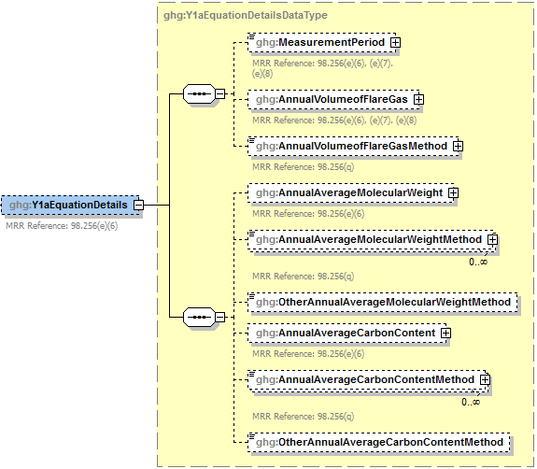

**Conditionally**

**Required**

**Conditionally**

**Required**

**Note:** Data elements boxed in red are required. Please see page 4 of this document for more information on conditionally required elements.

To calculate the annual CO2 emissions from flare units using Equation Y‑1a, you can download the Y‑1a spreadsheet from the e‑GGRT help site or use the following information:



Where:

CO2 = Annual CO2 emissions for a specific fuel type (metric tons/year).

0.98 = Assumed combustion efficiency of a flare.

0.001 = Unit conversion factor (metric tons per kilogram, mt/kg).

n = Number of measurement periods. The minimum value for n is 52 (for weekly measurements); the maximum value for n is 366 (for daily measurements during a leap year).

p = Measurement period index.

44 = Molecular weight of CO2 (kg/kg‑mole).

12 = Atomic weight of C (kg/kg‑mole).

(Flare)p = Volume of flare gas combusted during measurement period (standard cubic feet per period, scf/period). If a mass flow meter is used, measure flare gas flow rate in kg/period and replace the term “(MW)p/MVC” with “1”.

(MW)p = Average molecular weight of the flare gas combusted during measurement period (kg/kg‑mole). If measurements are taken more frequently than daily, use the arithmetic average of measurement values within the day to calculate a daily average.

MVC = Molar volume conversion factor (849.5 scf/kg-mole at 68 ºF and 14.7 psia or 836.6 scf/kg-mole at 60 ºF and 14.7 psia).

(CC)p = Average carbon content of the flare gas combusted during measurement period (kg C per kg flare gas). If measurements are taken more frequently than daily, use the arithmetic average of measurement values within the day to calculate a daily average.

You must report the following data if you used Equation Y‑1a to calculate CO2 emissions:

* An indication of whether daily or weekly measurement periods are used [98.256(e)(6)]
* The annual volume of flare gas combusted (in scf) [98.256(e)(6)]
* The specific consensus-based standard method number or description of the procedure specified by the flow meter manufacturer [98.256(q)]
* The number of days during the reporting year missing data procedures were used to determine the volume of flare gas combusted [98.3(c)(8)]
* The annual average molecular weight (in kg/kg-mole) [98.256(e)(6)]
* The method used to measure molecular weight [98.256(q)]
* The number of days during the reporting year missing data procedures were used to determine molecular weight [98.3(c)(8)]
* The annual average carbon content of the flare gas (kg carbon/kg flare gas) [98.256(e)(6)]
* The method used to measure carbon content [98.256(q)]
* The number of days during the reporting year missing data procedures were used to determine carbon content [98.3(c)(8)]

1. Y1aEquationDetails Data Element Definitions

| **Data Element Name** | **Description** |
| --- | --- |
| **Y1aEquationDetails** | **Parent Element (Conditionally Required)** |
| MeasurementPeriod | An indication of whether daily or weekly measurement periods are used. [98.256(e)(6)] Below is a list of the allowable values:  Daily  Weekly |
| AnnualVolumeofFlareGas | The annual volume of flare gas combusted. [98.256(e)(6)] Report the value in the child data element **MeasureValue**. Set the units of measure to “scf” in the attribute**volUOM**. Also report the number of days that missing data procedures were used in measuring the annual volume of flare gas combusted in the child data element **NumberofTimesSubstituted**. [98.3(c)(8)] |
| AnnualVolumeofFlareGasMethod | The specific consensus-based standard method or description of the procedure specified by the flow meter manufacturer. [98.256(q)] |
| AnnualAverageMolecularWeight | The annual average molecular weight. [98.256(e)(6)] Report the value in the child data element **MeasureValue**. Set the units of measure to “kg/kg-mole” in the attribute **molewtUOM**. Also report the number of days that missing data procedures were used in measuring the annual average molecular weight in the child data element **NumberofTimesSubstituted**. [98.3(c)(8)] |
| AnnualAverageMolecularWeightMethod | The method(s) used to determine the annual average molecular weight of the flare gas. [98.256(q)] Below is the list of allowable values.  Method 18 at 40 CFR part 60, appendix A‑6  ASTM D1945‑03  ASTM D1946‑90 (Reapproved 2006)  GPA 2261‑00  UOP539‑97  ASTM D2503‑92 (Reapproved 2007)  Chromatographic analysis: manufacturer’s instructions  Other (specify) |
| OtherAnnualAverageMolecularWeightMethod | **Conditionally Required:** Specify the method used to determine the annual average molecular weight of the flare gas if not listed above. |
| AnnualAverageCarbonContent | The annual average carbon content of the flare gas. [98.256(e)(6)] Report the value in the child data element **MeasureValue**. Set the units of measure to “decimal fraction; kg carbon/kg flare gas” in the attribute**carboncontentUOM**. Also report the number of days that missing data procedures were used in measuring the annual average carbon content of the flare gas in the child data element **NumberofTimesSubstituted**. [98.3(c)(8)] |
| AnnualAverageCarbonContentMethod | The method(s) used to determine the annual average carbon content of the flare gas. Below is the list of allowable values. [98.256(q)]  Method 18 at 40 CFR part 60, appendix A‑6  ASTM D1945‑03  ASTM D1946‑90 (Reapproved 2006)  GPA 2261‑00  UOP539‑97  ASTM D2503‑92 (Reapproved 2007)  Chromatographic analysis: manufacturer’s instructions  Other (specify) |
| OtherAnnualAverageCarbonContentMethod | **Conditionally Required:** Specify the method used to determine the annual average carbon content of the flare gas if not listed above. |

1. Example for Equation Y‑1a

<ghg:Y1aEquationDetails>

<ghg:MeasurementPeriod>Daily</ghg:MeasurementPeriod>

<ghg:AnnualVolumeofFlareGas volUOM="scf">

<ghg:MeasureValue>2332.2342</ghg:MeasureValue>

<ghg:NumberofTimesSubstituted>2</ghg:NumberofTimesSubstituted>

</ghg:AnnualVolumeofFlareGas>

<ghg:AnnualVolumeofFlareGasMethod>Method 123</ghg:AnnualVolumeofFlareGasMethod>

<ghg:AnnualAverageMolecularWeight molewtUOM="kg/kg-mole">

<ghg:MeasureValue>235.45678</ghg:MeasureValue>

<ghg:NumberofTimesSubstituted>5</ghg:NumberofTimesSubstituted>

</ghg:AnnualAverageMolecularWeight>

<ghg:AnnualAverageMolecularWeightMethod>GPA 2261-00</ghg:AnnualAverageMolecularWeightMethod>

<ghg:AnnualAverageCarbonContent carboncontentUOM="decimal fraction; kg carbon/kg flare gas">

<ghg:MeasureValue>.21</ghg:MeasureValue>

<ghg:NumberofTimesSubstituted>7</ghg:NumberofTimesSubstituted>

</ghg:AnnualAverageCarbonContent>

<ghg:AnnualAverageCarbonContentMethod>ASTM D1945-03</ghg:AnnualAverageCarbonContentMethod>

</ghg:Y1aEquationDetails>

**Note:**  The XML example above is presented here to demonstrate the concept of reporting the details for Equation Y‑1a.

### Equation Y‑1b Details, Gas Composition Monitored

**Conditionally Required:** This topic provides a step‑by‑step description of how to report details about Equation Y‑1b. This method is used for calculating CO2 emissions if you monitor gas composition and measure both the mole percentage of CO2 concentration and the number of carbon compounds, other than CO2, in the flare gas stream.

1. Equation Y‑1b Details Schema Diagram

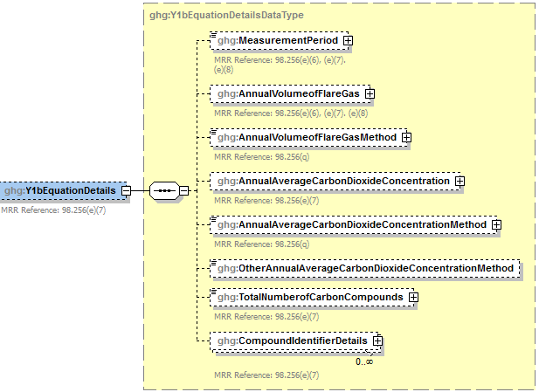

**Conditionally**

**Required**

1. Compound Identifier Details Schema Diagram

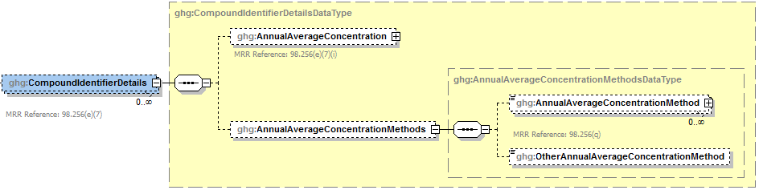

**Conditionally Required**

**Note:** Data elements boxed in red are required. Please see page 4 of this document   
for more information on conditionally required elements.

To calculate the annual CO2 emissions from flare units, you can download the Y‑1b spreadsheet from the e‑GGRT help site or use the following information:



Where:

CO2 = Annual CO2 emissions for a specific fuel type (metric tons/year).

N = Number of measurement periods. The minimum value for n is 52 (for weekly measurements); the maximum value for n is 366 (for daily measurements during a leap year).

p = Measurement period index.

(Flare)p = Volume of flare gas combusted during measurement period (standard cubic feet per period, scf/period). If a mass flow meter is used, you must determine the average molecular weight of the flare gas during the measurement period and convert the mass flow to a volumetric flow.

44 = Molecular weight of CO2 (kg/kg‑mole).

MVC = Molar volume conversion factor (849.5 scf/kg‑mole at 68ºF and 14.7 psia or 836.6 scf/kg‑mole at 60ºF and 14.7 psia).

0.001 = Unit conversion factor (metric tons per kilogram, mt/kg).

(%CO2)p = Mole percent CO2 concentration in the flare gas stream during the measurement period (mole percent = percent by volume).

y = Number of carbon‑containing compounds other than CO2 in the flare gas stream.

X = Index for carbon‑containing compounds other than CO2.

0.98 = Assumed combustion efficiency of a flare (mole CO2 per mole carbon).

(%Cx)p = Mole percent concentration of compound “x” in the flare gas stream during the measurement period (mole percent = percent by volume)

CMNx = Carbon mole number of compound “x” in the flare gas stream (mole carbon atoms per mole compound). E.g., CMN for ethane (C2H6) is 2; CMN for propane (C3H8) is 3.

You must report the following data if you used Equation Y‑1b to calculate CO2 emissions:

* An indication of whether daily or weekly measurement periods are used [98.256(e)(7)]
* The annual volume of flare gas combusted (in scf) [98.256(e)(7)]
* The number of days missing data procedures were used to determine the annual volume of flare gas combusted
* The specific consensus-based standard method number or description of the procedure specified by the flow meter manufacturer [98.256(q)]
* The annual average CO2 concentration (percent by volume or mole) [98.256(e)(7)]
* The number of days missing data procedures were used to determine the annual average CO2 concentration
* The method used to measure the annual average CO2 concentration [98.256(q)]
* The total number of carbon containing compounds other than CO2 that are in the flare gas stream [98.256(e)(7)]

For each carbon containing compound other than CO2 in the flare gas stream identified by the facility, and for each flare using the Equation Y-1b, report the following:

* The annual average concentration of the compound (percent by volume or mole) [98.256(e)(7)(i)]
* The number of days missing data procedures were used to determine annual average concentration of the compound
* The method used to measure the annual average concentration of the compound [98.256(q)]

1. Y1bEquationDetails Data Element Definitions

| **Data Element Name** | **Description** |
| --- | --- |
| **Y1bEquationDetails** | **Parent Element (Conditionally Required)** |
| MeasurementPeriod | An indication of whether daily or weekly measurement periods are used. [98.256(e)(7)] Below is a list of the allowable values:  Daily  Weekly |
| AnnualVolumeofFlareGas | The annual volume of flare gas combusted. [98.256(e)(7)] Report the value in the child data element **MeasureValue**. Set the units of measure to “scf” in the attribute**volUOM**. Also report the number of days that missing data procedures were used in measuring the annual volume of flare gas combusted in the child data element **NumberofTimesSubstituted**. [98.3(c)(8)] |
| AnnualVolumeofFlareGasMethod | The specific consensus-based standard method or description of the procedure specified by the flow meter manufacturer. [98.256(q)] |
| AnnualAverageCarbonDioxideConcentration | The annual average CO2 concentration in the flare gas stream. [98.256(e)(7)] Report the value in the child data element **MeasureValue**. Set the units of measure to “percent by volume or mole” in the attribute **concentrationUOM**. Also report the number of days that missing data procedures were used in measuring the annual average CO2 concentration in the flare gas stream in the child data element **NumberofTimesSubstituted**. [98.3(c)(8)] |
| AnnualAverageCarbonDioxideConcentration Method | The method used to determine the annual average CO2 concentration in the flare gas. [98.256(q)] Below is the list of allowable values.  Method 18 at 40 CFR part 60, appendix A‑6  ASTM D1945‑03  ASTM D1946‑90 (Reapproved 2006)  GPA 2261‑00  UOP539‑97  ASTM D2503‑92 (Reapproved 2007)  Chromatographic analysis: manufacturer’s instructions  Other (specify) |
| OtherAnnualAverageCarbonDioxideConcentration Method | **Conditionally Required:** Specify the method used to determine the annual average CO2 concentration in the flare gas if not listed above. |
| TotalNumberofCarbonCompounds | The total number of carbon containing compounds other than CO2 in the flare gas stream (integer). [98.256(e)(7)] |
| **CompoundIdentifierDetails** | **Parent Element:** A collection of data elements containing details about the carbon containing compounds, other than CO2, in the flare gas stream. |
| AnnualAverageConcentration | The annual average concentration of the compound for each carbon containing compound, other than CO2, in the flare gas stream. [98.256(e)(7)(i)] Report the value in the child data element **MeasureValue**. Set the units of measure to “percent by volume or mole” in the attribute **concentrationUOM**. Also report the number of days that missing data procedures were used in measuring the annual average concentration of the compound in the child data element **NumberofTimesSubstituted**. [98.3(c)(8)] |
| **AnnualAverageConcentrationMethods** | **Parent Element** |
| AnnualAverageConcentrationMethod | The method used to determine the annual average concentration of the carbon containing compound in the flare gas stream. [98.256(q)] Below is the list of allowable values.  Method 18 at 40 CFR part 60, appendix A‑6  ASTM D1945‑03  ASTM D1946‑90 (Reapproved 2006)  GPA 2261‑00  UOP539‑97  ASTM D2503‑92 (Reapproved 2007)  Chromatographic analysis: manufacturer’s instructions   Other (specify) |
| OtherAnnualAverageConcentrationMethod | **Conditionally Required:** Specify the method used to determine the annual average concentration of the carbon containing compound in the flare gas stream if not listed above. |

1. Example for Equation Y‑1b

<ghg:Y1bEquationDetails>

<ghg:MeasurementPeriod>Weekly</ghg:MeasurementPeriod>

<ghg:AnnualVolumeofFlareGas volUOM="scf">

<ghg:MeasureValue>2332.23568</ghg:MeasureValue>

<ghg:NumberofTimesSubstituted>2</ghg:NumberofTimesSubstituted>

</ghg:AnnualVolumeofFlareGas>

<ghg:AnnualVolumeofFlareGasMethod>Method 123</ghg:AnnualVolumeofFlareGasMethod>

<ghg:AnnualAverageCarbonDioxideConcentration concentrationUOM="percent by volume or mole">

<ghg:MeasureValue>23</ghg:MeasureValue>

<ghg:NumberofTimesSubstituted>5</ghg:NumberofTimesSubstituted>

</ghg:AnnualAverageCarbonDioxideConcentration>

<ghg:AnnualAverageCarbonDioxideConcentrationMethod>UOP539-97</ghg:AnnualAverageCarbonDioxideConcentrationMethod>

<ghg:TotalNumberofCarbonCompounds>1</ghg:TotalNumberofCarbonCompounds>

<ghg:CompoundIdentifierDetails>

<ghg:AnnualAverageConcentration concentrationUOM="percent by volume or mole">

<ghg:MeasureValue>99</ghg:MeasureValue>

<ghg:NumberofTimesSubstituted>0</ghg:NumberofTimesSubstituted>

</ghg:AnnualAverageConcentration>

<ghg:AnnualAverageConcentrationMethods>

<ghg:AnnualAverageConcentrationMethod>UOP539-97</ghg:AnnualAverageConcentrationMethod>

</ghg:AnnualAverageConcentrationMethods>

</ghg:CompoundIdentifierDetails>

</ghg:Y1bEquationDetails>

**Note:** The XML example above is presented here to demonstrate the concept of reporting the details for Equation Y‑1b.

### Equation Y‑2 Details, Heat Content Monitored

**Conditionally Required:** This topic provides a step‑by‑step description of how to report details about Equation Y‑2. This method is used for calculating CO2 emissions if you monitor heat content but do not monitor gas composition.

1. Equation Y‑2 Details Schema Diagram

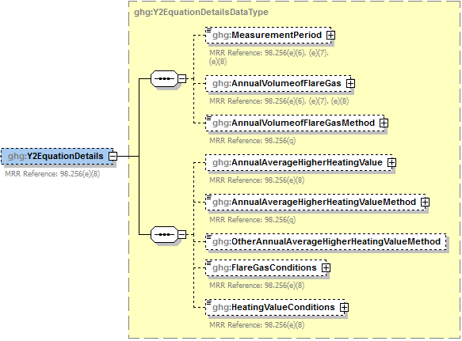

**Conditionally**

**Required**

**Note:** Data elements boxed in red are required. Please see page 4 of this document   
for more information on conditionally required elements.

To calculate the annual CO2 emissions from flare units, you can download the Y‑1b spreadsheet from the e‑GGRT help site or use the following information:



Where:

CO2 = Annual CO2 emissions for a specific fuel type (metric tons/year).

0.98 = Assumed combustion efficiency of a flare.

0.001 = Unit conversion factor (metric tons per kilogram, mt/kg).

n = Number of measurement periods. The minimum value for n is 52 (for weekly measurements); the maximum value for n is 366 (for daily measurements during a leap year).

p = Measurement period index.

(Flare)p = Volume of flare gas combusted during measurement period (million (MM) scf/period). If a mass flow meter is used, you must also measure molecular weight and convert the mass flow to a volumetric flow as follows: Flare[MMscf] = 0.000001 × Flare[kg] × MVC/(MW)p, where MVC is the molar volume conversion factor [849.5 scf/kg‑mole at 68 ºF and 14.7 psia or 836.6 scf/kg‑mole at 60 ºF and 14.7 psia depending on the standard conditions used when determining (HHV)p] and (MW)p is the average molecular weight of the flare gas combusted during measurement period (kg/kg‑mole).

(HHV)p = Higher heating value for the flare gas combusted during measurement period (British thermal units per scf, Btu/scf = MMBtu/MMscf). If measurements are taken more frequently than daily, use the arithmetic average of measurement values within the day to calculate a daily average.

EmF = Default CO2 emission factor of 60 kilograms CO2/MMBtu (HHV basis).

You must report the following data if you used Equation Y‑2 to calculate CO2 emissions:

* An indication of whether daily or weekly measurement periods are used [98.256(e)(8)]
* The annual volume of flare gas combusted (MMscf) [98.256(e)(8)]
* The number of days missing data procedures were used to determine the annual volume of flare gas combusted
* The specific consensus-based standard method number or describe the procedure specified by the flow meter manufacturer [98.256(q)]
* The annual average higher heating value of the flare gas (MMBtu/MMscf) [98.256(e)(8)]
* The number of days missing data procedures were used to determine the annual average higher heating value of the flare gas
* The method used to measure annual average higher heating value of the flare gas [98.256(q)]
* An indication of whether the annual volume of flare gas combusted was determined using standard conditions of 68 ºF and 14.7 psia or 60 ºF and 14.7 psia [98.256(e)(8)]
* An indication of whether the annual average higher heating value of the flare gas was determined using standard conditions of 68 ºF and 14.7 psia or 60 ºF and 14.7 psia [98.256(e)(8)]

1. Y2EquationDetails Data Element Definitions

| **Data Element Name** | **Description** |
| --- | --- |
| **Y2EquationDetails** | **Parent Element (Conditionally Required)** |
| MeasurementPeriod | An indication of whether daily or weekly measurement periods are used. [98.256(e)(8)] Below is a list of the allowable values.  Daily  Weekly |
| AnnualVolumeofFlareGas | The annual volume of flare gas combusted. [98.256(e)(8)] Report the value in the child data element **MeasureValue**. Set the units of measure to “MMscf” in the attribute **volUOM**. Also report the number of days that missing data procedures were used in measuring the annual volume of flare gas combusted in the child data element **NumberofTimesSubstituted**. [98.3(c)(8)] |
| AnnualVolumeofFlareGasMethod | The specific consensus-based standard method or description of the procedure specified by the flow meter manufacturer. [98.256(q)] |
| AnnualAverageHigherHeatingValue | The annual average higher heating value of the flare gas combusted. [98.256(e)(8)] Report the value in the child data element **MeasureValue**. Set the units of measure to “MMBtu/MMscf” in the attribute **heatUOM**. Also report the number of days that missing data procedures were used in the child data element **NumberofTimesSubstituted**. [98.3(c)(8)] |
| AnnualAverageHigherHeatingValueMethod | The method used to determine the annual average higher heating value of the flare gas. Below is a list of allowable values. [98.256(q)]  ASTM D4809‑06 ASTM D240‑02 (Reapproved 2007) ASTM D1826‑94 (Reapproved 2003) ASTM D3588‑98 (Reapproved 2003) ASTM D4891‑89 (Reapproved 2006) Chromatographic analysis: manufacturer’s instructions  Other (specify) |
| OtherAnnualAverageHigherHeatingValueMethod | **Conditionally Required:** Specify the method used to determine the annual average higher heating value of the flare gas if not listed above. |
| FlareGasConditions | The conditions on which the annual volume of flare gas combusted was determined. [98.256(e)(8)] Below is the list of allowable values.  60 degrees F and 14.7 psia  68 degrees F and 14.7 psia |
| HeatingValueConditions | The conditions on which the annual average higher heating value of the flare gas stream was determined. [98.256(e)(8)] Below is the list of allowable values.  60 degrees F and 14.7 psia  68 degrees F and 14.7 psia |

1. Example for Equation Y‑2

<ghg:Y2EquationDetails>

<ghg:MeasurementPeriod>Daily</ghg:MeasurementPeriod>

<ghg:AnnualVolumeofFlareGas volUOM="MMscf">

<ghg:MeasureValue>2332.2314</ghg:MeasureValue>

<ghg:NumberofTimesSubstituted>2</ghg:NumberofTimesSubstituted>

</ghg:AnnualVolumeofFlareGas>

<ghg:AnnualVolumeofFlareGasMethod>specific consensus-based method 123</ghg:AnnualVolumeofFlareGasMethod>

<ghg:AnnualAverageHigherHeatingValue heatUOM="MMBtu/MMscf">

<ghg:MeasureValue>25</ghg:MeasureValue>

<ghg:NumberofTimesSubstituted>24</ghg:NumberofTimesSubstituted>

</ghg:AnnualAverageHigherHeatingValue>

<ghg:AnnualAverageHigherHeatingValueMethod>ASTM D4809-06</ghg:AnnualAverageHigherHeatingValueMethod>

<ghg:FlareGasConditions >68 degrees F and 14.7 psia</ghg:FlareGasConditions >

<ghg:HeatingValueConditions >60 degrees F and 14.7 psia</ghg:HeatingValueConditions>

</ghg:Y2EquationDetails>

**Note:**  The XML example above is presented here to demonstrate the concept of reporting the details for Equation Y-2.

### Equation Y‑3 Details, Start‑up, Shutdown, Malfunction

**Conditionally Required:** This topic provides a step‑by‑step description of how to report details about Equation Y‑3. This method is used for calculating CO2 emissions if you do not monitor gas composition nor measure the higher heating value or carbon content of the flare gas at least weekly.

1. Equation Y‑3 Summary and Result Schema Diagram

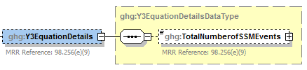

**Note:** Data elements boxed in red are required.

Where:

CO2 = Annual CO2 emissions for a specific fuel type (metric tons/year).

0.98 = Assumed combustion efficiency of a flare.

0.001 = Unit conversion factor (metric tons per kilogram, mt/kg).

FlareNorm= Annual volume of flare gas combusted during normal operations from company records, (million (MM) standard cubic feet per year, MMscf/year).

HHV = Higher heating value for fuel gas or flare gas from company records (British thermal units per scf, Btu/scf = MMBtu/MMscf).

EmF = Default CO2 emission factor for flare gas of 60 kilograms CO2/MMBtu (HHV basis).

n = Number of start‑up, shutdown and malfunction events during the reporting year exceeding 500,000 scf/day.

P = Start‑up, shutdown and malfunction event index.

44 = Molecular weight of CO2 (kg/kg‑mole).

12 = Atomic weight of C (kg/kg‑mole).

(FlareSSM)p= Volume of flare gas combusted during indexed start‑up, shutdown, or malfunction event from engineering calculations, (scf/event).

(MW)p = Average molecular weight of the flare gas, from the analysis results or engineering calculations for the event (kg/kg‑mole).

MVC = Molar volume conversion factor (849.5 scf/kg‑mole at 68 ºF and 14.7 psia or 836.6 scf/kg‑mole at 60 ºF and 14.7 psia).

(CC)p = Average carbon content of the flare gas, from analysis results or engineering calculations for the event (kg C per kg flare gas).

For each flare using the Equation Y-3 calculation method, identify the total number of start-up, shutdown, or malfunction (SSM) events exceeding 500,000 scf/day.

1. Y3EquationDetails Data Element Definitions

|  |  |
| --- | --- |
| **Data Element Name** | **Description** |
| **Y3EquationDetails** | **Parent Element (Conditionally Required)** |
| TotalNumberofSSMEvents | The total number of start‑up, shutdown, or malfunction (SSM) events exceeding 500,000 scf/day (integer). [98.256(e)(9)] |

1. Example for Equation Y‑3

<ghg:Y3EquationDetails>

<ghg:TotalNumberofSSMEvents>15</ghg:TotalNumberofSSMEvents>

</ghg:Y3EquationDetails>

**Note:** The XML example above is presented here to demonstrate the concept of reporting the details for Equation Y‑3.

?

***Does the facility have any catalytic cracking, fluid coking or catalytic reforming unit information to report?***

If the facility has any catalytic cracking, fluid coking and/or catalytic reforming units, see Section 3.0 for instructions on how to report for the parent element “CrackingCokingReformingDetails.”

If the facility has no catalytic cracking, fluid coking and/or catalytic reforming units, see Section 4.1 for required subpart-level reporting for the parent element “SulfurRecoveryDetails.”

## Catalytic Cracking, Fluid Coking and Catalytic Reforming Unit Information

**Conditionally Required Unit-Level Data**

This topic provides a step‑by‑step description of how to report Catalytic Cracking, Fluid Coking or Catalytic Reforming unit information.

### Cracking Coking Unit Details

You must report CO2, CH4 and N2O coke burn‑off emissions from each catalytic cracking unit, fluid coking unit and catalytic reforming unit which is not monitored by a CEMS under this Subpart. For units monitored by a CEMS, CH4 and N2O emissions must be reported, however CO2 emissions must be reported for the corresponding CEMS monitoring location (CML).

1. Cracking Coking Reforming Unit Details Schema Diagram

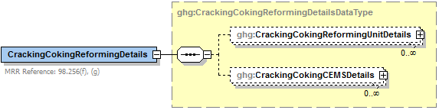

**Conditionally**

**Required**

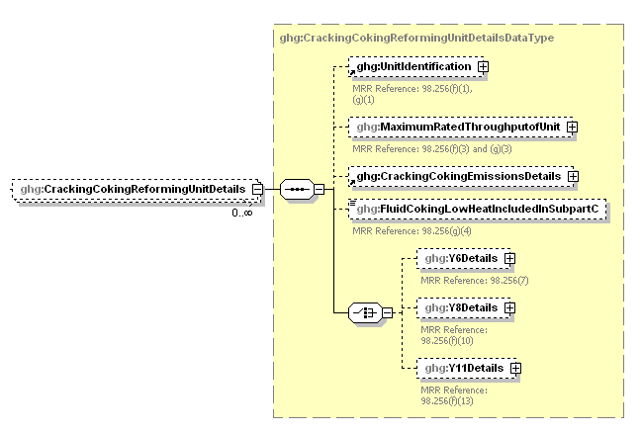

**Conditionally**

**Required**

**Report only one**

**Conditionally**

**Required**

**Note:** Data elements boxed in red are required. Please see page 4 of this document   
for more information on conditionally required elements.

You are required to report the following data about your Catalytic Cracking, Fluid Coking, or Catalytic Reforming unit:

* A unique name or identifier, plus an optional description for this unit (see also [About Unique Unit Names](http://www.ccdsupport.com/confluence/display/help/About+Unique+Unit+Names)).
* The type of unit.
  + Fluid Catalytic Cracking Unit
  + Thermal Catalytic Cracking Unit
  + Traditional Fluid Coking Unit
  + Catalytic Reforming Unit
  + Fluid Coking Unit with Flexicoking Design
* The maximum rated throughput of the fluid catalytic cracking unit (bbl per stream day).

1. Cracking Coking Reforming Unit Data Element Definitions

|  |  |
| --- | --- |
| **Data Element Name** | **Description** |
| **CrackingCokingReformingDetails** | **Parent Element (Conditionally Required)** |
| **CrackingCokingReformingUnitDetails** | **Parent Element:** A collection of data elements containing details about emissions from each catalytic cracking unit, traditional fluid coking unit, and catalytic reforming unit. |
| UnitIdentification | A collection of data elements containing the identity of each cracking, coking or reforming unit. Report a unique unit name (ID) in the child data element **UnitName**, an optional brief description in the child data element **UnitDescription** and the type of unit in the child data element **UnitType**. [98.256(f)(1) & (2), (g)(1) & (2)] Report one of the following unit types:   |  | | --- | | Fluid Catalytic Cracking Unit  Thermal Catalytic Cracking Unit  Traditional Fluid Coking Unit  Catalytic Reforming Unit  Fluid Coking Unit with Flexicoking Design | |
| MaximumRatedThroughputofUnit | The maximum rated throughput of the unit. Report the value in the child data element **MeasureValue**. Set the units of measure to “bbls/streamday" in the attribute **rateUOM**. [98.256(f)(3) & (g)(3)] |

1. Example for Cracking Coking Reforming Unit Details

<ghg:CrackingCokingReformingDetails>

<ghg:CrackingCokingReformingUnitDetails>

<ghg:UnitIdentification>

<ghg:UnitName>008</ghg:UnitName>

<ghg:UnitType>Fluid Catalytic Cracking Unit</ghg:UnitType>

</ghg:UnitIdentification>

<ghg:MaximumRatedThroughputofUnit rateUOM="bbls/streamday">

<ghg:MeasureValue>1000</ghg:MeasureValue>

</ghg:MaximumRatedThroughputofUnit>

**Note:** The XML example above is presented here to demonstrate the concept of reporting details for catalytic cracking, fluid coking or catalytic reforming units.

1. Cracking Coking Emissions Details Schema Diagram

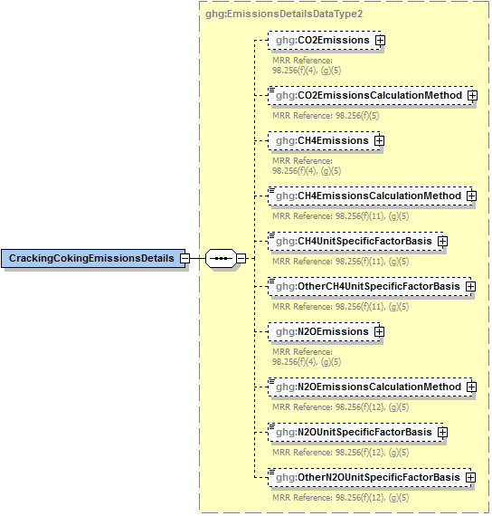

**Conditionally**

**Required**

**Note:** Data elements boxed in red are required. Please see page 4 of this document   
for more information on conditionally required elements.

Subpart Y collects the following data about your catalytic cracking, or fluid coking and catalytic reforming unit emissions:

* **Conditionally Required:** The calculated CO2 annual emissions for each non-CEMS unit, expressed in metric tons. To report annual CO2 emissions, follow the instructions that correspond to the calculation method reported. (See the applicable section in this document: Equation Y‑1a Details, Equation Y‑1b Details, Equation Y‑2 Details, or Equation Y‑3 Details). **Note:** This does not apply to Fluid Coking Units with flexicoking design having GHG emissions accounted for in Subpart C.
* **Conditionally Required:** Method used to calculate the CO2 emissions for each unit. **Note:** This does not apply to Fluid Coking Units with flexicoking design having GHG emissions accounted for in Subpart C.   
  + 98.253(c)(1) - CEMS
  + 98.253(c)(2) ‑ Equation Y‑6 and continuous monitor for flow (but not meeting the CEMS monitoring requirements of 98.253(c)(1); e.g., not meeting the full CEMS quality assurance requirements)
  + 98.253(c)(2) ‑ Equation Y‑6 and Y‑7a
  + 98.253(c)(2) ‑ Equation Y‑6 and Y‑7b
  + 98.253(c)(3) ‑ Equation Y‑8 **Note:** This option applies only to Catalytic Cracking or Coking units; applicable only for catalytic cracking units and fluid coking units with rated capacities of 10,000 barrels per stream day (bbls/streamday) or less that do not use a continuous CO2 CEMS for the final exhaust stack).
  + 98.253(e)(3) ‑ Equation Y‑11 **Note:** This option applies only to Catalytic Reforming units.
* **Conditionally Required:** The calculated CH4 and N2O annual emissions for each unit, expressed in metric tons of each GHG emitted. **Note:** This does not apply to Fluid Coking Units with flexicoking design having GHG emissions accounted for in Subpart C.
* **Conditionally Required:** Method used to calculate CH4 emissions. **Note:** This does not apply to Fluid Coking Units with flexicoking design having GHG emissions accounted for in Subpart C.
  + Unit-specific measurement data
  + Unit‑specific emissions factor based on a source test of the unit
  + Equation Y-9 with a default emission factor
* **Conditionally Required:** Method used to calculate N2O emissions. **Note:** This does not apply to Fluid Coking Units with flexicoking design having GHG emissions accounted for in Subpart C.
  + Unit-specific measurement data
  + Unit‑specific emissions factor based on a source test of the unit
  + Equation Y-10 with a default emission factor
* **Conditionally Required:** The basis for each unit-specific emissions factor based on a source test of the unit that is used to calculate CH4 and N2O emissions, if reported.
  + Weekly or more frequent measurements
  + Periodic (less frequent than weekly) measurements
  + Average of multiple source tests
  + One-time source test
  + Other (specify)

**Conditionally Required:** For each unit of the type “Fluid Coking Unit with Flexicoking Design”, indicate whether the GHG emissions from the low heat value gas are accounted for in Subpart C instead of 98.253(c).

1. Cracking Coking Reforming Emissions Data Element Definitions

| **Data Element Name** | **Description** |
| --- | --- |
| **CrackingCokingEmissionsDetails** | **Parent Element** |
| CO2Emissions | **Conditionally Required:** Calculated CO2 annual emissions for each non-CEMS unit. [98.256(f)(4)] Report the value in the child data element **CalculatedValue**. Set the units of measure to “Metric Tons” in the attribute**massUOM**. **Note:** This does not apply to Fluid Coking Units with flexicoking design having GHG emissions accounted for in Subpart C. |
| CO2EmissionsCalculationMethod | **Conditionally Required:** The method used to calculate the CO2 emissions for each unit (e.g., reference section and equation number). [98.256(f)(5)] **Note:** This does not apply to Fluid Coking Units with flexicoking design having GHG emissions accounted for in Subpart C. Also, Equation Y-11 below only applies to catalytic reforming units. Below is the list of allowable values.   |  | | --- | | CEMS - 98.253(c)(1) Equation Y-6 and Y-7a - 98.253(c)(2) Equation Y-6 and Y-7b - 98.253(c)(2) Equation Y-6 and continuous monitor for flow - 98.253(c)(2) Equation Y-8 - 98.253(c)(3) Equation Y-11 - 98.253(e)(3) | |
| CH4Emissions | **Conditionally Required:** Calculated CH4 annual emissions for each unit. Report the value in the child data element **CalculatedValue**. Set the units of measure to “Metric Tons” in the attribute**massUOM**. **Note:** This does not apply to Fluid Coking Units with flexicoking design having GHG emissions accounted for in Subpart C. |
| CH4EmissionsCalculationMethod | **Conditionally Required:** The method used to calculate the CH4 emissions for each unit (e.g., reference section and equation number). [98.256(f)(11) and 98.256(g)(5)] **Note:** This does not apply to Fluid Coking Units with flexicoking design having GHG emissions accounted for in Subpart C. Below is the list of allowable values.   |  | | --- | | Unit-specific measurement data  Unit‑specific emissions factor based on a source test of the unit  Equation Y-9 with a default emission factor | |
| CH4UnitSpecificFactorBasis | **Conditionally Required:** The basis for the unit-specific emission factor used to determine CH4 annual emissions if the emission factor was based on a source test of the unit. [98.256(f)(11) and 98.256(g)(5)] Below is the list of allowable values.  Weekly or more frequent measurements  Periodic (less frequent than weekly) measurements  Average of multiple source tests  One-time source test  Other (specify) |
| OtherCH4UnitSpecificFactorBasis | **Conditionally Required:** The basis for the unit-specific emission factor used to determine CH4 emissions if not referenced in the list of allowable basis values. |
| N2OEmissions | **Conditionally Required:** Annual N2O emissions for each unit. [98.256(f)(4) and 98.256(g)(5)] Report the value in the child data element **CalculatedValue**. Set the units of measure to “Metric Tons” in the attribute**massUOM**. **Note:** This does not apply to Fluid Coking Units with flexicoking design having GHG emissions accounted for in Subpart C. |
| N2OEmissionsCalculationMethod | **Conditionally Required:** The method used to calculate the N2O emissions for each unit (e.g., reference section and equation number). [98.256(f)(12) and 98.256(g)(5)] **Note:** This does not apply to Fluid Coking Units with flexicoking design having GHG emissions accounted for in Subpart C. Below is the list of allowable values.   |  | | --- | | Unit-specific measurement data  Unit‑specific emissions factor based on a source test of the unit  Equation Y-10 with a default emission factor | |
| N2OUnitSpecificFactorBasis | **Conditionally Required:** The basis for the unit-specific emission factor used to determine N2O annual emissions if the emission factor was based on a source test of the unit. [98.256(f)(12) and 98.256(g)(5)] Below is the list of allowable values.  Weekly or more frequent measurements  Periodic (less frequent than weekly) measurements  Average of multiple source tests  One-time source test  Other (specify) |
| OtherN2OUnitSpecificFactorBasis | **Conditionally Required:** The basis for the unit-specific emission factor used to determine N2O emissions if not referenced in the list of allowable basis values. |
| FluidCokingLowHeatIncludedInSubpartC | **Conditionally Required:** For each unit of the type “Fluid Coking Unit with Flexicoking Design”, indicate (Y/N) whether the GHG emissions from the low heat value gas are accounted for in Subpart C instead of 98.253(c). [98.256(g)(4)] |

1. Example for Cracking Coking Emissions

<ghg:CrackingCokingEmissionsDetails>

<ghg:CO2Emissions massUOM=**"Metric Tons"**>

<ghg:CalculatedValue>4322.6</ghg:CalculatedValue>

</ghg:CO2Emissions>

<ghg:CO2EmissionsCalculationMethod>Equation Y-6 and Y-7a - 98.253(c)(2)</ghg:CO2EmissionsCalculationMethod>

<ghg:CH4Emissions massUOM=**"Metric Tons"**>

<ghg:CalculatedValue>2342.88</ghg:CalculatedValue>

</ghg:CH4Emissions>

<ghg:CH4EmissionsCalculationMethod>Equation Y-9 with a default emission factor</ghg:CH4EmissionsCalculationMethod>

<ghg:N2OEmissions massUOM=**"Metric Tons"**>

<ghg:CalculatedValue>2221.234</ghg:CalculatedValue>

</ghg:N2OEmissions>

<ghg:N2OEmissionsCalculationMethod>Unit-specific emission factor based on a source test of the unit</ghg:N2OEmissionsCalculationMethod>

<ghg:N2OUnitSpecificFactorBasis>Other (specify)</ghg:N2OUnitSpecificFactorBasis>

<ghg:OtherN2OUnitSpecificFactorBasis>Bi-weekly</ghg:OtherN2OUnitSpecificFactorBasis>

</ghg:CrackingCokingEmissionsDetails>

**Note:** The XML example above is presented here to demonstrate the concept of reporting CO2, CH4 and N2O emissions for a fluid coking unit with flexicoking design.

?

***Which equation did you use to calculate CO2 emissions for the unit?***

If you used Equation Y-6, see Section 3.1.1 for instructions on how to report for the parent element “Y6Details.”

If you used Equation Y-8, see Section 3.1.2 for instructions on how to report for the parent element “Y8Details.”

If you used Equation Y-11, see Section 3.1.3 for instructions on how to report for the parent element “Y11Details.”

#### Equation Y-6 Details

This topic provides a step-by-step description of how to report details about the method used to calculate CO2 emissions from catalytic cracking units and fluid coking units with rated capacities greater than 10,000 barrels per stream day that do not use a continuous CO2 CEMS for the final exhaust stack. This topic also applies to reporting CO2 emissions from catalytic cracking units and fluid coking units with rated capacities of 10,000 barrels per stream day or less that do not use a continuous CO2 CEMS for the final exhaust stack, but that monitor at least daily the O2, CO2 and (if necessary) CO concentrations in the exhaust stack from the catalytic cracking unit regenerator or fluid coking unit burner prior to the combustion of other fossil fuels.

1. Equation Y-6 Details Schema Diagram

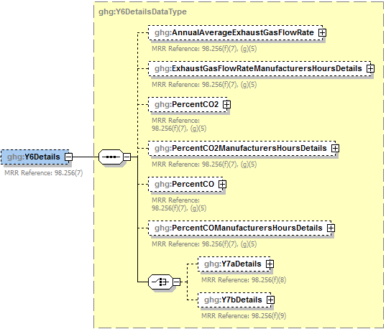

**Conditionally Required –**

**Report only one**

**Note:** Data elements boxed in red are required. Please see page 4 of this document   
for more information on conditionally required elements.

**Method 1: 98.253(c)(2) - Equation Y-6 and continuous monitor for flow**

If you continuously monitored the volumetric flow rate of exhaust gas from the fluid catalytic cracking unit regenerator or fluid coking unit burner prior to the combustion of other fossil fuels, you are required to report the following:

* Annual average volumetric flow rate of exhaust gas from the unit prior to the combustion of other fossil fuels (dscf/hour) and the number of hours that missing data procedures were used. (If using Equation Y-7a or Y-7b, replace this value with the result of the equation.)
* A description of the manufacturer's recommended methods used to determine the following:
  + Annual average volumetric flow rate of exhaust gas
  + Hourly average percentage of CO2 concentration in the exhaust gas stream
  + Hourly average percentage of CO concentration in the exhaust gas stream, if applicable.
* Hourly average percentage of CO2 concentration (and CO, if applicable) in the exhaust gas stream from the unit (percent by volume – dry basis). Also report the number of hours that missing data procedures were used.

**Note:**  The information above is required if Equation Y-6 was used.

1. Equation Y-6 Details Data Element Definitions

| **Data Element Name** | **Description** |
| --- | --- |
| **Y6Details** | **Parent Element (Conditionally Required)** |
| AnnualAverageExhaustGasFlowRate | The annual average volumetric flow rate of exhaust gas from the fluid catalytic cracking unit prior to the combustion of other fossil fuels. [98.256(f)(7), (g)(5)] Report the value in the child data element **MeasureValue**. Set the units of measure to “dscf/hour” in the attribute **rateUOM**. Also report the number of hours that missing data procedures were used for the annual average volumetric flow rate of exhaust gas in the child data element **NumberofTimesSubstituted**. [98.3(c)(8)] |
| **ExhaustGasFlowRateManufacturersHoursDetails** | **Parent Element** |
| ManufacturersMethod | Specify the manufacturer’s recommended method that was used to determine the annual average volumetric flow rate of exhaust gas. [98.256(q)] |
| PercentCO2 | The annual average percent of CO2 in the exhaust gas stream. [98.256(f)(7), (g)(5)] Report the value in the child data element **MeasureValue**. Set the units of measure to “Number (between 0 and 100)” in the attribute **percentUOM**. Also report the number of hours that missing data procedures were used to determine the annual average percent of CO2 in the exhaust gas stream in the child data element **NumberofTimesSubstituted**. [98.3(c)(8)] |
| **PercentCO2ManufacturersHoursDetails** | **Parent Element** |
| ManufacturersMethod | Specify the manufacturer’s recommended method that was used to determine the annual average percent of CO2 in the exhaust gas stream. [98.256(q)] |
| PercentCO | The annual average percent of CO in the exhaust gas stream. [98.256(f)(7), (g)(5)] Report the value in the child data element **MeasureValue**. Set the units of measure to “Number (between 0 and 100)” in the attribute **percentUOM**. Also report the number of hours that missing data procedures were used to determine the annual average percent of CO in the exhaust gas stream in the child data element **NumberofTimesSubstituted**. [98.3(c)(8)] |
| **PercentCOManufacturersHoursDetails** | **Parent Element** |
| ManufacturersMethod | Specify the manufacturer’s recommended method that was used to determine the annual average percent of CO in the exhaust gas stream. [98.256(q)] |

1. Example for Equation Y-6

<ghg:Y6Details>

<ghg:AnnualAverageExhaustGasFlowRate **rateUOM**="**dscf/hour**">

<ghg:MeasureValue>232,2345</ghg:MeasureValue>

<ghg:NumberofTimesSubstituted>65</ghg:NumberofTimesSubstituted>

</ghg:AnnualAverageExhaustGasFlowRate>

<ghg:ExhaustGasFlowRateManufacturersHoursDetails>

<ghg:ManufacturersMethod>Manufacturer’s test method 1</ghg:ManufacturersMethod>

</ghg:ExhaustGasFlowRateManufacturersHoursDetails>

<ghg:PercentCO2 **percentUOM**=**"Number (between 0 and 100)"**>

<ghg:MeasureValue>67</ghg:MeasureValue>

<ghg:NumberofTimesSubstituted>67</ghg:NumberofTimesSubstituted>

</ghg:PercentCO2>

<ghg:PercentCO2ManufacturersHoursDetails>

<ghg:ManufacturersMethod> Manufacturer’s test method 2</ghg:ManufacturersMethod>

</ghg:PercentCO2ManufacturersHoursDetails>

<ghg:PercentCO **percentUOM**=**"Number (between 0 and 100)"**>

<ghg:MeasureValue>2</ghg:MeasureValue>

<ghg:NumberofTimesSubstituted>2</ghg:NumberofTimesSubstituted>

</ghg:PercentCO>

<ghg:PercentCOManufacturersHoursDetails>

<ghg:ManufacturersMethod>Manufacturer’s test method 3</ghg:ManufacturersMethod>

</ghg:PercentCOManufacturersHoursDetails>

</ghg:Y6Details>

**Note:** The XML example above is presented here to demonstrate the concept of reporting details for Equation Y-6.

?

***In addition to Equation Y-6, did you use Equation Y-7a or Equation Y-7b to calculate the volumetric flow rate of exhaust gas from the fluid catalytic cracking unit regenerator or fluid coking unit burner?***

If you calculated the volumetric flow rate of exhaust gas from the fluid catalytic cracking unit regenerator or fluid coking unit burner using Equation Y-7a, see Equation Y-7a Details Schema Diagram and the instructions following it on how to report for the parent element “Y7aDetails.”

If you calculated the volumetric flow rate of exhaust gas from the fluid catalytic cracking unit regenerator or fluid coking unit burner using Equation Y-7b, see Equation Y-7b Details Schema Diagram and the instructions following it on how to report for the parent element “Y7bDetails.”

If you used Equation Y-6 and did not use Equation Y-7a or Equation Y-7b, proceed to Section 3.2 for instructions on how to report for a unit monitored by CEMS or Section 4.1 for required subpart-level summary data for sour gas sent off-site.

1. Equation Y-7a Details Schema Diagram

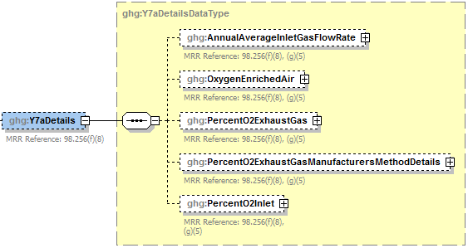

**Note:** Data elements boxed in red are required.

**Method 2: 98.253(c)(2) - Equation Y-6 and Equation Y-7a**

**Conditionally Required:** If you calculated the volumetric flow rate of exhaust gas from the fluid catalytic cracking unit regenerator or fluid coking unit burner using Equation Y-7a, then report the following information, in addition to the items referenced under Method 1:

* Annual average volumetric flow rate of inlet air to the unit, as determined from control room instrumentation (dscf/hour).
* Annual average volumetric flow rate of oxygen-enriched air inlet to the unit, as determined from control room instrumentation (dscf/hour).
* The annual average percent of O2 in the exhaust gas stream. Also report the number of hours missing data procedures were used to determine the annual average percent of O2 in the exhaust gas stream.
* Description of the manufacturer's recommended method used to determine the annual average percentage of O2 concentration in the exhaust gas stream.
* The annual average percentage of O2 concentration in the oxygen-enriched gas stream inlet to the unit based on oxygen purity specifications of the oxygen supply used for enrichment (percent by volume – dry basis).

1. Equation Y-7a Details Data Element Definitions

| **Data Element Name** | **Description** |
| --- | --- |
| **Y7aDetails** | **Parent Element (Conditionally Required)** |
| AnnualAverageInletGasFlowRate | The annual average flow rate of inlet air. Report the value in the child data element **MeasureValue**. Set the units of measure to “dscf/hour” in the attribute **rateUOM**. [98.256(f)(8), (g)(5)] |
| OxygenEnrichedAir | The annual average flow rate of oxygen-enriched air. Report the value in the child data element **MeasureValue**. Set the units of measure to “dscf/hour” in the attribute **rateUOM**. [98.256(f)(8), (g)(5)] |
| PercentO2ExhaustGas | The annual average percent of O2 in the exhaust gas stream. [98.256(f)(8), (g)(5)] Report the value in the child data element **MeasureValue**. Set the units of measure to “Number (between 0 and 100)” in the attribute **percentUOM**. Also report the number of hours missing data procedures were used to determine the annual average percent of O2 in the exhaust gas stream in the child data element **NumberofTimesSubstituted**. [98.3(c)(8)] |
| **PercentO2ExhaustGasManufacturersMethodDetails** | **Parent Element** |
| ManufacturersMethod | Specify the manufacturer’s recommended method that was used to determine the annual average percent of O2 in the exhaust gas stream. [98.256(q)] |
| PercentO2Inlet | The annual average percent of O2 in the oxygen-enriched gas stream inlet. Report the value in the child data element **MeasureValue**. Set the units of measure to “Number (between 0 and 100)” in the attribute **percentUOM**. [98.256(f)(8), (g)(5)] |

1. Example for Equation Y-7a

<ghg:Y7aDetails>

<ghg:AnnualAverageInletGasFlowRate rateUOM="dscf/hour">

<ghg:MeasureValue>45.5675</ghg:MeasureValue>

</ghg:AnnualAverageInletGasFlowRate>

<ghg:OxygenEnrichedAir rateUOM="dscf/hour">

<ghg:MeasureValue>35.456</ghg:MeasureValue>

</ghg:OxygenEnrichedAir>

<ghg:PercentO2ExhaustGas percentUOM="Number (between 0 and 100)">

<ghg:MeasureValue>75</ghg:MeasureValue>

<ghg:NumberofTimesSubstituted>0</ghg:NumberofTimesSubstituted>

</ghg:PercentO2ExhaustGas>

<ghg:PercentO2ExhaustGasManufacturersMethodDetails>

<ghg:ManufacturersMethod>Test Method 3</ghg:ManufacturersMethod>

</ghg:PercentO2ExhaustGasManufacturersMethodDetails>

<ghg:PercentO2Inlet percentUOM="Number (between 0 and 100)">

<ghg:MeasureValue>66</ghg:MeasureValue>

</ghg:PercentO2Inlet>

</ghg:Y7aDetails>

**Note:** The XML example above is presented here to demonstrate the concept of reporting details for Equation Y-7a.

Proceed to Section 3.2 for instructions on how to report for a unit monitored by CEMS or Section 4.1 for required subpart-level summary data for sour gas sent off-site.

1. Equation Y-7b Details Schema Diagram

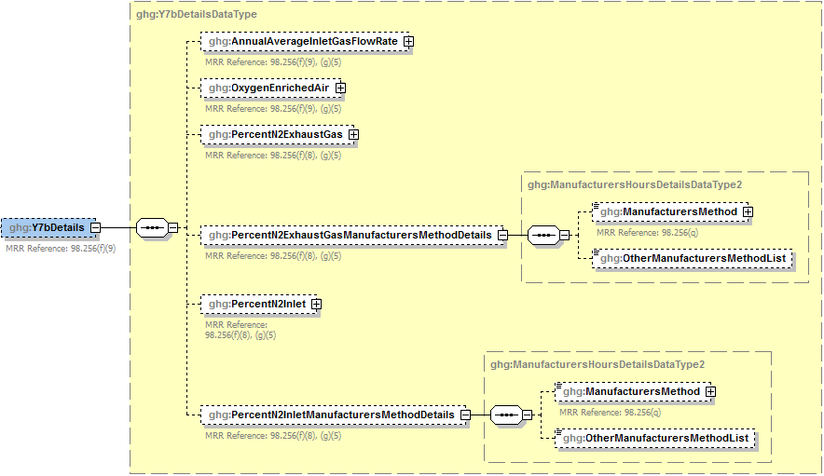

**Conditionally**

**Required**

**Conditionally**

**Required**

**Note:** Data elements boxed in red are required. Please see page 4 of this document   
for more information on conditionally required elements.

.

**Method 3: 98.253(c)(2) - Equation Y-6 and Equation Y-7b**

**Conditionally Required:** If you calculated the volumetric flow rate of exhaust gas from the fluid catalytic cracking unit regenerator or fluid coking unit burner using Equation Y-7b, then report the following information, in addition to the items referenced under Method 1:

* Annual average volumetric flow rate of inlet air to the unit, as determined from control room instrumentation (dscf/hour).
* Annual average volumetric flow rate of oxygen-enriched air to the unit, as determined from control room instrumentation (dscf/hour).
* Hourly average percentage of N2 concentration in the exhaust gas stream from the fluid catalytic cracking unit regenerator or fluid coking unit burner (percent by volume – dry basis) including the number of hours that missing data procedures were used.
* Description of the manufacturer's recommended method used to determine the hourly average percentage of N2 concentration in the exhaust gas stream.
  + Method 18 at 40 CFR part 60, appendix A‑6
  + ASTM D1945‑03
  + ASTM D1946‑90‑Reapproved 2006
  + GPA 2261‑00
  + UOP539‑97
  + ASTM D2503‑92‑Reapproved 2007
  + Chromatographic analysis: manufacturer's instructions
  + Maximum N2 impurity specification
  + Other (specify)
* N2 concentration in the oxygen-enriched gas stream inlet to the unit based on oxygen purity specifications of the oxygen supply used for enrichment (percent by volume – dry basis) including the number of hours that missing data procedures were used.
* Description of the manufacturer's recommended method used to determine the N2 concentration in the oxygen-enriched gas stream inlet to the unit, if applicable.
  + Method 18 at 40 CFR part 60, appendix A‑6
  + ASTM D1945‑03
  + ASTM D1946‑90‑Reapproved 2006
  + GPA 2261‑00
  + UOP539‑97
  + ASTM D2503‑92‑Reapproved 2007
  + Chromatographic analysis: manufacturer's instructions
  + Maximum N2 impurity specification
  + Other (specify)

1. Equation Y-7b Details Data Element Definitions

| **Data Element Name** | **Description** |
| --- | --- |
| **Y7bDetails** | **Parent Element (Conditionally Required)** |
| AnnualAverageInletGasFlowRate | The annual average flow rate of inlet air. Report the value in the child data element **MeasureValue**. Set the units of measure to “dscf/hour” in the attribute **rateUOM**. [98.256(f)(9), (g)(5)] |
| OxygenEnrichedAir | The annual average flow rate of oxygen-enriched air. Report the value in the child data element **MeasureValue**. Set the units of measure to “dscf/hour” in the attribute **rateUOM**. [98.256(f)(9), (g)(5)] |
| PercentN2ExhaustGas | The annual average percent of N2 in the exhaust gas stream. [98.256(f)(9), (g)(5)] Report the value in the child data element **MeasureValue**. Set the units of measure to “Number (between 0 and 100)” in the attribute **percentUOM**. Also report the number of hours missing data procedures were used to determine the annual average percent of N2 in the exhaust gas stream in the child data element **NumberofTimesSubstituted**. [98.3(c)(8)] |
| **PercentN2ExhaustGasManufacturersMethodDetails** | **Parent Element** |
| ManufacturersMethod | Specify the method that was used to determine the annual average percent of N2 in the exhaust gas stream. Below is the list of allowable values. [98.256(q)]   Method 18 at 40 CFR part 60, appendix A-6 ASTM D1945-03 ASTM D1946-90 (Reapproved 2006) GPA 2261-00 UOP539-97 ASTM D2503-92 (Reapproved 2007) Chromatographic analysis: manufacturer’s instructions  Maximum N2 impurity specification  Other (specify) |
| OtherManufacturersMethodList | **Conditionally Required:** The method that was used to determine the annual average percent of N2 in the exhaust gas stream if not referenced in the list of allowable values. |
| PercentN2Inlet | The annual average percent of N2 in the oxygen-enriched gas stream inlet. [98.256(f)(9), (g)(5)] Report the value in the child data element **MeasureValue**. Set the units of measure to “Number (between 0 and 100)” in the attribute **percentUOM**. Also report the number of hours missing data procedures were used to determine the annual average percent of N2 in the oxygen-enriched gas stream inlet in the child data element **NumberofTimesSubstituted**. [98.3(c)(8)] |
| **PercentN2InletManufacturersMethodDetails** | **Parent Element** |
| ManufacturersMethod | Specify the method that was used to determine the annual average percent of N2 in the oxygen-enriched gas stream inlet. Below is the list of allowable values. [98.256(q)]  Method 18 at 40 CFR part 60, appendix A-6 ASTM D1945-03 ASTM D1946-90 (Reapproved 2006) GPA 2261-00 UOP539-97 ASTM D2503-92 (Reapproved 2007) Chromatographic analysis: manufacturer’s instructions  Maximum N2 impurity specification  Other (specify) |
| OtherManufacturersMethodList | **Conditionally Required:** The method that was used to determine the annual average percent of N2 in the oxygen-enriched gas stream inlet if not referenced in the list of allowable values. |

1. Example for Equation Y-7b

<ghg:Y7bDetails>

<ghg:AnnualAverageInletGasFlowRate rateUOM="dscf/hour">

<ghg:MeasureValue>564.456</ghg:MeasureValue>

</ghg:AnnualAverageInletGasFlowRate>

<ghg:OxygenEnrichedAir rateUOM="dscf/hour">

<ghg:MeasureValue>345</ghg:MeasureValue>

</ghg:OxygenEnrichedAir>

<ghg:PercentN2ExhaustGas percentUOM="Number (between 0 and 100)">

<ghg:MeasureValue>45</ghg:MeasureValue>

<ghg:NumberofTimesSubstituted>3</ghg:NumberofTimesSubstituted>

</ghg:PercentN2ExhaustGas>

<ghg:PercentN2ExhaustGasManufacturersMethodDetails>

<ghg:ManufacturersMethod>Method 18 at 40 CFR part 60, appendix A-6</ghg:ManufacturersMethod>

</ghg:PercentN2ExhaustGasManufacturersMethodDetails>

<ghg:PercentN2Inlet percentUOM="Number (between 0 and 100)">

<ghg:MeasureValue>3</ghg:MeasureValue>

<ghg:NumberofTimesSubstituted>70</ghg:NumberofTimesSubstituted>

</ghg:PercentN2Inlet>

<ghg:PercentN2InletManufacturersMethodDetails>

<ghg:ManufacturersMethod>UOP539-97</ghg:ManufacturersMethod>

</ghg:PercentN2InletManufacturersMethodDetails>

</ghg:Y7bDetails>

**Note:** The XML example above is presented here to demonstrate the concept of reporting details for Equation Y-7b.

Proceed to Section 3.2 for instructions on how to report for a unit monitored by CEMS or Section 4.1 for required subpart-level summary data for sour gas sent off-site.

#### Equation Y-8 Details

This topic provides a step-by-step description of how to report details about the method used to calculate CO2 emissions from catalytic cracking units and fluid coking units with rated capacities of 10,000 barrels per stream day or less that do not use a continuous CO2 CEMS for the final exhaust stack.

1. Equation Y-8 Details Schema Diagram

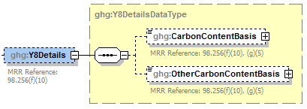

**Conditionally**

**Required**

**Note:** Data elements boxed in red are required. Please see page 4 of this document   
for more information on conditionally required elements.

**Conditionally Required:** If you do not monitor at least daily the O2, CO2 and (if necessary) CO concentrations in the exhaust stack from the catalytic cracking unit regenerator or fluid coking unit burner prior to the combustion of other fossil fuels, calculate the CO2 emissions from each catalytic cracking unit and fluid coking unit using Equation Y-8.

For each unit using the Equation Y-8 calculation method, identify the basis for the carbon content value:

* Weekly or more frequent measurements
* Periodic (less frequent than weekly but at least quarterly) measurements
* Semi‑annual or annual measurements
* Historical measurement value
* Engineering estimate
* Default value
* Other

1. Equation Y-8 Details Data Element Definitions

| **Data Element Name** | **Description** |
| --- | --- |
| **Y8Details** | **Parent Element (Conditionally Required)** |
| CarbonContentBasis | The basis for the carbon content value. [98.256(f)(10), (g)(5)] Below is the list of allowable values.  Weekly or more frequent measurements  Periodic (less frequent than weekly but at least quarterly) measurements Semi-annual or annual measurements Historical measurement value Engineering estimate  Default value  Other (specify) |
| OtherCarbonContentBasis | Specify the basis for the carbon content value if not referenced above. [98.256(f)(10), (g)(5)] |

1. Example for Equation Y-8

<ghg:Y8Details>

<ghg:CarbonContentBasis>Other (specify)</ghg:CarbonContentBasis>

<ghg:OtherCarbonContentBasis>Bi-weekly</ghg:OtherCarbonContentBasis>

</ghg:Y8Details>

**Note:** The XML example above is presented here to demonstrate the concept of reporting details for Equation Y-8.

Proceed to Section 3.2 for instructions on how to report for a unit monitored by CEMS or Section 4.1 for required subpart-level summary data for sour gas sent off-site.

#### Equation Y-11 Details

This topic provides a step-by-step description of how to report details about the method used to calculate CO2 emissions from catalytic reforming catalyst regenerator units.

1. Equation Y-11 Details Schema Diagram

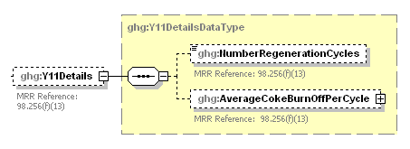

**Note:** Data elements boxed in red are required.

**Conditionally Required:** For each catalytic reforming unit using the Equation Y-11 calculation method, you are required to report the following:

* The total number of regeneration cycles or measurement periods. [98.256(f)(13)]
* The average coke burn-off quantity per cycle or measurement period. [98.256(f)(13)]

1. Equation Y-11 Data Element Definitions

| **Data Element Name** | **Description** |
| --- | --- |
| **Y11Details** | **Parent Element (Conditionally Required)** |
| NumberRegenerationCycles | The total number of regeneration cycles or measurement periods in the calendar year (integer). [98.256(f)(13)] |
| AverageCokeBurnOffPerCycle | The average coke burn-off quantity per cycle or measurement period. Report the value in the child data element **MeasureValue**. Set the units of measure to “kg/cycle or kg/measurement period” in the attribute **rateUOM**. [98.256(f)(13)] |

1. Example for Equation Y-11

<ghg:Y11Details>

<ghg:NumberRegenerationCycles>3</ghg:NumberRegenerationCycles>

<ghg:AverageCokeBurnOffPerCycle rateUOM="kg/cycle or kg/measurement period">

<ghg:MeasureValue>345</ghg:MeasureValue>

</ghg:AverageCokeBurnOffPerCycle>

</ghg:Y11Details>

</ghg:CrackingCokingReformingUnitDetails>

**Note:** The XML example above is presented here to demonstrate the concept of reporting details for Equation Y-11 (Catalytic Reforming unit).

Proceed to Section 3.2 for instructions on how to report for a unit monitored by CEMS or Section 4.1 for required subpart-level summary data for sour gas sent off-site.

### Cracking Coking CEMS Unit Details

For each catalytic cracking, fluid coking and catalytic reforming unit that is monitored with a CEMS to measure CO2 emissions, according to the guidelines specified in Subpart C, report the unit’s identification information.

1. Cracking Coking CEMS Details Schema Diagram

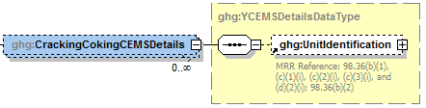

**Note:** Data elements boxed in red are required.

In addition to reporting the identification of each catalytic reforming unit that is monitored with a CEMS, you must report the relevant information required under 98.36 for the Tier 4 Calculation Methodology. See instructions for reporting parent element “YTier4CEMSDetails” in this document. **Note:** Use the same identification for the unit as was used for the parent element “CrackingCokingReformingUnitDetails”.

1. Cracking Coking CEMS Details Data Element Definitions

| **Data Element Name** | **Description** |
| --- | --- |
| **CrackingCokingCEMSDetails** | **Parent Element (Conditionally Required)** |
| UnitIdentification | A collection of data elements containing the identity of each CEMS cracking coking or reforming unit. Report a unique unit name (ID) in the child data element **UnitName**, an optional brief description in the child data element **UnitDescription** and the type of unit in the child data element **UnitType**. Report one of the following unit types:   |  | | --- | | Fluid Catalytic Cracking Unit  Thermal Catalytic Cracking Unit  Traditional Fluid Coking Unit  Catalytic Reforming Unit  Fluid Coking Unit with Flexicoking Design |   **Note:** Use the same identification for the unit as was used for the parent element “CrackingCokingReformingUnitDetails”. |

1. Example for Cracking Coking CEMS Details

<CrackingCokingCEMSDetails>

<UnitIdentification>

<UnitName>CC-CEMS-001</UnitName>

<UnitType>Fluid Catalytic Cracking Unit</UnitType>

</UnitIdentification>

</CrackingCokingCEMSDetails>

**Note:** The XML example above is presented here to demonstrate the concept of reporting the identification of each catalytic reforming unit that is monitored with a CEMS.

## Sulfur Recovery Details

### Sour Gas Sent Off-site

**Required Subpart-Level Summary Data**

For petroleum refinery sources required to report under Subpart Y, you are required to report the annual CO2 emissions from sour gas sent off-site for sulfur recovery. You must also report information about the annual volume of sour gas fed to the sulfur recovery plant and the annual average mole fraction of carbon in the sour gas.

1. Sour Gas Sent Off-site Schema Diagram

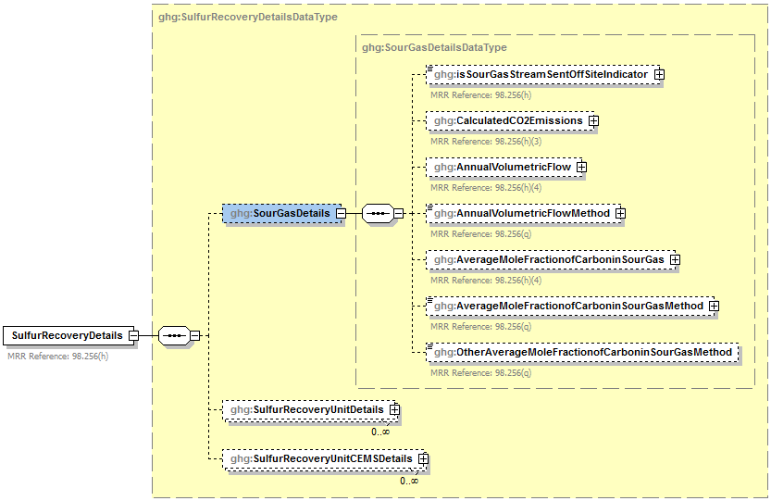

**Conditionally**

**Required**

**Note:** Data elements boxed in red are required. Please see page 4 of this document   
 for more information on conditionally required elements.

**Equation Y‑12**

If you use Equation Y‑12 to calculate the cumulative CH4 emissions from sour gas sent off-site, you can download the Y‑12 spreadsheet from the e‑GGRT help site or use the following information:



Where:

CO2 = Annual CO2 emissions (metric tons/year).

FSG = Volumetric flow rate of sour gas feed (including sour water stripper gas) to the sulfur recovery plant (scf/year).

44 = Molecular weight of CO2 (kg/kg‑mole).

MVC = Molar volume conversion factor (849.5 scf/kg‑mole at 68 ºF and 14.7 psia or 836.6 scf/kg‑mole at 60 ºF and 14.7 psia).

MFC = Mole fraction of carbon in the sour gas to the sulfur recovery plant (kg‑mole C/kg‑mole gas); default = 0.20.

0.001 = Conversion factor, kg to metric tons

1. Sour Gas Sent Off-site Data Element Definitions

| **Data Element Name** | **Description** |
| --- | --- |
| **SulfurRecoveryDetails** | **Parent Element:** A collection of data elements containing details about the calculated annual CO2 emissions from sour gas sent off-site for sulfur recovery and the calculated CO2 annual emissions for each sulfur recovery plant. |
| **SourGasDetails** | **Parent Element** |
| isSourGasStreamSentOffSiteIndicator | An indication (Y/N) of whether the facility sends a sour gas stream off‑site for sulfur recovery. [98.256(h)] |
| CalculatedCO2Emissions | **Conditionally Required:** If sour gas is sent off-site, then report the calculated annual CO2 emissions from sour gas sent off-site for sulfur recovery, expressed in metric tons. Report the value in the child data element **CalculatedValue**. Set the units of measure to “Metric Tons” in the attribute**massUOM**. [98.256(h)(3)] |
| AnnualVolumetricFlow | **Conditionally Required:** If measured, the number of hours that missing data procedures were used to determine the annual volume of sour gas fed. Report the number of hours in the child data element **NumberofTimesSubstituted**. [98.3(c)(8)] |
| AnnualVolumetricFlowMethod | **Conditionally Required:** If measured, indicate the specific consensus‑based standard method or description of the procedure specified by the flow meter manufacturer to measure annual volume of sour gas fed. [98.256(q)] |
| AverageMoleFractionofCarboninSourGas | **Conditionally Required:** If measured, the number of hours that missing data procedures were used to determine the annual average mole fraction of carbon in the sour gas. Report the number of hours in the child data element **NumberofTimesSubstituted**. [98.3(c)(8)] |
| AverageMoleFractionofCarboninSourGasMethod | **Conditionally Required:** If measured, describe the method used to measure the annual average mole fraction of carbon in the sour gas. [98.256(q)] Below is the list of allowable values.  Method 18 at 40 CFR part 60, appendix A-6  ASTM D1945-03  ASTM D1946-90 (Reapproved 2006)  GPA 2261-00  UOP539-97  ASTM D2503-92 (Reapproved 2007)  Chromatographic analysis: manufacturer’s instructions  Other (specify) |
| OtherAverageMoleFractionofCarboninSourGasMethod | **Conditionally Required:** Method used to measure the annual average mole fraction of carbon in the sour gas if not listed above. |

1. Example for Sour Gas Sent Off-site

<ghg:SulfurRecoveryDetails>

<ghg:SourGasDetails>

<ghg:isSourGasStreamSentOffSiteIndicator>Y</ghg:isSourGasStreamSentOffSiteIndicator>

<ghg:CalculatedCO2Emissions massUOM ="Metric Tons">

<ghg:CalculatedValue>250.8</ghg:CalculatedValue>

</ghg:CalculatedCO2Emissions>

<ghg:AnnualVolumetricFlow>

<ghg:NumberofTimesSubstituted>1</ghg:NumberofTimesSubstituted>

</ghg:AnnualVolumetricFlow>

<ghg:AnnualVolumetricFlowMethod>Standard sour gas fed to plant</ghg:AnnualVolumetricFlowMethod>

<ghg:AverageMoleFractionofCarboninSourGas>

<ghg:NumberofTimesSubstituted>2</ghg:NumberofTimesSubstituted>

</ghg:AverageMoleFractionofCarboninSourGas>

<ghg:AverageMoleFractionofCarboninSourGasMethod> ASTM D1946-90 (Reapproved 2006)</ghg:AverageMoleFractionofCarboninSourGasMethod>

</ghg:SourGasDetails>

**Note:** The XML example above is presented here to demonstrate the concept of reporting sour gas information.

?

***Does the facility have any sulfur recovery plants to report?***

If the facility has any sulfur recovery plants, see Section 4.2 for instructions on how to report for the parent element “SulfurRecoveryUnitDetails.”

?

***Does the facility have any coke calcining unit information to report?***

If the facility has any coke calcining units, see Section 5.0 for instructions on how to report for the parent element “CokeCalciningDetails.”

?

***Does the facility have any asphalt blowing units to report?***

If the facility has any asphalt blowing units, see Section 6.0 for instructions on how to report for the parent element “AsphaltBlowingDetails.”

If the facility has neither sulfur recovery plants, coke calcining units, nor asphalt blowing units, see Section 7.1 for required subpart-level reporting for the parent element “DelayedCokingDetails.”

### Sulfur Recovery Plant Information

**Conditionally Required Unit-Level Data**

This topic provides a step‑by‑step description of how to report Sulfur Recovery Plant information for your facility. You are required to report CO2 process emissions from each on‑site sulfur recovery plant subject to this Subpart.

1. Sulfur Recovery Details Schema Diagram

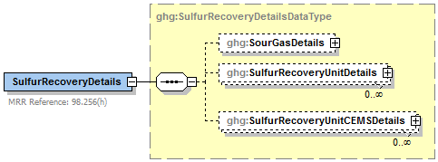

**This section pertains only to the unit-level reporting of sulfur recovery plants.**

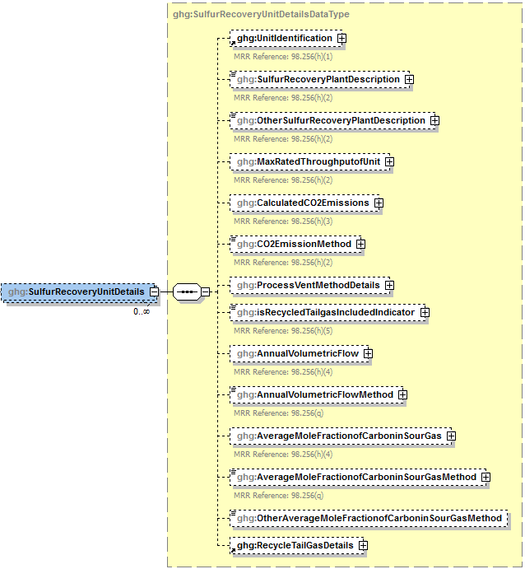

**Conditionally**

**Required**

**Conditionally**

**Required**

**Conditionally**

**Required - applies only if the Equation Y-12 method is reported.**

**Conditionally**

**Required - applies only if the Process Vent method is reported.**

**Note:** Data elements boxed in red are required. Please see page 4 of this document   
 for more information on conditionally required elements.

Subpart Y collects the following data about each sulfur recovery plant:

* A unique name or identifier, plus optional description
* Type (description) of sulfur recovery plant:
* Caustic scrubber
* Claus
* Lo‑cat
* Sulfuric acid plant
* Other (specify)
* Maximum rated throughput of the sulfur recovery plant (metric tons sulfur per stream day)
* **Conditionally Required:** If the unit is not monitored by a CEMS, report the calculated CO2 annual emissions of the sulfur recovery plant expressed in metric tons.
* Method used to calculate the CO2 emissions.
* CO2 CEMS
* Equation Y-12
* Process Vent Method

**Note:** The Process Vent Method does not apply to Claus plants.

1. Sulfur Recovery Unit Details Data Element Definitions

| **Data Element Name** | **Description** |
| --- | --- |
| **SulfurRecoveryUnitDetails** | **Parent Element (Conditionally Required)** |
| UnitIdentification | A collection of data elements containing the identity of each sulfur recovery plant unit. Report a unique unit name (ID) in the child data element **UnitName**, an optional brief description in the child data element **UnitDescription** and the type of unit in the child data element **UnitType**. [98.256(h)(1)] Report the following unit type:   |  | | --- | | Sulfur Recovery Plant | |
| SulfurRecoveryPlantDescription | The type of sulfur recovery plant. Below is the list of allowable values. [98.256(h)(2)]  Caustic scrubber  Claus  Lo-cat  Sulfuric acid plant  Other (specify) |
| OtherSulfurRecoveryPlantDescription | **Conditionally Required:** Specify the type of sulfur recovery plant you are reporting if your type is not listed above. |
| MaxRatedThroughputofUnit | Maximum rated throughput of the specified sulfur recovery plant. Report the value in the child data element **MeasureValue**. Set the units of measure to “metric tons/streamday” in the attribute **rateUOM**. [98.256(h)(2)] |
| CalculatedCO2Emissions | **Conditionally Required:** The calculated CO2 annual emissions for the sulfur recovery plant if not monitored by a CEMS, expressed in metric tons. Report the value in the child data element **CalculatedValue**. Set the units of measure to “Metric Tons” in the attribute**massUOM**. [98.256(h)(3)] |
| CO2EmissionMethod | The method used to calculate CO2 annual emissions for the sulfur recovery plant. [98.256(h)(2)] Below is the list of allowable values.  CO2 CEMS  Equation Y-12  Process Vent Method  **Note:** The Process Vent Method does not apply to Claus plants. |

1. Example for Sulfur Recovery Units

<ghg:SulfurRecoveryUnitDetails>

<ghg:UnitIdentification>

<ghg:UnitName>SR-NC-001</ghg:UnitName>

<ghg:UnitDescription>Eastman Factory</ghg:UnitDescription>

<ghg:UnitType>Sulfur Recovery Plant</ghg:UnitType>

</ghg:UnitIdentification>

<ghg:SulfurRecoveryPlantDescription>Caustic scrubber</ghg:SulfurRecoveryPlantDescription>

<ghg:MaxRatedThroughputofUnit rateUOM="metric tons/streamday">

<ghg:MeasureValue>23444</ghg:MeasureValue>

</ghg:MaxRatedThroughputofUnit>

<ghg:CalculatedCO2Emissions massUOM="Metric Tons">

<ghg:CalculatedValue>45343.2</ghg:CalculatedValue>

</ghg:CalculatedCO2Emissions>

<ghg:CO2EmissionMethod>Equation Y-12</ghg:CO2EmissionMethod>

**Note:** The XML example above is presented here to demonstrate the concept of reporting details for sulfur recovery plant units.

?

***Which method was used to calculate CO2 emissions?***

If CEMS was used, see “Sulfur Recovery CEMS Details” for instructions on how to report for the parent element “SulfurRecoveryUnitCEMSDetails.”

If Equation Y-12 was used, see “Equation Y-12 Details” for instructions on how to report additional information.

If the Process Vent method was used, see “Process Vent Method Details” for instructions on how to report for the parent element “ProcessVentMethodDetails.”

1. Process Vent Method Details Schema Diagram

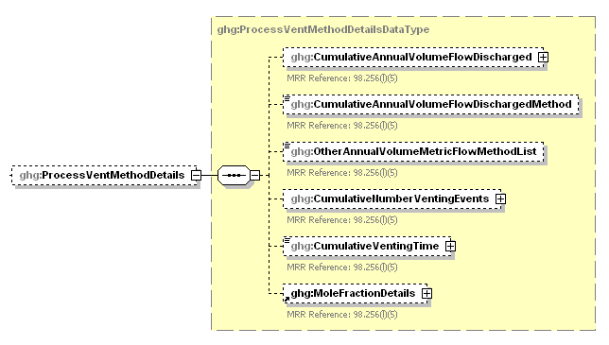

**Conditionally**

**Required**

**Conditionally**

**Required**

**Conditionally**

**Required**

**Note:** Data elements boxed in red are required. Please see page 4 of this document   
 for more information on conditionally required elements.

**Conditionally Required:** If the Process Vent method was used to calculate CO2 emissions, then report the following:

* Annual volumetric flow discharged to the atmosphere (scf).
* Method used to measure or estimate the annual volumetric flow rate.
  + Continuous or at least hourly measurements
  + Routine (less frequent than hourly but at least weekly) measurements
  + Periodic (less frequent than weekly) measurements
  + Process knowledge
  + Engineering calculation
  + Other (specify)
* **Conditionally Required:** Number of venting events, if vent is intermittent.
* **Conditionally Required:** Cumulative venting time, if vent is intermittent (hours).
* CO2 mole fraction details. (See Mole Fraction Details Schema Diagram.)

1. Process Vent Method Details Data Element Definitions

| **Data Element Name** | **Description** |
| --- | --- |
| **ProcessVentMethodDetails** | **Parent Element (Conditionally Required)** |
| CumulativeAnnualVolumeFlowDischarged | The cumulative annual volumetric flow discharged to the atmosphere. Report the value in the child data element **MeasureValue**. Set the units of measure to “scf” in the attribute **volUOM**. [98.256(l)(5)] |
| CumulativeAnnualVolumeFlowDischargedMethod | The method used to measure or estimate the annual volumetric flow discharged to the atmosphere. Below is the list of allowable values. [98.256(l)(5)]  Continuous or at least hourly measurements  Routine (less frequent than hourly but at least weekly) measurements  Periodic (less frequent than weekly) measurements  Process knowledge  Engineering calculation  Other (specify) |
| OtherAnnualVolumeMetricFlowMethodList | **Conditionally Required:** Specify the method used to measure or estimate the annual volumetric flow discharged to the atmosphere if not listed above. [98.256(l)(5)] |
| CumulativeNumberVentingEvents | **Conditionally Required:** The number of cumulative venting events for all relevant vents, if vents are intermittent (not applicable for continuous venting). Report the integer value in the child data element **MeasureValue**. [98.256(l)(5)] |
| CumulativeVentingTime | **Conditionally Required:** The cumulative venting time in hours for all intermittent vents. Set the units of measure to “Hours” in the attribute **timeUOM**. Report the decimal value. [98.256(l)(5)] |

1. Example for Process Vent Method Details

<ghg:ProcessVentMethodDetails>

<ghg:CumulativeAnnualVolumeFlowDischarged volUOM="scf">

<ghg:MeasureValue>123.23145</ghg:MeasureValue>

</ghg:CumulativeAnnualVolumeFlowDischarged>

<ghg:CumulativeAnnualVolumeFlowDischargedMethod>Process

knowledge</ghg:CumulativeAnnualVolumeFlowDischargedMethod>

<ghg:CumulativeNumberVentingEvents>

<ghg:MeasureValue>25</ghg:MeasureValue>

</ghg:CumulativeNumberVentingEvents>

<ghg:CumulativeVentingTime timeUOM="Hours">187</ghg:CumulativeVentingTime>

**Note:** The XML example above is presented here to demonstrate the concept of reporting details for the process vent method if used to calculate CO2 emissions for the sulfur recovery plant.

1. Mole Fraction Details Schema Diagram

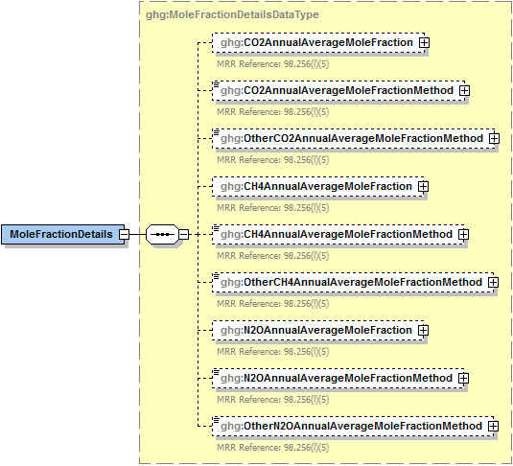

**Conditionally**

**Required**

**Note:** Data elements boxed in red are required. Please see page 4 of this document   
 for more information on conditionally required elements.

.

If the Process Vent method was used to calculate CO2 emissions, then report the following:

* Annual average mole fraction of CO2.
* Method used to measure or estimate the annual average mole fraction of CO2.
  + Engineering estimates/process knowledge
  + Direct measurement
  + Other (specify)

1. Mole Fraction Details Data Element Definitions

| **Data Element Name** | **Description** |
| --- | --- |
| **MoleFractionDetails** | **Parent Element** |
| CO2AnnualAverageMoleFraction | Report the annual average mole fraction of CO2. Report the value in the child data element **MeasureValue**. Set the units of measure to “fraction (number between 0 and 1)” in the attribute **fractionUOM**. [98.256(l)(5)] |
| CO2AnnualAverageMoleFractionMethod | Report the method used to measure or estimate the mole fraction of CO2. [98.256(l)(5)] Below is the list of allowable values.   |  | | --- | | Engineering estimates/process knowledge  Direct measurement  Other (specify) | |
| OtherCO2AnnualAverageMoleFractionMethod | **Conditionally Required:** Specify the method used to measure or estimate the mole fraction of CO2 if not referenced above. [98.256(l)(5)] |

1. Example for Mole Fraction Details

<ghg:MoleFractionDetails>

<ghg:CO2AnnualAverageMoleFraction fractionUOM="fraction (number between 0 and 1)">

<ghg:MeasureValue>0.5</ghg:MeasureValue>

</ghg:CO2AnnualAverageMoleFraction>

<ghg:CO2AnnualAverageMoleFractionMethod>Direct measurement</ghg:CO2AnnualAverageMoleFractionMethod>

</ghg:MoleFractionDetails>

</ghg:ProcessVentMethodDetails>

**Note:** The XML example above is presented here to demonstrate the concept of reporting the CO2 mole fraction details.

1. Equation Y-12 Details Schema Diagram



**Conditionally**

**Required**

**Note:** Data elements boxed in red are required. Please see page 4 of this document   
for more information on conditionally required elements.

**Conditionally Required:** If Equation Y-12 is used to calculate CO2 emissions, then the following information is required:

* An indication that if you recycle tail gas to the front of the plant, the recycled flow rate and carbon content of recycled tail gas are included in the measured volumetric flow and carbon mole fraction data. (If you do not recycle tail gas, please report “N”).
* **Conditionally Required:** If measured, report the following:
* The number of hours that missing data procedures were used to determine the annual volume of sour gas fed to the sulfur recovery plant.
* One or more methods used to estimate the annual volume of sour gas fed to the sulfur recovery plant.
* The number of hours that missing data procedures were used to determine the annual average mole fraction of carbon in the sour gas.
* The method used to estimate the annual average mole fraction of carbon in the sour gas.

**Note:** The above data collection elements are not required if you use a non-measurement option provided in the rule to report this data (i.e. engineering estimates).

1. Equation Y-12 Details Data Element Definitions

| **Data Element Name** | **Description** |
| --- | --- |
| isRecycledTailgasIncludedIndicator | For each plant using the Equation Y-12 calculation method, an indication that if you recycle tail gas to the front of the plant, the recycled flow rate and carbon content of recycled tail gas are included in the measured volumetric flow and carbon mole fraction data. (If you do not recycle tail gas, please report “N”). [98.256(h)(5)] |
| AnnualVolumetricFlow | **Conditionally Required:** For each plant using the Equation Y-12 calculation method, if measured, report the number of hours that missing data procedures were used to determine the annual volume of sour gas fed to the sulfur recovery plant in the child data element **NumberofTimesSubstituted**. [98.3(c)(8), 98.256(h)(4)]] |
| AnnualVolumetricFlowMethod | **Conditionally Required:**  For each plant using the Equation Y-12 calculation method, if measured, report one or more methods used to estimate the annual volume of sour gas fed to the sulfur recovery plant. [98.256(q)] |
| AverageMoleFractionofCarboninSourGas | **Conditionally Required:** For each plant using the Equation Y-12 calculation method, if measured, report the number of hours that missing data procedures were used to determine the annual average mole fraction of carbon in the sour gas in the child data element **NumberofTimesSubstituted**. [98.3(c)(8), 98.256(q)] |
| AverageMoleFractionofCarboninSourGasMethod | **Conditionally Required:** For each plant using the Equation Y-12 calculation method, if measured, report the method used to estimate the annual average mole fraction of carbon in the sour gas. Below is the list of allowable values. [98.256(q)]  Method 18 at 40 CFR part 60, appendix A-6  ASTM D1945-03  ASTM D1946-90 (Reapproved 2006)  GPA 2261-00  UOP539-97  ASTM D2503-92 (Reapproved 2007)  Chromatographic analysis: manufacturer’s instructions  Other (specify) |
| OtherAverageMoleFractionofCarboninSourGasMethod | **Conditionally Required:** Method used to measure the annual average mole fraction of carbon in the sour gas if not listed above. |

1. Example for Equation Y-12 Details

<ghg:isRecycledTailgasIncludedIndicator>Y</ghg:isRecycledTailgasIncludedIndicator>

<ghg:AnnualVolumetricFlow">

<ghg:NumberofTimesSubstituted>51</ghg:NumberofTimesSubstituted>

</ghg:AnnualVolumetricFlow>

<ghg:AnnualVolumetricFlowMethod>Method A</ghg:AnnualVolumetricFlowMethod>

<ghg:AverageMoleFractionofCarboninSourGas>

<ghg:NumberofTimesSubstituted>15</ghg:NumberofTimesSubstituted>

</ghg:AverageMoleFractionofCarboninSourGas>

<ghg:AverageMoleFractionofCarboninSourGasMethod>ASTM D1946-90 (Reapproved 2006</ghg:AverageMoleFractionofCarboninSourGasMethod>

**Note:** The XML example above is presented here to demonstrate the concept of reporting details for sulfur recovery plant units using Equation Y-12.

1. Recycle Tail Gas (Equation Y-12 Method) Details Schema Diagram

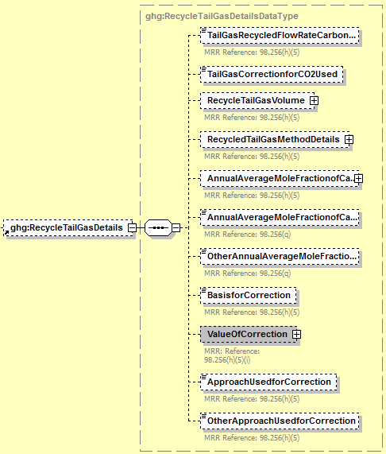

**Conditionally**

**Required**

**Note:** Data elements boxed in red are required. Please see page 4 of this document   
 for more information on conditionally required elements.

**Conditionally Required:** If Equation Y-12 is used to calculate CO2 emissions, report the following information:

* An indication that if you recycle tail gas to the front of the plant, the recycled flow rate and carbon content of recycled tail gas are included in the measured volumetric flow and carbon mole fraction data. (If you do not recycle tail gas, please report “N”). **Note:** This is the same indicator as used for the data element “isRecycledTailgasIncludedIndicator”.
* **Conditionally Required:** If you indicated that you recycle tail gas to the front of the plant and the recycled flow rate and carbon content of recycled tail gas are included in the measured volumetric flow and carbon mole fraction data, indicate whether a correction for CO2 emissions in the tail gas is used for Equation Y-12. **Note**: Per Section 98.253(f)(5), if tail gas is recycled to the front of the sulfur recovery plant and the recycled flow rate and carbon content are included in the measured data, then the annual CO2 emissions must be corrected to avoid double counting these emissions.

**Conditionally Required:** If a correction for CO2 emissions in the tail gas is used for Equation Y-12, report the following information:

* **Conditionally Required:** Annual volume of recycled tail gas (report only if the default correction factor was used and this value was not used to calculate the correction factor, in scf).
* **Conditionally Required:** If measured, the number of hours missing data procedures were used for annual volume of recycled tail gas.
* **Conditionally Required:**  If measured, the method used to estimate the annual volume of recycled tail gas.
* **Conditionally Required:** Annual average mole fraction of carbon in the tail gas (report only if the default correction factor was used and this value was not used to calculate the correction factor, in kg-mole C/kg-mole gas).
* **Conditionally Required:** If measured, the number of hours missing data procedures were used for annual average mole fraction of carbon in the tail gas.
* **Conditionally Required:** If measured, the method used to estimate the annual average mole fraction of carbon in the tail gas.

**Note:** Data collection elements that contains the phrase "If measured" above are not required if you use a non-measurement option provided in the rule to report this data (i.e. engineering estimates).

* An indication of whether the default correction factor or a unit-specific correction factor was used.
* **Conditionally Required:** If a unit-specific correction factor was used, the method used to determine the correction factor used to calculate the CO2 emissions:
* Used measurement data for the annual volume of recycled tail gas and annual average mole fraction of carbon in the tail gas
* Used measurement data for the annual volume of recycled tail gas and engineering calculations for mole fraction of carbon in the tail gas
* Used measurement data for the mole fraction of carbon in the tail gas and engineering calculations for the annual volume of recycled tail gas
* Used engineering calculations for both the annual volume of recycled tail gas and annual average mole fraction of carbon in the tail gas
* Other (specify)

1. Recycle Tail Gas Details Data Element Definitions

| **Data Element Name** | **Description** |
| --- | --- |
| **RecycleTailGasDetails** | **Parent Element (Conditionally Required)** |
| TailGasRecycledFlowRateCarbonContentIncluded | For each plant using the Equation Y-12 calculation method, an indication that if you recycle tail gas to the front of the plant, the recycled flow rate and carbon content of recycled tail gas are included in the measured volumetric flow and carbon mole fraction data. (If you do not recycle tail gas, please report “N”). [98.256(h)(5)] |
| TailGasCorrectionforCO2Used | **Conditionally Required:** If you indicated that you recycle tail gas to the front of the plant and the recycled flow rate and carbon content of recycled tail gas are included in the measured volumetric flow and carbon mole fraction data, indicate (Y/N) whether a correction for CO2 emissions in the tail gas is used for Equation Y-12. [98.256(h)(5)] |
| RecycleTailGasVolume | **Conditionally Required:** For each plant using the Equation Y-12 calculation method that also recycles tail gas to the front of the plant and that also includes a tail gas correction, report the annual volume of recycled tail gas (report only if the default correction factor was used and this value was not used to calculate the correction factor). Report the value in the child data element **MeasureValue**. Set the units of measure to “scf” in the attribute **volUOM**. [98.256(h)(5)]  **Conditionally Required:** For each plant using the Equation Y-12 calculation method that also recycles tail gas to the front of the plant and that also includes a tail gas correction, if measured, report the number of hours that missing data procedures were used in determining the annual volume of recycled tail gas in the child data element **NumberofTimesSubstituted**. [98.3(c)(8), 98.256(h)(5)] |
| **RecycledTailGasMethodDetails** | **Parent Element (Conditionally Required)** |
| RecycledTailGasMethod | For each plant using the Equation Y-12 calculation method that also recycles tail gas to the front of the plant and that also includes a tail gas correction, if measured, the method used to estimate the annual volume of recycled tail gas. Below is the list of allowable values. [98.256(q)]  Consensus based standard method Procedures specified by manufacturer Engineering estimates Company records Other (specify) |
| OtherRecycledTailGasMethod | **Conditionally Required:** Specify the method used to measure the annual volume of recycled tail gas if “Consensus based standard method”, “Procedures specified by manufacturer” or “Other (specify)” was reported above. |
| AnnualAverageMoleFractionofCarbon | **Conditionally Required:** For each plant using the Equation Y-12 calculation method that also recycles tail gas to the front of the plant and that also includes a tail gas correction, report the annual average mole fraction of carbon in the tail gas (report only if the default correction factor was used and this value was not used to calculate the correction factor). Report the value in the child data element **MeasureValue**. Set the units of measure to “kg-mole C/kg-molegas” in the attribute **fractionUOM**. [98.256(h)(5)]  **Conditionally Required:** For each plant using the Equation Y-12 calculation method that also recycles tail gas to the front of the plant and that also includes a tail gas correction, if measured, report the number of hours that missing data procedures were used in determining the annual average mole fraction of carbon in the tail gas, if measured in the child data element **NumberofTimesSubstituted**. Set the units of measure to “kg-mole C/kg-molegas” in the attribute **fractionUOM**. **Note:** Although the measured value of the annual average mole fraction of carbon in the tail gas may not be required, the attribute **fractionUOM** is required by the schema and must be reported if **AnnualAverageMoleFractionofCarbon** is reported. [98.3(c)(8), [98.256(h)(5)] |
| AnnualAverageMoleFractionofCarbonMethod | **Conditionally Required:** For each plant using the Equation Y-12 calculation method that also recycles tail gas to the front of the plant and that also includes a tail gas correction, if measured, report the method used to measure the annual average mole fraction of carbon in the tail gas. Below is the list of allowable values. [98.256(q)]  Continuous composition monitor Routine (daily, weekly, or monthly) measurements Limited measurement data Engineering calculations Default value Other (specify) |
| OtherAnnualAverageMoleFractionofCarbonMethod | **Conditionally Required:** Specify the method used to measure the annual average mole fraction of carbon in the tail gas if not listed above. |
| BasisforCorrection | **Conditionally Required:** For each plant using the Equation Y-12 calculation method that also recycles tail gas to the front of the plant and that also includes a tail gas correction, indicate whether you used the default (95%) or a unit specific correction factor. [98.256(h)(5)] Below is the list of allowable values.  Default correction factor (95%)  Unit-specific correction factor |
| ValueOfCorrection | **Conditionally Required:** For each plant using the Equation Y-12 calculation method that also recycles tail gas to the front of the plant and that also includes a tail gas correction, indicate the value of the correction factor. |
| ApproachUsedforCorrection | **Conditionally Required:** For each plant using the Equation Y-12 calculation method that also specifies use of a unit-specific correction for tail gas, the approach used to determine the correction factor used to calculate the CO2 emissions. Below is the list of allowable values. [98.256(q)]  Used measurement data for the annual volume of recycled tail gas and annual average mole fraction of carbon in the tail gas  Used measurement data for the annual volume of recycled tail gas and engineering calculations for mole fraction of carbon in the tail gas  Used measurement data for the mole fraction of carbon in the tail gas and engineering calculations for the annual volume of recycled tail gas  Used engineering calculations for both the annual volume of recycled tail gas and annual average mole fraction of carbon in the tail gas  Other (specify) |
| OtherApproachUsedforCorrection | **Conditionally Required:** Specify the approach used to determine correction factor used to calculate the CO2 emissions if not listed above. |

1. Example for Recycled Tail Gas Details (Default Correction Factor)

<

<ghg:RecycleTailGasDetails>

<ghg:TailGasRecycledFlowRateCarbonContentIncluded>Y</ghg:TailGasRecycledFlowRateCarbonContentIncluded>

<ghg:TailGasCorrectionforCO2Used>Y</ghg:TailGasCorrectionforCO2Used>

<ghg:RecycleTailGasVolume volUOM="scf">

<ghg:MeasureValue>342.2364</ghg:MeasureValue>

<ghg:NumberofTimesSubstituted>147</ghg:NumberofTimesSubstituted>

</ghg:RecycleTailGasVolume>

<ghg:RecycledTailGasMethodDetails>

<ghg:RecycledTailGasMethod>Engineering estimates</ghg:RecycledTailGasMethod>

  </ghg:RecycledTailGasMethodDetails>

<ghg:AnnualAverageMoleFractionofCarbon fractionUOM="kg-mole C/kg-molegas">

<ghg:MeasureValue>0.454</ghg:MeasureValue>

<ghg:NumberofTimesSubstituted>123</ghg:NumberofTimesSubstituted>

</ghg:AnnualAverageMoleFractionofCarbon>

<ghg:AnnualAverageMoleFractionofCarbonMethod>Engineering calculations</ghg:AnnualAverageMoleFractionofCarbonMethod>

  <ghg:BasisforCorrection>Default correction factor (95%)</ghg:BasisforCorrection>

</ghg:RecycleTailGasDetails>

**Note:** The XML example above is presented here to demonstrate the concept of reporting details for the recycled tail gas if Equation Y-12 and the default correction factor were used to calculate CO2 emissions for the sulfur recovery plant.

1. Example for Recycled Tail Gas Details (Unit-Specific Correction Factor)

<

<ghg:RecycleTailGasDetails>

<ghg:TailGasRecycledFlowRateCarbonContentIncluded>Y</ghg:TailGasRecycledFlowRateCarbonContentIncluded>

<ghg:TailGasCorrectionforCO2Used>Y</ghg:TailGasCorrectionforCO2Used>

<ghg:RecycleTailGasVolume>

<ghg:NumberofTimesSubstituted>147</ghg:NumberofTimesSubstituted>

</ghg:RecycleTailGasVolume>

<ghg:RecycledTailGasMethodDetails>

<ghg:RecycledTailGasMethod>Engineering estimates</ghg:RecycledTailGasMethod>

  </ghg:RecycledTailGasMethodDetails>

<ghg:AnnualAverageMoleFractionofCarbon fractionUOM="kg-mole C/kg-molegas">

<ghg:NumberofTimesSubstituted>123</ghg:NumberofTimesSubstituted>

</ghg:AnnualAverageMoleFractionofCarbon>

<ghg:AnnualAverageMoleFractionofCarbonMethod>Engineering calculations</ghg:AnnualAverageMoleFractionofCarbonMethod>

  <ghg:BasisforCorrection>Unit-specific correction factor</ghg:BasisforCorrection>

  <ghg:ApproachUsedforCorrection>Used measurement data for the annual volume of recycled tail gas and annual average mole fraction of carbon in the tail gas</ghg:ApproachUsedforCorrection>

</ghg:RecycleTailGasDetails>

**Note:** The XML example above is presented here to demonstrate the concept of reporting details for the recycled tail gas if Equation Y-12 and a unit-specific correction factor were used to calculate CO2 emissions for the sulfur recovery plant.

### Sulfur Recovery CEMS Details

**Conditionally Required Unit-Level Data**

For each sulfur recovery unit that is monitored with a CEMS to measure CO2 emissions, according to the guidelines specified in Subpart C, report the unit’s identification information and the relevant information required under 98.36 for the Tier 4 Calculation Methodology. See instructions for reporting parent element “YTier4CEMSDetails.” **Note:** Use the same identification for the unit as was used for the parent element “SulfurRecoveryUnitDetails”.

1. Sulfur Recovery Unit CEMS Details Schema Diagram

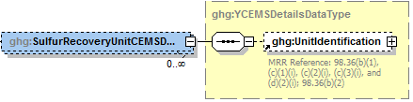

**Note:** Data elements boxed in red are required.

1. Sulfur Recovery Unit CEMS Details Data Element Definitions

| **Data Element Name** | **Description** |
| --- | --- |
| **SulfurRecoveryUnitCEMSDetails** | **Parent Element** |
| UnitIdentification | A collection of data elements containing the identity of each CEMS sulfur recovery plant unit. Report a unique unit name (ID) in the child data element **UnitName**, an optional brief description in the child data element **UnitDescription** and the type of unit in the child data element **UnitType**. Report the following unit type:   |  | | --- | | Sulfur Recovery Plant | | **Note:** Use the same identification for the unit as was used for the parent element “SulfurRecoveryUnitDetails”. | |

1. Example for Sulfur Recovery Unit CEMS Details

<ghg:SulfurRecoveryUnitCEMSDetails>

<ghg:UnitIdentification>

<ghg:UnitName>SRP-001</ghg:UnitName>

<ghg:UnitType>Sulfur Recovery Plant</ghg:UnitType>

</ghg:UnitIdentification>

</ghg:SulfurRecoveryUnitCEMSDetails>

**Note:** The XML example above is presented here to demonstrate the concept of reporting unit identification for a sulfur recovery plant monitored by CEMS.

## Coke Calcining Unit Information

**Conditionally Required Unit-Level Data**

This topic provides a step‑by‑step description of how to report Subpart Y Coke Calcining unit information for your facility.

### Coke Calcining Unit Details

You are required to report CO2, CH4 and N2O emissions from each coke calcining unit under this Subpart.

1. Coke Calcining Unit Details Schema Diagram

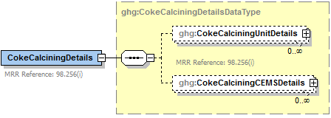

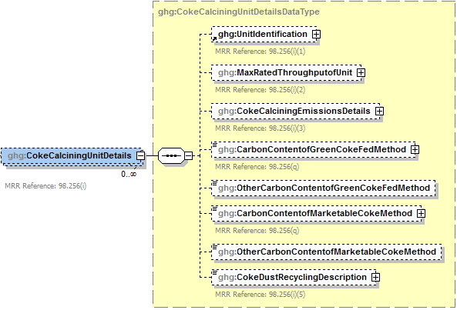

**Conditionally**

**Required**

**Conditionally**

**Required**

**Note:** Data elements boxed in red are required. Please see page 4 of this document   
for more information on conditionally required elements.

You are required to report the following data about each coke calcining unit:

* A unique name or identifier, plus optional description for each coke calcining unit. See also [About Unique Unit Names](http://www.ccdsupport.com/confluence/display/help/About+Unique+Unit+Names).
* Maximum rated throughput of the coke calcining unit (metric tons coke calcined per stream day)

1. Coke Calcining Unit Details Data Element Definitions

| **Data Element Name** | **Description** |
| --- | --- |
| **CokeCalciningDetails** | **Parent Element (Conditionally Required)** |
| **CokeCalciningUnitDetails** | **Parent Element** |
| UnitIdentification | A collection of data elements containing the identity of each coke calcining unit. Report a unique unit name (ID) in the child data element **UnitName**, an optional brief description in the child data element **UnitDescription** and the type of unit in the child data element **UnitType**. [98.256(i)(1)] Report the following unit type:   |  | | --- | | Coke Calcining Unit | |
| MaxRatedThroughputofUnit | Maximum rated throughput of the specified coke calcining unit (metric tons coke calcined per stream day). Report the value in the child data element **MeasureValue**. Set the units of measure to “metric tons/streamday” in the attribute **rateUOM**. [98.256(i)(2)] |

1. Example for Coke Calcining Unit Details

<

<ghg:CokeCalciningUnitDetails>

<ghg:UnitIdentification>

<ghg:UnitName>CC-001</ghg:UnitName>

<ghg:UnitType>Coke Calcining Unit</ghg:UnitType>

</ghg:UnitIdentification>

<ghg:MaxRatedThroughputofUnit rateUOM="metric tons/streamday">

<ghg:MeasureValue>232</ghg:MeasureValue>

</ghg:MaxRatedThroughputofUnit>

**Note:** The XML example above is presented here to demonstrate the concept of reporting details for coke calcining units.

1. Coke Calcining Emissions Details Schema Diagram

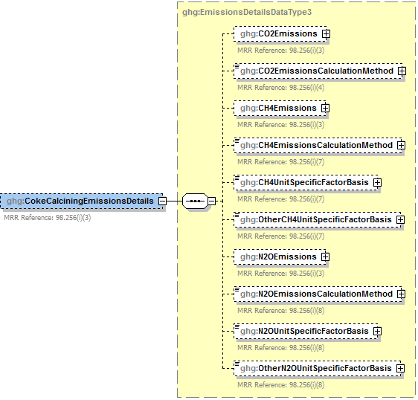

**Conditionally**

**Required**

**Conditionally**

**Required**

**Conditionally**

**Required**

**Conditionally**

**Required**

**Conditionally**

**Required**

**Note:** Data elements boxed in red are required. Please see page 4 of this document   
 for more information on conditionally required elements.

Subpart Y collects the following data about your coke calcining unit emissions:

* **Conditionally Required:** The calculated CO2 annual emissions for each unit not monitored by a CEMS, expressed in metric tons. To calculate the annual CO2 emissions rate, use Equation Y‑13.
* An indication of the method used to calculate CO2 annual emissions for each coke calcining unit.
* The calculated CH4 and N2O annual emissions for each unit, expressed in metric tons of each GHG emitted.
* The calculation method used to calculate CH4 and N2O annual emissions for each unit.
* **Conditionally Required:** Basis for the unit-specific emission factors used to calculate CH4 and N2O emissions. (Report this value only if you used a unit‑specific emission factor based on a source test result.)
  + Weekly or more frequent measurements
  + Periodic (less frequent than weekly) measurements
  + Average of multiple source tests
  + One‑time source test
  + Other

1. Coke Calcining Emissions Details Data Element Definitions

| **Data Element Name** | **Description** |
| --- | --- |
| **CokeCalciningEmissionsDetails** | **Parent Element** |
| CO2Emissions | **Conditionally Required:** The calculated CO2 annual emissions for the specified coke calcining unit if not monitored by a CEMS. Report the value in the child data element **CalculatedValue**. Set the units of measure to “Metric Tons” in the attribute**massUOM**. [98.256(i)(3)] |
| CO2EmissionsCalculationMethod | The method used to calculate the CO2 emissions for the specified coke calcining unit. [98.256(i)(4)] Below is the list of allowable values.   |  | | --- | |  | | CO2 CEMS Equation Y-13 | |
| CH4Emissions | The calculated CH4 annual emissions for the specified coke calcining unit. Report the value in the child data element **CalculatedValue**. Set the units of measure to “Metric Tons” in the attribute**massUOM**. [98.256(i)(3)] |
| CH4EmissionsCalculationMethod | The method used to calculate the CH4 emissions for the specified coke calcining unit. [98.256(i)(7)] Below is the list of allowable values.   |  | | --- | |  | | Unit-specific measurement data  Unit‑specific emissions factor based on a source test of the unit  Equation Y-9 with a default emission factor | |
| CH4UnitSpecificFactorBasis | **Conditionally Required:** The basis for the unit-specific emission factor used to determine CH4 annual emissions if the emission factor was based on a source test of the unit. [98.256(i)(7)] Below is the list of allowable values.  Weekly or more frequent measurements  Periodic (less frequent than weekly) measurements  Average of multiple source tests  One-time source test  Other (specify) |
| OtherCH4UnitSpecificFactorBasis | **Conditionally Required:** Specify the basis for the unit-specific emission factor used to determine CH4 emissions if not referenced in the list of allowable basis values. [98.256(i)(7)] |
| N2OEmissions | The calculated N2O annual emissions for the specified coke calcining unit. Report the value in the child data element **CalculatedValue**. Set the units of measure to “Metric Tons” in the attribute**massUOM**. [98.256(i)(3)] |
| N2OEmissionsCalculationMethod | The method used to calculate the N2O emissions for the specified coke calcining unit. [98.256(i)(8)] Below is the list of allowable values.   |  | | --- | |  | | Unit-specific measurement data  Unit‑specific emissions factor based on a source test of the unit  Equation Y-10 with a default emission factor | |
| N2OUnitSpecificFactorBasis | **Conditionally Required:** The basis for the unit-specific emission factor used to determine N2O annual emissions if the emission factor was based on a source test of the unit. [98.256(i)(8)] Below is the list of allowable values.  Weekly or more frequent measurements  Periodic (less frequent than weekly) measurements  Average of multiple source tests  One-time source test  Other (specify) |
| OtherN2OUnitSpecificFactorBasis | **Conditionally Required:** Specify the basis for the unit-specific emission factor used to determine N2O emissions if not referenced in the list of allowable basis values. [98.256(i)(8)] |

1. Example for Coke Calcining Emissions Details

<ghg:CokeCalciningEmissionsDetails>

<ghg:CO2Emissions massUOM="Metric Tons">

<ghg:CalculatedValue>22230.8</ghg:CalculatedValue>

</ghg:CO2Emissions>

<ghg:CO2EmissionsCalculationMethod>Equation Y-13</ghg:CO2EmissionsCalculationMethod>

<ghg:CH4Emissions massUOM="Metric Tons">

<ghg:CalculatedValue>4562.12</ghg:CalculatedValue>

</ghg:CH4Emissions>

<ghg:CH4EmissionsCalculationMethod>Equation Y-9 with a default emission factor</ghg:CH4EmissionsCalculationMethod>

<ghg:N2OEmissions massUOM="Metric Tons">

<ghg:CalculatedValue>8765.123</ghg:CalculatedValue>

</ghg:N2OEmissions>

<ghg:N2OEmissionsCalculationMethod> Unit-specific emission factor based on a source test of the

unit</ghg:N2OEmissionsCalculationMethod>

<ghg:N2OUnitSpecificFactorBasis>One-time source test</ghg:N2OUnitSpecificFactorBasis>

</ghg:CokeCalciningEmissionsDetails>

**Note:** The XML example above is presented here to demonstrate the concept of reporting emissions details for coke calcining units.

**Conditionally Required:** The following information is required for each coke calcining unit using the Equation Y-13 calculation method (which is not monitored by a CEMS):

* Method used to measure the annual carbon content of green coke fed to the unit.
  + ASTM D3176‑89‑Reapproved 2002
  + ASTM D5291‑02‑Reapproved 2007
  + ASTM D5373‑08
* Method used to measure the annual carbon content of marketable coke produced.
  + ASTM D3176‑89‑Reapproved 2002
  + ASTM D5291‑02‑Reapproved 2007
  + ASTM D5373‑08
* Description of coke dust recycling for the unit.
  + All dust is recycled
  + A portion of the dust is recycled
  + None of the dust is recycled

1. Coke Calcining Unit Method Details Data Element Definitions

| **Data Element Name** | **Description** |
| --- | --- |
| CarbonContentofGreenCokeFedMethod | **Conditionally Required:** If the unit used the Equation Y-13 calculation method, the method used to measure the annual carbon content of green coke fed to the unit. [98.256(q)] Below is the list of allowable values.  ASTM D3176-89 (Reapproved 2002) ASTM D5291-02 (Reapproved 2007 ASTM D5373-08  Other (specify) |
| OtherCarbonContentofGreenCokeFedMethod | **Conditionally Required:** The method used to measure the annual carbon content of green coke fed to the unit if not listed above. |
| CarbonContentofMarketableCokeMethod | **Conditionally Required:** If the unit used the Equation Y-13 calculation method, the method used to measure the annual carbon content of marketable coke produced. [98.256(q)] Below is the list of allowable values.  ASTM D3176-89 (Reapproved 2002) ASTM D5291-02 (Reapproved 2007) ASTM D5373-08  Other (specify) |
| OtherCarbonContentofMarketableCokeMethod | **Conditionally Required:** The method used to measure the annual carbon content of marketable coke produced if not listed above. |
| CokeDustRecyclingDescription | **Conditionally Required:** If the unit used the Equation Y-13 calculation method, a description of coke dust recycling for the unit. [98.256(i)(5)] Below is the list of allowable values.  All dust is recycled A portion of the dust is recycled None of the dust is recycled |

1. Example for Coke Calcining Unit Method Details

<ghg:CarbonContentofGreenCokeFedMethod>ASTM D5373-08</ghg:CarbonContentofGreenCokeFedMethod>

<ghg:CarbonContentofMarketableCokeMethod> ASTM D5373-08</ghg:CarbonContentofMarketableCokeMethod>

<ghg:CokeDustRecyclingDescription>All dust is recycled</ghg:CokeDustRecyclingDescription>

</ghg:CokeCalciningUnitDetails>

**Note:** The XML example above is presented here to demonstrate the concept of reporting details for coke calcining units.

### Coke Calcining CEMS Details

For each coke calcining unit that is monitored with a CEMS to measure CO2 emissions according to the guidelines specified in Subpart C, report the unit’s identification information and the relevant information required under 98.36 for the Tier 4 Calculation Methodology. See instructions for reporting parent element “YTier4CEMSDetails.”

1. Coke Calcining CEMS Details Schema Diagram

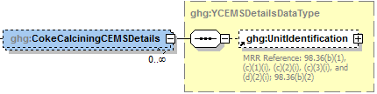

**Note:** Data elements boxed in red are required.

1. Coke Calcining CEMS Details Data Element Definitions

| **Data Element Name** | **Description** |
| --- | --- |
| **CokeCalciningCEMSDetails** | **Parent Element** |
| UnitIdentification | A collection of data elements containing the identity of each CEMS coke calcining unit. Report a unique unit name (ID) in the child data element **UnitName**, an optional brief description in the child data element **UnitDescription** and the type of unit in the child data element **UnitType**. Report the following unit type:   |  | | --- | | Coke Calcining Unit | | **Note:** Use the same identification for the unit as was used for the parent element “CokeCalciningUnitDetails”. | |

1. Example for Coke Calcining CEMS Details

< <ghg:CokeCalciningCEMSDetails>

<ghg:UnitIdentification>

<ghg:UnitName>CC-001</ghg:UnitName>

<ghg:UnitType>Coke Calcining Unit</ghg:UnitType>

</ghg:UnitIdentification>

</ghg:CokeCalciningCEMSDetails>

</ghg:CokeCalciningDetails>

**Note:** The XML example above is presented here to demonstrate the concept of reporting details for coke calcining units.

## Asphalt Blowing Operations

**Conditionally Required Unit-Level Data**

This topic provides a step‑by‑step description of how to report Subpart Y asphalt blowing operations information for your facility. You are required to report CO2 and CH4 emissions from each asphalt blowing operations unit that is subject to this Subpart.

1. Asphalt Blowing Unit Details Schema Diagram

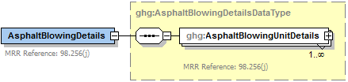

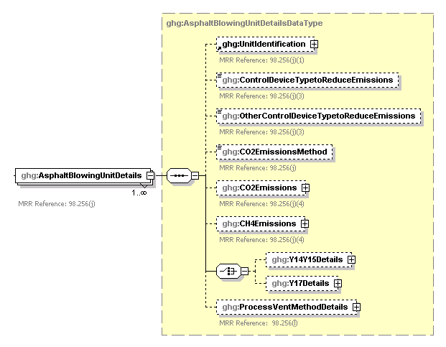

**One must be reported.**

**Conditionally**

**Required**

**Conditionally**

**Required**

**Note:** Data elements boxed in red are required. Please see page 4 of this document   
for more information on conditionally required elements.

.

Subpart Y requires you to report the following data about your asphalt blowing operations:

* A unique name or identifier, plus optional description for each asphalt blowing unit.
* The control device used to reduce methane (and other organic) emissions from the unit.
  + Vapor scrubber
  + Thermal oxidizer
  + Flare
  + Other (specify)
  + None
* The method used to calculate the CO2 emissions for your asphalt blowing operations.
  + Equations Y‑14 and Y‑15
  + Equations Y‑16a and Y‑17
  + Equations Y‑16b and Y‑17
  + Equation Y-19 (Process Vent)

**Note:** For uncontrolled asphalt blowing operations or for asphalt blowing operations controlled by vapor scrubbing, calculate CO2 and CH4 emissions using Equations Y‑14 and Y‑15, respectively. For asphalt blowing operations controlled by thermal oxidizer or flare, calculate CH4 emissions using Equation Y-17 and calculate CO2 emissions using either Equations Y‑16a or Equation Y-16b, provided these emissions are not already included in the flare emissions calculated elsewhere in the XML file.

* The calculated CO2 and CH4 annual emissions for each asphalt blower unit, expressed in metric tons.

1. Asphalt Blowing Unit Details Data Element Definitions

| **Data Element Name** | **Description** |
| --- | --- |
| **AsphaltBlowingDetails** | **Parent Element (Conditionally Required)** |
| **AsphaltBlowingUnitDetails** | **Parent Element** |
| UnitIdentification | A collection of data elements containing the identity of each asphalt blowing operations unit. Report a unique unit name (ID) in the child data element **UnitName**, an optional brief description in the child data element **UnitDescription** and the type of unit in the child data element **UnitType**. [98.256(j)(1)] Report the following unit type:   |  | | --- | | Asphalt Blowing Unit | |
| ControlDeviceTypetoReduceEmissions | The type of control device used to reduce methane (and other organic) emissions from the unit. Below is the list of allowable values. [98.256(j)(3)]  Vapor scrubber  Thermal oxidizer  Flare  Other (specify)  None |
| OtherControlDeviceTypetoReduceEmissions | **Conditionally Required:** Specify the type of control device used if not listed above. [98.256(j)(3)] |
| CO2EmissionsMethod | The method used to calculate the CO2 emissions for your asphalt blowing operations. [98.256(j)] Below is the list of allowable values.  Equation Y-14 and Y-15  Equation Y-16a and Y-17  Equation Y-16b and Y-17  Equation Y-19 (Process Vent) |
| CO2Emissions | The calculated CO2 annual emissions for each asphalt blowing unit. Report the value in the child data element **CalculatedValue**. Set the units of measure to “Metric Tons” in the attribute**massUOM**. [98.256(j)(4)] |
| CH4Emissions | The calculated CH4 annual emissions for each asphalt blowing unit. Report the value in the child data element **CalculatedValue**. Set the units of measure to “Metric Tons” in the attribute**massUOM**. [98.256(j)(4)] |

1. Example for Asphalt Blowing Unit Details

< <ghg:AsphaltBlowingDetails>

<ghg:AsphaltBlowingUnitDetails>

<ghg:UnitIdentification>

<ghg:UnitName>ABO-001</ghg:UnitName>

<ghg:UnitDescription>Bitumen blowing unit</ghg:UnitDescription>

<ghg:UnitType>Asphalt Blowing Unit</ghg:UnitType>

</ghg:UnitIdentification>

<ghg:ControlDeviceTypetoReduceEmissions>Vapor scrubber</ghg:ControlDeviceTypetoReduceEmissions>

<ghg:CO2EmissionsMethod>Equation Y-14 and Y-15</ghg:CO2EmissionsMethod>

<ghg:CO2Emissions massUOM="Metric Tons">

<ghg:CalculatedValue>3443.2</ghg:CalculatedValue>

</ghg:CO2Emissions>

<ghg:CH4Emissions massUOM="Metric Tons">

<ghg:CalculatedValue>786.89</ghg:CalculatedValue>

</ghg:CH4Emissions>

**Note:** The XML example above is presented here to demonstrate the concept of reporting emissions details for asphalt blowing units.

### Equation Y-14 and Y-15 Details

1. Equations Y-14 and Y-15 Details Schema Diagram

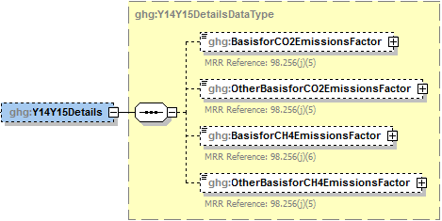

**Conditionally**

**Required**

**Conditionally**

**Required**

**Note:** Data elements boxed in red are required. Please see page 4 of this document   
for more information on conditionally required elements.

.

**Conditionally Required:** If you used Equation Y-14 and Y-15 to calculate CO2 and CH4 annual emissions for your asphalt blowing operation, then you must also report the basis for CO2 and CH4 emissions factors:

* Used default emission factor
* Weekly or more frequent measurements
* Periodic (less frequent than weekly) measurements
* Average of multiple source tests
* One‑time source test
* Other (specify)
* Used default emission factor

1. Equations Y-14 and Y-15 Details Data Element Definitions

| **Data Element Name** | **Description** |
| --- | --- |
| **Y14Y15Details** | **Parent Element (Conditionally Required)** |
| BasisforCO2EmissionsFactor | The basis for the CO2 emission factor used in Equation Y-14. [98.256(j)(5)] Below is the list of allowable values.   |  | | --- | | Weekly or more frequent measurements  Periodic (less frequent than weekly) measurements  Average of multiple source tests  One-time source test  Other (specify)  Used default emission factor | |
| OtherBasisforCO2EmissionsFactor | **Conditionally Required:** Specify the basis for the CO2 emission factor used in Equation Y-14 if not referenced above. [98.256(j)(5)] |
| BasisforCH4EmissionsFactor | The basis for the CH4 emission factor used in Equation Y-15. [98.256(j)(6)] Below is the list of allowable values.   |  | | --- | | Weekly or more frequent measurements  Periodic (less frequent than weekly) measurements  Average of multiple source tests  One-time source test  Other (specify)  Used default emission factor | |
| OtherBasisforCH4EmissionsFactor | **Conditionally Required:** Specify the basis for the CH4 emission factor used in Equation Y-15 if not referenced above. [98.256(j)(6)] |

1. Example for Equations Y-14 and Y-15 Details

< <ghg:Y14Y15Details>

<ghg:BasisforCO2EmissionsFactor>One-time source test</ghg:BasisforCO2EmissionsFactor>

<ghg:BasisforCH4EmissionsFactor>Other (specify)</ghg:BasisforCH4EmissionsFactor>

<ghg:OtherBasisforCH4EmissionsFactor> Daily measurements</ghg:OtherBasisforCH4EmissionsFactor>

</ghg:Y14Y15Details>

</ghg:AsphaltBlowingUnitDetails>

</ghg:AsphaltBlowingDetails>

**Note:** The XML example above is presented here to demonstrate the concept of reporting the basis for CO2 and CH4 emission factors used in Equations Y-14 and Y-15.

### Equation Y-17 Details

1. Equation Y-17 Details Schema Diagram

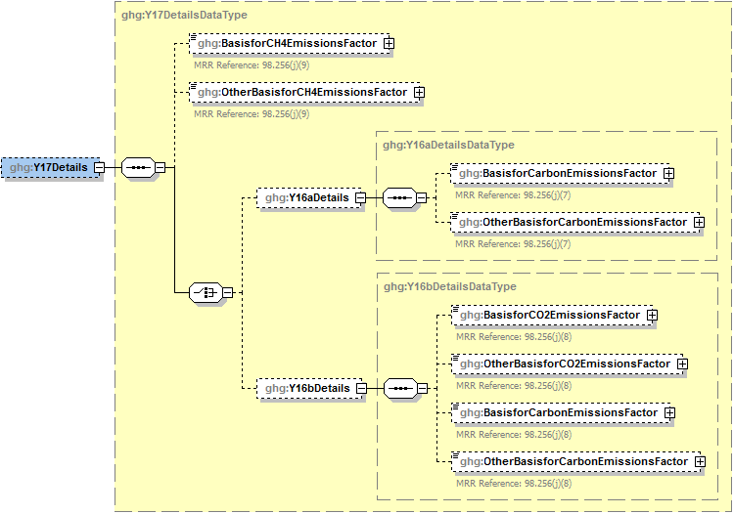

**Conditionally**

**Required**

**Conditionally**

**Required**

**Conditionally**

**Required**

**Conditionally**

**Required**

**Report only one of these methods**

**Note:** Data elements boxed in red are required. Please see page 4 of this document   
 for more information on conditionally required elements.

**Conditionally Required:** If you used Equation Y-17 and Equation Y-16a or Y-16b to calculate the CO2 and CH4 annual emissions for your asphalt blowing operation, then you must also report the basis for the emissions factors used:

* Weekly or more frequent measurements
* Periodic (less frequent than weekly) measurements
* Average of multiple source tests
* One‑time source test
* Other (specify)
* Used default emission factor

1. Equation Y-17 Details Data Element Definitions

| **Data Element Name** | **Description** |
| --- | --- |
| **Y17Details** | **Parent Element (Conditionally Required)** |
| BasisforCH4EmissionsFactor | For each controlled asphalt blowing unit using Equation 17, the basis for the CH4 emissions factor used in Equation Y-17. [98.256(j)(9)] Below is the list of allowable values.   |  | | --- | | Weekly or more frequent measurements  Periodic (less frequent than weekly) measurements  Average of multiple source tests  One-time source test  Other (specify)  Used default emission factor | |
| OtherBasisforCH4EmissionsFactor | **Conditionally Required:** Specify the basis for the CH4 emissions factor used in Equation Y-17 if not referenced above. [98.256(j)(9)] |
| **Y16aDetails** | **Parent Element (Conditionally Required)** |
| BasisforCarbonEmissionsFactor | For each controlled asphalt blowing unit using Equation 16a, the basis for the carbon emissions factor used in Equation Y-16a. [98.256(j)(7)] Below is the list of allowable values.   |  | | --- | | Weekly or more frequent measurements  Periodic (less frequent than weekly) measurements  Average of multiple source tests  One-time source test  Other (specify)  Used default emission factor | |
| OtherBasisforCarbonEmissionsFactor | **Conditionally Required:** Specify the basis for the carbon emissions factor used in Equation Y-16a if not referenced above. [98.256(j)(7)] |
| **Y16bDetails** | **Parent Element (Conditionally Required)** |
| BasisforCO2EmissionsFactor | For each controlled asphalt blowing unit using Equation 16b, the basis for the CO2 emissions factor used in Equation Y-16b. [98.256(j)(8)]. Below is the list of allowable values.   |  | | --- | | Weekly or more frequent measurements  Periodic (less frequent than weekly) measurements  Average of multiple source tests  One-time source test  Other (specify)  Used default emission factor | |
| OtherBasisforCO2EmissionsFactor | **Conditionally Required:** Specify the basis for the CO2 emissions factor used in Equation Y‑16b if not referenced above. [98.256(j)(8)] |
| BasisforCarbonEmissionsFactor | For each controlled asphalt blowing unit using Equation 16b, the basis for the carbon emission factor used in Equation Y-16b. [98.256(j)(8)] Below is the list of allowable values.   |  | | --- | | Weekly or more frequent measurements  Periodic (less frequent than weekly) measurements  Average of multiple source tests  One-time source test  Other (specify)  Used default emission factor | |
| OtherBasisforCarbonEmissionsFactor | **Conditionally Required:** Specify the basis for the carbon emissions factor used in Equation Y-16b if not referenced above. [98.256(j)(8)] |

1. Example for Equation Y-17 and Y-16a Details

<ghg:Y17Details>

<ghg:BasisforCH4EmissionsFactor>Periodic (less frequent than weekly) measurements</ghg:BasisforCH4EmissionsFactor>

<ghg:Y16aDetails>

<ghg:BasisforCarbonEmissionsFactor>Other (specify)</ghg:BasisforCarbonEmissionsFactor>

<ghg:OtherBasisforCarbonEmissionsFactor>Bi-weekly measurements</ghg:OtherBasisforCarbonEmissionsFactor>

</ghg:Y16aDetails>

</ghg:Y17Details>

</ghg:AsphaltBlowingUnitDetails>

</ghg:AsphaltBlowingDetails>

**Note:** The XML example above is presented here to demonstrate the concept of reporting the basis for CH4 and carbon emission factors used in Equations Y-17 and Y-16a.

1. Example for Equation Y-17 and Y-16b Details

<ghg:Y17Details>

<ghg:BasisforCH4EmissionsFactor>Periodic (less frequent than weekly) measurements</ghg:BasisforCH4EmissionsFactor>

<ghg:Y16bDetails>

<ghg:BasisforCO2EmissionsFactor>Average or multiple source tests</ghg:BasisforCO2EmissionsFactor>

<ghg:BasisforCarbonEmissionsFactor>Weekly or more frequent measurements</ghg:BasisforCarbonEmissionsFactor>

</ghg:Y16bDetails>

</ghg:Y17Details>

</ghg:AsphaltBlowingUnitDetails>

</ghg:AsphaltBlowingDetails>

**Note:** The XML example above is presented here to demonstrate the concept of reporting the basis for CH4,CO2, and carbon emission factors used in Equations Y-17 and Y-16b.

### Equation Y-19 Process Vent Method Details

1. Equation Y-19 Process Vent Method Details Schema Diagram



**Conditionally**

**Required**

**Conditionally**

**Required**

**Conditionally**

**Required**

**Note:** Data elements boxed in red are required. Please see page 4 of this document   
for more information on conditionally required elements.

**Conditionally Required:** If Equation Y-19 Process Vent method was used to calculate CO2 emissions, then report the following:

* Annual volumetric flow discharged to the atmosphere (scf).
* Method used to measure or estimate the annual volumetric flow rate.
  + Continuous or at least hourly measurements
  + Routine (less frequent than hourly but at least weekly) measurements
  + Periodic (less frequent than weekly) measurements
  + Process knowledge
  + Engineering calculation
  + Other (specify)
* **Conditionally Required:** Number of venting events, if vent is intermittent.
* **Conditionally Required:** Cumulative venting time, if vent is intermittent (hours).
* CO2 and CH4 mole fraction details. (See Mole Fraction Details Schema Diagram.)

1. Process Vent Method Details Data Element Definitions

| **Data Element Name** | **Description** |
| --- | --- |
| **ProcessVentMethodDetails** | **Parent Element (Conditionally Required)** |
| CumulativeAnnualVolumeFlowDischarged | The cumulative annual volumetric flow discharged to the atmosphere. Report the value in the child data element **MeasureValue**. Set the units of measure to “scf” in the attribute **volUOM**. [98.256(l)(5)] |
| CumulativeAnnualVolumeFlowDischargedMethod | The method used to measure or estimate the annual volumetric flow discharged to the atmosphere. Below is the list of allowable values. [98.256(l)(5)]  Continuous or at least hourly measurements  Routine (less frequent than hourly but at least weekly) measurements  Periodic (less frequent than weekly) measurements  Process knowledge  Engineering calculation  Other (specify) |
| OtherAnnualVolumeMetricFlowMethodList | **Conditionally Required:** Specify the method used to measure or estimate the annual volumetric flow discharged to the atmosphere if not listed above. [98.256(l)(5)] |
| CumulativeNumberVentingEvents | **Conditionally Required:** The number of cumulative venting events for all relevant vents, if vents are intermittent (not applicable for continuous venting). Report the integer value in the child data element **MeasureValue**. [98.256(l)(5)] |
| CumulativeVentingTime | **Conditionally Required:** The cumulative venting time in hours for all intermittent vents. Set the units of measure to “Hours” in the attribute **timeUOM**. [98.256(l)(5)] |

1. Example for Process Vent Method Details

<ghg:ProcessVentMethodDetails>

<ghg:CumulativeAnnualVolumeFlowDischarged volUOM="scf">

<ghg:MeasureValue>123</ghg:MeasureValue>

</ghg:CumulativeAnnualVolumeFlowDischarged>

<ghg:CumulativeAnnualVolumeFlowDischargedMethod>Process knowledge</ghg:CumulativeAnnualVolumeFlowDischargedMethod>

<ghg:CumulativeNumberVentingEvents>

<ghg:MeasureValue>25</ghg:MeasureValue>

</ghg:CumulativeNumberVentingEvents>

<ghg:CumulativeVentingTime timeUOM="Hours">187</ghg:CumulativeVentingTime>

**Note:** The XML example above is presented here to demonstrate the concept of reporting details for the process vent method if used to calculate CO2 emissions for the asphalt blowing unit.

1. Mole Fraction Details Schema Diagram



**Conditionally**

**Required**

**Conditionally**

**Required**

**Note:** Data elements boxed in red are required. Please see page 4 of this document   
for more information on conditionally required elements.

If Equation Y-19 Process Vent method was used to calculate emissions, then report the following:

* Annual average mole fraction of CO2.
* Method used to measure or estimate the annual average mole fraction of CO2.
  + Engineering estimates/process knowledge
  + Direct measurement
  + Other (specify)
* Annual average mole fraction of CH4.
* Method used to measure or estimate the annual average mole fraction of CH4.
  + Engineering estimates/process knowledge
  + Direct measurement
  + Other (specify)

1. Mole Fraction Details Data Element Definitions

| **Data Element Name** | **Description** |
| --- | --- |
| **MoleFractionDetails** | **Parent Element** |
| CO2AnnualAverageMoleFraction | Report the annual average mole fraction of CO2. Report the value in the child data element **MeasureValue**. Set the units of measure to “fraction (number between 0 and 1)” in the attribute **fractionUOM**. [98.256(l)(5)] |
| CO2AnnualAverageMoleFractionMethod | Report the method used to measure or estimate the mole fraction of CO2. [98.256(l)(5)] Below is the list of allowable values.   |  | | --- | | Engineering estimates/process knowledge  Direct measurement  Other (specify) | |
| OtherCO2AnnualAverageMoleFractionMethod | **Conditionally Required:** Specify the method used to measure or estimate the mole fraction of CO2 if not referenced above. [98.256(l)(5)] |
| CH4AnnualAverageMoleFraction | Report the annual average mole fraction of CH4. Report the value in the child data element **MeasureValue**. Set the units of measure to “fraction (number between 0 and 1)” in the attribute **fractionUOM**. [98.256(l)(5)] |
| CH4AnnualAverageMoleFractionMethod | Report the method used to measure or estimate the mole fraction of CH4. [98.256(l)(5)] Below is the list of allowable values.   |  | | --- | | Engineering estimates/process knowledge  Direct measurement  Other (specify) | |
| OtherCH4AnnualAverageMoleFractionMethod | **Conditionally Required:** Specify the method used to measure or estimate the mole fraction of CH4 if not referenced above. [98.256(l)(5)] |

1. Example for Mole Fraction Details

<ghg:MoleFractionDetails>

<ghg:CO2AnnualAverageMoleFraction fractionUOM="fraction (number between 0 and 1)">

<ghg:MeasureValue>0.5</ghg:MeasureValue>

</ghg:CO2AnnualAverageMoleFraction>

<ghg:CO2AnnualAverageMoleFractionMethod>Direct

measurement</ghg:CO2AnnualAverageMoleFractionMethod>

<ghg:CH4AnnualAverageMoleFraction fractionUOM="fraction (number between 0 and 1)">

<ghg:MeasureValue>0.25</ghg:MeasureValue>

</ghg:CH4AnnualAverageMoleFraction>

<ghg:CH4AnnualAverageMoleFractionMethod>Engineering estimates/process

knowledge</ghg:CH4AnnualAverageMoleFractionMethod>

</ghg:MoleFractionDetails>

</ghg:ProcessVentMethodDetails>

</ghg:AsphaltBlowingUnitDetails>

</ghg:AsphaltBlowingDetails>

**Note:** The XML example above is presented here to demonstrate the concept of reporting CO2 and CH4 mole fraction details.

## Delayed Coking Emissions Summary

### Subpart Level Delayed Coking Details

**Required Subpart-Level Summary Data**

For petroleum refinery sources required to report under Subpart Y, you are required to report the cumulative methane (CH4) emissions for all delayed coking units at the facility. You must also report the total number of delayed coking units and the total number of delayed coking drums at the facility and details about each coking drum set at the facility, including the number of coking drums in the set, the basis for the volumetric void fraction of the coke vessel prior to steaming and the basis for the mole fraction of CH4 in the coking gas.

1. Delayed Coking Details (Subpart‑Level) Schema Diagram

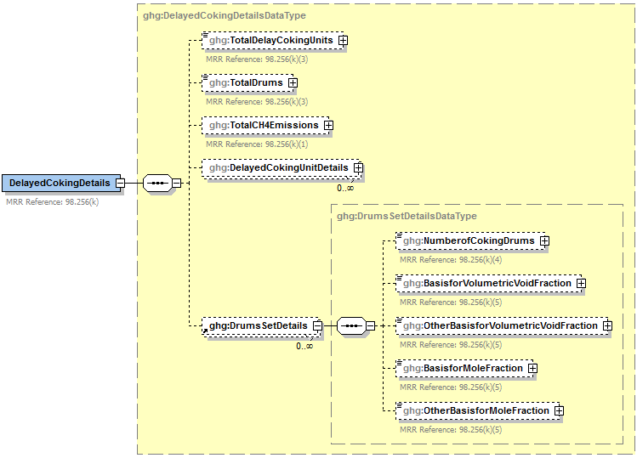

**Conditionally**

**Required**

**Conditionally**

**Required**

**Note:** Data elements boxed in red are required. Please see page 4 of this document   
 for more information on conditionally required elements.

1. Delayed Coking Details (Subpart‑Level) Data Element Definitions

| **Data Element Name** | **Description** |
| --- | --- |
| **DelayedCokingDetails** | **Parent Element** |
| TotalDelayCokingUnits | The total number of delayed coking units at the facility (integer) [98.256(k)(3)] |
| TotalDrums | The total number of delayed coking drums at the facility (integer) [98.256(k)(3)] |
| TotalCH4Emissions | The cumulative annual CH4 emissions in metric tons for all delayed coking units at the facility. Report the value in the child data element **MeasureValue**. Set the units of measure to “Metric Tons” in the attribute **massUOM**. [98.256(k)(1)] |

1. Example for Delayed Coking Details (Subpart‑Level)

<ghg:DelayedCokingDetails>

<ghg:TotalDelayCokingUnits>10</ghg:TotalDelayCokingUnits>

<ghg:TotalDrums>28</ghg:TotalDrums>

<ghg:TotalCH4Emissions massUOM="Metric Tons">

<ghg:MeasureValue>234.45</ghg:MeasureValue>

</ghg:TotalCH4Emissions>

**Note:** The XML example above is presented here to demonstrate the concept of reporting the cumulative CH4 emissions for all delayed coking units at the facility.

### Delayed Coking Unit Details

**Conditionally Required Unit-Level Data**

The instructions provided below are for unit‑level data reporting.

1. Delayed Coking Details (Unit‑Level) Schema Diagram

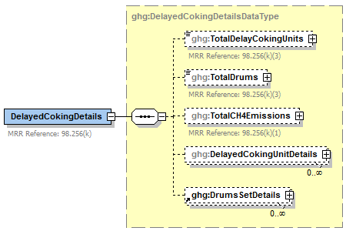

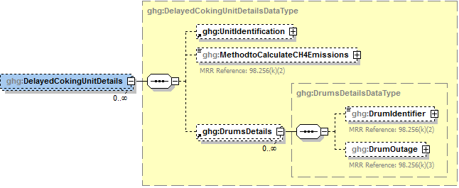

**Note:** Data elements boxed in red are required. Please see page 4 of this document   
for more information on conditionally required elements.

Subpart Y requires you to report the following data about each delayed coking unit:

* A unique name or identifier, plus an optional description for your delayed coking unit.
* The method used to calculate the CH4 annual emissions for your delayed coking unit.

**Note:** If the method used to calculate CH4 annual emissions is “Equation Y-18 and Y-19 - 98.253(i)(1)”, you must also add the process vent associated with this delayed coking unit in the Process Vent section (see Section 8.0). The emissions that you report for the process vent unit should be zero, because those emissions should be included in the facility-level emissions reported for delayed coking units. Be sure to report "Delayed coking" for the data element “OperationType”.

* Details about the drums used for each delayed coking unit.

1. Delayed Coking Unit Details Data Element Definitions

| **Data Element Name** | **Description** |
| --- | --- |
| **DelayedCokingUnitDetails** | **Parent Element** |
| UnitIdentification | A collection of data elements containing the identity of each delayed coking unit. Report a unique unit name (ID) in the child data element **UnitName**, an optional brief description in the child data element **UnitDescription** and the type of unit in the child data element **UnitType**. [98.256(k)] Report the following unit type:   |  | | --- | | Delayed Coking Unit | |
| MethodtoCalculateCH4Emissions | Method used to calculate the CH4 annual emissions for each delayed coking unit. [98.256(k)(2)] Below is the list of allowable values.   |  | | --- | | Equation Y-18 and Y-19 - 98.253(i)(1) Equation Y-18 - 98.253(i)(2) | |
| **DrumsDetails** | **Parent Element** |
| DrumIdentifier | For each delayed coking unit, a unique identifier/description for each coke drum. [98.256(k)] |
| DrumOutage | For the specified coke drum, the typical drum outage (i.e. the unfilled distance from the top of the drum). Report the value in the child data element **MeasureValue**. Set the units of measure to “Feet” in the attribute **heightUOM**. [98.256(k)(3)] |

1. Example for Delayed Coking Unit Details

<

<ghg:DelayedCokingUnitDetails>

<ghg:UnitIdentification>

<ghg:UnitName>DC-001</ghg:UnitName>

<ghg:UnitDescription>This is a test unit. </ghg:UnitDescription>

<ghg:UnitType>Delayed Coking Unit</ghg:UnitType>

</ghg:UnitIdentification>

<ghg:MethodtoCalculateCH4Emissions> Equation Y-18 and Y-19 - 98.253(i)(1) </ghg:MethodtoCalculateCH4Emissions>

<ghg:DrumsDetails>

<ghg:DrumIdentifier>DRUM-001</ghg:DrumIdentifier>

<ghg:DrumOutage heightUOM="Feet">

<ghg:MeasureValue>35</ghg:MeasureValue>

</ghg:DrumOutage>

</ghg:DrumsDetails>

</ghg:DelayedCokingUnitDetails>

**Note:** The XML example above is presented here to demonstrate the concept of reporting details about the delayed coking unit.

### Coking Drums Set Details

1. Delayed Coking Drum Set Details Schema Diagram

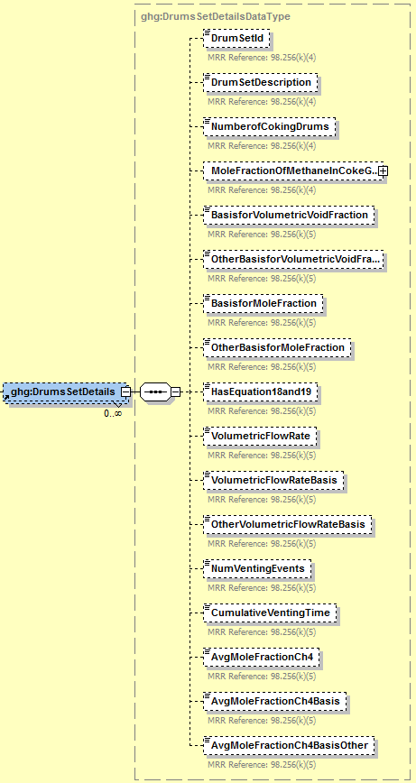

* **Conditionally**

**Required**

* **Conditionally**

**Required**

* **Conditionally**

**Required**

* **Conditionally**

**Required**

**Required Subpart-Level Summary Data**

For each set of coking drum dimensions, the facility must report the following:

* The number of coking drums in the set
* The basis for volumetric void fraction of the coke vessel prior to steaming
* The basis for the mole fraction of methane in the coking gas

1. Coking Drums Set Details Data Element Definitions

|  |  |
| --- | --- |
| **Data Element Name** | **Description** |
| **DrumsSetDetails** | **Parent Element (Conditionally Required)** |
| DrumSetID | Unique identified for each set of coking drums which must match the ID provided in the IVT inputs file. |
| DrumSetDescription | An optional brief description of each coking drum set, DrumSetID. |
| NumberofCokingDrums | For each set of coking drum dimensions (the combination of height and diameter), report the number of coking drums in the set. [98.256(k)(4)] |
| MoleFractionOfMethaneinCokeGas | For each set of coking drum dimensions report the mole fraction of methane in the coke gas.[98.256(k)(4)] |
| BasisforVolumetricVoidFraction | For each set of coking drum dimensions, specify the basis for the volumetric void fraction of the coke vessel prior to steaming. [98.256(k)(5)] Below is the list of allowable values.  Measurement data  Engineering calculation  Default value  Other (specify) |
| OtherBasisforVolumetricVoidFraction | **Conditionally Required:** Specify the basis for the volumetric void fraction of the coke vessel prior to steaming if not listed above. |
| BasisforMoleFraction | For each set of coking drum dimensions, specify the basis for the mole fraction of methane in the coking gas. [98.256(k)(5)] Below is the list of allowable values.  Weekly or more frequent measurements   Periodic (less frequent than weekly) measurements   Average of multiple source tests   One‑time source test   Engineering calculation   Default value   Other (specify) |
| OtherBasisforMoleFraction | **Conditionally Required:** Specify the basis for the mole fraction of methane in the coking gas if not listed above. |
| HasEquation18and19 | Specify “Y” is Equation 19 and 19 are used as the basis or “N” otherwise. |
| VolumetricFlowRate | Annual volumetric flow discharged to the atmosphere. Below is the list of allowable values.  Weekly or more frequent measurements   Periodic (less frequent than weekly) measurements   Average of multiple source tests   One‑time source test   Engineering calculation   Default value   Other (specify) |
| VolumetricFlowRateBasis | Basis for the volumetric void fraction of the coke vessel prior to steaming. Below is the list of allowable values.  Measurement data  Engineering calculation  Default value  Other (specify) |
| OtherVolumetricFlowRateBasis | **Conditionally Required:** Specify other basis |
| NumVentingEvents | Number of venting events, if vent is intermittent (not applicable for continuous venting) |
| CumulativeVentingTime | Cumulative venting time in hours. Reported as a decimal. |
| AvgMoleFractionCh4 | Annual average mole fraction of CH4 in vent gas |
| AvgMoleFractionCh4Basis | Method used to measure or estimate the mole fraction of CH4 in vent gas. Below is the list of allowable values.  Engineering estimates/process knowledge  Direct measurement  Other (specify) |
| AvgMoleFractionCh4BasisOther | **Conditionally Required:** Specify other basis |

1. Example for Coking Drums Set Details

</ghg:DelayedCokingDetails>

<ghg:DrumsSetDetails>

<ghg:DrumSetId>Drum Set 1A>/ghg:DrumSetId>

<ghg:DrumSetDescription>Optional description of drum Set 1A>/ghg:DrumSetDescription>

<ghg:NumberofCokingDrums>5>/ghg:NumberofCokingDrums>

<ghg:MoleFractionOfMethaneInCokeGas fractionUOM="kg-mole CH4/kg-molegas">

<ghg:MeasureValue>0.2>/ghg:MeasureValue>

<ghg:/MoleFractionOfMethaneInCokeGas>

<ghg:BasisforVolumetricVoidFraction>Measurement data>/ghg:BasisforVolumetricVoidFraction>

<ghg:BasisforMoleFraction>Weekly or more frequent measurements>/ghg:BasisforMoleFraction>

<ghg:HasEquation18and19>Y>/ghg:HasEquation18and19>

<ghg:VolumetricFlowRate>2000>/ghg:VolumetricFlowRate>

<ghg:VolumetricFlowRateBasis>Continuous or at least hourly measurements>/ghg:VolumetricFlowRateBasis>

<ghg:CumulativeVentingTime>8564.1>/ghg:CumulativeVentingTime>

<ghg:AvgMoleFractionCh4>0.15>/ghg:AvgMoleFractionCh4>

</ghg:DrumsSetDetails>

</ghg:DelayedCokingDetails>

**Note:** The XML example above is presented here to demonstrate the concept of reporting coking drums set details.

## Process Vents Unit Information

**Conditionally Required Unit-Level Data**

This topic provides a step‑by‑step description of how to enter Subpart Y Process Vents unit information about your facility. You must report CO2, CH4 and N2O emissions from each process vent not specifically included in sections 98.252(a) through 98.252(g).

1. Process Vents Details (Unit‑Level) Schema Diagram

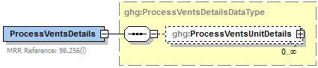

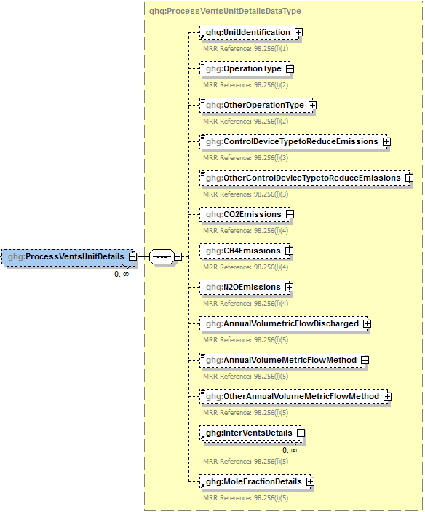

**Conditionally**

**Required**

**Conditionally**

**Required**

**Conditionally**

**Required**

**Conditionally**

**Required**

**Note:** Data elements boxed in red are required. Please see page 4 of this document   
 for more information on conditionally required elements.

Subpart Y collects the following data about each Process Vent meeting the criteria described in 98.253(j):

* A unique name or identifier, plus optional description for the process vent unit. See also [About Unique Unit Names](http://www.ccdsupport.com/confluence/display/help/About+Unique+Unit+Names).
* Operation type associated with the process vent.
* Control device used to reduce methane (and other organic) emissions from the unit. If not applicable, report “None”.
  + Thermal or catalytic incinerator/oxidizer
  + Carbon adsorber
  + Condenser
  + Oil scrubber
  + None
  + Other (specify)
* **Conditionally Required:** The calculated annual CO2, CH4 and N2O emissions for the process vent, expressed in metric tons of each pollutant emitted. Use Equation Y‑19 to calculate values for each of these GHGs. CO2 emissions must be reported if the process vent contains 2 percent by volume CO2 or greater. CH4 emissions must be reported if the process vent contains 0.5 percent by volume of CH4 or greater. N2O emissions must be reported if the process vent contains 0.01 percent by volume of N2O or greater.
* Annual volumetric flow discharged to the atmosphere (scf).
* Method used to measure or estimate the annual volumetric flow rate. Select from:
  + Continuous or at least hourly measurements
  + Routine (less frequent than hourly but at least weekly) measurements
  + Periodic (less frequent than weekly) measurements
  + Process knowledge
  + Engineering calculation
  + Other (specify)

1. Process Vents Unit Details Data Element Definitions

| **Data Element Name** | **Description** |
| --- | --- |
| **ProcessVentsDetails** | **Parent Element (Conditionally Required)** |
| **ProcessVentsUnitDetails** | **Parent Element** |
| UnitIdentification | A collection of data elements containing the identity of each process vent meeting the criteria described in 98.253(j). Report a unique unit name (ID) in the child data element **UnitName**, an optional brief description in the child data element **UnitDescription** and the type of unit in the child data element **UnitType**. [98.256(l)(1)] Report the following unit type:   |  | | --- | | ProcessVent | |
| OperationType | The type of operation associated with the process vent’s emissions. [98.256(l)(2)] Below is the list of allowable values.  Atmospheric crude distillation  Vacuum distillation  Delayed coking  Fluid coking (traditional)  Flexicoking  Visbreaking, other thermal cracking  Fluid catalytic cracking unit  Non-fluid catalytic cracking unit  Catalytic hydrocracking  Catalytic reforming unit - continuous regeneration  Catalytic reforming unit - cyclic regeneration  Catalytic reforming unit - semi-regenerative  Fuels solvent deasphalting  Desulfurization/ hydrotreat - naphtha/reformer feed  Desulfurization/ hydrotreat - gasoline  Desulfurization/ hydrotreat - kerosene/jet fuel  Desulfurization/ hydrotreat - diesel  Desulfurization/ hydrotreat - other distillate  Desulfurization/ hydrotreat - residual  Desulfurization/ hydrotreat - heavy gas oil  Desulfurization/ hydrotreat - other  HF alkylation  H2SO4 alkylation  Aromatics production  Asphalt production  Isomerization - Isobutane  Isomerization - Iso C5,C6  Lubricants production  Petroleum coke storage  Sulfur plant  Gas plant (LPG production unit)  Oxygenate plant - MTBE  Oxygenate plant - ETBE  Oxygenate plant - TAME  Oxygenate plant - other (specify)  Marine vessel loading/unloading  Truck/tank truck loading/unloading  Rail car loading/unloading  Blow down system  Knock-out pot  Analyzer  Vacuum jet exhaust  Wastewater treatment unit  Wastewater collection system (drain, junction box, etc.)  Soil remediation  Other |
| OtherOperationType | **Conditionally Required:** Specify the type of operation associated with the emissions if not referenced above. [98.256(l)(2)] |
| ControlDeviceTypetoReduceEmissions | The type of control device used to reduce methane (and other organic) emissions from the unit. If not applicable, report “None”. [98.256(l)(3)] Below is the list of allowable values.   |  | | --- | | Thermal or catalytic incinerator/oxidizer  Carbon adsorber  Condenser  Oil scrubber  None  Other (specify) | |
| OtherControlDeviceTypetoReduceEmissions | **Conditionally Required:** Specify the type of control device used to reduce methane (and other organic) emissions from the unit if not referenced above. [98.256(l)(3)] |
| CO2Emissions | **Conditionally Required:** If the process vent contains 2 percent by volume CO2 or greater, report the calculated annual CO2 emissions for the vent. Report the value in the child data element **CalculatedValue**. Set the units of measure to “Metric Tons” in the attribute**massUOM**. [98.256(l)(4)] |
| CH4Emissions | **Conditionally Required:** If the process vent contains 0.5 percent by volume CH4 or greater, report the calculated annual CH4 emissions for the vent. Report the value in the child data element **CalculatedValue**. Set the units of measure to “Metric Tons” in the attribute**massUOM**. [98.256(l)(4)] |
| N2OEmissions | **Conditionally Required:** If the process vent contains 0.01 percent by volume N2O or greater, report the calculated annual N2O emissions for the vent. Report the value in the child data element **CalculatedValue**. Set the units of measure to “Metric Tons” in the attribute**massUOM**. [98.256(l)(4)] |
| AnnualVolumetricFlowDischarged | The annual volumetric flow discharged to the atmosphere. Report the value in the child data element **MeasureValue**. Set the units of measure to “scf” in the attribute **rateUOM**. [98.256(l)(5)] |
| AnnualVolumeMetricFlowMethod | The method used to measure or estimate the annual volumetric flow rate. [98.256(l)(5)] Below is the list of allowable values.   |  | | --- | | Continuous or at least hourly measurements  Routine (less frequent than hourly but at least weekly) measurements  Periodic (less frequent than weekly) measurements  Process knowledge  Engineering calculation  Other (specify) | |
| OtherAnnualVolumeMetricFlowMethod | **Conditionally Required:** Specify the method used to measure or estimate the annual volumetric flow rate if not referenced above. [98.256(l)(5)] |

1. Example for Process Vents Unit Details

<ghg:ProcessVentsDetails>

<ghg:ProcessVentsUnitDetails>

<ghg:UnitIdentification>

<ghg:UnitName>PV-001</ghg:UnitName>

<ghg:UnitType>Process Vent</ghg:UnitType>

</ghg:UnitIdentification>

<ghg:OperationType>Petroleum coke storage</ghg:OperationType>

<ghg:ControlDeviceTypetoReduceEmissions>Thermal or catalytic

incinerator/oxidizer</ghg:ControlDeviceTypetoReduceEmissions>

<ghg:CO2Emissions massUOM="Metric Tons">

<ghg:CalculatedValue>3242.2</ghg:CalculatedValue>

</ghg:CO2Emissions>

<ghg:CH4Emissions massUOM="Metric Tons">

<ghg:CalculatedValue>1004.34</ghg:CalculatedValue>

</ghg:CH4Emissions>

<ghg:N2OEmissions massUOM="Metric Tons">

<ghg:CalculatedValue>235.234</ghg:CalculatedValue>

</ghg:N2OEmissions>

<ghg:AnnualVolumetricFlowDischarged rateUOM="scf">

<ghg:MeasureValue>3444.23442</ghg:MeasureValue>

</ghg:AnnualVolumetricFlowDischarged>

<ghg:AnnualVolumeMetricFlowMethod>Continuous or at least hourly measurements</ghg:AnnualVolumeMetricFlowMethod>

**Note:** The XML example above is presented here to demonstrate the concept of reporting details about a process vents unit.

1. Intermittent Vents Details Schema Diagram

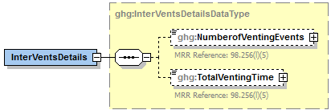

**Note:** Data elements boxed in red are required.

**Conditionally Required:** Subpart Y collects the following data for each intermittent Process Vent (not applicable for continuous venting):

* The number of venting events
* Cumulative venting time (hours)

1. Intermittent Vents Details Data Element Definitions

| **Data Element Name** | **Description** |
| --- | --- |
| **InterVentsDetails** | **Parent Element (Conditionally Required)** |
| NumberofVentingEvents | The number of venting events (integer). [98.256(l)(5)] |
| TotalVentingTime | The cumulative venting time. Set the units of measure to “Hours” in the attribute **timeUOM** expressed as a decimal. [98.256(l)(5)] |

1. Example for Intermittent Vents Details

<

<ghg:InterVentsDetails>

  <ghg:NumberofVentingEvents>3</ghg:NumberofVentingEvents>

  <ghg:TotalVentingTime timeUOM="Hours">40</ghg:TotalVentingTime>

</ghg:InterVentsDetails>

**Note:** The XML example above is presented here to demonstrate the concept of reporting the details of the intermittent vents.

1. Mole Fraction Details Schema Diagram



**Required if**

**N2O reported**

**Conditionally**

**Required**

**Conditionally**

**Required**

**Conditionally**

**Required**

**Required if**

**CH4 reported**

**Required if**

**CO2 reported**

**Note:** Data elements boxed in red are required. Please see page 4 of this document   
 for more information on conditionally required elements.

**Conditionally Required:** Subpart Y collects the following data if CO2 is being reported for this Process Vent:

* Annual average mole fraction of CO2.
* Method used to measure or estimate the annual average mole fraction of CO2.
  + Engineering estimates/process knowledge
  + Direct measurement
  + Other (specify)

**Conditionally Required:** Subpart Y collects the following data if CH4 is being reported for this Process Vent:

* Annual average mole fraction of CH4.
* Method used to measure or estimate the annual average mole fraction of CH4.
  + Engineering estimates/process knowledge
  + Direct measurement
  + Other (specify)

**Conditionally Required:** Subpart Y collects the following data if N2O is being reported for this Process Vent:

* Annual average mole fraction of N2O.
* Method used to measure or estimate the annual average mole fraction of N2O.
  + Engineering estimates/process knowledge
  + Direct measurement
  + Other (specify)

1. Mole Fraction Details Data Element Definitions

| **Data Element Name** | **Description** |
| --- | --- |
| **MoleFractionDetails** | **Parent Element** |
| CO2AnnualAverageMoleFraction | **Conditionally Required:** If CO2 was reported for the unit, report the annual average mole fraction of CO2. Report the value in the child data element **MeasureValue**. Set the units of measure to “fraction (number between 0 and 1)” in the attribute **fractionUOM**. [98.256(l)(5)] |
| CO2AnnualAverageMoleFractionMethod | **Conditionally Required:** If CO2 was reported for the unit, report the method used to measure or estimate the CO2 mole fraction. [98.256(l)(5)] Below is the list of allowable values.   |  | | --- | | Engineering estimates/process knowledge  Direct measurement  Other (specify) | |
| OtherCO2AnnualAverageMoleFractionMethod | **Conditionally Required:** Specify the method used to measure or estimate the CO2 mole fraction if not referenced above. [98.256(l)(5)] |
| CH4AnnualAverageMoleFraction | **Conditionally Required:** If CH4 was reported for the unit, report the annual average mole fraction of CH4. Report the value in the child data element **MeasureValue**. Set the units of measure to “fraction (number between 0 and 1)” in the attribute **fractionUOM**. [98.256(l)(5)] |
| CH4AnnualAverageMoleFractionMethod | **Conditionally Required:** If CH4 was reported for the unit, report the method used to measure or estimate the CH4 mole fraction. [98.256(l)(5)] Below is the list of allowable values.   |  | | --- | | Engineering estimates/process knowledge  Direct measurement  Other (specify) | |
| OtherCH4AnnualAverageMoleFractionMethod | **Conditionally Required:** Specify the method used to measure or estimate the CH4 mole fraction if not referenced above. [98.256(l)(5)] |
| N2OAnnualAverageMoleFraction | **Conditionally Required:** If N2O was reported for the unit, report the annual average mole fraction of N2O. Report the value in the child data element **MeasureValue**. Set the units of measure to “fraction (number between 0 and 1)” in the attribute **fractionUOM**. [98.256(l)(5)] |
| N2OAnnualAverageMoleFractionMethod | **Conditionally Required:** If N2O was reported for the unit, report the method used to measure or estimate the N2O mole fraction. [98.256(l)(5)] Below is the list of allowable values.   |  | | --- | | Engineering estimates/process knowledge  Direct measurement  Other (specify) | |
| OtherN2OAnnualAverageMoleFractionMethod | **Conditionally Required:** Specify the method used to measure or estimate the N2O mole fraction if not referenced above. [98.256(l)(5)] |

1. Example for Mole Fraction Details

<ghg:MoleFractionDetails>

<ghg:CO2AnnualAverageMoleFraction fractionUOM="fraction (number between 0 and 1)">

<ghg:MeasureValue>0.5</ghg:MeasureValue>

</ghg:CO2AnnualAverageMoleFraction>

<ghg:CO2AnnualAverageMoleFractionMethod>Direct measurement</ghg:CO2AnnualAverageMoleFractionMethod>

<ghg:CH4AnnualAverageMoleFraction fractionUOM="fraction (number between 0 and 1)">

<ghg:MeasureValue>0.33</ghg:MeasureValue>

</ghg:CH4AnnualAverageMoleFraction>

<ghg:CH4AnnualAverageMoleFractionMethod> Direct measurement</ghg:CH4AnnualAverageMoleFractionMethod>

<ghg:N2OAnnualAverageMoleFraction fractionUOM="fraction (number between 0 and 1)">

<ghg:MeasureValue>0.75</ghg:MeasureValue>

</ghg:N2OAnnualAverageMoleFraction>

<ghg:N2OAnnualAverageMoleFractionMethod>Other (specify)</ghg:N2OAnnualAverageMoleFractionMethod>

<ghg:OtherN2OAnnualAverageMoleFractionMethod>test method 2</ghg:OtherN2OAnnualAverageMoleFractionMethod>

</ghg:MoleFractionDetails>

**Note:** The XML example above is presented here to demonstrate the concept of reporting the CO2, CH4 and N2O mole fraction details.

## Uncontrolled Blowdown Systems

**Required Subpart-Level Summary Data**

For petroleum refinery sources required to report under Subpart Y, you are required to report the method used to calculate the CH4 emissions. If the facility does not have uncontrolled blowdown systems, that must be reported. If the facility does have uncontrolled blowdown systems, the annual CH4 emissions must be reported in metric tons.

1. Uncontrolled Blowdown Details Schema Diagram

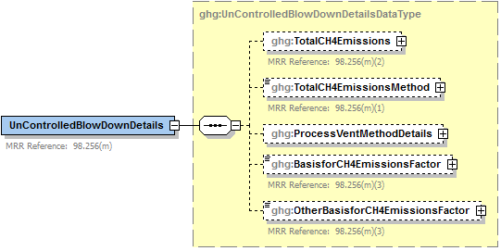

**Conditionally**

**Required**

**Conditionally**

**Required**

**Conditionally**

**Required**

**Conditionally**

**Required**

**Note:** Data elements boxed in red are required. Please see page 4 of this document   
 for more information on conditionally required elements.

.

**Note:** Blowdown systems in which the uncondensed gas stream is routed to a flare or similar control device are considered to be controlled.

**Specify the CH4 Estimation Method**

Subpart Y requires you to specify the appropriate option regarding the facility's uncontrolled blowdown system:

* You used equation Y‑20 to estimate CH4 emissions. [98.253(k)]
* You used a process vents method to estimate CH4 emissions. [98.253 (j)]
* The facility does not have any uncontrolled blowdown systems.

If the facility does not have any uncontrolled blowdown systems, then no further data is collected for uncontrolled blowdown systems.

**Equation Y‑20 Summary and Result**

To calculate the annual CH4 emissions from blowdown systems, you can download the Y‑20 spreadsheet from the e‑GGRT help site or use the following information:

CH4 = (QRef × EFBD × 16/MVC × 0.001)

Where:

CH4 = Methane emission rate from blowdown systems (Metric Tons CH4/year).

QRef = Quantity of crude oil plus the quantity of intermediate products received from off site that are processed at the facility (MMbbl/year).

EFBD = Methane emission factor for uncontrolled blown systems (scf CH4/MMbbl); default is 137,000.

16 = Molecular weight of CH4 (kg/kg‑mole).

MVC = Molar volume conversion factor (849.5 scf/kg‑mole at 68 ºF and 14.7 psia or 836.6 scf/kg‑mole at 60 ºF and 14.7 psia).

0.001 = Conversion factor (metric ton/kg).

1. UnControlledBlowDownDetails Data Element Definitions

| **Data Element Name** | **Description** |
| --- | --- |
| **UnControlledBlowDownDetails** | **Parent Element:** A collection of data elements containing the cumulative annual methane (CH4) emissions, expressed in metric tons, from uncontrolled blowdown systems and the method used to calculate the CH4 emissions. |
| TotalCH4Emissions | **Conditionally Required:** The cumulative annual CH4 emissions (in metric tons of CH4) for uncontrolled blowdown systems. Report the value in the child data element **CalculatedValue**. Set the units of measure to “Metric Tons” in the attribute**massUOM**. [98.256(m)(2)] |
| TotalCH4EmissionsMethod | The method used for calculating CH4 emissions from uncontrolled blowdown systems [98.256(m)(1)]. Below is the list of allowable values.  Reported under 98.256(k)  Reported under 98.256(j) No uncontrolled blowdown systems |

1. Example for Uncontrolled Blowdown System Details

<ghg:UnControlledBlowDownDetails>

<ghg:TotalCH4Emissions massUOM="Metric Tons">

  <ghg:CalculatedValue>4878.24</ghg:CalculatedValue>

</ghg:TotalCH4Emissions>

<ghg:TotalCH4EmissionsMethod>Reported under 98.256(j)</ghg:TotalCH4EmissionsMethod>

**Note:** The XML example above is presented here to demonstrate the concept of reporting uncontrolled blowdown systems details if you used the process vent method to calculate CH4 emissions

1. Process Vent Method Details Schema Diagram



**Conditionally**

**Required**

**Note:** Data elements boxed in red are required. Please see page 4 of this document   
 for more information on conditionally required elements.

.

**Process Vent Method for Uncontrolled Blowdown Systems**

**Conditionally Required:** Report the following data if you used a process vents method (under 98.256(j)) to calculate the CH4 emissions from uncontrolled blowdown systems:

* Annual volumetric flow discharged to the atmosphere (scf).
* Method used to measure or estimate the annual volumetric flow rate. Select from:
  + Continuous or at least hourly measurements
  + Routine (less frequent than hourly but at least weekly) measurements
  + Periodic (less frequent than weekly) measurements
  + Process knowledge
  + Engineering calculation
  + Other (specify)
* **Conditionally Required:** Number of venting events for all relevant vents, if vent is intermittent
* **Conditionally Required:** Cumulative venting time, if vent is intermittent (hours)
* CH4 mole fraction details. (See Mole Fraction Details Schema Diagram.)

1. Process Vent Method Details Data Element Definitions

| **Data Element Name** | **Description** |
| --- | --- |
| **ProcessVentMethodDetails** | **Parent Element (Conditionally Required):** A collection of data elements required if the process vent method was used to calculate CH4 emissions. |
| CumulativeAnnualVolumeFlowDischarged | The cumulative annual volumetric flow discharged to the atmosphere. Report the value in the child data element **MeasureValue**. Set the units of measure to “scf” in the attribute **volUOM**. [98.256(l)(5)] |
| CumulativeAnnualVolumeFlowDischargedMethod | The method used to measure the volumetric flow discharged to the atmosphere. [98.256(l)(5)] Below is the list of allowable values.  Continuous or at least hourly measurements  Routine (less frequent than hourly but at least weekly) measurements  Periodic (less frequent than weekly) measurements  Process knowledge  Engineering calculation  Other (specify) |
| OtherAnnualVolumeMetricFlowMethodList | **Conditionally Required:** The name of the method used to measure the volumetric flow discharged to the atmosphere if not found in the list of allowable methods. |
| CumulativeNumberVentingEvent | **Conditionally Required:** The number of cumulative venting events for all relevant vents, if vents are intermittent (not applicable for continuous venting). Report the integer value in the child data element **MeasureValue**. [98.256(l)(5)] |
| CumulativeVentingTime | **Conditionally Required:** The cumulative venting time in hours for all intermittent vents. Set the units of measure to “Hours” in the attribute **timeUOM**. Report as a decimal. [98.256(l)(5)] |

1. Example for Process Vent Method Details

<ghg:ProcessVentMethodDetails>

<ghg:CumulativeAnnualVolumeFlowDischarged volUOM="scf">

<ghg:MeasureValue>212.0</ghg:MeasureValue>

</ghg:CumulativeAnnualVolumeFlowDischarged>

<ghg:CumulativeAnnualVolumeFlowDischargedMethod>Process knowledge</ghg:CumulativeAnnualVolumeFlowDischargedMethod>

<ghg:CumulativeNumberVentingEvents>

<ghg:MeasureValue>23</ghg:MeasureValue>

<ghg:CumulativeVentingTime timeUOM="Hours">54.1</ghg:CumulativeVentingTime>

**Note:** The XML example above is presented here to demonstrate the concept of reporting uncontrolled blowdown systems details if you used the process vent method to calculate CH4 emissions.

1. Mole Fraction Details Schema Diagram



**Conditionally**

**Required**

**Note:** Data elements boxed in red are required. Please see page 4 of this document   
 for more information on conditionally required elements.

.

If a process vents method was used to estimate CH4 emissions, then report the following:

* Annual average mole fraction of CH4.
* Method used to measure or estimate the annual average mole fraction of CH4.
  + Engineering estimates/process knowledge
  + Direct measurement
  + Other (specify)

1. Mole Fraction Details Data Element Definitions

| **Data Element Name** | **Description** |
| --- | --- |
| **MoleFractionDetails** | **Parent Element** |
| CH4AnnualAverageMoleFraction | Report the annual average mole fraction of CH4. Report the value in the child data element **MeasureValue**. Set the units of measure to “fraction (number between 0 and 1)” in the attribute **fractionUOM**. [98.256(l)(5)] |
| CH4AnnualAverageMoleFractionMethod | Report the method used to measure or estimate the mole fraction of CH4. [98.256(l)(5)] Below is the list of allowable values.   |  | | --- | | Engineering estimates/process knowledge  Direct measurement  Other (specify) | |
| OtherCH4AnnualAverageMoleFractionMethod | **Conditionally Required:** Specify the method used to measure or estimate the mole fraction of CH4 if not referenced above. [98.256(l)(5)] |

1. Example for Mole Fraction Details

<ghg:MoleFractionDetails>

<ghg:CH4AnnualAverageMoleFraction fractionUOM="fraction (number between 0 and 1)">

<ghg:MeasureValue>0.5</ghg:MeasureValue>

</ghg:CH4AnnualAverageMoleFraction>

<ghg:CH4AnnualAverageMoleFractionMethod>Direct measurement</ghg:CH4AnnualAverageMoleFractionMethod>

</ghg:MoleFractionDetails>

</ghg:ProcessVentMethodDetails>

**Note:** The XML example above is presented here to demonstrate the concept of reporting the CH4 mole fraction details.

**Conditionally Required:** Report the following data if the uncontrolled blowdown emissions are reported under 98.256(k) (Equation Y-20 was used):

* The basis for the methane emission factor value.
* Company records
* Measurement data
* Process Knowledge/Engineering calculation
* Used default emission factor
* Other

1. Basis for CH4 Emissions Factor Data Element Definitions

|  |  |
| --- | --- |
| **Data Element Name** | **Description** |
| BasisforCH4EmissionsFactor | **Conditionally Required:** For uncontrolled blowdown systems reporting under 98.253(k), the basis for the CH4 emission factor value. [98.256(m)(3)] Below is the list of allowable values.  Company records  Measurement data  Process knowledge/engineering calculation  Used default emission factor  Other (specify) |
| OtherBasisforCH4EmissionsFactor | **Conditionally Required:** Specify the basis used for determining the CH4 emissions factor if not listed in the set of allowable values above. |

1. Example for Basis for CH4 Emissions Factor

  <ghg:BasisforCH4EmissionsFactor>Company records</ghg:BasisforCH4EmissionsFactor>

</ghg:UnControlledBlowDownDetails>

**Note:** The XML example above is presented here to demonstrate the concept of reporting the basis for the CH4 emission factor if you used Equation Y-20.

## Equipment Leaks

**Required Subpart-Level Summary Data**

For petroleum refinery sources required to report under Subpart Y, you are required to report the report cumulative CH4 emissions from all equipment leak sources in metric tons. You must also specify the method used to calculate the reported equipment leak emissions.

1. Equipment Leaks Details Schema Diagram

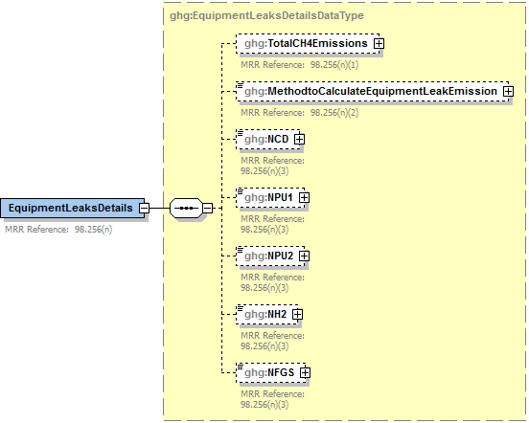

**Required only if the method described in 98.253(l)(1) is used**

**Note:** Data elements boxed in red are required. Please see page 4 of this document   
 for more information on conditionally required elements.

.

**Method Used to Calculate CH4 Emissions**

You must specify the method used to calculate the CH4 emissions from the facility's equipment leaks:

* Use process‑specific methane composition data and any of the emission estimation procedures provided in the Protocol for Equipment Leak Emissions Estimates (EPA‑453/R‑95‑017, NTIS PB96‑175401) [98.253(l)(1)]
* Use Equation Y‑21 [98.253(l)(2)]

**Process‑specific Methane Composition Data Method Summary and Result**

**Conditionally Required:** If you use the process‑specific methane composition data method to determine the cumulative CH4 emissions from equipment leaks, then you must also report the following information:

* Cumulative number of catalytic cracking units, coking units (delayed or fluid), hydrocracking and full‑range distillation columns (including depropanizer and debutanizer distillation columns) at the facility
* Cumulative number of hydrotreating/hydrorefining units, catalytic reforming units and visbreaking units at the facility
* Total number of hydrogen plants at the facility
* Total number of fuel gas systems at the facility
* Number of atmospheric crude oil distillation columns at the facility

**Equation Y‑21**

If you use Equation Y‑21 to calculate the cumulative CH4 emissions from equipment leaks, you can download the Y‑21 spreadsheet from the e‑GGRT help site or use the following information:

CH4 = (0.4×NCD) + (0.2×NPU1) + (0.1×NPU2) + (4.3×NH2) + (6×NFGS)

Where:

CH4 = Annual methane emissions from equipment leaks (metric tons/year)

NCD = Number of atmospheric crude oil distillation columns at the facility.

NPU1 = Cumulative number of catalytic cracking units, coking units (delayed or fluid), hydrocracking and full‑range distillation columns (including depropanizer and debutanizer distillation columns) at the facility.

NPU2 = Cumulative number of hydrotreating/hydrorefining units, catalytic reforming units and visbreaking units at the facility.

NH2 = Total number of hydrogen plants at the facility.

NFGS = Total number of fuel gas systems at the facility.

1. Equipment Leaks Details Data Element Definitions

| **Data Element Name** | **Description** |
| --- | --- |
| **EquipmentLeaksDetails** | **Parent Element** |
| TotalCH4Emissions | The cumulative annual CH4 emissions in metric tons from equipment leaks. Report the value in the child data element **CalculatedValue**. Set the units of measure to “Metric Tons” in the attribute**massUOM**. [98.256(n)(1)] |
| MethodtoCalculateEquipmentLeakEmission | The method used to calculate the reported equipment leak emissions as either that described in 98.253(l)(1) or (l)(2). [98.256(n)(2)] Below is the list of allowable values.  98.253(l)(1) method  98.253(l)(2) method |
| NCD | **Conditionally Required:** The number of atmospheric crude oil distillation columns at the facility (integer). Report if electing to use the 98.253(l)(1) method. [98.256(n)(3)] |
| **Data Element Name** | **Description** |
| NPU1 | **Conditionally Required:** The cumulative number of catalytic cracking units, coking units (delayed or fluid), hydrocracking and full-range distillation columns (including depropanizer and debutanizer distillation columns) at the facility (integer). Report if electing to use the 98.253(l)(1) method. [98.256(n)(3)] |
| NPU2 | **Conditionally Required:** The cumulative number of hydrotreating/hydrorefining units, catalytic reforming units and visbreaking units at the facility (integer). Report if electing to use the 98.253(l)(1) method. [98.256(n)(3)] |
| NH2 | **Conditionally Required:** The total number of hydrogen plants at the facility (integer). Report if electing to use the 98.253(l)(1) method. [98.256(n)(3)] |
| NFGS | **Conditionally Required:** The total number of fuel gas systems at the facility (integer). Report if electing to use the 98.253(l)(1) method. [98.256(n)(3)] |

1. Example for Equipment Leaks

<ghg:EquipmentLeaksDetails>

<ghg:TotalCH4Emissions massUOM="Metric Tons">

<ghg:CalculatedValue>213.24</ghg:CalculatedValue>

</ghg:TotalCH4Emissions>

<ghg:MethodtoCalculateEquipmentLeakEmission>98.253(l)(1) method</ghg:MethodtoCalculateEquipmentLeakEmission>

<ghg:NCD>55</ghg:NCD>

<ghg:NPU1>11</ghg:NPU1>

<ghg:NPU2>22</ghg:NPU2>

<ghg:NH2>33</ghg:NH2>

<ghg:NFGS>44</ghg:NFGS>

</ghg:EquipmentLeaksDetails>

**Note:**  The XML example above is presented here to demonstrate the concept of reporting the cumulative CH4 emissions from equipment leaks if using 98.253(l)(1) method.

## Storage Tanks

**Required Subpart-Level Summary Data**

For petroleum refinery sources required to report under Subpart Y, you are required to report the cumulative annual CH4 emissions (in metric tons) for all storage tanks and the methods used to calculate the reported storage tank emissions. The cumulative annual CH4 emissions and calculation methods used must be reported separately based on whether or not the storage tank was used to process unstabilized crude oil. If you did not receive either stabilized or unstabilized crude, that must be reported.

### Details for Storage Tanks Used to Process Stabilized Crude

1. Storage Tanks (Stabilized Crude) Schema Diagram

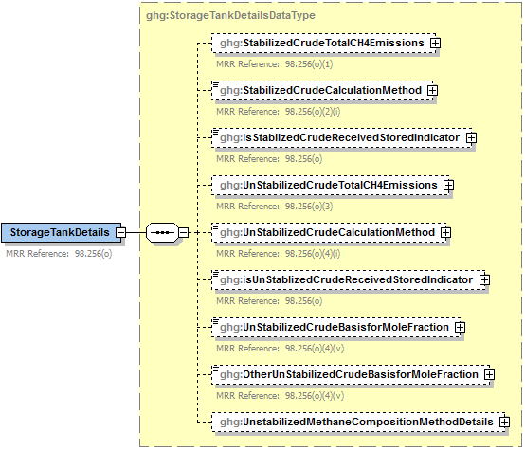

**See the following diagram.**

**Conditionally**

**Required**

**Conditionally**

**Required**

**Note:** Data elements boxed in red are required. Please see page 4 of this document   
 for more information on conditionally required elements.

**Conditionally Required: Method Used to Calculate CH4 Emissions**

If the facility did receive stored liquids other than unstabilized crude oil during the reporting year, you must report the CH4 emissions and specify the method used to calculate the CH4 emissions from storage tanks other than those processing unstabilized crude oil [98.256(o)(2)(i)]:

* AP‑42 ‑ Section 7.1 of the AP‑42: “Compilation of Air Pollutant Emission Factors, Volume 1: Stationary Point and Area Sources” (incorporated by reference, see 98.7)
* Use Equation Y‑22

**Equation Y‑22**

If you use Equation Y‑22 to calculate the cumulative CH4 emissions from all storage tanks other than those processing unstabilized crude oil, you can download the Y‑22 spreadsheet from the e‑GGRT help site or use the following information:



Where:

CH4 = Annual methane emissions from storage tanks (metric tons/year).

0.1 = Default emission factor for storage tanks (metric ton CH4/MMbbl).

QRef = Quantity of crude oil plus the quantity of intermediate products received from off site that are processed at the facility (MMbbl/year).

You must indicate whether or not the facility received unstabilized crude oil during the reporting year.

1. Storage Tanks (Stabilized Crude) Data Element Definitions

| **Data Element Name** | **Description** |
| --- | --- |
| **StorageTankDetails** | **Parent Element** |
| StabilizedCrudeTotalCH4Emissions | **Conditionally Required:**  If the facility did receive stored liquids other than unstabilized crude oil during the reporting year, report the cumulative annual CH4 emissions from all storage tanks (stored liquids), except for those used to process unstabilized crude oil. Report the value in the child data element **CalculatedValue**. Set the units of measure to “Metric Tons” in the attribute**massUOM**. [98.256(o)(1)] |
| StabilizedCrudeCalculationMethod | **Conditionally Required:**  If the facility did receive stored liquids other than unstabilized crude oil during the reporting year, report the method used to calculate the reported storage tank emissions for storage tanks other than those processing unstabilized crude. Below is the list of allowable values. [98.256(o)(2)(i)]   AP-42  Equation Y-22 |
| isStablizedCrudeReceivedStoredIndicator | An indication (Y/N) of whether the facility received stored liquids other than unstabilized crude oil during the reporting year. [98.256(o)] |

1. Example for Storage Tanks (Stabilized Crude)

<ghg:StorageTankDetails>

<ghg:StabilizedCrudeTotalCH4Emissions massUOM="Metric Tons">

<ghg:CalculatedValue>235.67</ghg:CalculatedValue>

</ghg:StabilizedCrudeTotalCH4Emissions>

<ghg:StabilizedCrudeCalculationMethod>Equation Y-22</ghg:StabilizedCrudeCalculationMethod>

<ghg:isStablizedCrudeReceivedStoredIndicator>Y</ghg:isStablizedCrudeReceivedStoredIndicator>

**Note:**  The XML example above is presented here to demonstrate the concept of reporting emissions data for storage tanks other than those processing unstabilized crude oil.

### Details for Storage Tanks Used to Process Unstabilized Crude

1. Storage Tanks (Unstabilized Crude) Schema Diagram



**See the previous diagram.**

**Conditionally**

**Required**

**Conditionally**

**Required**

**Conditionally**

**Required**

**Conditionally**

**Required**

**Conditionally**

**Required**

**Note:** Data elements boxed in red are required. Please see page 4 of this document   
 for more information on conditionally required elements.

1. Unstabilized Methane Composition Method Details Schema Diagram

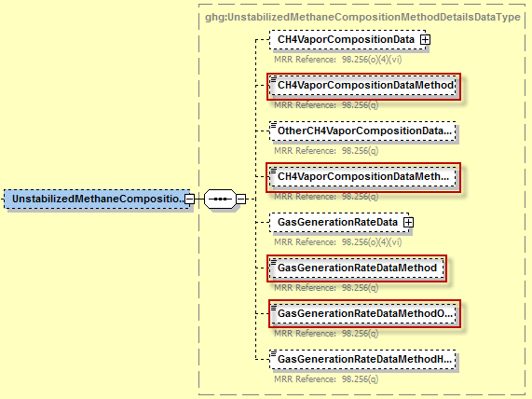

**Conditionally**

**Required**

**Conditionally**

**Required**

**Conditionally**

**Required**

**Conditionally**

**Required**

**Note:** Data elements boxed in red are required. Please see page 4 of this document   
for more information on conditionally required elements.

**Note:** You do not need to calculate CH4 emissions from storage tanks that meet any of the following descriptions:

* Units permanently attached to conveyances such as trucks, trailers, rail cars, barges, or ships;
* Pressure vessels designed to operate in excess of 204.9 kilopascals and without emissions to the atmosphere;
* Bottoms receivers or sumps;
* Vessels storing wastewater; or
* Reactor vessels associated with a manufacturing process unit.

**Conditionally Required: Method Used to Calculate CH4 Emissions**

If you are reporting emissions for storage tanks that process unstabilized crude oil, you must report the CH4 emissions and specify the method used to calculate the CH4 emissions [98.256(o)(4)(i)]:

* Tank‑specific methane composition data and direct measurement of gas generation rate
* Use Equation Y‑23

You must indicate whether or not the facility received unstabilized crude oil during the reporting year.

**Conditionally Required: Mole Fraction Basis**

Regardless of the method used to calculate CH4 emissions, you are required to report the basis for the average mole fraction of CH4 in the vent gas from the unstabilized crude oil storage tank. [98.256(o)(6)]:

* Equation Y-23 default
* Measurement data
* Product knowledge
* Other (specify)

**Conditionally Required: Tank-Specific Methane Composition Data Method Summary and Result**

If you use the tank-specific methane composition data method to determine the cumulative CH4 emissions from storage tanks processing unstabilized crude oil, then you must also report the following information:

* Cumulative CH4 emissions from unstabilized crude oil storage in metric tons
* Method used to measure tank-specific methane composition in the vapor
* **Conditionally Required:** If measured, the number of hours missing that data procedures were used to measure tank-specific methane composition
* Method used to measure the gas generation rate
* Specification of the procedures or method used to measure the gas generation rate
* **Conditionally Required:** If measured, the number of hours that missing data procedures were used to measure the gas generation rate

**Equation Y‑23**

If you use Equation Y‑23 to calculate the annual CH4 emissions from the storage of unstabilized crude oil, you can download the Y‑23 spreadsheet from the e‑GGRT help site or use the following information:



Where:

CH4 = Annual methane emissions from storage tanks (metric tons/year).

Qun = Quantity of unstabilized crude oil received at the facility (MMbbl/year).

ΔP = Pressure differential from the previous storage pressure to atmospheric pressure (pounds per square inch, psi).

MFCH4 = Average mole fraction of CH4 in vent gas from the unstabilized crude oil storage tanks from facility measurements (kg‑mole CH4/kg‑mole gas); use 0.27 as a default if measurement data are not available.

995,000 = Correlation Equation factor (scf gas per MMbbl per psi)

16 = Molecular weight of CH4 (kg/kg‑mole).

MVC = Molar volume conversion factor (849.5 scf/kg‑mole at 68 ºF and 14.7 psia or 836.6 scf/kg‑mole at 60 ºF and 14.7 psia).

0.001 = Conversion factor (metric ton/kg).

1. Storage Tanks (Unstabilized Crude) Data Element Definitions

| **Data Element Name** | **Description** |
| --- | --- |
| UnStabilizedCrudeTotalCH4Emissions | **Conditionally Required:** If the facility did receive unstabilized crude oil during the reporting year, report the cumulative annual CH4 emissions from storage tanks used to process unstabilized crude oil storage. Report the value in the child data element **CalculatedValue**. Set the units of measure to “Metric Tons” in the attribute**massUOM**. [98.256(o)(3)] |
| UnStabilizedCrudeCalculationMethod | **Conditionally Required:** If the facility did receive unstabilized crude oil during the reporting year, report the method used to calculate the reported unstabilized crude oil storage tank emissions. [98.256(o)(4)(i)] Below is the list of allowable values.   |  | | --- | | Tank‑specific methane composition data and direct measurement of gas generation rate | | Equation Y‑23 | |
| isUnStablizedCrudeReceivedStoredIndicator | An indication (Y/N) of whether the facility received unstabilized crude oil during the reporting year. [98.256(o)] |
| UnStabilizedCrudeBasisforMoleFraction | **Conditionally Required:** If the facility did receive unstabilized crude oil during the reporting year, report the basis for the average mole fraction of CH4 in vent gas from all unstabilized crude oil storage tanks. [98.256(o)(6)] Below is the list of allowable values.  Equation Y-23 default  Measurement data Product knowledge Other (specify) |
| OtherUnStabilizedCrudeBasisforMoleFraction | **Conditionally Required:** Specify the basis for the mole fraction if not listed above. |
| **UnstabilizedMethaneCompositionMethodDetails** | **Parent Element (Conditionally Required):** A collection of data elements to capture CH4 vapor data. Report this data if the tank‑specific methane composition data method was used to determine the cumulative CH4 emissions from storage tanks processing unstabilized crude oil. |
| CH4VaporCompositionData | Specify CH4 composition in Kg-mole CH4/kg-molegas |
| CH4VaporCompositionDataMethod | Specify the method used to measure tank-specific CH4 composition in the vapor. [98.256(q)] Below is the list of allowable values.  Measurement data Product knowledge Other (specify) |
| OtherCH4VaporCompositionDataMethod | **Conditionally Required:** Specify the method used to measure tank-specific CH4 composition in the vapor if not listed above. |
| CH4VaporCompositionDataMethodHoursMissingDataProcedures. | Report the number of hours missing data procedures were used to determine the tank-specific CH4 composition. |
| GasGenerationRateData | Specify the gas generation rate in units of scf/yr. |
| GasGenerationRateDataMethod | The method used to measure the gas generation rate. [98.256(q)] Below is the list of allowable values.   |  | | --- | | Procedures specified by flow meter manufacturer | | Method published by a consensus‑based standards organization | |
| GasGenerationRateDataMethodOther | The specification of the procedures or method used to measure the gas generation rate. [98.256(q)] |
| GasGenerationRateDataMethodHoursMissingProcedures | Report the number of hours missing data procedures were used to determine the gas generation rate. |

1. Example for Storage Tanks (Unstabilized Crude)

<ghg:UnStabilizedCrudeTotalCH4Emissions massUOM="Metric Tons">

<ghg:CalculatedValue>190.0</ghg:CalculatedValue>

</ghg:UnStabilizedCrudeTotalCH4Emissions><ghg:UnStabilizedCrudeCalculationMethod>Tank-specific methane composition data and direct measurement of

gas generation rate</ghg:UnStabilizedCrudeCalculationMethod>

<ghg:isUnStablizedCrudeReceivedStoredIndicator>Y</ghg:isUnStablizedCrudeReceivedStoredIndicator>

<ghg:UnStabilizedCrudeBasisforMoleFraction>Product knowledge</ghg:UnStabilizedCrudeBasisforMoleFraction>

<ghg:UnstabilizedMethaneCompositionMethodDetails>

<ghg:CH4VaporCompositionData fractionUOM="**kg-mole CH4/kg-molegas**">

<ghg:MeasureValue>0.05</MeasureValue>

</ghg:CH4VaporCompositionData>

<ghg:CH4VaporCompositionDataMethod>Measurement data</ghg: CH4VaporCompositionDataMethod>

<ghg:CH4VaporCompositionDataMethodHoursMissingDataProcedures>999</ghg: CH4VaporCompositionDataMethodHoursMissingDataProcedures>

<ghg:GasGenerationRateDatarateUOM="**scf/yr**">

<ghg:MeasureValue>2</ghg:MeasureValue>

</ghg:GasGenerationRateData>

<ghg:GasGenerationRateDataMethod>Method published by a consensus-based standards organization</ghg:GasGenerationRateDataMethod>

<ghg:GasGenerationRateDataMethodOther>MY METHOD</ghg:GasGenerationRateDataMethodOther>

<ghg:GasGenerationRateDataMethodHoursMissingDataProcedures>999</ghg:GasGenerationRateDataMethodHoursMissingDataProcedures>

</ghg:UnstabilizedMethaneCompositionMethodDetails>

</ghg:StorageTankDetails>

**Note:**  The XML example above is presented here to demonstrate the concept of reporting emissions data for storage tanks that process unstabilized crude oil calculated using the tank-specific methane composition data method.

## Loading Operations

**Required Subpart-Level Summary Data**

For petroleum refinery sources required to report under Subpart Y, you are required to report the cumulative methane (CH4) emissions for all loading operations. **Note:** A zero must be entered for facilities that have no materials with a vapor-phase CH4 concentration of 0.5 volume percent or greater.

1. Loading Operations Details Schema Diagram

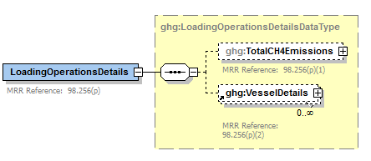

**Conditionally**

**Required**

**Note:** Data elements boxed in red are required.

**Conditionally Required:** You must also specify each type of vessel loaded during the reporting year with one or more materials containing a vapor-phase concentration of CH4 of 0.5 volume percent or greater.

* For each such vessel, you must report the type of each material containing a vapor-phase concentration of CH4 of 0.5 volume percent or greater.
* For each material for each vessel type, report the type of control system used to reduce emissions from the loading of the material.

1. Vessel Details Schema Diagram

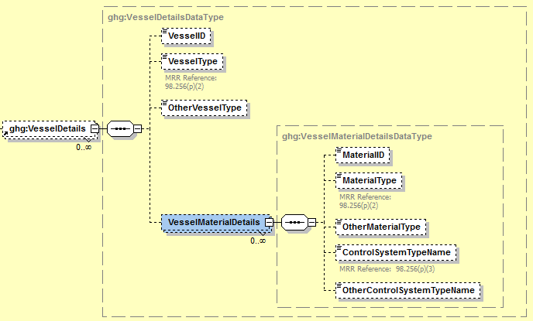

**Conditionally**

**Required**

**Conditionally**

**Required**

**Conditionally**

**Required**

**Note:** Data elements boxed in red are required. Please see page 4 of this document   
 for more information on conditionally required elements.

.

1. Loading Operations Details Data Element Definitions

| **Data Element Name** | **Description** |
| --- | --- |
| **LoadingOperationsDetails** | **Parent Element** |
| TotalCH4Emissions | The cumulative annual CH4 emissions (in metric tons of CH4) for loading operations. Report the value in the child data element **CalculatedValue**. Set the units of measure to “Metric Tons” in the attribute**massUOM**. **Note:** A zero must be entered for facilities that have no materials with a vapor-phase CH4 concentration of 0.5 volume percent or greater. [98.256(p)(1)] |
| **VesselDetails** | **Parent Element (Conditionally Required)** |
| VesselID | Unique identifier for vessel, which must match the VesselID used in the Subpart C Inputs XML file |
| VesselType | The type of each vessel used to transport material(s) containing an equilibrium vapor-phase CH4 concentration of at least 0.5 percent during the reporting year. [98.256(p)(2)] Below is the list of allowable values.  Ship or ocean‑going vessel  Barge  Railcar  Tank truck  Container (e.g., 55-gallon drum)  Other (specify) |
| OtherVesselType | **Conditionally Required:** Specify each type of vessel not listed above that was used to transport material containing a vapor‑phase concentration of 0.5 volume percent or greater. |
| **VesselMaterialDetails** | **Parent Element:** A collection of data element containing details about the materials loaded. Report a separate **VesselMaterialDetails** record for each type of material loaded. |
| MaterialID | Unique identifier for material, which must match the MaterialID used in the Subpart C Inputs XML file |
| MaterialType | For the specified vessel type, report the type of each material containing a vapor‑phase CH4 concentration of 0.5 volume percent or greater. [98.256(p)(2)] Below is the list of allowable values.  Unstabilized crude oil Stabilized crude oil Still gas or refinery fuel gas LPG (propane/butane) Ethylene Oxygenates Naphtha Gasoline or gasoline blending stocks other than oxygenates Other (specify) |
| OtherMaterialType | **Conditionally Required:** Specify each type of material not listed above that contained a vapor‑phase concentration of CH4 of 0.5 volume percent or greater. |
| ControlSystemTypeName | The type of control system used to reduce emissions from the loading of the specified material. [98.256(p)(3)] Below is the list of allowable values.  Submerged loading or bottom filling only; no other control system  Vapor balancing  Thermal or catalytic incinerator/oxidizer  Flare  Carbon adsorber  Condenser  Oil scrubber  None  Other (specify) |
| OtherControlSystemTypeName | **Conditionally Required:** Specify each type of control system used not listed above that was used to reduce emissions from the loading of the material. |

1. Example for Loading Operations Details

<ghg:LoadingOperationsDetails>

<ghg:TotalCH4Emissions massUOM="Metric Tons">

<ghg:CalculatedValue>123.65</ghg:CalculatedValue>

</ghg:TotalCH4Emissions>

<ghg:VesselDetails>

<ghg:VesselID>Edmund Fitzgerald</ghg:VesselID>

<ghg:VesselType>Barge</ghg:VesselType>

<ghg:VesselMaterialDetails>

<ghg:MaterialID>Vessel Material 1</ghg:MaterialID>

<ghg:MaterialType>Still gas or refinery fuel gas</ghg:MaterialType>

<ghg:ControlSystemTypeName>Thermal or catalytic incinerator/oxidizer</ghg:ControlSystemTypeName>

</ghg:VesselMaterialDetails>

<ghg:VesselMaterialDetails>

<ghg:MaterialID>Vessel Material 2</ghg:MaterialID>

<ghg:MaterialType>Oxygenates</ghg:MaterialType>

<ghg:ControlSystemTypeName>Condenser</ghg:VesselMaterialDetails>

</ghg:VesselMaterialDetails>

</ghg:VesselDetails>

<ghg:VesselDetails>

<ghg:VesselID>Casey Jones</ghg:VesselID>

<ghg:VesselType>Railcar</ghg:VesselType>

<ghg:VesselMaterialDetails>

<ghg:MaterialID>Vessel Material 3</ghg:MaterialID>

<ghg:MaterialType>Ethylene</ghg:MaterialType>

<ghg:ControlSystemTypeName>Oil scrubber</ghg:ControlSystemTypeName>

</ghg:VesselMaterialDetails>

</ghg:VesselDetails>

</ghg:LoadingOperationsDetails>

**Note:**  The XML example above is presented here to demonstrate the concept of reporting the cumulative CH4 emissions from loading operations. In the example above, there are two vessels, a barge and a railcar. The barge transported two types of material containing a vapor‑phase CH4 concentration of at least 0.5 percent and the railcar contained a single type.

## Tier 4 CEMS Information

**Conditionally Required Unit-Level Data**

This section describes the emissions information that must be reported if the following types of process units were monitored by a continuous emissions monitoring system (CEMS) during the reporting year: Coke calcining units, Catalytic cracking units, Traditional fluid coking units, Fluid coking units with flexicoking design, Catalytic reforming units or Sulfur recovery plants.

1. Tier 4 CEMS Details Schema Diagram

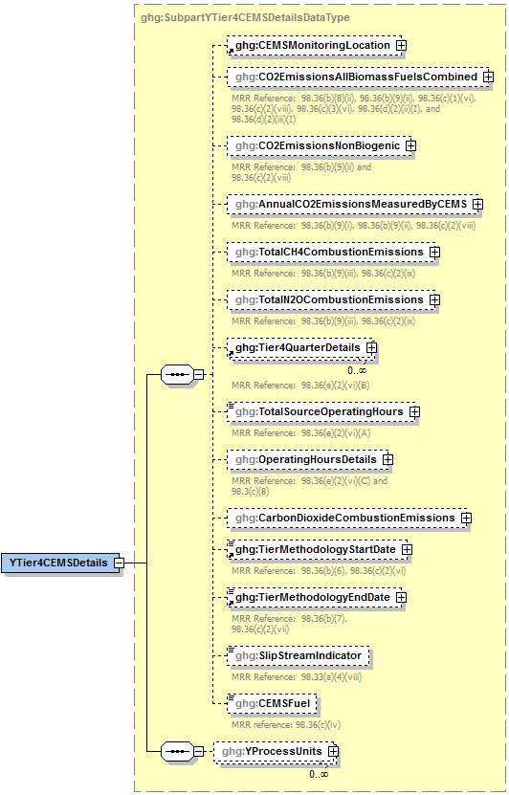

See the following figures for required data elements.

1. Tier 4 CEMS Location and Emissions Details Schema Diagram

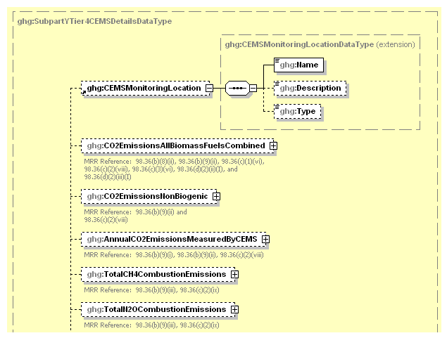

**Optional**

**Note:** Data elements boxed in red are required.

For Subpart Y, information on each CEMS monitoring location (CML) is required including the name [98.36(c)(2)(i)] , an optional description and the configuration type. For each CML identified by the facility, the facility must specify the configuration type from the following list:

* Single industrial process or process unit that exhausts to a dedicated stack.
* Multiple industrial processes or process units share a common stack.
* Industrial process or process unit shares a common stack with a Tier 4 stationary fuel combustion unit.

For each CEMS monitoring location identified, the following emissions data must be reported:

* The total annual biogenic CO2 mass emissions from combustion of all biomass fuels combined [98.36(b)(9)(ii), 98.36(c)(2)(viii)]
* The total annual non-biogenic CO2 mass emissions (i.e. CO2 mass emissions from fossil fuels, sorbent use and process emissions) [98.36(b)(9)(ii), 98.36(c)(2)(viii)]
* The total annual CO2 mass emissions (biogenic and non-biogenic) measured by the CEMS [98.36(b)(9)(i)-(ii), 98.36(c)(2)(viii)]
* The total annual CH4 mass emissions derived from Equation C-10, in metric tons CH4 [98.36(b)(9)(iii), 98.36(c)(2)(ix)]
* The total annual N2O mass emissions derived from Equation C-10, in metric tons N2O [98.36(b)(9)(iii), 98.36(c)(2)(ix)]

1. Tier 4 CEMS Location and Emissions Details Data Element Definitions

| **Data Element Name** | **Description** |
| --- | --- |
| **YTier4CEMSDetails** | **Parent Element (Conditionally Required):** A collection of data elements containing information about each CEMS monitoring location. |
| CEMSMonitoringLocation | A collection of data elements containing the identity of a CEMS monitoring location. [98.36(c)(2)(i)] It includes the location's name in the child data element **Name**, an optional description in the child data element **Description** and configuration type in the child data element **Type**. Below is the list of allowable configuration types.   |  | | --- | | Single process/process unit exhausts to dedicated stack | | Multiple processes/process units share common stack | | Process/stationary combustion units share common stack | |
| CO2EmissionsAllBiomassFuelsCombined | Total annual biogenic CO2 mass emissions for the specified CEMS monitoring location. [98.36(b)(9)(ii), 98.36(c)(2)(viii)] Report the value in the child data element **CalculatedValue**. Set the units of measure to “Metric Tons” in the attribute**massUOM**. |
| CO2EmissionsNonBiogenic | The total annual non-biogenic CO2 mass emissions for the specified CEMS monitoring location. [98.36(b)(9)(ii), 98.36(c)(2)(viii)] Report the value in the child data element **CalculatedValue**. Set the units of measure to “Metric Tons” in the attribute**massUOM**. |
| AnnualCO2EmissionsMeasuredByCEMS | The total annual CO2 mass emissions measured by the CEMS at the specified CEMS monitoring location. [98.36(b)(9)(i)-(ii), 98.36(c)(2)(viii)] Report the value in the child data element **CalculatedValue**. Set the units of measure to “Metric Tons” in the attribute**massUOM**. |
| TotalCH4CombustionEmissions | The annual CH4 mass emissions measured at the specified CEMS monitoring location during the reporting year calculated using Equation C-10 expressed in mass of CH4. [98.36(b)(9)(iii), 98.36(c)(2)(ix)] Report the value in the child data element **CalculatedValue**. Set the units of measure to “Metric Tons” in the attribute**massUOM**. |
| TotalN2OCombustionEmissions | The annual N2O mass emissions at the specified CEMS monitoring location during the reporting year calculated using Equation C-10 expressed in mass of N2O. [98.36(b)(9)(iii), 98.36(c)(2)(ix)] Report the value in the child data element **CalculatedValue**. Set the units of measure to “Metric Tons” in the attribute**massUOM**. |

1. Example for Tier 4 CEMS Location and Emissions Details

ghg:YTier4CEMSDetails>

<ghg:CEMSMonitoringLocation>

<ghg:Name>CS- Location 1</ghg:Name>

<ghg:Description>Northwest</ghg:Description>

<ghg:Type>Single process/process unit exhausts to dedicated stack</ghg:Type>

</ghg:CEMSMonitoringLocation>

<ghg:CO2EmissionsAllBiomassFuelsCombined massUOM="Metric Tons">

<ghg:CalculatedValue>150.6</ghg:CalculatedValue>

</ghg:CO2EmissionsAllBiomassFuelsCombined>

<ghg:CO2EmissionsNonBiogenic massUOM="Metric Tons">

<ghg:CalculatedValue>1400.2</ghg:CalculatedValue>

</ghg:CO2EmissionsNonBiogenic>

<ghg:AnnualCO2EmissionsMeasuredByCEMS massUOM="Metric Tons">

<ghg:CalculatedValue>1500.7</ghg:CalculatedValue>

</ghg:AnnualCO2EmissionsMeasuredByCEMS>

<ghg:TotalCH4CombustionEmissions massUOM="Metric Tons">

<ghg:CalculatedValue>250.44</ghg:CalculatedValue>

</ghg:TotalCH4CombustionEmissions>

<ghg:TotalN2OCombustionEmissions massUOM="Metric Tons">

<ghg:CalculatedValue>350.851</ghg:CalculatedValue>

</ghg:TotalN2OCombustionEmissions>

**Note:** The code excerpt above is presented here to demonstrate the concept of reporting CEMS monitoring location details and measured greenhouse gas emissions.

1. Tier 4 CEMS Quarter and Additional Details Schema Diagram

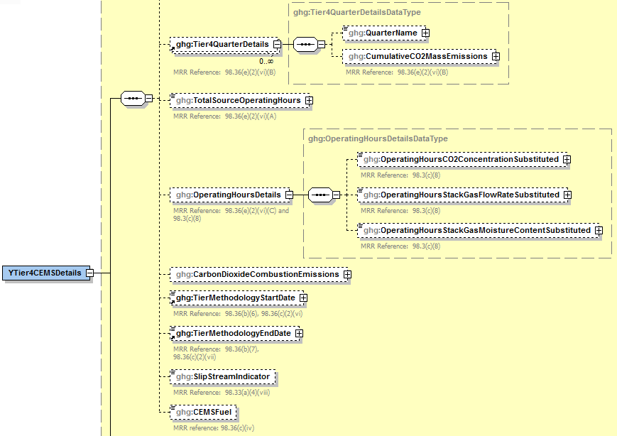

**Conditionally**

**Required**

**Note:** Data elements boxed in red are required. Please see page 4 of this document   
 for more information on conditionally required elements.

For each quarter of the reporting year, the facility must provide the cumulative CO2 mass emissions for each CML [98.36(e)(2)(vi)(B)].

The facility must provide the following additional information for each CML:

* + The total number of source operating hours in the reporting year [98.36(e)(2)(vi)(A)]
  + The total operating hours in which a substitute data value was used in the emissions calculations for the CO2 concentration parameter [98.36(e)(2)(vi)(C), 98.3(c)(8)]
  + The total operating hours in which a substitute data value was used in the emissions calculations for the stack gas flow rate parameter [98.36(e)(2)(vi)(C), 98.3(c)(8)]
  + If moisture correction is required and a continuous moisture monitor is used, the total operating hours in which a substitute data value was used in the emissions calculations for the stack gas moisture content parameter [98.36(e)(2)(vi)(C), 98.3(c)(8)]
  + The CO2 emissions from the total annual CO2 mass emissions (biogenic and non-biogenic) measured by the CEMS at the specified CML that are attributable to combustion
  + The Tier 4 methodology start date [98.36(b)(6), 98.36(c)(2)(vi)]
  + The Tier 4 methodology end date [98.36(b)(7), 98.36(c)(2)(vii)]
  + Specify if emissions reported for the CEMS include emissions calculated according to 98.33(a)(4)(viii) for a slipstream that bypassed the CEMS [98.33(a)(4)(viii)]
  + Each type of fuel combusted in the group of units during the reporting year [98.36(b)(4), 98.36(c)(2)(iv)]

1. Tier 4 CEMS Quarter and Additional Details Data Element Definitions

| **Data Element Name** | **Description** |
| --- | --- |
| **Tier4QuarterDetails** | **Parent Element** |
| QuarterName | The name of the quarter. Below is the list of allowable values.   |  | | --- | | First Quarter | | Second Quarter | | Third Quarter | | Fourth Quarter | |
| CumulativeCO2MassEmissions | The cumulative CO2 mass emissions for the specified CEMS monitoring location for the specified quarter of the reporting year. [98.36(e)(2)(vi)(B)] Report the value in the child data element **CalculatedValue**. Set the units of measure to “Metric Tons” in the attribute**massUOM**. |
| TotalSourceOperatingHours | The total number of source operating hours in the reporting year for the specified CEMS monitoring location. [98.36(e)(2)(vi)(A)] |
| **OperatingHoursDetails** | **Parent Element** |
| OperatingHoursCO2ConcentrationSubstituted | The total operating hours in which a substitute data value was used in the emissions calculations for the CO2 concentration parameter at the specified CEMS monitoring location. [98.36(e)(2)(vi)(C), 98.3(c)(8)] |
| OperatingHoursStackGasFlowRateSubstituted | The total operating hours in which a substitute data value was used in the emissions calculations for the stack gas flow rate parameter at the specified CEMS monitoring location. [98.36(e)(2)(vi)(C), 98.3(c)(8)] |
| OperatingHoursStackGasMoistureContentSubstituted | **Conditionally Required:** If moisture correction is required and a continuous moisture monitor is used, the total operating hours in which a substitute data value was used in the emissions calculations for the stack gas moisture content parameter at the specified CEMS monitoring location. [98.36(e)(2)(vi)(C), 98.3(c)(8)] |
| CarbonDioxideCombustionEmissions | CO2 emissions from the total annual CO2 mass emissions (biogenic and non-biogenic) measured by the CEMS at the specified CML that are attributable to combustion. [98.256(f)(6), 98.256(h)(6)] Report the value in the child data element **MeasureValue**. Set the units of measure to “Metric Tons” in the attribute **massUOM**. |
| TierMethodologyStartDate | The tier methodology start date for the specified CEMS monitoring location (YYYY-MM-DD). [98.36(b)(6), 98.36(c)(2)(vi)] |
| TierMethodologyEndDate | The tier methodology end date for the specified CEMS monitoring location (YYYY-MM-DD). [98.36(b)(7), 98.36(c)(2)(vii)] |
| SlipStreamIndicator | An indication (Y/N) that the emissions reported for the CEMS include emissions calculated according to 98.33(a)(4)(viii) for a slipstream that bypassed the CEMS. [98.33(a)(4)(viii)] |
| CEMSFuel | Each type of fuel combusted in the group of units during the reporting year. [98.36(b)(4), 98.36(c)(2)(iv)] |

1. Example for Y Tier 4 CEMS Quarter and Additional Details

<ghg:Tier4QuarterDetails>

<ghg:QuarterName>First Quarter</ghg:QuarterName>

<ghg:CumulativeCO2MassEmissions massUOM="Metric Tons">

<ghg:CalculatedValue>600.3</ghg:CalculatedValue>

</ghg:CumulativeCO2MassEmissions>

</ghg:Tier4QuarterDetails>

<ghg:Tier4QuarterDetails>

<ghg:QuarterName>Second Quarter</ghg:QuarterName>

<ghg:CumulativeCO2MassEmissions massUOM="Metric Tons">

<ghg:CalculatedValue>700.2</ghg:CalculatedValue>

</ghg:CumulativeCO2MassEmissions>

</ghg:Tier4QuarterDetails>

<ghg:Tier4QuarterDetails>

<ghg:QuarterName>Third Quarter</ghg:QuarterName>

<ghg:CumulativeCO2MassEmissions massUOM="Metric Tons">

<ghg:CalculatedValue>800.1</ghg:CalculatedValue>

</ghg:CumulativeCO2MassEmissions>

</ghg:Tier4QuarterDetails>

<ghg:Tier4QuarterDetails>

<ghg:QuarterName>Fourth Quarter</ghg:QuarterName>

<ghg:CumulativeCO2MassEmissions massUOM="Metric Tons">

<ghg:CalculatedValue>900.8</ghg:CalculatedValue>

</ghg:CumulativeCO2MassEmissions>

</ghg:Tier4QuarterDetails>

<ghg:TotalSourceOperatingHours>8400</ghg:TotalSourceOperatingHours>

<ghg:OperatingHoursDetails>

<ghg:OperatingHoursCO2ConcentrationSubstituted>450</ghg:OperatingHoursCO2ConcentrationSubstituted>

<ghg:OperatingHoursStackGasFlowRateSubstituted>550</ghg:OperatingHoursStackGasFlowRateSubstituted>

<ghg:OperatingHoursStackGasMoistureContentSubstituted>650</ghg:OperatingHoursStackGasMoistureContentSubstituted>

</ghg:OperatingHoursDetails>

<ghg:CarbonDioxideCombustionEmissions massUOM="Metric Tons">

<ghg:MeasureValue>3452.1</ghg:MeasureValue>

</ghg:CarbonDioxideCombustionEmissions>

<ghg:TierMethodologyStartDate>2010-01-01</ghg:TierMethodologyStartDate>

<ghg:TierMethodologyEndDate>2010-12-31</ghg:TierMethodologyEndDate>

<ghg:SlipStreamIndicator>Y</ghg:SlipStreamIndicator>

<ghg:CEMSFuel>coal, coke, natural gas</ghg:CEMSFuel>

**Note:** The code excerpt above is presented here to demonstrate the concept of reporting Tier 4 CEMS details and quarterly data.

1. Tier 4 CEMS Quarter and Additional Details Schema Diagram

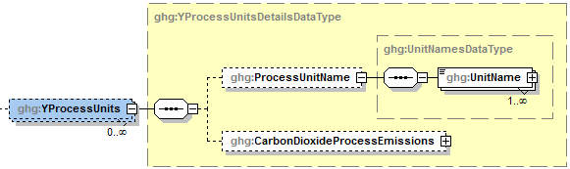

**Note:** Data elements boxed in red are required.

For each CML that is monitoring a Subpart Y petroleum refinery process unit, report the following for each process unit:

* The name/ID of the process unit monitored at the CML.
* The CO2 emissions from the CML which are attributable to process CO2 emissions from the process unit.

1. Tier 4 CEMS Process Units Details Data Element Definitions

|  |  |
| --- | --- |
| **Data Element Name** | **Description** |
| **YProcessUnits** | **Parent Element:** A collection of data elements for process units monitored at the specified CEMS monitoring location. Report each unit separately. |
| **ProcessUnitName** | **Parent Element:** A parent element for the identification of the process unit monitored at the specified CEMS monitoring location. |
| UnitName | The name of one process unit that is monitored at the specified CML. Use the same unit name as was used for "UnitIdentification". [98.256(f)(1), 98.256(h)(1), 98.256(i)(1)] |
| CarbonDioxideProcessEmissions | The CO2 emissions from the CML which are attributable to process CO2 emissions from the specified process unit. [98.256(f)(6), 98.256(h)(6), 98.256(i)(6)] Report the value in the child data element **MeasureValue**. Set the units of measure to “Metric Tons” in the attribute **massUOM**. |

1. Example for Tier 4 CEMS Process Units Details

<ghg:YProcessUnits>

<ghg:ProcessUnitName>

<ghg:UnitName>CEMS-001</ghg:ProcessUnitName>

</ghg:ProcessUnitName>

<ghg:CarbonDioxideProcessEmissions massUOM="Metric Tons">

<ghg:ghg:MeasureValue>123.4</ghg:MeasureValue>

</ghg:CarbonDioxideProcessEmissions >

</ghg:YProcessUnits>

<ghg:YProcessUnits>

<ghg:ProcessUnitName>

<ghg:UnitName>CEMS-002</ghg:ProcessUnitName>

</ghg:ProcessUnitName>

<ghg:CarbonDioxideProcessEmissions massUOM="Metric Tons">

<ghg:ghg:MeasureValue>567.8</ghg:MeasureValue>

</ghg:CarbonDioxideProcessEmissions >

</ghg:YProcessUnits>

<ghg:YProcessUnits>

<ghg:ProcessUnitName>

<ghg:UnitName>CEMS-003</ghg:ProcessUnitName>

</ghg:ProcessUnitName>

<ghg:CarbonDioxideProcessEmissions massUOM="Metric Tons">

<ghg:ghg:MeasureValue>901.2</ghg:MeasureValue>

</ghg:CarbonDioxideProcessEmissions >

</ghg:YProcessUnits>

</ghg:YTier4CEMSDetails>

</ghg:SubPartY>

**Note:** The code excerpt above is presented here to demonstrate the concept of reporting Tier 4 CEMS process unit data.

## Facility-Level Roll-up Emissions

**Required Subpart-Level Summary Data**

Each facility must report the following facility-level emission totals:

* Total CO2 equivalent (CO2e) emissions (excluding biogenic CO2) aggregated across all direct emitter source categories (Subparts C-HH) associated with the facility.
* Total biogenic CO2 emissions aggregated across all direct emitter source categories (Subparts C-HH) associated with the facility.

Each supplier must report the following supplier totals:

* Total CO2e associated with products supplied aggregated across Subparts NN, OO and PP (as applicable). **Note:** Do not include Subpart LL and MM totals in this data element as these values are not being collected in e‑GGRT.

1. Facility-Level Roll-up Emissions Schema Diagram

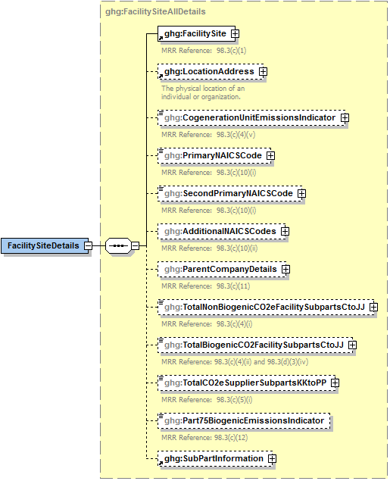

**Note:** Data elements boxed in red are required.

1. Add the total CO2e value for Subpart Y in metric tons to the total CO2e emissions (excluding biogenic CO2) aggregated across all source category Subparts associated with the facility according to the following guidelines:

* Add the value reported for Carbon Dioxide at the Subpart level.
* Multiply the value reported for CH4 at the Subpart level by the Global Warming Potential for CH4 of 21, and add the resulting value.
* Multiply the value reported for N2O at the Subpart level by the Global Warming Potential for N2O of 310, and add the resulting value.

1. Add the total annual biogenic CO2 mass emissions in metric tons for each CML to the total biogenic CO2 aggregated across all source category Subparts associated with the facility.

**Note:** You must follow the rounding rules found in Table 1.

1. Facility-Level Roll-up Emissions Data Element Definitions

| **Data Element Name** | **Description** |
| --- | --- |
| TotalNonBiogenicCO2eFacilitySubpartsCtoJJ | Add the total CO2e value for Subpart Y in metric tons to the total CO2e emissions (excluding biogenic CO2) aggregated across all source category Subparts associated with the facility according to the guidelines above. Set the units of measure to “Metric Tons” in the attribute **massUOM**. |
| TotalBiogenicCO2FacilitySubpartsCtoJJ | Add the total annual biogenic CO2 value for Subpart Y in metric tons to the total biogenic CO2 emissions aggregated across all source category Subparts associated with the facility according to the guideline above. Set the units of measure to “Metric Tons” in the attribute **massUOM**. |

1. Example for Facility-Level Roll-up Emissions

<ghg:TotalNonBiogenicCO2eFacilitySubpartsCtoJJ **massUOM="Metric Tons"**>**5110969.6**</ghg:TotalNonBiogenicCO2eFacilitySubpartsCto JJ>

<ghg:TotalBiogenicCO2FacilitySubpartsCtoJJ **massUOM="Metric Tons"**>**3234.4**</ghg:TotalBiogenicCO2FacilitySubpartsCtoJJ>

**Note:** The code excerpt above is presented here to demonstrate the concept of reporting facility level roll-up greenhouse gas emissions data.

# Appendix A – Sample XML Document for Subpart Y

***(Note: Data values do not reflect an actual facility's emissions.)***

<GHG xmlns="http://www.ccdsupport.com/schema/ghg">

<FacilitySiteInformation>

<CertificationStatement>The designated representative or alternate designated representative must sign (i.e., agree to) this certification statement. If you are an agent and you click on "SUBMIT", you are not agreeing to the certification statement, but are submitting the certification statement on behalf of the designated representative or alternate designated representative who is agreeing to the certification statement. An agent is only authorized to make the electronic submission on behalf of the designated representative, not to sign (i.e., agree to) the certification statement.</CertificationStatement>

<ReportingYear>2014</ReportingYear>

<FacilitySiteDetails>

<FacilitySite>

<FacilitySiteIdentifier>515108</FacilitySiteIdentifier>

<FacilitySiteName>Cubnell Basket</FacilitySiteName>

</FacilitySite>

<LocationAddress>

<LocationAddressText>8923 Washington Blvd</LocationAddressText>

<LocalityName>Arlington</LocalityName>

<StateIdentity>

<StateCode>VA</StateCode>

</StateIdentity>

<AddressPostalCode>22207</AddressPostalCode>

</LocationAddress>

<CogenerationUnitEmissionsIndicator>N</CogenerationUnitEmissionsIndicator>

<PrimaryNAICSCode>221111</PrimaryNAICSCode>

<ParentCompanyDetails>

<ParentCompany>

<ParentCompanyLegalName>MLH Resources Inc</ParentCompanyLegalName>

<StreetAddress>3829 N Woodrow St</StreetAddress>

<City>Arlington</City>

<State>VA</State>

<Zip>22207</Zip>

<PercentOwnershipInterest>100</PercentOwnershipInterest>

</ParentCompany>

</ParentCompanyDetails>

<TotalNonBiogenicCO2eFacilitySubpartsCtoJJ massUOM="Metric Tons">306422.3</TotalNonBiogenicCO2eFacilitySubpartsCtoJJ>

<TotalBiogenicCO2FacilitySubpartsCtoJJ massUOM="Metric Tons">0</TotalBiogenicCO2FacilitySubpartsCtoJJ>

<TotalCO2eSupplierSubpartsKKtoPP massUOM="Metric Tons">0</TotalCO2eSupplierSubpartsKKtoPP>

<PlantCodeIndicator>N</PlantCodeIndicator>

<SubPartInformation>

<SubPartY>

<GHGasInfoDetails>

<GHGasName>Biogenic Carbon dioxide</GHGasName>

<GHGasQuantity massUOM="Metric Tons">

<CalculatedValue>0</CalculatedValue>

</GHGasQuantity>

</GHGasInfoDetails>

<GHGasInfoDetails>

<GHGasName>Methane</GHGasName>

<GHGasQuantity massUOM="Metric Tons">

<CalculatedValue>11171.52</CalculatedValue>

</GHGasQuantity>

</GHGasInfoDetails>

<GHGasInfoDetails>

<GHGasName>Nitrous Oxide</GHGasName>

<GHGasQuantity massUOM="Metric Tons">

<CalculatedValue>55.669</CalculatedValue>

</GHGasQuantity>

</GHGasInfoDetails>

<GHGasInfoDetails>

<GHGasName>Carbon Dioxide</GHGasName>

<GHGasQuantity massUOM="Metric Tons">

<CalculatedValue>10544.9</CalculatedValue>

</GHGasQuantity>

</GHGasInfoDetails>

<FlareGasDetails>

<FlareGasUnitDetails>

<UnitIdentification>

<UnitName>Flare 1</UnitName>

<UnitDescription>Flare 1</UnitDescription>

<UnitType>Flare</UnitType>

</UnitIdentification>

<FlareType>Steam assisted</FlareType>

<FlareService>General facility flare</FlareService>

<EmissionsDetails>

<CO2EmissionsCalculationMethod>98.253(b)(1)(ii)(A) - Equation Y-1a Gas Composition Monitored</CO2EmissionsCalculationMethod>

<CO2Emissions massUOM="Metric Tons">

<CalculatedValue>36.7</CalculatedValue>

<OverrideIndicator>Y</OverrideIndicator>

</CO2Emissions>

<CH4Emissions massUOM="Metric Tons">

<CalculatedValue>0.03</CalculatedValue>

<OverrideIndicator>Y</OverrideIndicator>

</CH4Emissions>

<N2OEmissions massUOM="Metric Tons">

<CalculatedValue>0.000</CalculatedValue>

<OverrideIndicator>Y</OverrideIndicator>

</N2OEmissions>

</EmissionsDetails>

<FlareGasCarbonFractionBasis>Default Value</FlareGasCarbonFractionBasis>

<Y1aEquationDetails>

<MeasurementPeriod>Daily</MeasurementPeriod>

<AnnualVolumeofFlareGas volUOM="scf">

<MeasureValue>799</MeasureValue>

<NumberofTimesSubstituted>0</NumberofTimesSubstituted>

</AnnualVolumeofFlareGas>

<AnnualVolumeofFlareGasMethod>Std Method ASTM xxx</AnnualVolumeofFlareGasMethod>

<AnnualAverageMolecularWeight molewtUOM="kg/kg-mole">

<MeasureValue>45</MeasureValue>

<NumberofTimesSubstituted>0</NumberofTimesSubstituted>

</AnnualAverageMolecularWeight>

<AnnualAverageMolecularWeightMethod>Method 18 at 40 CFR part 60, appendix A-6</AnnualAverageMolecularWeightMethod>

<AnnualAverageCarbonContent carboncontentUOM="decimal fraction; kg carbon/kg flare gas">

<MeasureValue>0.2</MeasureValue>

<NumberofTimesSubstituted>0</NumberofTimesSubstituted>

</AnnualAverageCarbonContent>

<AnnualAverageCarbonContentMethod>Method 18 at 40 CFR part 60, appendix A-6</AnnualAverageCarbonContentMethod>

</Y1aEquationDetails>

</FlareGasUnitDetails>

</FlareGasDetails>

<CrackingCokingReformingDetails>

<CrackingCokingReformingUnitDetails>

<UnitIdentification>

<UnitName>Cracker 1</UnitName>

<UnitDescription>Cracker 1</UnitDescription>

<UnitType>Traditional Fluid Coking Unit</UnitType>

</UnitIdentification>

<MaximumRatedThroughputofUnit rateUOM="bbls/streamday">

<MeasureValue>900</MeasureValue>

</MaximumRatedThroughputofUnit>

<CrackingCokingEmissionsDetails>

<CO2Emissions massUOM="Metric Tons">

<CalculatedValue>5100</CalculatedValue>

</CO2Emissions>

<CO2EmissionsCalculationMethod>Equation Y-6 and continuous monitor for flow - 98.253(c)(2)</CO2EmissionsCalculationMethod>

<CH4Emissions massUOM="Metric Tons">

<CalculatedValue>566</CalculatedValue>

</CH4Emissions>

<CH4EmissionsCalculationMethod>Equation Y-9 with a default emission factor</CH4EmissionsCalculationMethod>

<N2OEmissions massUOM="Metric Tons">

<CalculatedValue>23</CalculatedValue>

</N2OEmissions>

<N2OEmissionsCalculationMethod>Equation Y-10 with a default emission factor</N2OEmissionsCalculationMethod>

</CrackingCokingEmissionsDetails>

<Y6Details>

<AnnualAverageExhaustGasFlowRate rateUOM="dscf/hour">

<MeasureValue>677</MeasureValue>

<NumberofTimesSubstituted>0</NumberofTimesSubstituted>

</AnnualAverageExhaustGasFlowRate>

<ExhaustGasFlowRateManufacturersHoursDetails>

<ManufacturersMethod>Guage</ManufacturersMethod>

</ExhaustGasFlowRateManufacturersHoursDetails>

<PercentCO2 percentUOM="Number (between 0 and 100)">

<MeasureValue>0.04</MeasureValue>

<NumberofTimesSubstituted>0</NumberofTimesSubstituted>

</PercentCO2>

<PercentCO2ManufacturersHoursDetails>

<ManufacturersMethod>Thermal</ManufacturersMethod>

</PercentCO2ManufacturersHoursDetails>

<PercentCO percentUOM="Number (between 0 and 100)">

<MeasureValue>0.01</MeasureValue>

<NumberofTimesSubstituted>0</NumberofTimesSubstituted>

</PercentCO>

<PercentCOManufacturersHoursDetails>

<ManufacturersMethod>Thremal</ManufacturersMethod>

</PercentCOManufacturersHoursDetails>

</Y6Details>

</CrackingCokingReformingUnitDetails>

</CrackingCokingReformingDetails>

<SulfurRecoveryDetails>

<SourGasDetails>

<isSourGasStreamSentOffSiteIndicator>N</isSourGasStreamSentOffSiteIndicator>

</SourGasDetails>

<SulfurRecoveryUnitDetails>

<UnitIdentification>

<UnitName>Sulfur 1</UnitName>

<UnitDescription>Sulfur 1</UnitDescription>

<UnitType>Sulfur Recovery Plant</UnitType>

</UnitIdentification>

<SulfurRecoveryPlantDescription>Claus</SulfurRecoveryPlantDescription>

<MaxRatedThroughputofUnit rateUOM="metric tons/streamday">

<MeasureValue>4556</MeasureValue>

</MaxRatedThroughputofUnit>

<CalculatedCO2Emissions massUOM="Metric Tons">

<CalculatedValue>0.5</CalculatedValue>

</CalculatedCO2Emissions>

<CO2EmissionMethod>Equation Y-12</CO2EmissionMethod>

<isRecycledTailgasIncludedIndicator>N</isRecycledTailgasIncludedIndicator>

<AnnualVolumetricFlow>

<NumberofTimesSubstituted>0</NumberofTimesSubstituted>

</AnnualVolumetricFlow>

<AnnualVolumetricFlowMethod>Venturi</AnnualVolumetricFlowMethod>

<AverageMoleFractionofCarboninSourGas>

<NumberofTimesSubstituted>0</NumberofTimesSubstituted>

</AverageMoleFractionofCarboninSourGas>

<AverageMoleFractionofCarboninSourGasMethod>ASTM D1945-03</AverageMoleFractionofCarboninSourGasMethod>

<RecycleTailGasDetails>

<TailGasRecycledFlowRateCarbonContentIncluded>N</TailGasRecycledFlowRateCarbonContentIncluded>

<TailGasCorrectionforCO2Used>N</TailGasCorrectionforCO2Used>

</RecycleTailGasDetails>

</SulfurRecoveryUnitDetails>

</SulfurRecoveryDetails>

<CokeCalciningDetails>

<CokeCalciningUnitDetails>

<UnitIdentification>

<UnitName>Coke Calcining 1</UnitName>

<UnitDescription>Calcin 1</UnitDescription>

<UnitType>Coke Calcining Unit</UnitType>

</UnitIdentification>

<MaxRatedThroughputofUnit rateUOM="metric tons/streamday">

<MeasureValue>60</MeasureValue>

</MaxRatedThroughputofUnit>

<CokeCalciningEmissionsDetails>

<CO2Emissions massUOM="Metric Tons">

<CalculatedValue>237.7</CalculatedValue>

</CO2Emissions>

<CO2EmissionsCalculationMethod>Equation Y-13</CO2EmissionsCalculationMethod>

<CH4Emissions massUOM="Metric Tons">

<CalculatedValue>900</CalculatedValue>

</CH4Emissions>

<CH4EmissionsCalculationMethod>Equation Y-9 with a default emission factor</CH4EmissionsCalculationMethod>

<N2OEmissions massUOM="Metric Tons">

<CalculatedValue>32.669</CalculatedValue>

</N2OEmissions>

<N2OEmissionsCalculationMethod>Equation Y-10 with a default emission factor</N2OEmissionsCalculationMethod>

</CokeCalciningEmissionsDetails>

<CarbonContentofGreenCokeFedMethod>ASTM D3176-89 (Reapproved 2002)</CarbonContentofGreenCokeFedMethod>

<CarbonContentofMarketableCokeMethod>ASTM D3176-89 (Reapproved 2002)</CarbonContentofMarketableCokeMethod>

<CokeDustRecyclingDescription>All dust is recycled</CokeDustRecyclingDescription>

</CokeCalciningUnitDetails>

</CokeCalciningDetails>

<AsphaltBlowingDetails>

<AsphaltBlowingUnitDetails>

<UnitIdentification>

<UnitName>Asphault Blowing 1</UnitName>

<UnitDescription>Blow 1</UnitDescription>

<UnitType>Asphalt Blowing Unit</UnitType>

</UnitIdentification>

<ControlDeviceTypetoReduceEmissions>Thermal oxidizer</ControlDeviceTypetoReduceEmissions>

<CO2EmissionsMethod>Equation Y-16b and Y-17</CO2EmissionsMethod>

<CO2Emissions massUOM="Metric Tons">

<CalculatedValue>1681</CalculatedValue>

</CO2Emissions>

<CH4Emissions massUOM="Metric Tons">

<CalculatedValue>9011</CalculatedValue>

</CH4Emissions>

<Y17Details>

<BasisforCH4EmissionsFactor>One-time source test</BasisforCH4EmissionsFactor>

<Y16bDetails>

<BasisforCO2EmissionsFactor>Weekly or more frequent measurements</BasisforCO2EmissionsFactor>

<BasisforCarbonEmissionsFactor>Weekly or more frequent measurements</BasisforCarbonEmissionsFactor>

</Y16bDetails>

</Y17Details>

</AsphaltBlowingUnitDetails>

</AsphaltBlowingDetails>

<DelayedCokingDetails>

<TotalDelayCokingUnits>1</TotalDelayCokingUnits>

<TotalDrums>1</TotalDrums>

<TotalCH4Emissions massUOM="Metric Tons">

<MeasureValue>0.49</MeasureValue>

</TotalCH4Emissions>

<DelayedCokingUnitDetails>

<UnitIdentification>

<UnitName>Delayed Coke 1</UnitName>

<UnitDescription>Decription</UnitDescription>

<UnitType>Delayed Coking Unit</UnitType>

</UnitIdentification>

<MethodtoCalculateCH4Emissions>Equation Y-18 and Y-19 - 98.253(i)(1)</MethodtoCalculateCH4Emissions>

<DrumsDetails>

<DrumIdentifier>Drum Set 1</DrumIdentifier>

<DrumOutage heightUOM="Feet">

<MeasureValue>11</MeasureValue>

</DrumOutage>

</DrumsDetails>

</DelayedCokingUnitDetails>

<DrumsSetDetails>

<DrumSetId>Drum Set 1A</DrumSetId>

<DrumSetDescription>Drum set 1A consists of 5 drums<DrumSetDescription><NumberofCokingDrums>5</NumberofCokingDrums>

<MoleFractionOfMethaneInCokeGas fractionUOM="kg-mole CH4/kg-molegas">

<MeasureValue>0.2</MeasureValue>

</MoleFractionOfMethaneInCokeGas>

<BasisforVolumetricVoidFraction>Measurement data</BasisforVolumetricVoidFraction>

<BasisforMoleFraction>Weekly or more frequent measurements</BasisforMoleFraction>

<HasEquation18and19>Y</HasEquation18and19>

<VolumetricFlowRate>2000</VolumetricFlowRate>

<VolumetricFlowRateBasis>Continuous or at least hourly measurements</VolumetricFlowRateBasis>

<CumulativeVentingTime>8564</CumulativeVentingTime>

<AvgMoleFractionCh4>0.15</AvgMoleFractionCh4>

</DrumsSetDetails>

</DelayedCokingDetails>

<ProcessVentsDetails>

<ProcessVentsUnitDetails>

<UnitIdentification>

<UnitName>Vent 1</UnitName>

<UnitDescription>Vent 1</UnitDescription>

<UnitType>Process Vent</UnitType>

</UnitIdentification>

<OperationType>Atmospheric crude distillation</OperationType>

<ControlDeviceTypetoReduceEmissions>Condenser</ControlDeviceTypetoReduceEmissions>

<CO2Emissions massUOM="Metric Tons">

<CalculatedValue>3489</CalculatedValue>

</CO2Emissions>

<CH4Emissions massUOM="Metric Tons">

<CalculatedValue>690</CalculatedValue>

</CH4Emissions>

<AnnualVolumetricFlowDischarged rateUOM="scf">

<MeasureValue>8900</MeasureValue>

</AnnualVolumetricFlowDischarged>

<AnnualVolumeMetricFlowMethod>Routine (less frequent than hourly but at least weekly) measurements</AnnualVolumeMetricFlowMethod>

<InterVentsDetails>

<TotalVentingTime timeUOM="Hours">8355</TotalVentingTime>

</InterVentsDetails>

<MoleFractionDetails>

<CO2AnnualAverageMoleFraction fractionUOM="fraction (number between 0 and 1)">

<MeasureValue>0.011</MeasureValue>

</CO2AnnualAverageMoleFraction>

<CO2AnnualAverageMoleFractionMethod>Engineering estimates/process knowledge</CO2AnnualAverageMoleFractionMethod>

<CH4AnnualAverageMoleFraction fractionUOM="fraction (number between 0 and 1)">

<MeasureValue>0.01</MeasureValue>

</CH4AnnualAverageMoleFraction>

<CH4AnnualAverageMoleFractionMethod>Engineering estimates/process knowledge</CH4AnnualAverageMoleFractionMethod>

</MoleFractionDetails>

</ProcessVentsUnitDetails>

</ProcessVentsDetails>

<UnControlledBlowDownDetails>

<TotalCH4EmissionsMethod>No uncontrolled blowdown systems</TotalCH4EmissionsMethod>

</UnControlledBlowDownDetails>

<EquipmentLeaksDetails>

<TotalCH4Emissions massUOM="Metric Tons">

<CalculatedValue>4</CalculatedValue>

</TotalCH4Emissions>

<MethodtoCalculateEquipmentLeakEmission>98.253(l)(1) method</MethodtoCalculateEquipmentLeakEmission>

<NCD>1</NCD>

<NPU1>4</NPU1>

<NPU2>3</NPU2>

<NH2>3</NH2>

<NFGS>3</NFGS>

</EquipmentLeaksDetails>

<StorageTankDetails>

<StabilizedCrudeTotalCH4Emissions massUOM="**Metric Tons**">

<CalculatedValue>1</CalculatedValue>

</StabilizedCrudeTotalCH4Emissions>

<StabilizedCrudeCalculationMethod>AP-42</StabilizedCrudeCalculationMethod>

<isStablizedCrudeReceivedStoredIndicator>Y</isStablizedCrudeReceivedStoredIndicator>

<UnStabilizedCrudeTotalCH4Emissions massUOM="**Metric Tons**">

<CalculatedValue>10</CalculatedValue>

</UnStabilizedCrudeTotalCH4Emissions>

<UnStabilizedCrudeCalculationMethod>Tank-specific methane composition data and direct measurement of gas generation rate</UnStabilizedCrudeCalculationMethod>

<isUnStablizedCrudeReceivedStoredIndicator>Y</isUnStablizedCrudeReceivedStoredIndicator>

<UnStabilizedCrudeBasisforMoleFraction>Product knowledge</UnStabilizedCrudeBasisforMoleFraction>

<UnstabilizedMethaneCompositionMethodDetails>

<CH4VaporCompositionData fractionUOM="**kg-mole CH4/kg-molegas**">

<MeasureValue>0.05</MeasureValue>

</CH4VaporCompositionData>

<CH4VaporCompositionDataMethod>Measurement data</CH4VaporCompositionDataMethod>

<CH4VaporCompositionDataMethodHoursMissingDataProcedures>999</CH4VaporCompositionDataMethodHoursMissingDataProcedures>

<GasGenerationRateData rateUOM="**scf/yr**">

<MeasureValue>2</MeasureValue>

</GasGenerationRateData>

<GasGenerationRateDataMethod>Method published by a consensus-based standards organization</GasGenerationRateDataMethod>

<GasGenerationRateDataMethodOther>MY METHOD</GasGenerationRateDataMethodOther>

<GasGenerationRateDataMethodHoursMissingDataProcedures>999</GasGenerationRateDataMethodHoursMissingDataProcedures>

</UnstabilizedMethaneCompositionMethodDetails>

</StorageTankDetails>

</SubPartY>

</SubPartInformation>

</FacilitySiteDetails>

<StartDate>2014-01-01</StartDate>

<EndDate>2014-12-31</EndDate>

<DateTimeReportGenerated>2015-03-11T09:14:34</DateTimeReportGenerated>

<SubpartBAMMDetails>

<SubpartName>AR4</SubpartName>

</SubpartBAMMDetails>

<SubpartBAMMDetails>

<SubpartName>Y</SubpartName>

</SubpartBAMMDetails>

</FacilitySiteInformation>

</GHG>