Greenhouse Gas Reporting Program

XML Reporting Instructions
for Subpart P –
Hydrogen Production

United States Environmental Protection Agency
Climate Change Division
Washington, DC

December 15, 2017

These instructions explain how to report the required data for the applicable regulations. Owners and operators of units should refer to the applicable regulations for information about what data are required to be reported.

.
Table of Contents
Page
I. Introduction 1
II. Summary of Changes 8
III. Subpart P Overview 9
1.0 Subpart P Total Emissions 12
2.0 Non-CO₂ Carbon 14
3.0 CEMS Hydrogen Unit Details 15
4.0 Tier 4 CEMS Details 17
5.0 Non-CEMS Hydrogen Unit Details and Emissions 24
6.0 Total CEMS Unit Production 29
7.0 Facility Level Roll-up Emissions 30
IV. Appendix A 32

List of Tables

Page

Table 1 Reporting Numbers for Subpart P 2
Table 2 Calculated Details Data Element Definitions 5
Table 3 Measurement Details Data Element Definitions 6
Table 4 Unit Identification Details Data Element Definitions 6
Table 5 Summary of Changes to the Schema for Subpart P 8
Table 6 Greenhouse Gas Information Details Data Element Definitions 13
Table 7 Non-CO₂ Carbon Data Element Definitions 14
Table 8 CEMS Unit Details Data Element Definitions 15
Table 9 Tier 4 CEMS Location and Emissions Details Data Element Definitions 19
Table 10 Tier 4 CEMS Quarter and Additional Details Data Element Definitions 22
Table 11 Non-CEMS Hydrogen Unit Details and Emissions Factors Data Element Definitions 25
Table 12 Total CEMS Unit Production Data Element Definitions 29
Table 13 Facility Level Roll-up Emissions Data Element Definitions 31

List of Figures

Page

Figure 1 Example of an XML Tree 3
Figure 2 Calculated Details Data Type Schema Diagram 5
Figure 3 Measurement Details Data Type Schema Diagram 5
Figure 4 Unit Identification Details Data Type Schema Diagram 6
Figure 5 “Unbounded” Symbol in Schema Diagram 7
Figure 6 Logical “Or” Symbol in Schema Diagram 7
Figure 7 Subpart P Reporting Diagram 9
Figure 8 Subpart P Schema Diagram 11
Figure 9 Greenhouse Gas Information Details Schema Diagram 12
Figure 10 Non-CO₂ Carbon Schema Diagram 14
Figure 11 CEMS Hydrogen Unit Details Schema Diagram 15
Figure 12 Tier 4 CEMS Details Schema Diagram 17
Figure 13 Tier 4 CEMS Location and Emissions Details Schema Diagram 18
Figure 14 Tier 4 CEMS Quarter and Additional Details Schema Diagram 21
Figure 15 Non-CEMS Hydrogen Unit Details and Emissions Schema Diagram 24
Figure 16 Fuel Feedstock Details Schema Diagram 25
Figure 17 Total CEMS Unit Production Schema Diagram 29
Figure 18 Facility Level Roll-up Emissions Schema Diagram 30

List of XML Excerpts

Page

XML Excerpt 1 Example for “Unbounded” Parent Element 7
XML Excerpt 2 Example for Greenhouse Gas Information Details 13
XML Excerpt 3 Example for Non-CO₂ Carbon 14
XML Excerpt 4 Example for CEMS Unit Details 16
XML Excerpt 5 Example for Tier 4 CEMS Location and Emissions Details 20
XML Excerpt 6 Example for Tier 4 CEMS Quarter and Additional Details 23
XML Excerpt 7 Example for Non-CEMS Hydrogen Unit Details and Emissions 28
XML Excerpt 8 Example for Total CEMS Unit Production 29
XML Excerpt 9 Example for Facility Level Roll-up Emissions 31

Introduction
The U.S. Environmental Protection Agency’s (EPA’s) electronic greenhouse gas reporting tool (e-GGRT) extensible markup language (XML) Reporting Schema contains all of the data elements needed to comply with the Greenhouse Gas Reporting Program (GHGRP) beginning with the 2010 data collection year. The XML schema defines expected data elements and attributes, allowable data formats for each data element, and the hierarchical structure and sequence in which data elements must appear in the XML file. Similar to an architectural blueprint that describes the structural design of a house, an XML schema describes the structural design of an XML file. In some cases, it also defines which elements are optional and which are required and the maximum number of occurrences allowed for each element.

The e-GGRT XML schema is made up of a root data element and complex and simple data elements. A simple element is a single piece of data. A complex element is a group of simple elements which are logically grouped together. The root data element is the base of the XML schema.

The schema’s structure can be thought of as a family tree. The elements are related to each other in parent-child relationships. The root element is the parent element of the entire schema. Complex elements are children of the root element, and complex elements can also be children of other complex elements.

The XML upload method may be used for reporting a facility or supplier’s annual greenhouse gas (GHG) data; however, the following actions can only be performed using the e-GGRT web forms:
- User, facility and supplier registration
- Certificate of Representation and Notice of Delegation signing
- Facility representative and agent changes
- Facility and supplier address changes
- Notice of intent to not submit an annual GHG report

All XML files submitted to e-GGRT must be well formed and will be accepted only if they conform to the current version of the e-GGRT XML schema.

An XML submission must only contain GHG data for a single facility or supplier. All data for a facility or supplier must be submitted in a single file as a complete report and must include all of the relevant Subparts. It is not possible to submit a subset of any portion of a facility's data to add, delete, correct or update. The entire report must be resubmitted to make any modification at all. Each subsequent submission for the same facility replaces all of the previously submitted data.

The e-GGRT XML schema contains enumerated values for certain data elements. For rules regarding the unit of measure or allowable values for a specific data element, please refer to the appropriate Data Element Definitions table.

The e-GGRT XML Reporting Schema is available for download at the e-GGRT help website: http://www.ccdsupport.com/confluence/display/help/XML+Reporting+Instructions. The zip file contains:

- GHG_Final.xsd and Included Files
- SchemaChanges.xlsx

- Reporting Numbers for Subpart P

Number Format | Description
Rounding | - CO₂e and CO₂ data expressed in metric tons should be rounded to one decimal place. This should be done regardless of the level of data collection (e.g., unit-level, facility-level). Quantities less than 0.05 metric tons would round to 0.0 and be reported as such. Quantities greater than or equal to 0.05 metric tons would round up to 0.1 and be reported as such.  - CH₄ emissions data expressed in metric tons should be rounded to two decimal places.  - N₂O emissions data expressed in metric tons should be rounded to three decimal places.  - Other (non-emissions) quantitative data reported by the user (e.g., a monthly HHV sample result, an annual production quantity) will not need to be rounded.  - In the case of aggregation/roll-ups, those calculations should be performed on the rounded values.
Percentages | If a value must be reported as a percentage, then the number should be within the range of 0 to 100 (percent), e.g. 85.5% should be reported as 85.5.
Fractions | If a value must be reported as a decimal fraction, then the number should be within the range of 0 and 1, e.g., 1/4 should be reported as 0.25. Leading zeroes are optional.

Key XML Terms

- XML: A markup language for documents containing structured information. The XML specification defines a standard way to add markup to documents. Its primary purpose is to facilitate the sharing of structured data across different information systems, particularly via the internet.
- XML Schema: An XML schema describes the structure of an XML document. The schema also defines the set of rules to which the XML document must conform in order to be considered "valid".
- XML file: A file containing data organized into a structured document using XML markup.
- Data Element: An XML data element is used for storing and classifying data in an XML file. Opening and closing tags represent the start and end of a data element. An opening tag looks like <elementName>, while a closing tag has a slash that is placed before the element’s name </elementName>. The following example shows how to report the facility’s identification number: <FacilitySiteIdentifier>23222</FacilitySiteIdentifier>. The information shaded in blue represents the data element’s value.
If a data element does not contain a value, then a single empty tag name may be used. An empty tag has a slash placed after the element’s name <FacilitySiteIdentifier/>. Note: If you do not intend to report a value for a particular data element, then it is recommended that you do not include the data element in the XML file.
- Attribute: An XML attribute contains additional information about a specific data element. An attribute for a data element is placed within the opening tag. The syntax for including an attribute in an element is <elementName attributeName="value">. For example, <TotalCH4CombustionEmissions massUOM="Metric Tons">.
- Root/Parent/Child Element: The schema’s structure can be thought of as a family tree. At the top of the tree is some early ancestor and at the bottom of the tree are the latest children. With a tree structure you can see which children belong to which parents and many other relationships.
XML data elements are sometimes referenced in terms of how they relate to each other, e.g., parent-child relationships, within the schema’s tree structure, also known are hierarchy. The top of the XML tree is considered the root – it is the parent to all data elements within the schema. In the example below, “GHG_Unit_Details” is the root, and just like in many other family trees, there is more than one item with the same name (e.g., “Unit_ID”). The easiest way to distinguish these items is by referencing them in terms of their parent-child relationships, e.g., NoCEMS /Unit_ID vs. CEMS/Unit_ID.

- Example of an XML Tree

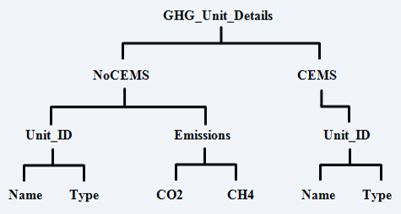

This document provides a step-by-step description of how to report emissions data using the XML schema. Please note the following:

- Non-applicable data elements should not be included in the facility’s XML file. The schema contains many data elements, some of which may not be applicable to XML reporters in general or to a particular situation. If a data element is not referenced in the instructions (definition tables), then do not report or include it in the facility’s XML file.

- Data elements must be reported in a specific order. The figures and tables in this document depict the specific sequence in which data elements must be arranged in the facility’s XML file in order to produce a well-formed XML report.

- Enumerations are case sensitive. Many data elements have a defined set of allowable values, also known as enumerations. Values for enumerations must be entered exactly as they are defined within the schema (including punctuation marks) in order to be accepted by schema validation. See the definition tables for a complete list of enumerations.

- Schema diagrams depict the hierarchy (or tree structure). The primary purpose of the schema diagrams is to indicate the sequence in which data elements must appear within the facility’s XML file and to identify the data elements that are required (must be reported) and conditionally required (see last bullet). Required data elements are boxed in red and conditionally required data elements are noted.

- Definition tables provide details for required and conditionally required data elements. The tables are designed to provide unique instructions for reporting a given data element, including the list of enumerations and required units of measure, if defined. As noted above, there are some data elements in the schema that are not applicable to XML reporters or to a particular situation. For example, the “OverrideIndicator” data element is used solely by e-GGRT to indicate that the web form reporter chose to override the system’s calculated value with their own. These non-applicable data elements are not included in the definition tables. If a data element is not referenced in a definition table, then do not report or include it in the facility’s XML file.

- Commonly used data types are not depicted in the schema diagrams nor listed separately in the definition tables. The schema diagrams display almost every data element in the schema except those that are associated with the three most commonly occurring data types:
- Calculated Details
- Measurement Details
- Unit Identification Details

Once defined, these data types (static collection of data elements) are then associated as children to every data element in the schema containing a measured or calculated value or unit details. These child data elements do not appear in the diagrams and are not listed on separate rows in the definition tables in order reduce their redundancy. They are however, referenced in the tables in the description of their parent data element. See Figures 2-4 and Tables 2-4.

- Some data elements are conditionally required. Data elements which are conditionally required are noted in the schema diagrams and the data element definitions tables. If your facility meets the condition specified for the data element, then the data element is required and you must report it in the facility’s XML file. If your facility does not meet the condition specified for the data element, then do not include the data element in the facility’s XML file. If a parent element is not required, then do not include any of its child data elements in the facility’s XML file.

- Calculated Details Data Type Schema Diagram
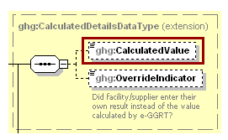
Note: Data elements boxed in red are required.

- Calculated Details Data Element Definitions

Data Element Name | Description
CalculatedDetailsDataType
CalculatedValue | Calculated value (decimal).
OverrideIndicator | Note: Do not include this data element in the facility’s XML file because it only applies to web form reporters. It is a flag set by e-GGRT to indicate that the system-calculated value was overridden with the web form reporter’s value.

- Measurement Details Data Type Schema Diagram
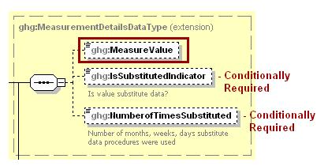
Note: Data elements boxed in red are required. Please see page 4 of this document
for more information on conditionally required elements.

- Measurement Details Data Element Definitions

Data Element Name | Description
MeasurementDetailsDataType
MeasureValue | Measured value (decimal).
IsSubstitutedIndicator | An indication (Y/N) that the measured value contains substituted data.  Note: Do not include this data element in your XML file unless noted in the instructions for the particular measured value.
NumberofTimesSubstituted | The number (integer) of days, months, weeks or hours in the reporting year that missing data procedures were followed.  Note: Do not include this data element in your XML file unless noted in the instructions for the particular measured value.

- Unit Identification Details Data Type Schema Diagram
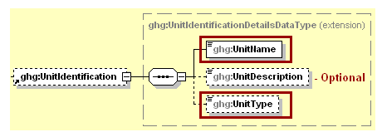
Note: Data elements boxed in red are required.

- Unit Identification Details Data Element Definitions

Data Element Name | Description
UnitIdentificationDetails
UnitName | A unique name (ID) for each unit so that the data for different units can be recorded, maintained and retrieved clearly.
UnitDescription | Optional brief description of the unit.
UnitType | The type of unit. The list of allowable values varies. For more information, see the instructions for the specific unit process to be reported. For example, if reporting Flare Gas details, the unit type would be “Flare”.

The XML symbol “1..∞” shown in Figure 5 means that the parent element is “unbounded” so that multiple instances of the parent element can be reported. XML Excerpt 1 shows an example of reporting multiple instances of a parent element.

- “Unbounded” Symbol in Schema Diagram
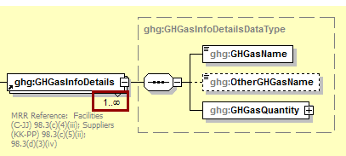

- Example for “Unbounded” Parent Element

<ghg:GHGasInfoDetails>
<ghg:GHGasName>Carbon Dioxide </ghg:GHGasName>
<ghg:GHGasQuantity massUOM="Metric Tons">
<ghg:CalculatedValue>384781.2</ghg:CalculatedValue>
</ghg:GHGasQuantity></ghg:GHGasInfoDetails>
<ghg:GHGasInfoDetails>
<ghg:GHGasInfoDetails>
<ghg:GHGasName>Methane</ghg:GHGasName>
<ghg:GHGasQuantity massUOM="Metric Tons">
<ghg:CalculatedValue>4004.12</ghg:CalculatedValue>
</ghg:GHGasQuantity></ghg:GHGasInfoDetails>
<ghg:GHGasInfoDetails>

The XML symbol for a logical “Or” shown in Figure 6 means that only one of the data elements following the symbol can be reported for the current instance of the parent element.

- Logical “Or” Symbol in Schema Diagram
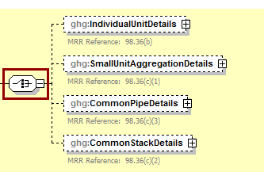

Summary of Changes

Substantive changes to the Subpart P XML schema and reporting guidelines for Reporting Year 2017 include:

- Summary of Changes to the Schema for Subpart P

No. | Change Description | Applicable Reporting Years
1 | New data elements in the GHGasInfoDetails node (GHGasCASRegistryNumber, GHGasLinearChemicalFormula, OtherGHGasCASRegistryNumber, and OtherGHGaslinearChemicalFormula) now appear in the schema but are only applicable to gases other than Carbon Dioxide, Methane, Nitrous Oxide, and Biogenic Carbon Dioxide so they should NOT be used in the reporting of Subpart P (see section 1, Subpart P Total Emissions) | 2017

Subpart P Overview

This document provides a step-by-step description of how to report data for Subpart P Hydrogen Production and overall total Subpart P emissions for a facility using the XML schema.

- Subpart P Reporting Diagram

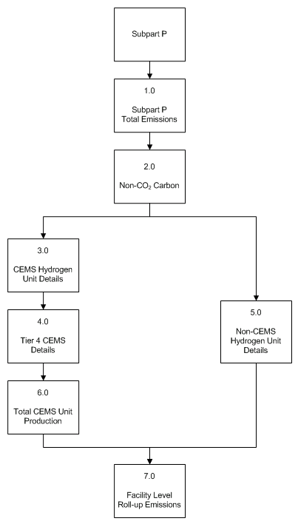

Subpart P is comprised of process units that produce hydrogen by reforming, gasification, oxidation, reaction or other transformations of feedstock and that sell the hydrogen gas or liquid as a product to other entities. Hydrogen production units that are located within other facilities are included in this source category if they are not owned by or under the direct control of the other facility’s owner and operator.

The XML schema includes the following areas for reporting for Subpart P, as displayed in the reporting diagram:

- Subpart P Total Emissions: includes the total emissions for greenhouse gases required to be reported.
- Non-CO₂ Carbon: annual quantity of carbon other than CO₂ collected and transferred off site.
- Continuous emissions monitoring system (CEMS) Hydrogen Unit Details: includes information on unit identification and the quantity of hydrogen and ammonia produced.
- Tier 4 CEMS Details: includes information on each CEMS monitoring location and emissions details.
- Non-CEMS Hydrogen Unit Details: includes information on unit identification, fuel and feedstock details, the quantity of hydrogen and ammonia produced and annual CO₂ emissions.
- Total CEMS Unit Production: includes hydrogen and ammonia produced by all units monitored by CEMS combined.
- Facility Level Roll-up Emissions: includes information on how to report total emissions for CO₂e (excluding biogenic CO₂) and biogenic CO₂.

NOTE: If your facility is subject to reporting under Subpart P (Hydrogen Production), EPA recommends that you also consider the following source categories in your facility applicability determination: Subpart C (General Stationary Fuel Combustion), Subpart X (Petrochemical Production), Subpart Y (Petroleum Refineries), Subpart OO (Suppliers of Industrial Greenhouse Gases) and Subpart PP (Suppliers of CO₂). These source categories are only provided as suggestions - additional Subparts may be relevant for a given facility/supplier and not all listed Subparts are relevant for all facilities/suppliers.

- Subpart P Schema Diagram

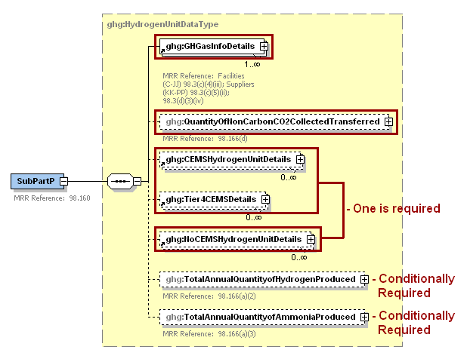
Note: Data elements boxed in red are required. Please see page 4 of this document
for more information on conditionally required elements.

Subpart P Total Emissions

Greenhouse gas information details comprise a collection of data elements to report the total annual emissions of each greenhouse gas (GHG) listed in Table A-1 of 40 CFR 98 Mandatory Reporting of Greenhouse Gases reported under Subpart P, expressed in metric tons.

- Greenhouse Gas Information Details Schema Diagram

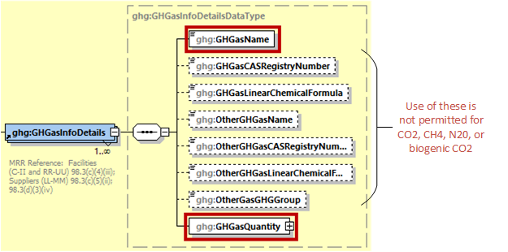
Note: Data elements boxed in red are required.

For Subpart P, report the gas name and emissions for biogenic carbon dioxide (CO₂) and CO₂ (excluding biogenic CO₂; do NOT report the CAS Registry Number, Linear Chemical Formula, or the other gas data elements for CO2 or biogenic CO2. using the following guidelines.

- Total CO₂ emissions (excluding biogenic CO₂):
- Add the annual CO₂ emissions from each hydrogen processing unit in metric tons.
- Add the total annual CO₂ mass emissions measured by the CEMS in metric tons for each CEMS monitoring location (CML).
- Subtract the total annual biogenic CO₂ mass emissions in metric tons for each CML.
- Total biogenic CO₂ emissions: Add the total annual biogenic CO₂ mass emissions in metric tons for each CML.

Note: You must follow the rounding rules found in Table 1.

- Greenhouse Gas Information Details Data Element Definitions

Data Element Name | Description
GHGasInfoDetails | Parent Element: A collection of data elements containing the total annual emissions of each greenhouse gas (GHG) listed in Table A-1 of 40 CFR 98 Mandatory Reporting of Greenhouse Gases reported under this Subpart, expressed in metric tons.
GHGasName | Specify the name of the GHG. See list of allowable values:  Carbon Dioxide  Biogenic Carbon dioxide
GHGasQuantity | A collection of data elements that quantify the annual emissions from this facility category. Report the value in the child data element CalculatedValue using the guidelines above. Set the units of measure to “Metric Tons” in the attribute massUOM.

- Example for Greenhouse Gas Information Details
<ghg:SubPartP>
<ghg:GHGasInfoDetails>
<ghg:GHGasName>Biogenic Carbon dioxide</ghg:GHGasName>
<ghg:GHGasQuantity massUOM="Metric Tons">
<ghg:CalculatedValue>150.4</ghg:CalculatedValue>
</ghg:GHGasQuantity>
</ghg:GHGasInfoDetails>
<ghg:GHGasInfoDetails>
<ghg:GHGasName>Carbon Dioxide</ghg:GHGasName>
<ghg:GHGasQuantity massUOM="Metric Tons">
<ghg:CalculatedValue>102350.2</ghg:CalculatedValue>
</ghg:GHGasQuantity>
</ghg:GHGasInfoDetails>

Note: The code excerpt above is presented here to demonstrate the concept of reporting greenhouse gas emissions data.

Non-CO₂ Carbon

Subpart P requires that the facility report the annual quantity of carbon other than CO₂ collected and transferred off site in either gas, liquid or solid forms (kg carbon) [98.166(d)].

- Non-CO₂ Carbon Schema Diagram

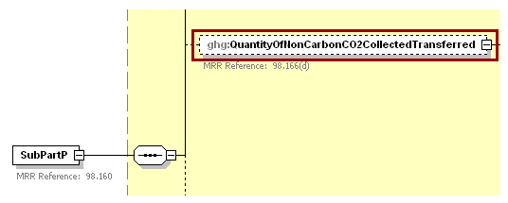
Note: Data elements boxed in red are required.

- Non-CO₂ Carbon Data Element Definitions

Data Element Name | Description
QuantityOfNonCarbonCO2CollectedTransferred | A collection of data elements containing information on the quantity of non-CO₂ carbon collected and transferred off site. It includes the annual quantity of carbon other than CO₂ collected and transferred off site in either gas, liquid or solid forms (kg carbon). [98.166(d)] Report the value in the child data element MeasureValue. Set the units of measure to “Kilograms” in the attribute massUOM.

- Example for Non-CO₂ Carbon

<ghg:QuantityOfNonCarbonCO2CollectedTransferred massUOM="Kilograms">
<ghg:MeasureValue>10000.234343</ghg:MeasureValue>
</ghg:QuantityOfNonCarbonCO2CollectedTransferred>

Note: The code excerpt above is presented here to demonstrate the concept of reporting non-CO₂ carbon collected and transferred off site.

CEMS Hydrogen Unit Details

Conditionally Required: For each hydrogen production processing unit for which CEMS is used to measure greenhouse gas emissions, report the following:

- A unique name or identifier, an optional description and the unit type, “Hydrogen production process unit” [98.166(a)(1)].
- Annual quantity of hydrogen produced (metric tons) [98.166(a)(2)].
- Annual quantity of ammonia produced (metric tons) [98.166(a)(3)].
- Annual quantity of methanol produced (metric tons) [98.166(e)].

- CEMS Hydrogen Unit Details Schema Diagram
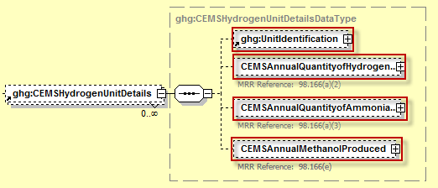

Note: Data elements boxed in red are required.

- CEMS Unit Details Data Element Definitions

Data Element Name | Description
CEMSHydrogenUnitDetails | Parent Element (Conditionally Required): A collection of data elements containing details about units which were monitored using a CEMS.
UnitIdentification | A collection of data elements containing the identity of each hydrogen processing unit monitored by a CEMS. [98.166(a)(1)] Report a unique unit name (ID) in the child data element UnitName, an optional brief description in the child data element UnitDescription and the type of unit in the child data element UnitType: "Hydrogen production process unit".
CEMSAnnualQuantityofHydrogenProduced | A collection of data elements containing information on the quantity of hydrogen produced by the specified unit. [98.166(a)(2)] It includes the annual quantity of hydrogen produced. Report the value in the child data element MeasureValue. Set the units of measure to “Metric Tons” in the attribute massUOM.
CEMSAnnualQuantityofAmmoniaProduced | A collection of data elements for the specified hydrogen production process unit containing information on the annual quantity of ammonia produced. [98.166(a)(3)] Report the value in the child data element MeasureValue. Set the units of measure to “Metric Tons” in the attribute massUOM.
CEMSAnnualQuantityofMethanolProduced | A collection of data elements for the specified hydrogen production process unit containing information on the annual quantity of ammonia produced. [98.166(e)] Report the value in the child data element MeasureValue. Set the units of measure to “Metric Tons” in the attribute massUOM.

- Example for CEMS Unit Details

<ghg:CEMSHydrogenUnitDetails>
<ghg:UnitIdentification>
<ghg:UnitName>002- CEMS</ghg:UnitName>
<ghg:UnitDescription>CEMS unit</ghg:UnitDescription>
<ghg:UnitType>Hydrogen production process unit</ghg:UnitType>
</ghg:UnitIdentification>
<ghg:CEMSAnnualQuantityofHydrogenProduced massUOM="Metric Tons">
<ghg:MeasureValue>3300.789076</ghg:MeasureValue>
</ghg:CEMSAnnualQuantityofHydrogenProduced>
<ghg:CEMSAnnualQuantityofAmmoniaProduced massUOM="Metric Tons">
<ghg:MeasureValue>4400.234678</ghg:MeasureValue>
</ghg:CEMSAnnualQuantityofAmmoniaProduced>
<ghg:CEMSAnnualQuantityofMethanooProduced massUOM="Metric Tons">
<ghg:MeasureValue>3477.234678</ghg:MeasureValue>
</ghg:CEMSAnnualQuantityofMethanolProduced>
</ghg:CEMSHydrogenUnitDetails>

Note: The code excerpt above is presented here to demonstrate the concept of reporting details for a hydrogen production process unit monitored by a CEMS.

Tier 4 CEMS Details

Conditionally Required: This section describes emissions information that must be reported if a continuous emissions monitoring system (CEMS) was in use during the reporting year.

- Tier 4 CEMS Details Schema Diagram
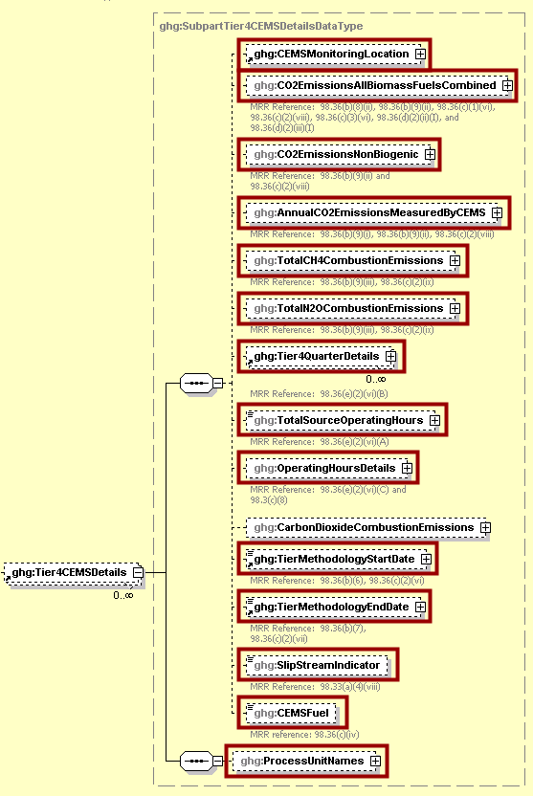
Note: Data elements boxed in red are required.
- Tier 4 CEMS Location and Emissions Details Schema Diagram
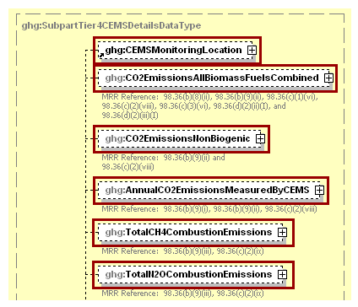
Note: Data elements boxed in red are required.

For Subpart P, information on each CEMS monitoring location (CML) is required including the name, an optional description and the configuration type. [98.36(c)(2)(i)] For each CML identified by the facility, the facility must specify the configuration type from the following list:

- Single industrial process or process unit that exhausts to a dedicated stack.
- Multiple industrial processes or process units share a common stack.
- Industrial process or process unit shares a common stack with a Tier 4 stationary fuel combustion unit.

For each CEMS monitoring location identified, the following emissions data must be reported:

- The total annual biogenic CO₂ mass emissions from combustion of all biomass fuels combined [98.36(b)(9)(ii)]
- The total annual non-biogenic CO₂ mass emissions (i.e. CO₂ mass emissions from fossil fuels, sorbent use and process emissions) [98.36(b)(9)(ii)]
- The total annual CO₂ mass emissions (biogenic and non-biogenic) measured by the CEMS [98.36(b)(9)(i)-(ii)]
- The total annual CH₄ mass emissions derived from Equation C-10, in metric tons CH₄ [98.36(c)(2)(ix), 98.166(a)] Note: Report CH₄ combustion emissions from fuels referenced in Table C-2 of the MRR only. If there are no combustion emissions from Table C-2 fuels in the CEMS Monitoring Location, please report 0.
- The total annual N₂O mass emissions derived from Equation C-10, in metric tons N₂O [98.36(c)(2)(ix), 98.166(a)] Note: Report N₂O combustion emissions from fuels referenced in Table C-2 of the MRR only. If there are no combustion emissions from Table C-2 fuels in the CEMS Monitoring Location, please report 0.

- Tier 4 CEMS Location and Emissions Details Data Element Definitions

Data Element Name | Description
Tier4CEMSDetails | Parent Element (Conditionally Required): A collection of data elements containing information about a CEMS monitoring location (CML).
CEMSMonitoringLocation | A collection of data elements containing the identity of each CEMS monitoring location. [98.36(c)(2)(i)] Report a unique CML name (ID) in the child data element Name, an optional brief description in the child data element Description and the type of configuration in the child data element Type. See the list of allowable configuration types:  Single process/process unit exhausts to dedicated stack  Multiple processes/process units share common stack  Process/stationary combustion units share common stack
CO2EmissionsAllBiomassFuelsCombined | Total annual biogenic CO₂ mass emissions for the specified CEMS monitoring location. [98.36(b)(9)(ii), 98.36(c)(2)(viii)] Report the value in the child data element CalculatedValue. Set the units of measure to “Metric Tons” in the attribute massUOM.
CO2EmissionsNonBiogenic | The total annual non-biogenic CO₂ mass emissions for the specified CEMS monitoring location. [98.36(b)(9)(ii), 98.36(c)(2)(viii)] Report the value in the child data element CalculatedValue. Set the units of measure to “Metric Tons” in the attribute massUOM.
AnnualCO2EmissionsMeasuredByCEMS | The total annual CO₂ mass emissions measured by the CEMS at the specified CEMS monitoring location. [98.36(b)(9)(i)-(ii), 98.36(c)(2)(viii)] Report the value in the child data element CalculatedValue. Set the units of measure to “Metric Tons” in the attribute massUOM.
TotalCH4CombustionEmissions | The total annual CH₄ mass emissions measured by the CEMS at the specified CEMS monitoring location calculated using Equation C-10 expressed in mass of CH₄. [98.36(c)(2)(ix), 98.166(a)(1)] Report the value in the child data element CalculatedValue. Set the units of measure to “Metric Tons” in the attribute massUOM.
TotalN2OCombustionEmissions | The total annual N₂O mass emissions measured by the CEMS at the specified CEMS monitoring location calculated using Equation C-10 expressed in mass of N₂O. [98.36(c)(2)(ix), 98.166(a)(1)] Report the value in the child data element CalculatedValue. Set the units of measure to “Metric Tons” in the attribute massUOM.

- Example for Tier 4 CEMS Location and Emissions Details
<ghg:Tier4CEMSDetails>
<ghg:CEMSMonitoringLocation>
<ghg:Name>003- CML</ghg:Name>
<ghg:Description>CML</ghg:Description>
<ghg:Type>Single process/process unit exhausts to dedicated stack</ghg:Type>
</ghg:CEMSMonitoringLocation>
<ghg:CO2EmissionsAllBiomassFuelsCombined massUOM="Metric Tons">
<ghg:CalculatedValue>150.2</ghg:CalculatedValue>
</ghg:CO2EmissionsAllBiomassFuelsCombined>
<ghg:CO2EmissionsNonBiogenic massUOM="Metric Tons">
<ghg:CalculatedValue>140.3</ghg:CalculatedValue>
</ghg:CO2EmissionsNonBiogenic>
<ghg:AnnualCO2EmissionsMeasuredByCEMS massUOM="Metric Tons">
<ghg:CalculatedValue>100000.5</ghg:CalculatedValue>
</ghg:AnnualCO2EmissionsMeasuredByCEMS>
<ghg:TotalCH4CombustionEmissions massUOM="Metric Tons">
<ghg:CalculatedValue>111.22</ghg:CalculatedValue>
</ghg:TotalCH4CombustionEmissions>
<ghg:TotalN2OCombustionEmissions massUOM="Metric Tons">
<ghg:CalculatedValue>11.333</ghg:CalculatedValue>
</ghg:TotalN2OCombustionEmissions>

Note: The code excerpt above is presented here to demonstrate the concept of reporting CEMS monitoring location and emissions details.

- Tier 4 CEMS Quarter and Additional Details Schema Diagram

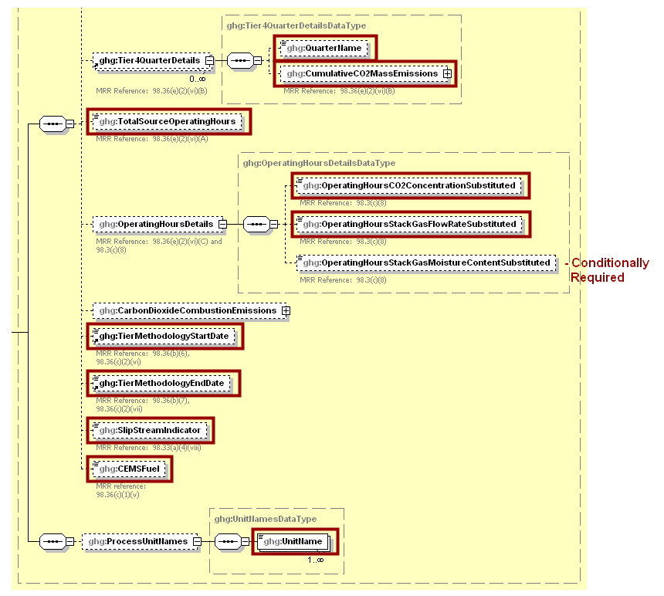
Note: Data elements boxed in red are required. Please see page 4 of this document
for more information on conditionally required elements.

For each quarter of the reporting year, the facility must provide the cumulative CO₂ mass emissions for each CML [98.36(e)(2)(vi)(B)].

The facility must provide the following additional information for each CML:
  - The total number of source operating hours in the reporting year [98.36(e)(2)(vi)(A)]
  - The total operating hours in which a substitute data value was used in the emissions calculations for the CO₂ concentration parameter [98.36(e)(2)(vi)(C), 98.3(c)(8)]
  - The total operating hours in which a substitute data value was used in the emissions calculations for the stack gas flow rate parameter [98.36(e)(2)(vi)(C), 98.3(c)(8)]
  - Conditionally Required: If moisture correction is required and a continuous moisture monitor is used, the total operating hours in which a substitute data value was used in the emissions calculations for the stack gas moisture content parameter [98.36(e)(2)(vi)(C), 98.3(c)(8)]
  - The Tier 4 methodology start date [98.36(b)(6), 98.36(c)(2)(vi)]
  - The Tier 4 methodology end date [98.36(b)(7), 98.36(c)(2)(vii)]
  - Specify if emissions reported for the CEMS include emissions calculated according to 98.33(a)(4)(viii) for a slipstream that bypassed the CEMS [98.33(a)(4)(viii)]
  - Each type of fuel combusted in the group of units during the reporting year [98.36(b)(4), 98.36(c)(2)(iv)]
  - The name of each hydrogen production process unit sharing the stack. [98.166(a)(1)] Note: Use the same identification for each unit as was used for the parent element “CEMSHydrogenUnitDetails”.

- Tier 4 CEMS Quarter and Additional Details Data Element Definitions

Data Element Name | Description
Tier4QuarterDetails | Parent Element
QuarterName | The name of the quarter. See list of allowable values:  First Quarter  Second Quarter  Third Quarter  Fourth Quarter
CumulativeCO2MassEmissions | The cumulative CO₂ mass emissions for the specified CEMS monitoring location for the specified quarter of the reporting year. [98.36(e)(2)(vi)(B)] Report the value in the child data element CalculatedValue. Set the units of measure to “Metric Tons” in the attribute massUOM.
TotalSourceOperatingHours | The total number of source operating hours in the reporting year for the specified CEMS monitoring location. [98.36(e)(2)(vi)(A)]
OperatingHoursDetails | Parent Element
OperatingHoursCO2ConcentrationSubstituted | The total operating hours in which a substitute data value was used in the emissions calculations for the CO₂ concentration parameter at the specified CEMS monitoring location. [98.36(e)(2)(vi)(C), 98.3(c)(8)]
OperatingHoursStackGasFlowRateSubstituted | The total operating hours in which a substitute data value was used in the emissions calculations for the stack gas flow rate parameter at the specified CEMS monitoring location. [98.36(e)(2)(vi)(C), 98.3(c)(8)]
OperatingHoursStackGasMoistureContentSubstituted | Conditionally Required: If moisture correction is required and a continuous moisture monitor is used, the total operating hours in which a substitute data value was used in the emissions calculations for the stack gas moisture content parameter at the specified CEMS monitoring location. Otherwise do not include this data element in your XML file. [98.36(e)(2)(vi)(C), 98.3(c)(8)]
TierMethodologyStartDate | The tier methodology start date for the specified CEMS monitoring location (YYYY-MM-DD). [98.36(b)(6), 98.36(c)(2)(vi)]
TierMethodologyEndDate | The tier methodology end date for the specified CEMS monitoring location (YYYY-MM-DD). [98.36(b)(7), 98.36(c)(2)(vii)]
SlipStreamIndicator | An indication (Y/N) that the emissions reported for the CEMS include emissions calculated according to 98.33(a)(4)(viii) for a slipstream that bypassed the CEMS. [98.33(a)(4)(viii)]
CEMSFuel | Each type of fuel combusted in the group of units during the reporting year. [98.36(b)(4), 98.36(c)(2)(iv)]
ProcessUnitNames | Parent Element: A collection of data elements identifying each unit or furnace which was monitored at the specified CEMS monitoring location.
UnitName | The unique name of each hydrogen production process unit that is monitored at the specified CEMS Monitoring Location. [98.166(a)(1)] Report each unit separately. Note: Use the same identification for each unit as was used for the parent element “CEMSHydrogenUnitDetails”.

- Example for Tier 4 CEMS Quarter and Additional Details
<ghg:Tier4QuarterDetails>
<ghg:QuarterName>First Quarter</ghg:QuarterName>
<ghg:CumulativeCO2MassEmissions massUOM="Metric Tons">
<ghg:CalculatedValue>10000.6</ghg:CalculatedValue>
</ghg:CumulativeCO2MassEmissions>
</ghg:Tier4QuarterDetails>
<ghg:Tier4QuarterDetails>
<ghg:QuarterName>Second Quarter</ghg:QuarterName>
<ghg:CumulativeCO2MassEmissions massUOM="Metric Tons">
<ghg:CalculatedValue>20000.3</ghg:CalculatedValue>
</ghg:CumulativeCO2MassEmissions>
</ghg:Tier4QuarterDetails>
<ghg:Tier4QuarterDetails>
<ghg:QuarterName>Third Quarter</ghg:QuarterName>
<ghg:CumulativeCO2MassEmissions massUOM="Metric Tons">
<ghg:CalculatedValue>30000.5</ghg:CalculatedValue>
</ghg:CumulativeCO2MassEmissions>
</ghg:Tier4QuarterDetails>
<ghg:Tier4QuarterDetails>
<ghg:QuarterName>Fourth Quarter</ghg:QuarterName>
<ghg:CumulativeCO2MassEmissions massUOM="Metric Tons">
<ghg:CalculatedValue>40000.2</ghg:CalculatedValue>
</ghg:CumulativeCO2MassEmissions>
</ghg:Tier4QuarterDetails>
<ghg:TotalSourceOperatingHours>8400</ghg:TotalSourceOperatingHours>
<ghg:OperatingHoursDetails>
<ghg:OperatingHoursCO2ConcentrationSubstituted>20</ghg:OperatingHoursCO2ConcentrationSubstituted>
<ghg:OperatingHoursStackGasFlowRateSubstituted>30</ghg:OperatingHoursStackGasFlowRateSubstituted>
<ghg:OperatingHoursStackGasMoistureContentSubstituted>40</ghg:OperatingHoursStackGasMoistureContentSubstituted>
</ghg:OperatingHoursDetails>
<ghg:TierMethodologyStartDate>2011-01-01</ghg:TierMethodologyStartDate>
<ghg:TierMethodologyEndDate>2011-12-31</ghg:TierMethodologyEndDate>
<ghg:SlipStreamIndicator>Y</ghg:SlipStreamIndicator>
<ghg:CEMSFuel>coal, coke, natural gas</ghg:CEMSFuel>
<ghg:ProcessUnitNames>
<ghg:UnitName>002- CEMS</ghg:UnitName>
<ghg:UnitName>003- CEMS</ghg:UnitName>
</ghg:ProcessUnitNames>
</ghg:Tier4CEMSDetails>

Note: The code excerpt above is presented here to demonstrate the concept of reporting Tier 4 CEMS details.

Non-CEMS Hydrogen Unit Details and Emissions

Conditionally Required: If a CEMS is not used to measure CO₂ emissions, then you must report the following information for each hydrogen production process unit:

- A unique name or identifier, an optional description and the unit type, “Hydrogen production process unit” for each unit [98.166(b)(1)].
- A unique name or identifier plus the phase for each fuel or feedstock. [98.166(b)(2)]
- Indicate if any monthly values used for your emissions calculation are based on substitute data values for each feedstock for each unit. For each month, indicate if:
- Consumption is based on one or more substitute data values. [98.166(b)(2) and 98.3(c)(8)]
- Carbon content is based on one or more substitute data values. [98.166(b)(5) and 98.3(c)(8)]
- Conditionally Required: Molecular weight is based on one or more substitute data values (gaseous feedstock only). [98.166(b)(6) and 98.3(c)(8)]
- Annual quantity of hydrogen produced (metric tons) [98.166(b)(3)].
- Annual quantity of ammonia produced (metric tons) [98.166(b)(4)].
- Name and annual quantity of each carbon-containing fuel and feedstock (metric tons) [98.166(b)(7)].
- Annual methanol production for each process unit (metric tons) [98.166(e)].
- Total annual CO₂ emissions for each feedstock processing unit [98.166(b)(1)]. The annual CO₂ emissions value for the unit is the sum of annual emissions associated with each fuel and feedstock calculated using the following equations:
- For each gaseous fuel and feedstock, use Equation P-1 [98.163(b)(1)].
- For each liquid fuel and feedstock, use Equation P-2 [98.163(b)(2)].
- For each solid fuel and feedstock, use Equation P-3 [98.163(b)(3)].

- Non-CEMS Hydrogen Unit Details and Emissions Schema Diagram

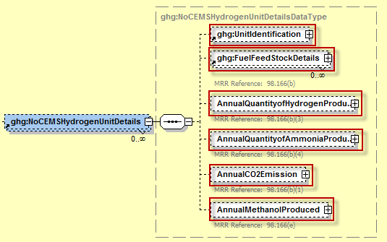

Note: Data elements boxed in red are required.
- Fuel Feedstock Details Schema Diagram

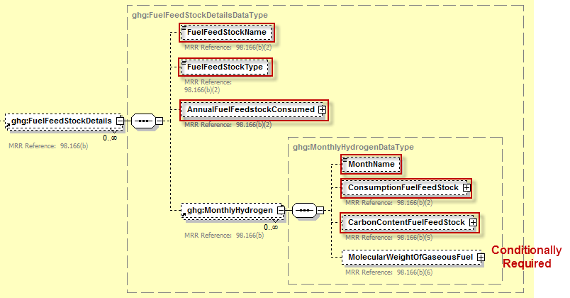

Note: Data elements boxed in red are required. Please see page 4 of this document
for more information on conditionally required elements.

- Non-CEMS Hydrogen Unit Details and Emissions Factors Data Element Definitions

Data Element Name | Description
NoCEMSHydrogenUnitDetails | Parent Element (Conditionally Required): A collection of data elements containing details for units which were not monitored using a CEMS.
UnitIdentification | A collection of data elements containing the identity of each hydrogen production processing unit which was not monitored using a CEMS. [98.166(b)(1)] Report a unique unit name (ID) in the child data element UnitName, an optional brief description in the child data element UnitDescription and the type of unit in the child data element UnitType: "Hydrogen production process unit".
FuelFeedStockDetails | Parent Element: A collection of data elements containing information on each fuel and or feedstock used in the specified unit.
FuelFeedStockName | A unique name/description for each fuel/feedstock used in the specified hydrogen production process unit during the reporting year. [98.166(b)(2)]
FuelFeedStockType | The phase of the specified fuel/feedstock used in the specified hydrogen production process unit during the reporting year. [98.166(b)(2)] See list of allowable values:  gaseous feedstock  liquid feedstock  solid feedstock
AnnualFuelFeedstockConsumed | A collection of data elements for the specified hydrogen production process unit containing information on the annual fuel feedstock consumed AnnualFuelFeedstockConsumed [98.166(b)(2)] Report the value in the child data element MeasureValue.
MonthlyHydrogen | Parent Element: A collection of data elements containing information on whether substitute data values were used for data for the specified fuel/feedstock for the specified unit for each month.
MonthName | Unique month name. See list of allowable values:  January  February  March  April  May  June  July  August  September  October  November  December
ConsumptionFuelFeedStock | For the specified fuel/feedstock, indicate (Y/N) if the consumption for the specified month is based on one or more substitute data values in the child data element IsSubstitutedIndicator. [98.166(b)(2), 98.3(c)(8)]
CarbonContentFuelFeedStock | For the specified fuel/feedstock, indicate (Y/N) if the carbon content for the specified month is based on one or more substitute data values in the child data element IsSubstitutedIndicator. [98.166(b)(5), 98.3(c)(8)]
MolecularWeightOfGaseousFuel | Conditionally Required: For the specified fuel/feedstock, if of the gaseous phase, indicate (Y/N) if the molecular weight for the specified month is based on one or more substitute data values in the child data element IsSubstitutedIndicator. Otherwise do not include this data element in your XML file. [98.166(b)(6), 98.3(c)(8)]
AnnualQuantityofHydrogenProduced | A collection of data elements for the specified hydrogen production process unit containing information on the annual quantity of hydrogen produced. [98.166(b)(3)] Report the value in the child data element MeasureValue. Set the units of measure to “Metric Tons” in the attribute massUOM.
AnnualQuantityofAmmoniaProduced | A collection of data elements for the specified hydrogen production process unit containing information on the annual quantity of ammonia produced. [98.166(b)(4)] Report the value in the child data element MeasureValue. Set the units of measure to “Metric Tons” in the attribute massUOM.
AnnualQuantityofMethanolProduced | A collection of data elements for the specified hydrogen production process unit containing information on the annual quantity of methanol produced. [98.166(e)] Report the value in the child data element MeasureValue, IsSubstituteIndicator, and NumberofTimeSubstituted.
AnnualCO2Emission | A collection of data elements for the total annual CO₂ emissions from the specified hydrogen production process unit. [98.166(b)(1)] Report the value in the child data element CalculatedValue. Set the units of measure to “Metric Tons” in the attribute massUOM.

- Example for Non-CEMS Hydrogen Unit Details and Emissions
<ghg:NoCEMSHydrogenUnitDetails>
<ghg:UnitIdentification>
<ghg:UnitName>001- Non-CEMS</ghg:UnitName>
<ghg:UnitDescription>Non-CEMS unit</ghg:UnitDescription>
<ghg:UnitType>Hydrogen production process unit</ghg:UnitType>
</ghg:UnitIdentification>
<ghg:FuelFeedStockDetails>
<ghg:FuelFeedStockName>Fuel A</ghg:FuelFeedStockName>
<ghg:FuelFeedStockType>gaseous feedstock</ghg:FuelFeedStockType>
<ghg:MonthlyHydrogen>
<ghg:MonthName>January</ghg:MonthName>
<ghg:ConsumptionFuelFeedStock>
<ghg:IsSubstitutedIndicator>Y</ghg:IsSubstitutedIndicator>
</ghg:ConsumptionFuelFeedStock>
<ghg:CarbonContentFuelFeedStock>
<ghg:IsSubstitutedIndicator>Y</ghg:IsSubstitutedIndicator>
</ghg:CarbonContentFuelFeedStock>
<ghg:MolecularWeightOfGaseousFuel>
<ghg:IsSubstitutedIndicator>Y</ghg:IsSubstitutedIndicator>
</ghg:MolecularWeightOfGaseousFuel>
</ghg:MonthlyHydrogen>
<ghg:MonthlyHydrogen>
<ghg:MonthName>February</ghg:MonthName>
<ghg:ConsumptionFuelFeedStock>
<ghg:IsSubstitutedIndicator>N</ghg:IsSubstitutedIndicator>
</ghg:ConsumptionFuelFeedStock>
<ghg:CarbonContentFuelFeedStock>
<ghg:IsSubstitutedIndicator>N</ghg:IsSubstitutedIndicator>
</ghg:CarbonContentFuelFeedStock>
<ghg:MolecularWeightOfGaseousFuel>
<ghg:IsSubstitutedIndicator>N</ghg:IsSubstitutedIndicator>
</ghg:MolecularWeightOfGaseousFuel>
</ghg:MonthlyHydrogen>
<ghg:MonthlyHydrogen>
<ghg:MonthName>March</ghg:MonthName>
<ghg:ConsumptionFuelFeedStock>
<ghg:IsSubstitutedIndicator>N</ghg:IsSubstitutedIndicator>
</ghg:ConsumptionFuelFeedStock>
<ghg:CarbonContentFuelFeedStock>
<ghg:IsSubstitutedIndicator>N</ghg:IsSubstitutedIndicator>
</ghg:CarbonContentFuelFeedStock>
<ghg:MolecularWeightOfGaseousFuel>
<ghg:IsSubstitutedIndicator>N</ghg:IsSubstitutedIndicator>
</ghg:MolecularWeightOfGaseousFuel>
</ghg:MonthlyHydrogen>
</ghg:FuelFeedStockDetails>
<ghg:AnnualQuantityofHydrogenProduced massUOM="Metric Tons">
<ghg:MeasureValue>1111.23654</ghg:MeasureValue>
</ghg:AnnualQuantityofHydrogenProduced>
<ghg:AnnualQuantityofAmmoniaProduced massUOM="Metric Tons">
<ghg:MeasureValue>2222.25874</ghg:MeasureValue>
</ghg:AnnualQuantityofAmmoniaProduced>
<ghg:AnnuualCO2Emission massUOM="Metric Tons">
<ghg:CalculatedValue>2500.5</ghg:CalculatedValue>
</ghg:AnnuualCO2Emission>
<ghg:AnnualMethanolProduced massUOM="Metric Tons">
<ghg:MeasureValue>1111.23654</ghg:MeasureValue>
<ghg:IsSubstitutedIndicator>N</ghg:IsSubstitutedIndicator>
</ghg:AnnualMethanolProduced>

</ghg:NoCEMSHydrogenUnitDetails>

Note: The code excerpt above is presented here to demonstrate the concept of reporting non-CEMS hydrogen unit details and emissions.

Total CEMS Unit Production

Conditionally Required: If a CEMS is used to measure CO₂ emissions, then you must report the following information:

- Annual quantity of hydrogen produced (metric tons) for all CEMS process units combined [98.166(a)(2)].
- Annual quantity of ammonia produced (metric tons) for all CEMS process units combined [98.166(a)(3)].

- Total CEMS Unit Production Schema Diagram
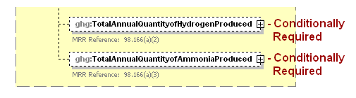
Note: Data elements boxed in red are required. Please see page 4 of this document
for more information on conditionally required elements.

- Total CEMS Unit Production Data Element Definitions

Data Element Name | Description
TotalAnnualQuantityofHydrogenProduced | Conditionally Required: A collection of data elements containing the annual quantity of hydrogen produced by all units monitored by CEMS combined. [98.166(a)(2)] This data element is required if reporting CEMS unit(s). Otherwise do not include this data element in your XML file. Report the value in the child data element MeasureValue. Set the units of measure to “Metric Tons” in the attribute massUOM.
TotalAnnualQuantityofAmmoniaProduced | Conditionally Required: A collection of data elements containing the annual quantity of ammonia produced by all units monitored by CEMS combined. [98.166(a)(3)] This data element is required if reporting CEMS unit(s). Otherwise do not include this data element in your XML file. Report the value in the child data element MeasureValue. Set the units of measure to “Metric Tons” in the attribute massUOM.

- Example for Total CEMS Unit Production
<ghg:TotalAnnualQuantityofHydrogenProduced massUOM="Metric Tons">
<ghg:MeasureValue>3333.87987</ghg:MeasureValue>
</ghg:TotalAnnualQuantityofHydrogenProduced>
<ghg:TotalAnnualQuantityofAmmoniaProduced massUOM="Metric Tons">
<ghg:MeasureValue>4444.2349001</ghg:MeasureValue>
</ghg:TotalAnnualQuantityofAmmoniaProduced>
</ghg:SubPartP>

Note: The code excerpt above is presented here to demonstrate the concept of reporting total CEMS unit production.

Facility Level Roll-up Emissions

Each facility must report the following facility-level emission totals:
- Total CO₂ equivalent (CO₂e) emissions (excluding biogenic CO₂) aggregated across all direct emitter source categories (Subparts C-HH) associated with the facility.
- Total biogenic CO₂ emissions aggregated across all direct emitter source categories (Subparts C-HH) associated with the facility.

Each supplier must report the following supplier totals:
- Total CO₂e associated with products supplied aggregated across Subparts NN, OO and PP (as applicable). Note: Do not include Subpart LL and MM totals in this data element as these values are not being collected in e-GGRT.

- Facility Level Roll-up Emissions Schema Diagram

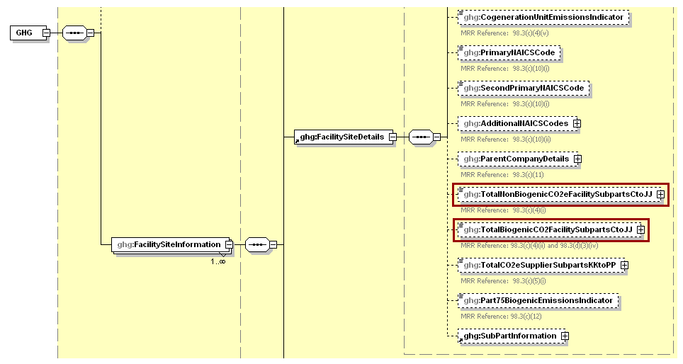
Note: Data elements boxed in red are required.

For Subpart P, report total emissions for CO₂e (excluding biogenic CO₂) and biogenic CO₂ using the following guidelines.

- Add the total CO₂e value for Subpart P in metric tons to the total CO₂e emissions (excluding biogenic CO₂) aggregated across all source category Subparts associated with the facility as follows:

- Add the annual CO₂ emissions from each hydrogen processing unit in metric tons.
- Add the total annual CO₂ mass emissions measured by the CEMS in metric tons for each CEMS monitoring location (CML) minus the total annual biogenic CO₂ mass emissions in metric tons (the difference of the total CO₂ monitored by the CEMS and the total biogenic CO₂) for each CML.

- Add the total annual biogenic CO₂ mass emissions in metric tons for each CML to the total biogenic CO₂ aggregated across all source category Subparts associated with the facility.

Note: You must follow the rounding rules found in Table 1.

- Facility Level Roll-up Emissions Data Element Definitions

Data Element Name | Description
TotalNonBiogenicCO2eFacilitySubpartsCtoJJ | Add the total CO₂e value for Subpart P in metric tons to the total CO₂e emissions (excluding biogenic CO₂) aggregated across all source category Subparts associated with the facility according to the guidelines above. [98.3(c)(4)(i)] Set the units of measure to “Metric Tons” in the attribute massUOM.
TotalBiogenicCO2FacilitySubpartsCtoJJ | Add the total annual biogenic CO₂ value for Subpart P in metric tons to the total biogenic CO₂ emissions aggregated across all source category Subparts associated with the facility according to the guideline above. [98.3(c)(4)(ii)] Set the units of measure to “Metric Tons” in the attribute massUOM.

- Example for Facility Level Roll-up Emissions

<ghg:TotalNonBiogenicCO2eFacilitySubpartsCtoJJ massUOM="Metric Tons">102350.7</ghg:TotalNonBiogenicCO2eFacilitySubpartsCtoJJ>
<ghg:TotalBiogenicCO2FacilitySubpartsCtoJJ massUOM="Metric Tons">150.6</ghg:TotalBiogenicCO2FacilitySubpartsCtoJJ>

Note: The code excerpt above is presented here to demonstrate the concept of reporting facility level roll-up emissions.

Appendix A

Sample XML Document for Subpart P

(Note: Data values do not reflect an actual facility's emissions. Additional sample XML files for Subpart D are posted on the e-GGRT help site. http://www.ccdsupport.com/confluence/display/help/Additional+XML+Examples )

<ghg:GHG xmlns="http://www.ccdsupport.com/schema/ghg">
<ghg:FacilitySiteInformation>
<ghg:CertificationStatement>The designated representative or alternate designated representative must sign (i.e., agree to) this certification statement. If you are an agent and you click on "SUBMIT", you are not agreeing to the certification statement, but are submitting the certification statement on behalf of the designated representative or alternate designated representative who is agreeing to the certification statement. An agent is only authorized to make the electronic submission on behalf of the designated representative, not to sign (i.e., agree to) the certification statement.</ghg:CertificationStatement>
<ghg:ReportingYear>2011</ghg:ReportingYear>
<ghg:FacilitySiteDetails>
<ghg:FacilitySite>
<ghg:FacilitySiteIdentifier>524097</ghg:FacilitySiteIdentifier>
<ghg:FacilitySiteName>Test Facility P</ghg:FacilitySiteName>
</ghg:FacilitySite>
<ghg:LocationAddress>
<ghg:LocationAddressText>1 Main St.</ghg:LocationAddressText>
<ghg:LocalityName>Charlottesville</ghg:LocalityName>
<ghg:StateIdentity>
<ghg:StateCode>VA</ghg:StateCode>
</ghg:StateIdentity>
<ghg:AddressPostalCode>22911</ghg:AddressPostalCode>
</ghg:LocationAddress>
<ghg:CogenerationUnitEmissionsIndicator>N</ghg:CogenerationUnitEmissionsIndicator>
<ghg:PrimaryNAICSCode>325120</ghg:PrimaryNAICSCode>
<ghg:ParentCompanyDetails>
<ghg:ParentCompany>
<ghg:ParentCompanyLegalName>Soda Ash Corporation</ghg:ParentCompanyLegalName>
<ghg:StreetAddress>108 Hillcrest Street</ghg:StreetAddress>
<ghg:City>Sandpoint</ghg:City>
<ghg:State>ID</ghg:State>
<ghg:Zip>83864</ghg:Zip>
<ghg:PercentOwnershipInterest>100.0</ghg:PercentOwnershipInterest>
</ghg:ParentCompany>
</ghg:ParentCompanyDetails>
<ghg:TotalNonBiogenicCO2eFacilitySubpartsCtoJJ massUOM="Metric Tons">102350.7</ghg:TotalNonBiogenicCO2eFacilitySubpartsCtoJJ>
<ghg:TotalBiogenicCO2FacilitySubpartsCtoJJ massUOM="Metric Tons">150.6</ghg:TotalBiogenicCO2FacilitySubpartsCtoJJ>
<ghg:TotalCO2eSupplierSubpartsKKtoPP massUOM="Metric Tons">0</ghg:TotalCO2eSupplierSubpartsKKtoPP>
<ghg:SubPartInformation>
<ghg:SubPartP>
<ghg:GHGasInfoDetails>
<ghg:GHGasName>Biogenic Carbon dioxide</ghg:GHGasName>
<ghg:GHGasQuantity massUOM="Metric Tons">
<ghg:CalculatedValue>150.6</ghg:CalculatedValue>
</ghg:GHGasQuantity>
</ghg:GHGasInfoDetails>
<ghg:GHGasInfoDetails>
<ghg:GHGasName>Carbon Dioxide</ghg:GHGasName>
<ghg:GHGasQuantity massUOM="Metric Tons">
<ghg:CalculatedValue>102350.7</ghg:CalculatedValue>
</ghg:GHGasQuantity>
</ghg:GHGasInfoDetails>
<ghg:QuantityOfNonCarbonCO2CollectedTransferred massUOM="Kilograms">
<ghg:MeasureValue>10000.12345</ghg:MeasureValue>
</ghg:QuantityOfNonCarbonCO2CollectedTransferred>
<ghg:CEMSHydrogenUnitDetails>
<ghg:UnitIdentification>
<ghg:UnitName>002- CEMS</ghg:UnitName>
<ghg:UnitDescription>CEMS unit</ghg:UnitDescription>
<ghg:UnitType>Hydrogen production process unit</ghg:UnitType>
</ghg:UnitIdentification>
<ghg:CEMSAnnualQuantityofHydrogenProduced massUOM="Metric Tons">
<ghg:MeasureValue>3300.42345</ghg:MeasureValue>
</ghg:CEMSAnnualQuantityofHydrogenProduced>
<ghg:CEMSAnnualQuantityofAmmoniaProduced massUOM="Metric Tons">
<ghg:MeasureValue>4400.454323</ghg:MeasureValue>
</ghg:CEMSAnnualQuantityofAmmoniaProduced>
<ghg:CEMSAnnualQuantityofMethanooProduced massUOM="Metric Tons">
<ghg:MeasureValue>3477.234678</ghg:MeasureValue>
</ghg:CEMSAnnualQuantityofMethanolProduced>
</ghg:CEMSHydrogenUnitDetails>
<ghg:Tier4CEMSDetails>
<ghg:CEMSMonitoringLocation>
<ghg:Name>003- CML</ghg:Name>
<ghg:Description>CML</ghg:Description>
<ghg:Type>Single process/process unit exhausts to dedicated stack</ghg:Type>
</ghg:CEMSMonitoringLocation>
<ghg:CO2EmissionsAllBiomassFuelsCombined massUOM="Metric Tons">
<ghg:CalculatedValue>150.2</ghg:CalculatedValue>
</ghg:CO2EmissionsAllBiomassFuelsCombined>
<ghg:CO2EmissionsNonBiogenic massUOM="Metric Tons">
<ghg:CalculatedValue>140.2</ghg:CalculatedValue>
</ghg:CO2EmissionsNonBiogenic>
<ghg:AnnualCO2EmissionsMeasuredByCEMS massUOM="Metric Tons">
<ghg:CalculatedValue>100000.1</ghg:CalculatedValue>
</ghg:AnnualCO2EmissionsMeasuredByCEMS>
<ghg:Tier4QuarterDetails>
<ghg:QuarterName>First Quarter</ghg:QuarterName>
<ghg:CumulativeCO2MassEmissions massUOM="Metric Tons">
<ghg:CalculatedValue>10000.3</ghg:CalculatedValue>
</ghg:CumulativeCO2MassEmissions>
</ghg:Tier4QuarterDetails>
<ghg:Tier4QuarterDetails>
<ghg:QuarterName>Second Quarter</ghg:QuarterName>
<ghg:CumulativeCO2MassEmissions massUOM="Metric Tons">
<ghg:CalculatedValue>20000.3</ghg:CalculatedValue>
</ghg:CumulativeCO2MassEmissions>
</ghg:Tier4QuarterDetails>
<ghg:Tier4QuarterDetails>
<ghg:QuarterName>Third Quarter</ghg:QuarterName>
<ghg:CumulativeCO2MassEmissions massUOM="Metric Tons">
<ghg:CalculatedValue>30000.6</ghg:CalculatedValue>
</ghg:CumulativeCO2MassEmissions>
</ghg:Tier4QuarterDetails>
<ghg:Tier4QuarterDetails>
<ghg:QuarterName>Fourth Quarter</ghg:QuarterName>
<ghg:CumulativeCO2MassEmissions massUOM="Metric Tons">
<ghg:CalculatedValue>40000.2</ghg:CalculatedValue>
</ghg:CumulativeCO2MassEmissions>
</ghg:Tier4QuarterDetails>
<ghg:TotalSourceOperatingHours>8400</ghg:TotalSourceOperatingHours>
<ghg:OperatingHoursDetails>
<ghg:OperatingHoursCO2ConcentrationSubstituted>20</ghg:OperatingHoursCO2ConcentrationSubstituted>
<ghg:OperatingHoursStackGasFlowRateSubstituted>30</ghg:OperatingHoursStackGasFlowRateSubstituted>
<ghg:OperatingHoursStackGasMoistureContentSubstituted>40</ghg:OperatingHoursStackGasMoistureContentSubstituted>
</ghg:OperatingHoursDetails>
<ghg:TierMethodologyStartDate>2011-01-01</ghg:TierMethodologyStartDate>
<ghg:TierMethodologyEndDate>2011-12-31</ghg:TierMethodologyEndDate>
<ghg:SlipStreamIndicator>Y</ghg:SlipStreamIndicator>
<ghg:CEMSFuel>coal, coke, natural gas</ghg:CEMSFuel>
<ghg:ProcessUnitNames>
<ghg:UnitName>002- CEMS</ghg:UnitName>
</ghg:ProcessUnitNames>
</ghg:Tier4CEMSDetails>
<ghg:NoCEMSHydrogenUnitDetails>
<ghg:UnitIdentification>
<ghg:UnitName>001- Non-CEMS</ghg:UnitName>
<ghg:UnitDescription>Non-CEMS unit</ghg:UnitDescription>
<ghg:UnitType>Hydrogen production process unit</ghg:UnitType>
</ghg:UnitIdentification>
<ghg:FuelFeedStockDetails>
<ghg:FuelFeedStockName>Fuel A</ghg:FuelFeedStockName>
<ghg:FuelFeedStockType>gaseous feedstock</ghg:FuelFeedStockType>
<ghg:MonthlyHydrogen>
<ghg:MonthName>January</ghg:MonthName>
<ghg:ConsumptionFuelFeedStock>
<ghg:IsSubstitutedIndicator>Y</ghg:IsSubstitutedIndicator>
</ghg:ConsumptionFuelFeedStock>
<ghg:CarbonContentFuelFeedStock>
<ghg:IsSubstitutedIndicator>Y</ghg:IsSubstitutedIndicator>
</ghg:CarbonContentFuelFeedStock>
<ghg:MolecularWeightOfGaseousFuel>
<ghg:IsSubstitutedIndicator>Y</ghg:IsSubstitutedIndicator>
</ghg:MolecularWeightOfGaseousFuel>
</ghg:MonthlyHydrogen>
<ghg:MonthlyHydrogen>
<ghg:MonthName>February</ghg:MonthName>
<ghg:ConsumptionFuelFeedStock>
<ghg:IsSubstitutedIndicator>N</ghg:IsSubstitutedIndicator>
</ghg:ConsumptionFuelFeedStock>
<ghg:CarbonContentFuelFeedStock>
<ghg:IsSubstitutedIndicator>N</ghg:IsSubstitutedIndicator>
</ghg:CarbonContentFuelFeedStock>
<ghg:MolecularWeightOfGaseousFuel>
<ghg:IsSubstitutedIndicator>N</ghg:IsSubstitutedIndicator>
</ghg:MolecularWeightOfGaseousFuel>
</ghg:MonthlyHydrogen>
<ghg:MonthlyHydrogen>
<ghg:MonthName>March</ghg:MonthName>
<ghg:ConsumptionFuelFeedStock>
<ghg:IsSubstitutedIndicator>N</ghg:IsSubstitutedIndicator>
</ghg:ConsumptionFuelFeedStock>
<ghg:CarbonContentFuelFeedStock>
<ghg:IsSubstitutedIndicator>N</ghg:IsSubstitutedIndicator>
</ghg:CarbonContentFuelFeedStock>
<ghg:MolecularWeightOfGaseousFuel>
<ghg:IsSubstitutedIndicator>N</ghg:IsSubstitutedIndicator>
</ghg:MolecularWeightOfGaseousFuel>
</ghg:MonthlyHydrogen>
<ghg:MonthlyHydrogen>
<ghg:MonthName>April</ghg:MonthName>
<ghg:ConsumptionFuelFeedStock>
<ghg:IsSubstitutedIndicator>N</ghg:IsSubstitutedIndicator>
</ghg:ConsumptionFuelFeedStock>
<ghg:CarbonContentFuelFeedStock>
<ghg:IsSubstitutedIndicator>N</ghg:IsSubstitutedIndicator>
</ghg:CarbonContentFuelFeedStock>
<ghg:MolecularWeightOfGaseousFuel>
<ghg:IsSubstitutedIndicator>N</ghg:IsSubstitutedIndicator>
</ghg:MolecularWeightOfGaseousFuel>
</ghg:MonthlyHydrogen>
<ghg:MonthlyHydrogen>
<ghg:MonthName>May</ghg:MonthName>
<ghg:ConsumptionFuelFeedStock>
<ghg:IsSubstitutedIndicator>N</ghg:IsSubstitutedIndicator>
</ghg:ConsumptionFuelFeedStock>
<ghg:CarbonContentFuelFeedStock>
<ghg:IsSubstitutedIndicator>N</ghg:IsSubstitutedIndicator>
</ghg:CarbonContentFuelFeedStock>
<ghg:MolecularWeightOfGaseousFuel>
<ghg:IsSubstitutedIndicator>N</ghg:IsSubstitutedIndicator>
</ghg:MolecularWeightOfGaseousFuel>
</ghg:MonthlyHydrogen>
<ghg:MonthlyHydrogen>
<ghg:MonthName>June</ghg:MonthName>
<ghg:ConsumptionFuelFeedStock>
<ghg:IsSubstitutedIndicator>N</ghg:IsSubstitutedIndicator>
</ghg:ConsumptionFuelFeedStock>
<ghg:CarbonContentFuelFeedStock>
<ghg:IsSubstitutedIndicator>N</ghg:IsSubstitutedIndicator>
</ghg:CarbonContentFuelFeedStock>
<ghg:MolecularWeightOfGaseousFuel>
<ghg:IsSubstitutedIndicator>N</ghg:IsSubstitutedIndicator>
</ghg:MolecularWeightOfGaseousFuel>
</ghg:MonthlyHydrogen>
<ghg:MonthlyHydrogen>
<ghg:MonthName>July</ghg:MonthName>
<ghg:ConsumptionFuelFeedStock>
<ghg:IsSubstitutedIndicator>N</ghg:IsSubstitutedIndicator>
</ghg:ConsumptionFuelFeedStock>
<ghg:CarbonContentFuelFeedStock>
<ghg:IsSubstitutedIndicator>N</ghg:IsSubstitutedIndicator>
</ghg:CarbonContentFuelFeedStock>
<ghg:MolecularWeightOfGaseousFuel>
<ghg:IsSubstitutedIndicator>N</ghg:IsSubstitutedIndicator>
</ghg:MolecularWeightOfGaseousFuel>
</ghg:MonthlyHydrogen>
<ghg:MonthlyHydrogen>
<ghg:MonthName>August</ghg:MonthName>
<ghg:ConsumptionFuelFeedStock>
<ghg:IsSubstitutedIndicator>N</ghg:IsSubstitutedIndicator>
</ghg:ConsumptionFuelFeedStock>
<ghg:CarbonContentFuelFeedStock>
<ghg:IsSubstitutedIndicator>N</ghg:IsSubstitutedIndicator>
</ghg:CarbonContentFuelFeedStock>
<ghg:MolecularWeightOfGaseousFuel>
<ghg:IsSubstitutedIndicator>N</ghg:IsSubstitutedIndicator>
</ghg:MolecularWeightOfGaseousFuel>
</ghg:MonthlyHydrogen>
<ghg:MonthlyHydrogen>
<ghg:MonthName>September</ghg:MonthName>
<ghg:ConsumptionFuelFeedStock>
<ghg:IsSubstitutedIndicator>N</ghg:IsSubstitutedIndicator>
</ghg:ConsumptionFuelFeedStock>
<ghg:CarbonContentFuelFeedStock>
<ghg:IsSubstitutedIndicator>N</ghg:IsSubstitutedIndicator>
</ghg:CarbonContentFuelFeedStock>
<ghg:MolecularWeightOfGaseousFuel>
<ghg:IsSubstitutedIndicator>N</ghg:IsSubstitutedIndicator>
</ghg:MolecularWeightOfGaseousFuel>
</ghg:MonthlyHydrogen>
<ghg:MonthlyHydrogen>
<ghg:MonthName>October</ghg:MonthName>
<ghg:ConsumptionFuelFeedStock>
<ghg:IsSubstitutedIndicator>N</ghg:IsSubstitutedIndicator>
</ghg:ConsumptionFuelFeedStock>
<ghg:CarbonContentFuelFeedStock>
<ghg:IsSubstitutedIndicator>N</ghg:IsSubstitutedIndicator>
</ghg:CarbonContentFuelFeedStock>
<ghg:MolecularWeightOfGaseousFuel>
<ghg:IsSubstitutedIndicator>N</ghg:IsSubstitutedIndicator>
</ghg:MolecularWeightOfGaseousFuel>
</ghg:MonthlyHydrogen>
<ghg:MonthlyHydrogen>
<ghg:MonthName>November</ghg:MonthName>
<ghg:ConsumptionFuelFeedStock>
<ghg:IsSubstitutedIndicator>N</ghg:IsSubstitutedIndicator>
</ghg:ConsumptionFuelFeedStock>
<ghg:CarbonContentFuelFeedStock>
<ghg:IsSubstitutedIndicator>N</ghg:IsSubstitutedIndicator>
</ghg:CarbonContentFuelFeedStock>
<ghg:MolecularWeightOfGaseousFuel>
<ghg:IsSubstitutedIndicator>N</ghg:IsSubstitutedIndicator>
</ghg:MolecularWeightOfGaseousFuel>
</ghg:MonthlyHydrogen>
<ghg:MonthlyHydrogen>
<ghg:MonthName>December</ghg:MonthName>
<ghg:ConsumptionFuelFeedStock>
<ghg:IsSubstitutedIndicator>N</ghg:IsSubstitutedIndicator>
</ghg:ConsumptionFuelFeedStock>
<ghg:CarbonContentFuelFeedStock>
<ghg:IsSubstitutedIndicator>N</ghg:IsSubstitutedIndicator>
</ghg:CarbonContentFuelFeedStock>
<ghg:MolecularWeightOfGaseousFuel>
<ghg:IsSubstitutedIndicator>N</ghg:IsSubstitutedIndicator>
</ghg:MolecularWeightOfGaseousFuel>
</ghg:MonthlyHydrogen>
</ghg:FuelFeedStockDetails>
<ghg:AnnualQuantityofHydrogenProduced massUOM="Metric Tons">
<ghg:MeasureValue>1111.45453</ghg:MeasureValue>
</ghg:AnnualQuantityofHydrogenProduced>
<ghg:AnnualQuantityofAmmoniaProduced massUOM="Metric Tons">
<ghg:MeasureValue>2222.2322</ghg:MeasureValue>
</ghg:AnnualQuantityofAmmoniaProduced>
<ghg:AnnualCO2Emission massUOM="Metric Tons">
<ghg:CalculatedValue>2500.6</ghg:CalculatedValue>
</ghg:AnnualCO2Emission>
<ghg:AnnualMethanolProduced massUOM="Metric Tons">
<ghg:MeasureValue>1111.23654</ghg:MeasureValue>
<ghg:IsSubstitutedIndicator>N</ghg:IsSubstitutedIndicator>
</ghg:AnnualMethanolProduced>
</ghg:NoCEMSHydrogenUnitDetails>
<ghg:TotalAnnualQuantityofHydrogenProduced massUOM="Metric Tons">
<ghg:MeasureValue>3333.123545</ghg:MeasureValue>
</ghg:TotalAnnualQuantityofHydrogenProduced>
<ghg:TotalAnnualQuantityofAmmoniaProduced massUOM="Metric Tons">
<ghg:MeasureValue>4444.23455</ghg:MeasureValue>
</ghg:TotalAnnualQuantityofAmmoniaProduced>
</ghg:SubPartP>
</ghg:SubPartInformation>
</ghg:FacilitySiteDetails>
<ghg:CalculationMethodologyChangesDescription>None </ghg:CalculationMethodologyChangesDescription>
<ghg:BestAvailableMonitoringMethodsUsed>N/A</ghg:BestAvailableMonitoringMethodsUsed>
<ghg:StartDate>2011-01-01</ghg:StartDate>
<ghg:EndDate>2011-12-31</ghg:EndDate>
<ghg:DateTimeReportGenerated>2012-02-09T16:06:10</ghg:DateTimeReportGenerated>
</ghg:FacilitySiteInformation>
</ghg:GHG>

