Greenhouse Gas Reporting Program

XML Reporting Instructions
for Subpart D –
Electricity Generation

United States Environmental Protection Agency
Climate Change Division
Washington, DC

January 5, 2015

These instructions explain how to report the required data. Reporters should refer to the applicable regulations for information about what data are required to be reported.

[This page intentionally left blank]

Table of Contents

Page
I. Introduction 1
II. Summary of Changes 8
III. Subpart D Overview 9
1.0 Subpart D Total Emissions 11
2.0 Unit Details and Emissions 13
3.0 Fuel Details and Emissions 17
4.0 Part 75 Methodology 22
4.1 CEMS Details 22
4.2 Appendix G, Equation G-4 Details 25
4.3 Appendix G, Equation G-1 Details 26
5.0 Facility-Level Roll-up Emissions 27
IV. Appendix A – Sample XML Document for Subpart D 29

List of Tables

Page

Table 1 Reporting Numbers 2
Table 2 Calculated Details Data Element Definitions 5
Table 3 Measurement Details Data Element Definitions 6
Table 4 Unit Identification Details Data Element Definitions 6
Table 5 Summary of Changes to the Schema for Subpart D Error! Bookmark not defined.
Table 6 Greenhouse Gas Information Details Data Element Definitions 12
Table 7 Unit Details and Emissions Data Element Definitions 15
Table 8 Fuel Details and Emissions Data Element Definitions 19
Table 9 CEMS Details Data Element Definitions 23
Table 10 Appendix G, Equation G-4 Details Data Element Definitions 25
Table 11 Appendix G, Equation G-1 Details Data Element Definitions 26
Table 12 Facility Level Roll-up Emissions Data Element Definitions 28

List of Figures

Page

Figure 1 Example of an XML Tree 3
Figure 2 Calculated Details Data Type Schema Diagram 5
Figure 3 Measurement Details Data Type Schema Diagram 5
Figure 4 Unit Identification Details Data Type Schema Diagram 6
Figure 5 “Unbounded” Symbol in Schema Diagram 7
Figure 6 Logical “Or” Symbol in Schema Diagram 7
Figure 7 Subpart D Reporting Diagram 9
Figure 8 Subpart D Schema Diagram 10
Figure 9 Greenhouse Gas Information Details Schema Diagram 11
Figure 10 Units D Details Schema Diagram 13
Figure 11 Unit Details and Emissions Schema Diagram 14
Figure 12 Fuel Details and Emissions Schema Diagram 18
Figure 13 Part 75 Methodology Schema Diagram 22
Figure 14 CEMS Details Schema Diagram 23
Figure 15 Appendix G, Equation G-4 Details Schema Diagram 25
Figure 16 Appendix G, Equation G-1 Details Schema Diagram 26
Figure 17 Facility-Level Roll-up Emissions Schema Diagram 27

List of XML Excerpts

Page

XML Excerpt 1 Example for “Unbounded” Parent Element 7
XML Excerpt 2 Example for Greenhouse Gas Information Details 12
XML Excerpt 3 Example for Unit Details and Emissions 16
XML Excerpt 4 Example for Fuel Details and Emissions 21
XML Excerpt 5 Example for CEMS Details 24
XML Excerpt 6 Example for Appendix G, Equation G-4 Details 25
XML Excerpt 7 Example for Appendix G, Equation G-1 Details 26
XML Excerpt 8 Example for Facility Level Roll-up Emissions 28

Introduction

This document provides a step-by-step description of how to report emissions data to the EPA electronic greenhouse gas reporting tool (e-GGRT) using the Greenhouse Gas (GHG) XML schema. The GHG XML schema contains all of the data elements needed to comply with the Greenhouse Gas Reporting Program (GHGRP). The schema defines expected data elements and attributes, allowable data formats for each data element, and the hierarchical structure and sequence in which data elements are placed within the XML file.

The GHG XML schema’s root data element is “GHG”. The data elements within the schema are related to each other in parent-child relationships. The root data element is the parent of the entire schema.

The e-GGRT XML upload method may be used for reporting a facility or supplier’s annual GHG data. However, the following actions must be performed using only the e-GGRT web forms:

- User, facility and supplier registration
- Certificate of Representation and Notice of Delegation signing
- Facility representative and agent changes
- Facility and supplier address changes
- Notice of intent to not submit an annual GHG report

Every XML file submitted to e-GGRT must be well-formed and conform to the current version of the GHG schema. Every XML file must contain GHG data only for a single facility or supplier. Reporters are required to submit a single XML file containing all emissions data for a facility or supplier as a complete report. The XML file must include all of the relevant Subparts. Reporters cannot submit a portion of a facility's data to add, delete, correct or update. To make any modification to previously submitted emissions data, a reporter must resubmit the entire set of emissions data. Each subsequent submission for the same facility replaces all of the previously submitted data.

The schema contains enumerated lists of the units of measures for some data elements and allowable values for some data elements. For rules regarding the unit of measure or allowable values for a specific data element, please refer to the appropriate Data Element Definitions table.

The reporting schema is available for download at the e-GGRT help website: http://www.ccdsupport.com/confluence/display/help/XML+Reporting+Instructions. The zip file contains:

- GHGFinalIncludedFiles (file folder)
- GHG_Final_v5.2 (XML schema file)

- Reporting Numbers

Number Format | Description
Rounding | - CO₂e and CO₂ emissions data expressed in metric tons should be rounded to one decimal place. This should be done regardless of the level of data collection (e.g., unit-level, facility-level). Quantities less than 0.05 metric tons would round to 0.0 and be reported as such. Quantities greater than or equal to 0.05 metric tons would round up to 0.1 and be reported as such.  - CH₄ emissions data expressed in metric tons should be rounded to two decimal places.  - N₂O emissions data expressed in metric tons should be rounded to three decimal places.  - Emissions data for all GHGs other than CO₂, N₂O and CH₄ expressed in metric tons should be rounded to the fourth digit to the right of the decimal (one tenth of a kilogram, or 1 ten thousandth of a metric ton). This rounding should be applied regardless of the level of data collection (unit, facility, etc.).  - Other (non-emissions) quantitative data reported by the user (e.g., a monthly HHV sample result, an annual production quantity) will not need to be rounded.  - In the case of aggregation/roll-ups, those calculations should be performed on the rounded values.
Percentages | If a value is reported as a percentage, then the number should be within the range of 0 to 100 (percent). For example, 85.5% is reported as 85.5.
Fractions | If a value must be reported as a decimal fraction, then the number should be within the range of 0 and 1, (e.g., 1/4 should be reported as 0.25). Leading zeroes are optional.

Key XML Terms

- XML: A markup language for documents containing structured information. The XML specification defines a standard way to add markup to documents. Its primary purpose is to facilitate the sharing of structured data across different information systems, particularly via the internet.
- XML Schema: An XML schema describes the structure of an XML document. The schema also defines the set of rules to which the XML document must conform in order to be considered "valid".
- XML file: A file containing data organized into a structured document using XML markup.
- Data Element: An XML data element is used for storing and classifying data in an XML file. Opening and closing tags represent the start and end of a data element. An opening tag looks like <elementName>, while a closing tag has a slash that is placed before the element’s name </elementName>. The following example shows how to report the facility’s identification number: <FacilitySiteIdentifier>23222</FacilitySiteIdentifier>. The information shaded in blue represents the data element’s value.
If a data element does not contain a value, then a single empty tag name may be used. An empty tag has a slash placed after the element’s name <FacilitySiteIdentifier/>. Note: If you do not intend to report a value for a particular data element, then it is recommended that you do not include the data element in the XML file.
- Attribute: An XML attribute contains additional information about a specific data element. An attribute for a data element is placed within the opening tag. The syntax for including an attribute in an element is <elementName attributeName="value">. For example, <TotalCH4CombustionEmissions massUOM="Metric Tons">.
- Root/Parent/Child Element: The schema’s structure is like a family tree. At the top of the tree is some early ancestor and at the bottom of the tree are the latest children. With a tree structure you can see which children belong to which parents and many other relationships.
XML data elements are sometimes referenced in terms of how they relate to each other, such as in a parent-to-child relationship. The top of the XML tree is considered the root – it is the parent to all data elements within the schema. In the example below, “GHG_Unit_Details” is the root, and just like in many other family trees, there is more than one item with the same name (e.g., “Unit_ID”). The easiest way to distinguish these items is by referencing them in terms of their parent-child relationships, e.g., NoCEMS /Unit_ID vs. CEMS/Unit_ID.

- Example of an XML Tree

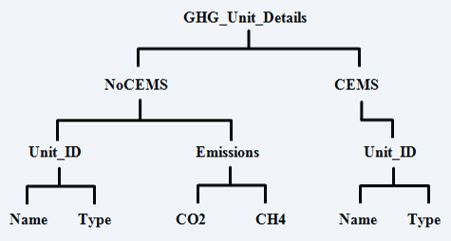

This document provides a step-by-step description of how to report emissions data using the XML schema. Please note the following seven tips on preparing your XML file:

- Do not include non-applicable data elements in your facility’s XML file. The schema contains many data elements, some of which may not be applicable to XML reporters in general or to a particular situation. If the instructions (definition tables) do not reference a particular data element, then do not report or include it in your facility’s XML file.

- Sequence data elements in the order specified by the schema. The figures and tables in this document depict the proper sequence in which data elements are arranged in the XML file to produce a well-formed XML report.

- Enumerations are case sensitive. Many data elements have a defined set of allowable values, also known as enumerations. Report values for enumerations exactly as they are defined within the schema, including punctuation marks. See the definition tables for a complete list of enumerations.

- Schema diagrams depict the hierarchy (or tree structure). The primary purpose of the schema diagrams is to indicate the sequence in which data elements must appear within the facility’s XML file and to identify the data elements that are required (must be reported) and conditionally required (see last bullet). Required data elements are boxed in red and conditionally required data elements are noted.

- Definition tables provide details for required and conditionally required data elements. The tables are designed to provide unique instructions for reporting a given data element, including the list of enumerations and required units of measure, if defined. As noted above, there are some data elements in the schema that are not applicable to XML reporters or to a particular situation. For example, the “OverrideIndicator” data element is used solely by e-GGRT to indicate that the web form reporter chose to override the system’s calculated value with their own. These non-applicable data elements are not included in the definition tables. If a data element is not referenced in a definition table, then do not report or include it in the facility’s XML file.

- The schema diagrams do not depict commonly used data types. The schema diagrams display almost every data element in the schema except the data elements that are associated with the three most commonly occurring data types:
- Calculated Details
- Measurement Details
- Unit Identification Details

Once defined, these commonly used data types (static collection of data elements) are associated as children to every data element in the schema containing a measured or calculated value or unit details. These child data elements do not appear in the diagrams and are not listed on separate rows in the definition tables in order reduce their redundancy. They are however, referenced in the definition tables in the description of their parent data element.

- Conditionally required data elements. Conditionally required data elements are noted in the schema diagrams and the data element definitions tables. If your facility meets the condition specified for the data element, then the data element is required and you must include it in your facility’s XML file. If your facility does not meet the condition specified for the data element, then do not include the data element in the facility’s XML file. Do not include a parent element that is not required, nor include any of its child data elements in your facility’s XML file.

- Calculated Details Data Type Schema Diagram
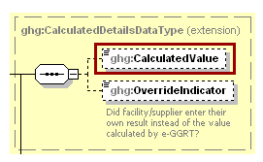
Note: Data elements boxed in red are required.

- Calculated Details Data Element Definitions

Data Element Name | Description
CalculatedDetailsDataType
CalculatedValue | Calculated value (decimal).
OverrideIndicator | Note: Do not include this data element in the facility’s XML file because it only applies to web form reporters. It is a flag set by e-GGRT to indicate that the system-calculated value was overridden with the web form reporter’s value.

- Measurement Details Data Type Schema Diagram
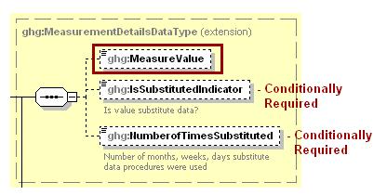
Note: Data elements boxed in red are required. Please see page 4 of this document
for more information on conditionally required elements.
- Measurement Details Data Element Definitions

Data Element Name | Description
MeasurementDetailsDataType
MeasureValue | Measured value (decimal).
IsSubstitutedIndicator | An indication (Y/N) that the measured value contains substituted data.  Note: Do not include this data element in your XML file unless noted in the instructions for the particular measured value.
NumberofTimesSubstituted | The number (integer) of days, months, weeks, or hours in the reporting year that missing data procedures were followed.  Note: Do not include this data element in your XML file unless noted in the instructions for the particular measured value.

- Unit Identification Details Data Type Schema Diagram
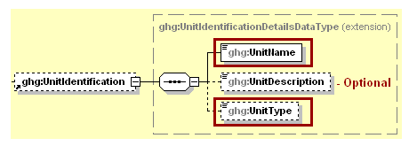
Note: Data elements boxed in red are required.

- Unit Identification Details Data Element Definitions

Data Element Name | Description
UnitIdentificationDetails
UnitName | A unique name (ID) for each unit so that the data for different units can be recorded, maintained and retrieved clearly.
UnitDescription | Optional brief description of the unit.
UnitType | The type of unit. The list of allowable values varies. For more information, see the instructions for the specific unit process to be reported. For example, if reporting Flare Gas details, the unit type would be “Flare”.
The XML symbol “1..∞” shown in Figure 5 means that the parent element is “unbounded” so that multiple instances of the parent element can be reported. XML Excerpt 1 shows an example of reporting multiple instances of a parent element.

- “Unbounded” Symbol in Schema Diagram
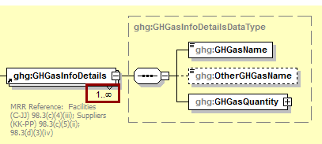

- Example for “Unbounded” Parent Element

<ghg:GHGasInfoDetails>
<ghg:GHGasName>Carbon Dioxide </ghg:GHGasName>
<ghg:GHGasQuantity massUOM="Metric Tons">
<ghg:CalculatedValue>384781.2</ghg:CalculatedValue>
</ghg:GHGasQuantity></ghg:GHGasInfoDetails>
<ghg:GHGasInfoDetails>
<ghg:GHGasInfoDetails>
<ghg:GHGasName>Methane</ghg:GHGasName>
<ghg:GHGasQuantity massUOM="Metric Tons">
<ghg:CalculatedValue>4004.12</ghg:CalculatedValue>
</ghg:GHGasQuantity></ghg:GHGasInfoDetails>
<ghg:GHGasInfoDetails>

The XML symbol for a logical “Or” shown in Figure 6 means that only one of the data elements following the symbol can be reported for the current instance of the parent element.

- Logical “Or” Symbol in Schema Diagram
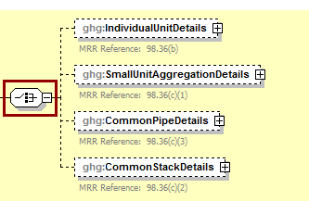

Summary of Changes

The following modifications were applied to the previous version (v4.2) of the GHG XML schema in relation to Subpart D for reporting year 2014.

- Summary of Changes to the Schema for Subpart D

No. | Change Description
1 | No changes to the XML Schema for Subpart D were made from v4.2 to v5.2

Subpart D Overview

This section provides a step-by-step description of how to report emissions data from electricity generation sources as required by Subpart D of the GHGRP using the XML schema.

- Subpart D Reporting Diagram

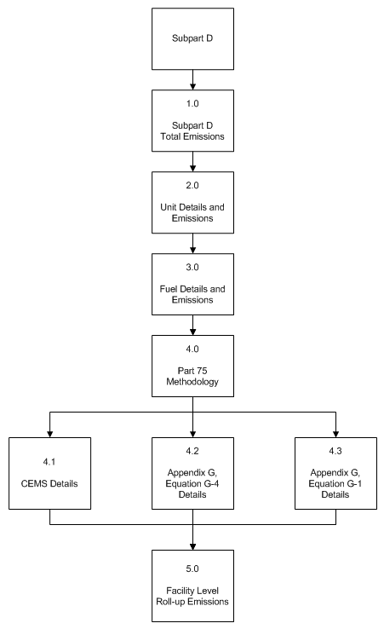

The electricity generation source category comprises electricity generating units that are subject to the requirements of the Acid Rain Program and any other electricity generating units that are required to monitor and report to EPA CO₂ mass emissions year-round according to 40 CFR part 75 (e.g. units subject to RGGI). This source category does not include portable equipment, emergency equipment or emergency generators, as defined in §98.6.

The XML schema includes the following areas for reporting for Subpart D, as displayed in the reporting diagram:

- Subpart D Total Emissions: includes the total emissions for carbon dioxide and CH₄ and N₂O combustion emissions from process units.
- Unit Details and Emissions: includes information on unit identification, methodology used and start and end dates, whether the unit is subject to the Acid Rain Program and CO₂ emissions.
- Fuel Details and Emissions: includes information on fuel type and CH₄ and N₂O emissions.
- Part 75 Methodology: includes additional information to report based on which methodology was used for the unit.
  - CEMS Details
  - Appendix G, Equation G-4 Details
  - Appendix G, Equation G-1 Details
- Facility Level Roll-up Emissions: includes information on how to report total emissions for CO₂e (excluding biogenic CO₂) and biogenic CO₂ from Subpart D at the facility level.

If your facility is subject to reporting under Subpart D (Electricity Generation), EPA recommends that you also consider the following source categories in your facility applicability determination: Subpart C (General Stationary Fuel Combustion) and Subpart PP (Suppliers of Carbon Dioxide). These source categories are only provided as suggestions - additional Subparts may be relevant for a given facility/supplier and not all listed Subparts are relevant for all facilities/suppliers.

- Subpart D Schema Diagram

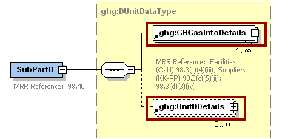
Note: Data elements boxed in red are required.

Subpart D Total Emissions

Greenhouse gas information details comprise a collection of data elements to report the total annual emissions of each greenhouse gas (GHG) listed in Table A-1 of 40 CFR 98 Mandatory Reporting of Greenhouse Gases reported under Subpart D, expressed in metric tons.

- Greenhouse Gas Information Details Schema Diagram
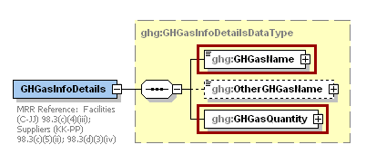
Note: Data elements boxed in red are required.

For Subpart D, report total emissions for biogenic carbon dioxide (CO₂), CO₂ (excluding biogenic CO₂), methane (CH₄) and nitrous oxide (N₂O). For greenhouse gas quantity, report the calculated value and mass unit of measure (Metric Tons) only according to the following guidelines:

- Total CO₂ emissions (excluding biogenic CO₂): Add the annual CO₂ emissions in metric tons minus the total biogenic CO₂ mass emissions in metric tons for each unit.
- Total biogenic CO₂ emissions: Add the total biogenic CO₂ mass emissions in metric tons for each unit.
- Total CH₄ emissions: Divide the CO₂ equivalent value for annual CH₄ emissions in metric tons by the Global Warming Potential for CH₄ (25 for RY 2013 onward or 21 for RY 2010 through RY 2012) for each fuel used for each unit, and add the result.
- Total N₂O emissions: Divide the CO₂ equivalent value for annual N₂O emissions in metric tons by the Global Warming Potential for N₂O (298 for RY 2013 onward or 310 for RY 2010 through RY 2012) for each fuel used for each unit, and add the result.

Note: You must follow the rounding rules found in Table 1.

- Greenhouse Gas Information Details Data Element Definitions

Data Element Name | Description
GHGasInfoDetails | Parent Element: A collection of data elements containing the total annual emissions of each greenhouse gas (GHG) listed in Table A-1 of 40 CFR 98 Mandatory Reporting of Greenhouse Gases reported under this Subpart, expressed in metric tons.
GHGasName | Specify the name of the GHG. See list of allowable values:  Carbon Dioxide  Biogenic Carbon dioxide  Methane  Nitrous Oxide
GHGasQuantity | A collection of data elements that quantify the annual emissions from this source category. Report the value in the child data element CalculatedValue. Set the units of measure to “Metric Tons” in the attribute massUOM.

- Example for Greenhouse Gas Information Details
<ghg:SubPartD>
<ghg:GHGasInfoDetails>
<ghg:GHGasName>Biogenic Carbon dioxide</ghg:GHGasName>
<ghg:GHGasQuantity massUOM="Metric Tons">
<ghg:CalculatedValue>1000.2</ghg:CalculatedValue>
</ghg:GHGasQuantity>
</ghg:GHGasInfoDetails>
<ghg:GHGasInfoDetails>
<ghg:GHGasName>Methane</ghg:GHGasName>
<ghg:GHGasQuantity massUOM="Metric Tons">
<ghg:CalculatedValue>47.62</ghg:CalculatedValue>
</ghg:GHGasQuantity>
</ghg:GHGasInfoDetails>
<ghg:GHGasInfoDetails>
<ghg:GHGasName>Nitrous Oxide</ghg:GHGasName>
<ghg:GHGasQuantity massUOM="Metric Tons">
<ghg:CalculatedValue>0.323</ghg:CalculatedValue>
</ghg:GHGasQuantity>
</ghg:GHGasInfoDetails>
<ghg:GHGasInfoDetails>
<ghg:GHGasName>Carbon Dioxide</ghg:GHGasName>
<ghg:GHGasQuantity massUOM="Metric Tons">
<ghg:CalculatedValue>9000.8</ghg:CalculatedValue>
</ghg:GHGasQuantity>
</ghg:GHGasInfoDetails>

Note: The code excerpt above is presented here to demonstrate the concept of reporting greenhouse gas emissions data.

Unit Details and Emissions

- Units D Details Schema Diagram
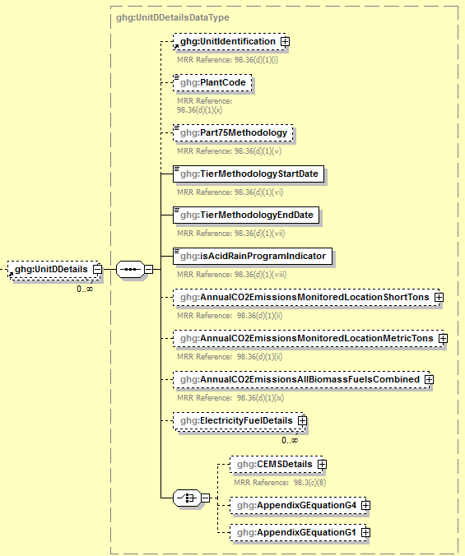

For each unit, stack or pipe at your facility, Subpart D requires the following information:

- A unique name or identifier (e.g., a unit ID number) for the monitoring location (unit, stack or pipe). The ID for this monitoring location should match the ID reported under §75.64 [98.36(d)(1)(i)].
- An optional description or label.
- The plant code associated with the facility as defined under 98.6 [98.36(d)(1)(x)]
- The Part 75 methodology used to determine the CO₂ mass emissions [98.36(d)(1)(v)]:
  - CEMS
  - Appendix G, Equation G-1
  - Appendix G, Equation G-4
  - Low Mass Emissions (LME) (§75.19(c)(4)(iii))
- The methodology start date and end date [98.36(d)(1)(vi)-(vii)].
- An indication of participation in the Acid Rain Program [98.36(d)(1)(viii)].

For each unit, stack or pipe Subpart D requires the facility to provide the following aggregated emissions data:

- The total annual CO₂ emissions at the monitored location in short tons (exactly as reported under Part 75) [98.36(d)(1)(ii)].
- The total annual CO₂ emissions at the monitored location in metric tons (divide the CO₂ emissions in short tons by 1.1023 to obtain the CO₂ emissions value in metric tons) [98.36(d)(1)(ii)].
- The total annual biogenic CO₂ emissions. This includes CO₂ emissions from the combustion of biomass fuels and the biogenic fraction of CO₂ emissions from fuels with a mixed biogenic and fossil component (i.e. MSW or tires) [98.36(d)(1)(ix)].

- Unit Details and Emissions Schema Diagram
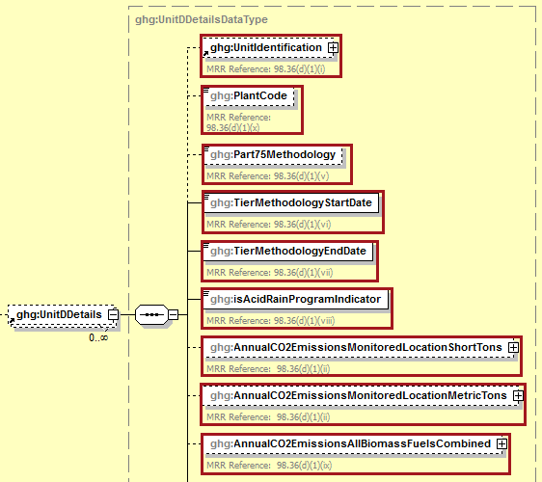
Note: Data elements boxed in red are required.
- Unit Details and Emissions Data Element Definitions

Data Element Name | Description
UnitDDetails | Parent Element: A collection of data elements containing details regarding each unit, stack or pipe reporting under Subpart D.
UnitIdentification | A collection of data elements containing the identity of each unit, stack or pipe reported under Subpart D. Report a unique unit name (ID) in the child data element UnitName, an optional brief description in the child data element UnitDescription and the type of unit in the child data element UnitType: “Electricity Generator”. Use the exact same unit, common stack, common pipe or multiple stack identification numbers that represent the monitored locations (e.g., 1, 2, CS001, MS1A) that are reported under §75.64.
PlantCode | The plant code associated with the facility as defined under 98.6. [98.36(d)(1)(x)]
Part75Methodology | The Part 75 methodology used to determine the CO₂ mass emissions. See list of allowable values:  CEMS  Appendix G, Equation G-1  Appendix G, Equation G-4  LME (§75.19(c)(4)(iii))
TierMethodologyStartDate | The methodology start date (YYYY-MM-DD).
TierMethodologyEndDate | The methodology end date (YYYY-MM-DD).
isAcidRainProgramIndicator | An indication (Y/N) of whether the unit is subject to the Acid Rain Program.
AnnualCO2EmissionsMonitoredLocationShortTons | The total annual CO₂ emissions at the monitored location in short tons. Report the value in the child data element CalculatedValue. Set the units of measure to “Short Tons” in the attribute massUOM.
AnnualCO2EmissionsMonitoredLocationMetricTons | The total annual CO₂ emissions at the monitored location in metric tons. Report the value in the child data element CalculatedValue. Set the units of measure to “Metric Tons” in the attribute massUOM.
AnnualCO2EmissionsAllBiomassFuelsCombined | The total annual biogenic CO₂ mass emissions. Report the value in the child data element CalculatedValue. Set the units of measure to “Metric Tons” in the attribute massUOM.

- Example for Unit Details and Emissions

<ghg:UnitDDetails>
<ghg:UnitIdentification>
<ghg:UnitName>003-AG-Eq G-4</ghg:UnitName>
<ghg:UnitDescription>Appendix G, Eq. G-4 unit</ghg:UnitDescription>
<ghg:UnitType>Electricity Generator</ghg:UnitType>
</ghg:UnitIdentification>
<ghg:PlantCode>885555</ghg:PlantCode>
<ghg:Part75Methodology>Appendix G, Equation G-4</ghg:Part75Methodology>
<ghg:TierMethodologyStartDate>2012-01-01</ghg:TierMethodologyStartDate>
<ghg:TierMethodologyEndDate>2012-12-31</ghg:TierMethodologyEndDate>
<ghg:isAcidRainProgramIndicator>Y</ghg:isAcidRainProgramIndicator>
<ghg:AnnualCO2EmissionsMonitoredLocationShortTons massUOM="Short Tons">
<ghg:CalculatedValue>3307.6</ghg:CalculatedValue>
</ghg:AnnualCO2EmissionsMonitoredLocationShortTons>
<ghg:AnnualCO2EmissionsMonitoredLocationMetricTons massUOM="Metric Tons">
<ghg:CalculatedValue>3000.3</ghg:CalculatedValue>
</ghg:AnnualCO2EmissionsMonitoredLocationMetricTons>
<ghg:AnnualCO2EmissionsAllBiomassFuelsCombined massUOM="Metric Tons">
<ghg:CalculatedValue>300.2</ghg:CalculatedValue>
</ghg:AnnualCO2EmissionsAllBiomassFuelsCombined>

Note: The code excerpt above is presented here to demonstrate the concept of reporting greenhouse gas emissions data.

Fuel Details and Emissions

For each unit, stack or pipe, Subpart D requires the facility to name each type of fuel combusted in the configuration during the reporting year.

For each fuel type listed in Table C-2 (or other fuel/fuel blend reported in lieu of or in addition to the fuel types listed in Table C-2) that is combusted in each unit, stack or pipe, Subpart D requires the facility to provide the data elements below.
- Conditionally Required: The total annual heat input from each fuel listed in Table C-2. Note: this reporting element is only required for fuels listed in Table C-2.
- Conditionally Required: The fuel type associated with the fuel blend. Note: this reporting element is only required if a fuel blend is reported in lieu of one of the fuels listed in Table C-2.
- Conditionally Required: The total annual CH₄ combustion emissions calculated using Equation C-10 expressed as CO₂ equivalent (CO₂e). Note: this reporting element is only required for fuels listed in Table C-2.
- Conditionally Required: The total annual N₂O combustion emissions calculated using Equation C-10 expressed as CO₂ equivalent (CO₂e). Note: this reporting element is only required for fuels listed in Table C-2.

Note: Units that use CEMS and elect to use the provision under 98.33(c)(4)(ii)(B) need only report the Table C-2 fuel to which the total annual heat input was attributed.

- Fuel Details and Emissions Schema Diagram

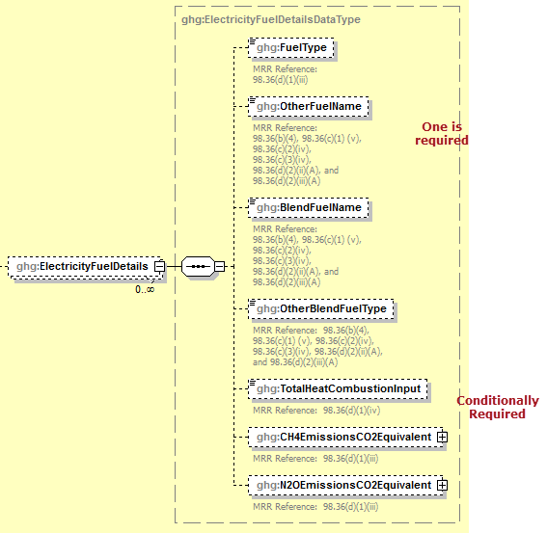

Note: Please see page 4 of this document for more information on conditionally required elements.

- Fuel Details and Emissions Data Element Definitions

Data Element Name | Description
ElectricityFuelDetails | Parent Element: A collection of data elements containing information about each type of fuel combusted in the configuration during the reporting year
FuelType | Conditionally Required: If the fuel type is on the list of allowable values, then specify the type of fuel combusted in the unit during the report year. See the list of allowable fuel types below. If reporting a fuel not on the list or a blended fuel, then specify its name using one of the following data elements, "OtherFuelName" or "BlendFuelName", as appropriate and do not report this data element. Note that the fuel type options for Coal Coke, Wood and Wood Residuals (dry basis), Landfill Gas, Other Biomass Gases, and Biodiesel (100%) are applicable only for RY 2013 onward. The options for Biodiesel, Coke, Wood and Wood Residuals, and Biogas (Captured Methane) are now only applicable for RY 2010 through 2012.  Anthracite  Bituminous  Subbituminous  Lignite  Coke  Coal Coke  Mixed (Commercial sector)  Mixed (Industrial coking)  Mixed (Industrial sector)  Mixed (Electric Power sector)  Mixed (Electric Power sector)  Plastics  Petroleum Coke  Municipal Solid Waste  Tires  Wood and Wood Residuals  Wood and Wood Residuals (dry basis)  Agricultural Byproducts  Peat  Distillate Fuel Oil No. 1  Distillate Fuel Oil No. 2  Distillate Fuel Oil No. 4  Residual Fuel Oil No. 5  Residual Fuel Oil No. 6  Used Oil  Kerosene  Liquefied petroleum gases (LPG)  Propylene  Ethane  Ethanol (100%)  Ethylene  Isobutane  Isobutylene  Butane  Butylene  Naphtha (&lt;401 deg F)  Natural Gasoline  Other Oil (&gt;401 deg F)  Pentanes Plus  Petrochemical Feedstocks  Petroleum Coke  Special Naphtha  Unfinished Oils  Heavy Gas Oils  Lubricants  Motor Gasoline  Aviation Gasoline  Kerosene-Type Jet Fuel  Asphalt and Road Oil  Crude Oil  Propane  Ethanol  Biodiesel  Biodiesel (100%)  Rendered Animal Fat  Vegetable Oil  Natural Gas (Weighted U.S. Average)  Blast Furnace Gas  Coke Oven Gas  Propane Gas  Fuel Gas  Biogas (Captured methane)  Landfill Gas  Solid Byproducts  Other Biomass Gases
OtherFuelName | Conditionally Required: Name of the specific fuel if not found in the list of allowable values above. Otherwise, do not report this data element.
BlendFuelName | Conditionally Required: Name of the specific fuel blend if not found in the list of allowable values and if component fuels cannot be reported individually. Otherwise, do not report this data element.
OtherBlendFuelType | Conditionally Required: Name of the specific type of fuel blend if reported in BlendFuelName. Otherwise, do not report this data element.  - Other (gas)  - Other (liquid)  - Other (solid)  - Blend (gas)  - Blend (liquid)  - Blend (solid)
TotalHeatCombustionInput | Conditionally Required: The total heat input from each fuel listed in Table C-2 of Subpart C combusted during the year in mmBtu. This reporting element is only required for fuels listed in Table C-2. Units that use CEMS and elect to use the provision under 98.33(c)(4)(ii)(B) need only report this element only for the Table C-2 fuel to which the total heat input was attributed.
CH4EmissionsCO2Equivalent | Conditionally Required: Annual CH₄ combustion emissions calculated using Equation C-10 at each monitored location for the specified fuel, in metric tons CO₂ equivalent. This reporting element is only required for fuels listed in Table C-2. Report the value in the child data element CalculatedValue. Set the units of measure to “Metric Tons” in the attribute massUOM.
N2OEmissionsCO2Equivalent | Conditionally Required: Annual N₂O combustion emissions calculated using Equation C-10 at each monitored location for the specified fuel, in metric tons CO₂ equivalent. This reporting element is only required for fuels listed in Table C-2. Report the value in the child data element CalculatedValue. Set the units of measure to “Metric Tons” in the attribute massUOM.

- Example for Fuel Details and Emissions
<ghg:ElectricityFuelDetails>
<ghg:FuelType>Anthracite</ghg:FuelType>
<ghg:TotalHeatCombustionInput>10000000</ghg:TotalHeatCombustionInput>
<ghg:CH4EmissionsCO2Equivalent massUOM="Metric Tons">
<ghg:CalculatedValue>2310.0</ghg:CalculatedValue>
</ghg:CH4EmissionsCO2Equivalent>
<ghg:N2OEmissionsCO2Equivalent massUOM="Metric Tons">
<ghg:CalculatedValue>4960.0</ghg:CalculatedValue>
</ghg:N2OEmissionsCO2Equivalent>
</ghg:ElectricityFuelDetails>

Note: The code excerpt above is presented here to demonstrate the concept of reporting greenhouse gas emissions data.

Part 75 Methodology

Details about the Part 75 methodology used to determine the CO₂ mass emissions for the unit must be reported based on the methodology indicated for the data element “Part75Methodology”.

Which Part 75 methodology was used to determine the CO₂ mass emissions for the unit?

If CEMS method was used for the unit, see Section 4.1 for reporting instructions.
If Appendix G, Equation G-4 was used for the unit, see Section 4.2 for reporting instructions.
If Appendix G, Equation G-1 was used for the unit, see Section 4.3 for reporting instructions.
If LME (75.19(c)(4)(iii)) was used for the unit, there are no additional details to report. See Section 5.0 for instructions on how to report facility level roll-up emissions.

- Part 75 Methodology Schema Diagram
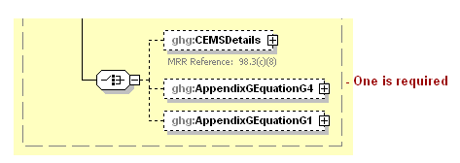
Note: Data elements boxed in red are required. Please see page 4 of this document
for more information on conditionally required elements.

CEMS Details

For each unit for which the facility selects "CEMS" as the Part 75 methodology used to determine CO₂ mass emissions, Subpart D requires the facility to provide the following additional information [98.3(c)(8)]:

- The total number of operating hours during the year that CO₂ concentration was missing.
- The total number of operating hours during the year that stack gas flow rate was missing.
- Conditionally Required: The total number of operating hours during the year that moisture content was missing (only if a continuous moisture monitor was in use).

- CEMS Details Schema Diagram
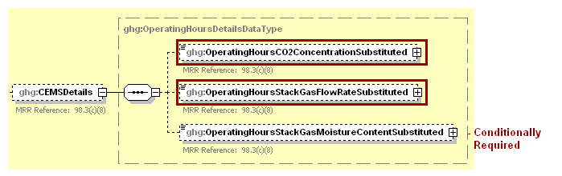
Note: Data elements boxed in red are required. Please see page 4 of this document
for more information on conditionally required elements.

- CEMS Details Data Element Definitions

Data Element Name | Description
CEMSDetails | Parent Element (Conditionally Required): Report only if "CEMS" was indicated as the Part 75 methodology used to determine CO₂ mass emissions for the unit specified. Otherwise do not report these data elements.
OperatingHoursCO2ConcentrationSubstituted | The total operating hours in which a substitute data value was used in the emissions calculations for the CO₂ concentration parameter.
OperatingHoursStackGasFlowRateSubstituted | The total operating hours in which a substitute data value was used in the emissions calculations for the stack gas flow rate parameter.
OperatingHoursStackGasMoistureContentSubstituted | Conditionally Required: If moisture correction is required and a continuous moisture monitor is used, then report the total operating hours in which a substitute data value was used in the emissions calculations for the stack gas moisture content parameter. Otherwise do not report this data element.

- Example for CEMS Details

<ghg:CEMSDetails>
<ghg:OperatingHoursCO2ConcentrationSubstituted>10</ghg:OperatingHoursCO2ConcentrationSubstituted>
<ghg:OperatingHoursStackGasFlowRateSubstituted>20</ghg:OperatingHoursStackGasFlowRateSubstituted>
<ghg:OperatingHoursStackGasMoistureContentSubstituted>30</ghg:OperatingHoursStackGasMoistureContentSubstituted>
</ghg:CEMSDetails>

Note: The code excerpt above is presented here to demonstrate the concept of reporting greenhouse gas emissions data.

See Section 5.0 for instructions on how to report facility level roll-up emissions.

Appendix G, Equation G-4 Details

For each unit for which the facility selects "Appendix G, Equation G-4" as the Part 75 methodology used to determine CO₂ mass emissions, Subpart D requires the facility to provide the following additional information [98.3(c)(8)]:

- The total number of operating hours during the year that fuel flow rate was missing.
- The total number of operating hours during the year that high heating value was missing.

- Appendix G, Equation G-4 Details Schema Diagram
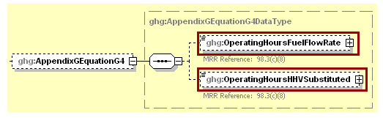
Note: Data elements boxed in red are required.

- Appendix G, Equation G-4 Details Data Element Definitions

Data Element Name | Description
AppendixGEquationG4 | Parent Element (Conditionally Required): Report only if "Appendix G, Equation G-4" was indicated as the Part 75 methodology used to determine CO₂ mass emissions. Otherwise do not report these data elements.
OperatingHoursFuelFlowRate | Total number of operating hours during the year that fuel flow rate was missing
OperatingHoursHHVSubstituted | Total number of operating hours during the year that high heating value was missing.

- Example for Appendix G, Equation G-4 Details
<ghg:AppendixGEquationG4>
<ghg:OperatingHoursFuelFlowRate>1</ghg:OperatingHoursFuelFlowRate>
<ghg:OperatingHoursHHVSubstituted>2</ghg:OperatingHoursHHVSubstituted>
</ghg:AppendixGEquationG4>

Note: The code excerpt above is presented here to demonstrate the concept of reporting greenhouse gas emissions data.

See Section 5.0 for instructions on how to report facility level roll-up emissions.

Appendix G, Equation G-1 Details

For each unit for which the facility selects "Appendix G, Equation G-1" as the Part 75 methodology used to determine CO₂ mass emissions, Subpart D requires the facility to provide the following additional information [98.3(c)(8)]:

- The total number of operating hours during the year that fuel carbon content was missing.

- Appendix G, Equation G-1 Details Schema Diagram
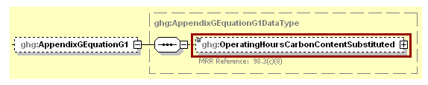
Note: Data elements boxed in red are required.

- Appendix G, Equation G-1 Details Data Element Definitions

Data Element Name | Description
AppendixGEquationG1 | Parent Element (Conditionally Required): Report only if "Appendix G, Equation G-1" was indicated as the Part 75 methodology used to determine CO₂ mass emissions. Otherwise do not report these data elements.
OperatingHoursCarbonContentSubstituted | The total number of operating hours in the reporting year for which missing data substitution was used for carbon content values.

- Example for Appendix G, Equation G-1 Details
<ghg:AppendixGEquationG1>
<ghg:OperatingHoursCarbonContentSubstituted>1</ghg:OperatingHoursCarbonContentSubstituted>
</ghg:AppendixGEquationG1>

Note: The code excerpt above is presented here to demonstrate the concept of reporting greenhouse gas emissions data.

See Section 5.0 for instructions on how to report facility level roll-up emissions.

Facility-Level Roll-up Emissions

This section provides a description of how to roll up Subpart D emissions totals into the facility’s total CO₂e emissions, reported under Subpart A.
- Each facility must report the following facility-level emission data:
  - Total CO₂ equivalent (CO₂e) emissions (excluding biogenic CO₂) aggregated across all direct emitter source categories (Subparts C-II and Subparts RR-UU) associated with the facility.
  - Total biogenic CO₂ emissions aggregated across all direct emitter source categories (Subparts C-II and Subparts RR-UU) associated with the facility.
- Each supplier must report the following supplier data:
  - Total CO₂e associated with products supplied aggregated across all supplier source categories (Subparts LL-QQ) associated with the facility.

- Facility-Level Roll-up Emissions Schema Diagram

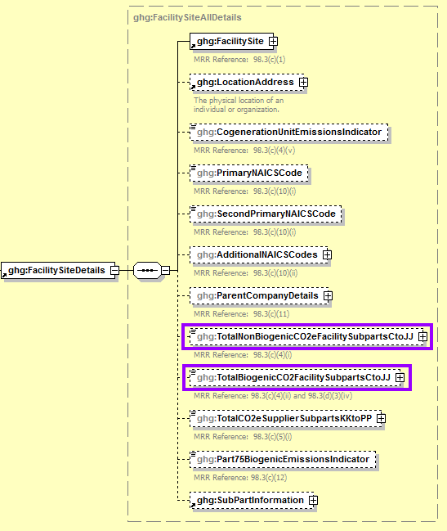
Note: Subpart D emissions totals roll up into the data element boxed in purple (Subpart A).
- Add the total CO₂e value for Subpart D in metric tons to the total CO₂e emissions (excluding biogenic CO₂) aggregated across all source category Subparts associated with the facility according to the following guidelines:

- Add the annual CO₂ emissions in metric tons minus the total biogenic CO₂ mass emissions in metric tons for each unit.
- Add the CO₂ equivalent value for annual CH₄ emissions in metric tons for each fuel used in each unit.
- Add the CO₂ equivalent value for annual N₂O emissions in metric tons for each fuel used in each unit.

- Add the total biogenic CO₂ mass emissions from each unit in metric tons to the total biogenic CO₂ aggregated across all source category Subparts associated with the facility.

Note: You must follow the rounding rules found in Table 1.

- Facility Level Roll-up Emissions Data Element Definitions

Data Element Name | Description
TotalNonBiogenicCO2eFacilitySubpartsCtoJJ | Add the total CO₂e value for Subpart D in metric tons to the total CO₂e emissions (excluding biogenic CO₂) aggregated across all source category Subparts associated with the facility according to the guidelines above. Set the units of measure to “Metric Tons” in the attribute massUOM.
TotalBiogenicCO2FacilitySubpartsCtoJJ | Add the total annual biogenic CO₂ value for Subpart D in metric tons to the total biogenic CO₂ emissions aggregated across all source category Subparts associated with the facility according to the guideline above. Set the units of measure to “Metric Tons” in the attribute massUOM.

- Example for Facility Level Roll-up Emissions

<ghg:TotalNonBiogenicCO2eFacilitySubpartsCtoJJ massUOM="Metric Tons">10100.2</ghg:TotalNonBiogenicCO2eFacilitySubpartsCtoJJ>
<ghg:TotalBiogenicCO2FacilitySubpartsCtoJJ massUOM="Metric Tons">1000.7</ghg:TotalBiogenicCO2FacilitySubpartsCtoJJ>

Note: The code excerpt above is presented here to demonstrate the concept of reporting greenhouse gas emissions data.

Appendix A – Sample XML Document for Subpart D

(Note: Data values do not reflect an actual facility's emissions. Additional sample XML files for Subpart D are posted on the e-GGRT help site. http://www.ccdsupport.com/confluence/display/help/Additional+XML+Examples )

<ghg:GHG xmlns="http://www.ccdsupport.com/schema/ghg">
<ghg:FacilitySiteInformation>
<ghg:CertificationStatement>The designated representative or alternate designated representative must sign (i.e., agree to) this certification statement. If you are an agent and you click on "SUBMIT", you are not agreeing to the certification statement, but are submitting the certification statement on behalf of the designated representative or alternate designated representative who is agreeing to the certification statement. An agent is only authorized to make the electronic submission on behalf of the designated representative, not to sign (i.e., agree to) the certification statement.</ghg:CertificationStatement>
<ghg:ReportingYear>2012</ghg:ReportingYear>
<ghg:FacilitySiteDetails>
<ghg:FacilitySite>
<ghg:FacilitySiteIdentifier>524477</ghg:FacilitySiteIdentifier>
<ghg:FacilitySiteName>Test Facility D</ghg:FacilitySiteName>
</ghg:FacilitySite>
<ghg:LocationAddress>
<ghg:LocationAddressText>1 Main St.</ghg:LocationAddressText>
<ghg:LocalityName>Charlottesville</ghg:LocalityName>
<ghg:StateIdentity>
<ghg:StateCode>VA</ghg:StateCode>
</ghg:StateIdentity>
<ghg:AddressPostalCode>22911</ghg:AddressPostalCode>
</ghg:LocationAddress>
<ghg:CogenerationUnitEmissionsIndicator>N</ghg:CogenerationUnitEmissionsIndicator>
<ghg:PrimaryNAICSCode>237130</ghg:PrimaryNAICSCode>
<ghg:ParentCompanyDetails>
<ghg:ParentCompany>
<ghg:ParentCompanyLegalName>Soda Ash Corporation</ghg:ParentCompanyLegalName>
<ghg:StreetAddress>108 Hillcrest Street</ghg:StreetAddress>
<ghg:City>Sandpoint</ghg:City>
<ghg:State>ID</ghg:State>
<ghg:Zip>83864</ghg:Zip>
<ghg:PercentOwnershipInterest>100.0</ghg:PercentOwnershipInterest>
</ghg:ParentCompany>
</ghg:ParentCompanyDetails>
<ghg:TotalNonBiogenicCO2eFacilitySubpartsCtoJJ massUOM="Metric Tons">10100.2</ghg:TotalNonBiogenicCO2eFacilitySubpartsCtoJJ>
<ghg:TotalBiogenicCO2FacilitySubpartsCtoJJ massUOM="Metric Tons">1000.2</ghg:TotalBiogenicCO2FacilitySubpartsCtoJJ>
<ghg:TotalCO2eSupplierSubpartsKKtoPP massUOM="Metric Tons">0</ghg:TotalCO2eSupplierSubpartsKKtoPP>
<ghg:SubPartInformation>
<ghg:SubPartD>
<ghg:GHGasInfoDetails>
<ghg:GHGasName>Biogenic Carbon dioxide</ghg:GHGasName>
<ghg:GHGasQuantity massUOM="Metric Tons">
<ghg:CalculatedValue>1000.4</ghg:CalculatedValue>
</ghg:GHGasQuantity>
</ghg:GHGasInfoDetails>
<ghg:GHGasInfoDetails>
<ghg:GHGasName>Methane</ghg:GHGasName>
<ghg:GHGasQuantity massUOM="Metric Tons">
<ghg:CalculatedValue>47.62</ghg:CalculatedValue>
</ghg:GHGasQuantity>
</ghg:GHGasInfoDetails>
<ghg:GHGasInfoDetails>
<ghg:GHGasName>Nitrous Oxide</ghg:GHGasName>
<ghg:GHGasQuantity massUOM="Metric Tons">
<ghg:CalculatedValue>0.323</ghg:CalculatedValue>
</ghg:GHGasQuantity>
</ghg:GHGasInfoDetails>
<ghg:GHGasInfoDetails>
<ghg:GHGasName>Carbon Dioxide</ghg:GHGasName>
<ghg:GHGasQuantity massUOM="Metric Tons">
<ghg:CalculatedValue>9000.5</ghg:CalculatedValue>
</ghg:GHGasQuantity>
</ghg:GHGasInfoDetails>
<ghg:UnitDDetails>
<ghg:UnitIdentification>
<ghg:UnitName>004-LME</ghg:UnitName>
<ghg:UnitDescription>LME unit</ghg:UnitDescription>
<ghg:UnitType>Electricity Generator</ghg:UnitType>
</ghg:UnitIdentification>
<ghg:PlantCode>885555</ghg:PlantCode>
<ghg:Part75Methodology>LME (§75.19(c)(4)(iii))</ghg:Part75Methodology>
<ghg:TierMethodologyStartDate>2012-01-01</ghg:TierMethodologyStartDate>
<ghg:TierMethodologyEndDate>2012-12-31</ghg:TierMethodologyEndDate>
<ghg:isAcidRainProgramIndicator>Y</ghg:isAcidRainProgramIndicator>
<ghg:AnnualCO2EmissionsMonitoredLocationShortTons massUOM="Short Tons">
<ghg:CalculatedValue>4409.2</ghg:CalculatedValue>
</ghg:AnnualCO2EmissionsMonitoredLocationShortTons>
<ghg:AnnualCO2EmissionsMonitoredLocationMetricTons massUOM="Metric Tons">
<ghg:CalculatedValue>4000.3</ghg:CalculatedValue>
</ghg:AnnualCO2EmissionsMonitoredLocationMetricTons>
<ghg:AnnualCO2EmissionsAllBiomassFuelsCombined massUOM="Metric Tons">
<ghg:CalculatedValue>400.6</ghg:CalculatedValue>
</ghg:AnnualCO2EmissionsAllBiomassFuelsCombined>
<ghg:ElectricityFuelDetails>
<ghg:FuelType>Anthracite</ghg:FuelType>
<ghg:TotalHeatCombustionInput>10000000</ghg:TotalHeatCombustionInput>
<ghg:CH4EmissionsCO2Equivalent massUOM="Metric Tons">
<ghg:CalculatedValue>2310.0</ghg:CalculatedValue>
</ghg:CH4EmissionsCO2Equivalent>
<ghg:N2OEmissionsCO2Equivalent massUOM="Metric Tons">
<ghg:CalculatedValue>4960.0</ghg:CalculatedValue>
</ghg:N2OEmissionsCO2Equivalent>
</ghg:ElectricityFuelDetails>
</ghg:UnitDDetails>
<ghg:UnitDDetails>
<ghg:UnitIdentification>
<ghg:UnitName>003-AG-Eq G-4</ghg:UnitName>
<ghg:UnitDescription>Appendix G, Eq. G-4 unit</ghg:UnitDescription>
<ghg:UnitType>Electricity Generator</ghg:UnitType>
</ghg:UnitIdentification>
<ghg:PlantCode>885555</ghg:PlantCode>
<ghg:Part75Methodology>Appendix G, Equation G-4</ghg:Part75Methodology>
<ghg:TierMethodologyStartDate>2012-01-01</ghg:TierMethodologyStartDate>
<ghg:TierMethodologyEndDate>2012-12-31</ghg:TierMethodologyEndDate>
<ghg:isAcidRainProgramIndicator>Y</ghg:isAcidRainProgramIndicator>
<ghg:AnnualCO2EmissionsMonitoredLocationShortTons massUOM="Short Tons">
<ghg:CalculatedValue>3307.3</ghg:CalculatedValue>
</ghg:AnnualCO2EmissionsMonitoredLocationShortTons>
<ghg:AnnualCO2EmissionsMonitoredLocationMetricTons massUOM="Metric Tons">
<ghg:CalculatedValue>3000.2</ghg:CalculatedValue>
</ghg:AnnualCO2EmissionsMonitoredLocationMetricTons>
<ghg:AnnualCO2EmissionsAllBiomassFuelsCombined massUOM="Metric Tons">
<ghg:CalculatedValue>300.1</ghg:CalculatedValue>
</ghg:AnnualCO2EmissionsAllBiomassFuelsCombined>
<ghg:ElectricityFuelDetails>
<ghg:FuelType>Anthracite</ghg:FuelType>
<ghg:TotalHeatCombustionInput>9000000</ghg:TotalHeatCombustionInput>
<ghg:CH4EmissionsCO2Equivalent massUOM="Metric Tons">
<ghg:CalculatedValue>2110.1</ghg:CalculatedValue>
</ghg:CH4EmissionsCO2Equivalent>
<ghg:N2OEmissionsCO2Equivalent massUOM="Metric Tons">
<ghg:CalculatedValue>3860.2</ghg:CalculatedValue>
</ghg:N2OEmissionsCO2Equivalent>
</ghg:ElectricityFuelDetails>
<ghg:AppendixGEquationG4>
<ghg:OperatingHoursFuelFlowRate>1</ghg:OperatingHoursFuelFlowRate>
<ghg:OperatingHoursHHVSubstituted>2</ghg:OperatingHoursHHVSubstituted>
</ghg:AppendixGEquationG4>
</ghg:UnitDDetails>
<ghg:UnitDDetails>
<ghg:UnitIdentification>
<ghg:UnitName>002-AG-Eq G-1</ghg:UnitName>
<ghg:UnitDescription>Appendix G, Eq. G-1 unit</ghg:UnitDescription>
<ghg:UnitType>Electricity Generator</ghg:UnitType>
</ghg:UnitIdentification>
<ghg:PlantCode>885555</ghg:PlantCode>
<ghg:Part75Methodology>Appendix G, Equation G-1</ghg:Part75Methodology>
<ghg:TierMethodologyStartDate>2012-01-01</ghg:TierMethodologyStartDate>
<ghg:TierMethodologyEndDate>2012-12-31</ghg:TierMethodologyEndDate>
<ghg:isAcidRainProgramIndicator>N</ghg:isAcidRainProgramIndicator>
<ghg:AnnualCO2EmissionsMonitoredLocationShortTons massUOM="Short Tons">
<ghg:CalculatedValue>2205.4</ghg:CalculatedValue>
</ghg:AnnualCO2EmissionsMonitoredLocationShortTons>
<ghg:AnnualCO2EmissionsMonitoredLocationMetricTons massUOM="Metric Tons">
<ghg:CalculatedValue>2000.2</ghg:CalculatedValue>
</ghg:AnnualCO2EmissionsMonitoredLocationMetricTons>
<ghg:AnnualCO2EmissionsAllBiomassFuelsCombined massUOM="Metric Tons">
<ghg:CalculatedValue>200.1</ghg:CalculatedValue>
</ghg:AnnualCO2EmissionsAllBiomassFuelsCombined>
<ghg:ElectricityFuelDetails>
<ghg:FuelType>Bituminous</ghg:FuelType>
<ghg:TotalHeatCombustionInput>9000000</ghg:TotalHeatCombustionInput>
<ghg:CH4EmissionsCO2Equivalent massUOM="Metric Tons">
<ghg:CalculatedValue>200.7</ghg:CalculatedValue>
</ghg:CH4EmissionsCO2Equivalent>
<ghg:N2OEmissionsCO2Equivalent massUOM="Metric Tons">
<ghg:CalculatedValue>20.8</ghg:CalculatedValue>
</ghg:N2OEmissionsCO2Equivalent>
</ghg:ElectricityFuelDetails>
<ghg:AppendixGEquationG1>
<ghg:OperatingHoursCarbonContentSubstituted>1</ghg:OperatingHoursCarbonContentSubstituted>
</ghg:AppendixGEquationG1>
</ghg:UnitDDetails>
<ghg:UnitDDetails>
<ghg:UnitIdentification>
<ghg:UnitName>001-CEMS</ghg:UnitName>
<ghg:UnitDescription>CEMS unit</ghg:UnitDescription>
<ghg:UnitType>Electricity Generator</ghg:UnitType>
</ghg:UnitIdentification>
<ghg:PlantCode>885555</ghg:PlantCode>
<ghg:Part75Methodology>CEMS</ghg:Part75Methodology>
<ghg:TierMethodologyStartDate>2012-01-01</ghg:TierMethodologyStartDate>
<ghg:TierMethodologyEndDate>2012-12-31</ghg:TierMethodologyEndDate>
<ghg:isAcidRainProgramIndicator>N</ghg:isAcidRainProgramIndicator>
<ghg:AnnualCO2EmissionsMonitoredLocationShortTons massUOM="Short Tons">
<ghg:CalculatedValue>1102.4</ghg:CalculatedValue>
</ghg:AnnualCO2EmissionsMonitoredLocationShortTons>
<ghg:AnnualCO2EmissionsMonitoredLocationMetricTons massUOM="Metric Tons">
<ghg:CalculatedValue>1000.5</ghg:CalculatedValue>
</ghg:AnnualCO2EmissionsMonitoredLocationMetricTons>
<ghg:AnnualCO2EmissionsAllBiomassFuelsCombined massUOM="Metric Tons">
<ghg:CalculatedValue>100.7</ghg:CalculatedValue>
</ghg:AnnualCO2EmissionsAllBiomassFuelsCombined>
<ghg:ElectricityFuelDetails>
<ghg:FuelType>Mixed (Electric Power sector)</ghg:FuelType>
<ghg:TotalHeatCombustionInput>9000000</ghg:TotalHeatCombustionInput>
<ghg:CH4EmissionsCO2Equivalent massUOM="Metric Tons">
<ghg:CalculatedValue>200.7</ghg:CalculatedValue>
</ghg:CH4EmissionsCO2Equivalent>
<ghg:N2OEmissionsCO2Equivalent massUOM="Metric Tons">
<ghg:CalculatedValue>20.8</ghg:CalculatedValue>
</ghg:N2OEmissionsCO2Equivalent>
</ghg:ElectricityFuelDetails>
<ghg:CEMSDetails>
<ghg:OperatingHoursCO2ConcentrationSubstituted>1</ghg:OperatingHoursCO2ConcentrationSubstituted>
<ghg:OperatingHoursStackGasFlowRateSubstituted>2</ghg:OperatingHoursStackGasFlowRateSubstituted>
<ghg:OperatingHoursStackGasMoistureContentSubstituted>3</ghg:OperatingHoursStackGasMoistureContentSubstituted>
</ghg:CEMSDetails>
</ghg:UnitDDetails>
</ghg:SubPartD>
</ghg:SubPartInformation>
</ghg:FacilitySiteDetails>
<ghg:CalculationMethodologyChangesDescription>None</ghg:CalculationMethodologyChangesDescription>
<ghg:BestAvailableMonitoringMethodsUsed>N/A</ghg:BestAvailableMonitoringMethodsUsed>
<ghg:StartDate>2012-01-01</ghg:StartDate>
<ghg:EndDate>2012-12-31</ghg:EndDate>
<ghg:DateTimeReportGenerated>2012-02-09T09:58:09</ghg:DateTimeReportGenerated>
</ghg:FacilitySiteInformation>
</ghg:GHG>

